CONTENTS

**SERVICE SPECIFICATION**

ETHNICITY IN MENTAL HEALTH IMPROVEMENT PROJECT (EMHIP) – PROCUREMENT TO APPOINT AN EVALUATION PARTNER

ON BEHALF OF

NHS SOUTH WEST LONDON INTEGRATED CARE BOARD (‘THE CONTRACTING AUTHORITY’)

15/11/2023

1. OVERVIEW 3

2. INTRODUCTION 3

2.1 EMHIP BACKGROUND 4

2.2 AIMS OF EVALUATION 6

3. CONTRACT SCOPE 9

3.1 TIMEFRAME & DELIVERY 9

3.2 OUTPUTS AND OUTCOMES 10

3.3 KEY ATTRIBUTES OF AN EXTERNAL EVALUATION PARTNER 11

**SPECIFICATION**

1. OVERVIEW

The Ethnicity in Mental Health Improvement Project (EMHIP) is an innovative partnership seeking to test new community led approaches to improving mental and physical health specifically to address and reduce health inequalities principally/ for the most part in Wandsworth and Croydon and beginning to expand across South West London.

NHS South West London Integrated Care Board (SWL ICB) wish to appoint an external Evaluation Partner to undertake an independent evaluation to complement the existing mechanisms and understand if the EMHIP project is making the desired impact, with a view to answering the following questions:

1. Has the EMHIP approach reduced inequalities in mental health outcomes and access to services for people from Black and minority ethnic communities?
2. If the EMHIP approach has achieved its objectives (as outlined above) what is the mechanism through which this has taken place (i.e. how do each of the component parts of the programme contribute)?
3. Are the EMHIP models and approaches cost effective? Do they represent value for money?
4. Do EMHIP models and approaches make positive impacts on wider health services? (Service definition is wide; extending beyond mental health to include physical health, and all settings)
5. How are EMHIP models received and supported by the community they seek to serve?
6. INTRODUCTION

The Ethnicity and Mental Health Improvement Project (EMHIP) is a locality-based service improvement programme to reduce ethnic inequalities in access, experience and outcome of mental health care in SW London. It is a collaborative partnership comprised of the following key partners:

* Wandsworth Community Empowerment Network (WCEN) and local BME community organisations and individuals
* South West London and St George’s Mental Health NHS Trust
* South West London Integrated Care Board Wandsworth Place
* South West London Integrated Care Board Croydon Place
* South London and Maudsley NHS Foundation Trust (SLaM)Croydon BME Forum and a Local network of BME voluntary, faith and community groups
* Asian Resource Centre Croydon
* Merton Connected
* South West London Integrated Care Board

Ethnicity in Mental Health Project (EMHIP) is a project devised, driven and owned by the local community in Wandsworth. Supported by the Wandsworth Community Empowerment Network (WCEN) local community groups collaborate with the local NHS and wider statutory partners to bring about positive change and improve the health of their community. EMHIP is the result of 15+ years of community mobilisation and the black mental health annual ‘Healing our Broken Village Conference’.

In 2018/19 South West London St George’s Mental Health NHS Trust supported the development of a Black Minority Ethnic Expert Panel to gather evidence, engage and consult and develop a set of recommendations. These recommendations were published and are split into five key intervention areas.

It was formally adopted as a programme of work in November 2020 by the then SWL Clinical Commissioning Group (Wandsworth). The cross organisation EMHIP Delivery Group started meeting monthly from November 2020 to design, steer and deliver the five key interventions outlined in the programme.

In October 2021 the Ethnicity and Mental Health Improvement Project (EMHIP) was commissioned by the then SWL Clinical Commissioning Group (Croydon) and SLaM in partnership with the BAME community and voluntary sector. Phase 1 of the Croydon project (October 2021 – March 2022) was completed with a report identifying five key interventions for implementation across the mental health system in Croydon. A transformation programme to begin implementation has begun in Croydon as well as early co-production and network building work in Merton.

## 2.1 EMHIP BACKGROUND

There are persistent and significant ethnic inequalities in most aspects of mental healthcare in the UK. Broadly, these can be understood as differences in access, experience and outcomes of mental healthcare, and particularly disproportionate representation and poorer outcomes for people from Black and minority ethnic communities in specialist mental health settings.

Unpicking the fundamental causes of ethnic inequalities in health is difficult. Available evidence suggests a complex interplay of deprivation, environmental, physiological, behavioural, and cultural factors. Multiple peer reviewed publications and reports over the last forty years have identified mechanisms and processes to improve mental health care for Black and minority ethnic communities. However, no significant and sustained improvement in access, experience or outcomes has been achieved.

In 2019, a BME Expert Panel was convened bringing together senior decision makers from WCEN, SWLSTG, community representatives, service users, commissioners, and independent experts. The Expert Panel commissioned the work on the Ethnicity and Mental Health Improvement Project (EMHIP). EMHIP was officially launched in 2019 at the ‘Healing our broken village’ Conference. Initially the programme focused on collating evidence relating to ethnic inequalities in mental health care and engaging and consulting with key stakeholders to identify and understand priorities for improvement. The EMHIP programme officially recommended five key interventions to bring about system change and improvement for people and launched a three-year programme to implement and deliver change starting in April 2021.

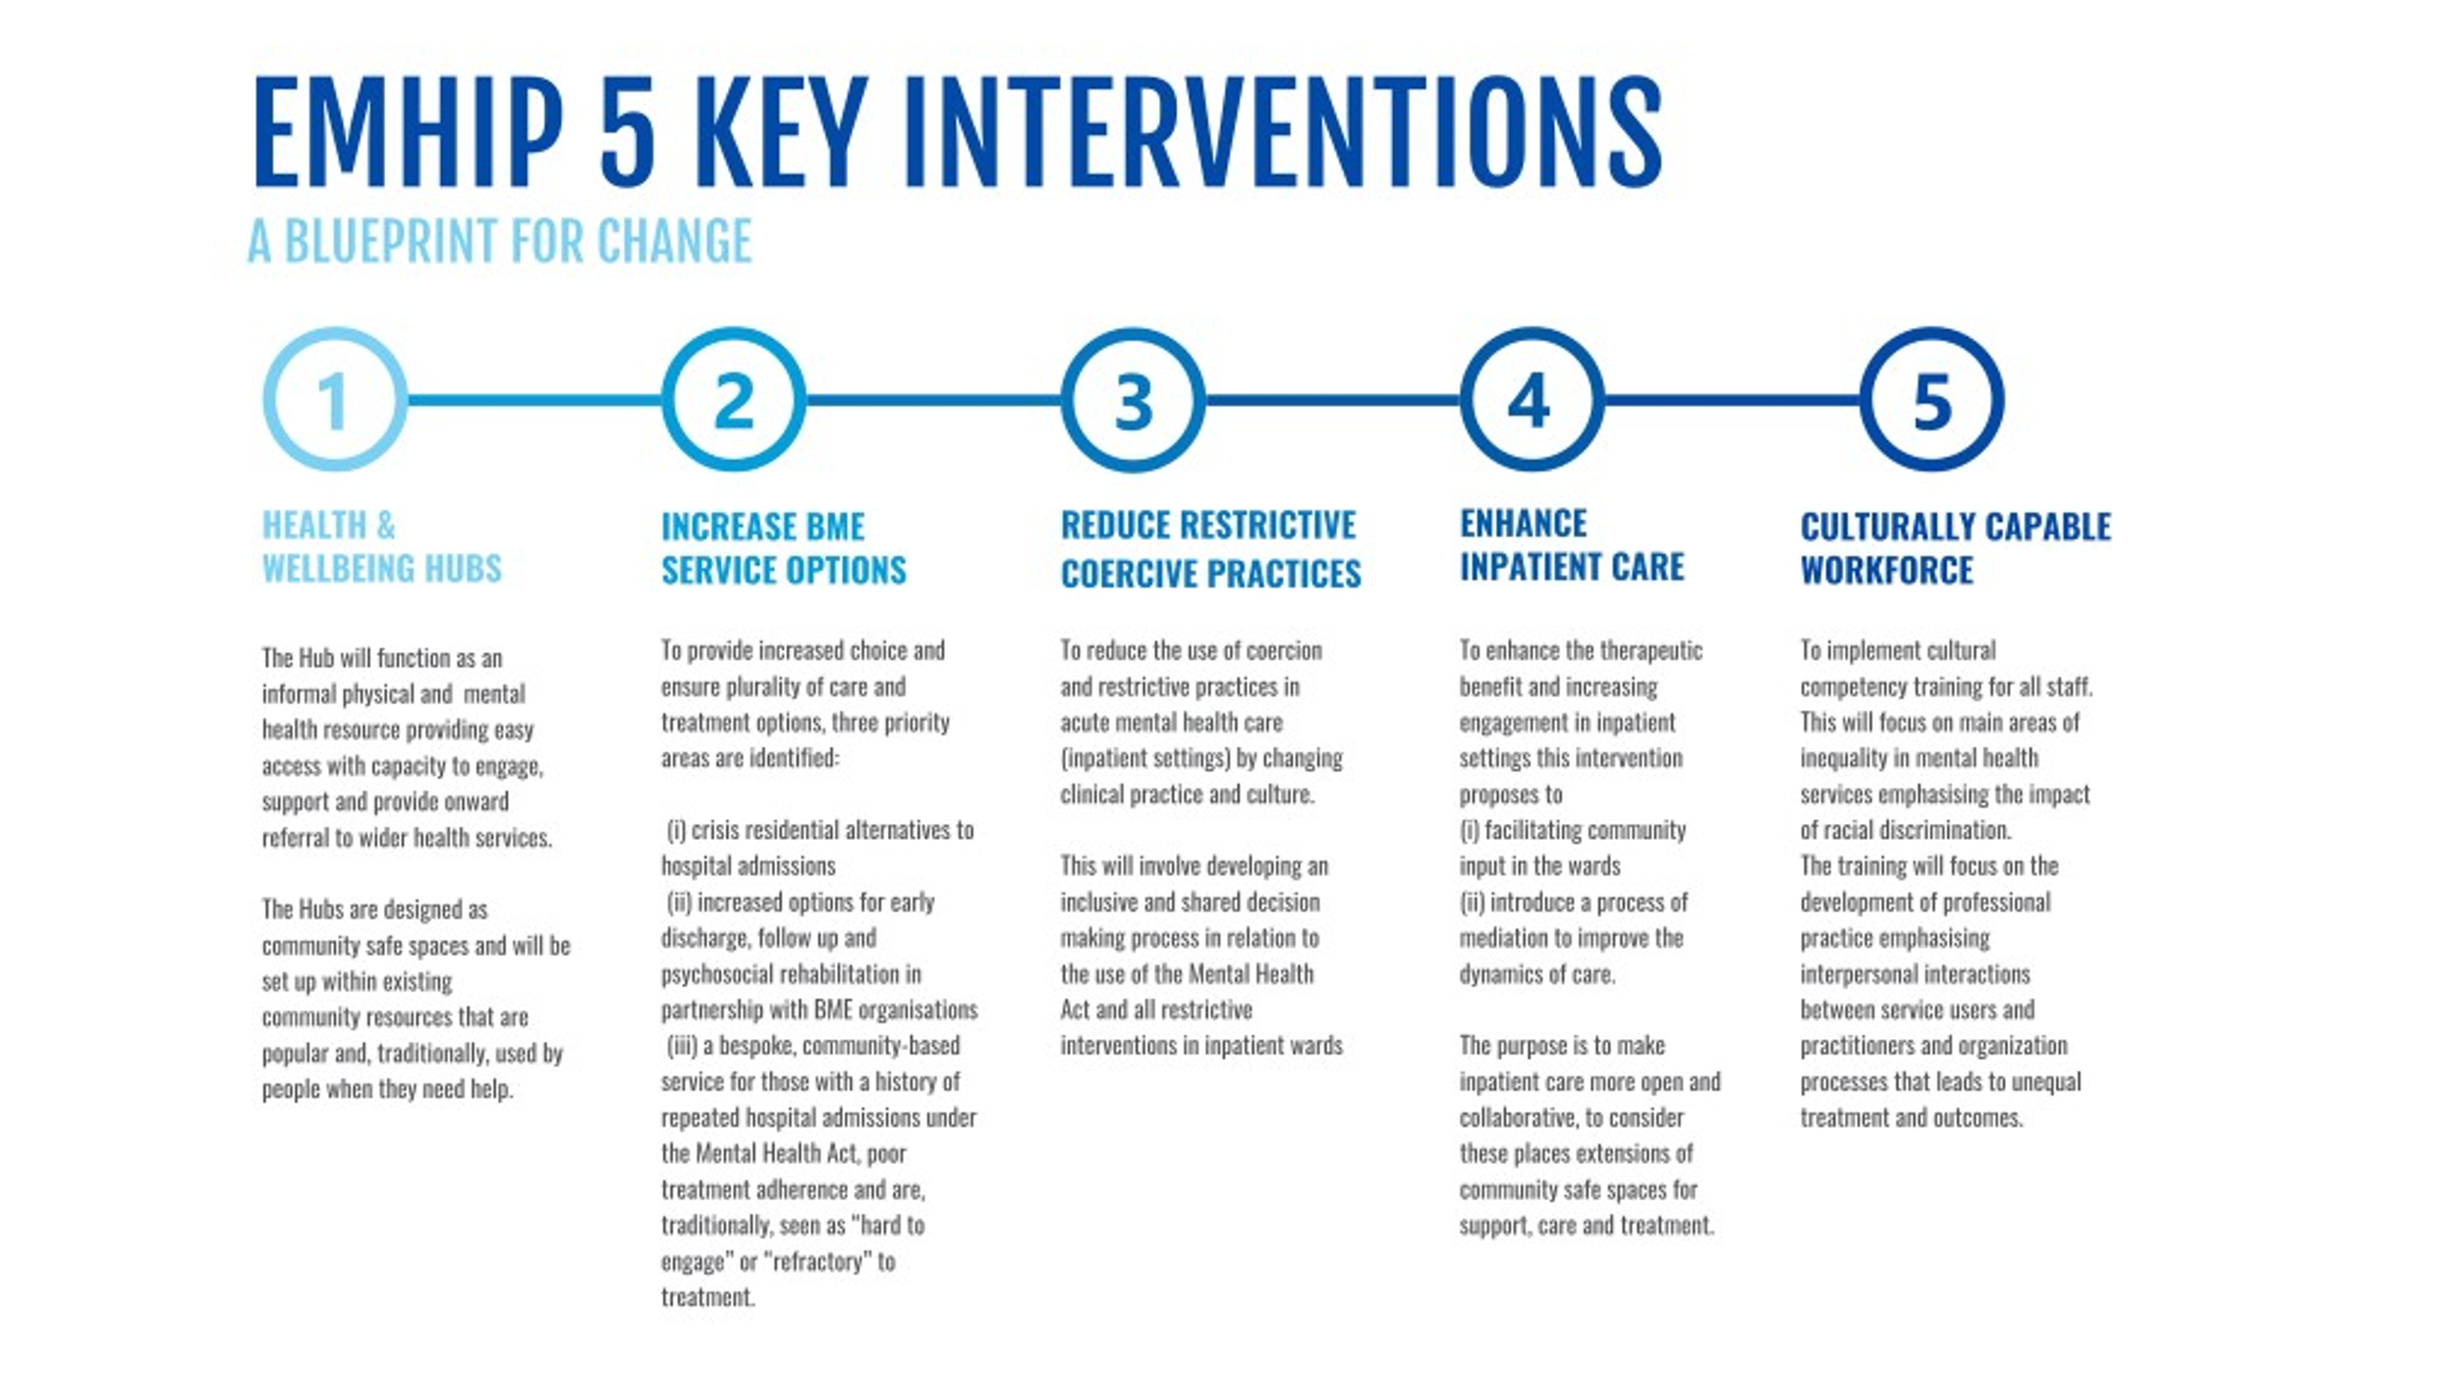

Figure 2. The five EMHIP interventions along the mental health patient pathway

The EMHIP Programme (Wandsworth) is taking a phased approach to delivery, with four key projects:

1. Health and Wellbeing Hubs
2. Crisis Family Placement Service
3. Reducing Restrictive Practices and Coercion
4. Cultural Competency

All EMHIP projects are fully supported by the EMHIP partners and overseen through a monthly EMHIP delivery group. Each project is at different stages of delivery, some still in initiation, working to build the business case, others have secured funding whilst others have begun implementing.

EMHIP started as a single programme with a phased implementation. Delivery has been delayed, due to a variety of issues spanning from recruitment challenges to the complexity of change required. The development of reflective practice, to the programme’s ability to remain dynamic and flexible is evidence of the continuous commitment to improvement and learning. It forms part of why the partners are keen to focus the external evaluation on impact and value for money, as the process evaluation should and could be undertaken internally.

Underpinning these projects and subsequent projects is a commitment to population health management and lived experience. Together with partners EMHIP has led the development of a dedicated population health management dashboard bringing together data from disparate parts of the NHS with a focus on community. This serves the dual aim of improving data collection around ethnicity to understand and reveal health inequalities and develop competency and capability to monitor and measure impact in tackling health inequalities.

EMHIP has launched a substantial project building the tools and techniques to enable genuine and effective co-production in the transformation design and delivery of EMHIP projects and in the wider governance and operations of mental health care. Through establishing the Lived Experience Access Panel (LEAP) EMHIP is building a network of empowered, informed lived experience representatives willing and able to actively take part as equals in the design, delivery, and governance of EMHIP initiatives.

The EMHIP Programme (Croydon) is taking a phased approach to delivery, with a key initial project and scoping work on the other four interventions:

1. Delivering a mobile Health and Wellbeing Hub within Croydon

The project is fully supported by the EMHIP partners and overseen through weekly EMHIP huddles, a monthly EMHIP implementation group and a quarterly Steering Group meeting. The project is at the mobilisation phase having secured funding, recruited to the hub team, and sourced locations within faith and community settings.

## 2.2 AIMS OF EVALUATION

EMHIP presents a methodology to reduce ethnic inequalities in mental health services, the aim of the evaluation is to test whether this methodology does create the desired impact in reducing ethnic health inequalities seen in access, experience, and outcomes.

It is important to understand whether:

1. Has the EMHIP approach reduced inequalities in mental health outcomes and access to services for people from Black and minority ethnic communities?
2. If the EMHIP approach has achieved its objectives (as outlined above) what is the mechanism through which this has taken place (i.e. how do each of the component parts of the programme contribute)?
3. Are the EMHIP models and approaches cost effective? Do they represent value for money?
4. Do EMHIP models and approaches make positive impacts on wider health services? (Service definition is wide; extending beyond mental health to include physical health, and all settings)
5. How are EMHIP models received and supported by the community they seek to serve?

These five areas represent the evaluation questions.

Value-for-money evaluation considers such issues, including whether the benefits of the policy are outweighed by the costs, and whether the intervention remains the most effective use of resources specifically in comparison to care as usual (care delivered without EMHIP interventions) It will be crucial to understand the wider social impact of the interventions as well as the more conventional finance costs within this evaluation area.

The evaluation will test whether this theory of change works and crucially will test the assumptions that underpin it.

The focus of this evaluation is to co-produce the design and approach with the EMHIP partnership and wider stakeholders, to complement existing mechanisms and to ensure objective and robust conclusions.

The evaluation should have due regard to sustainability scoring of EMHIP interventions in part, or as a whole.

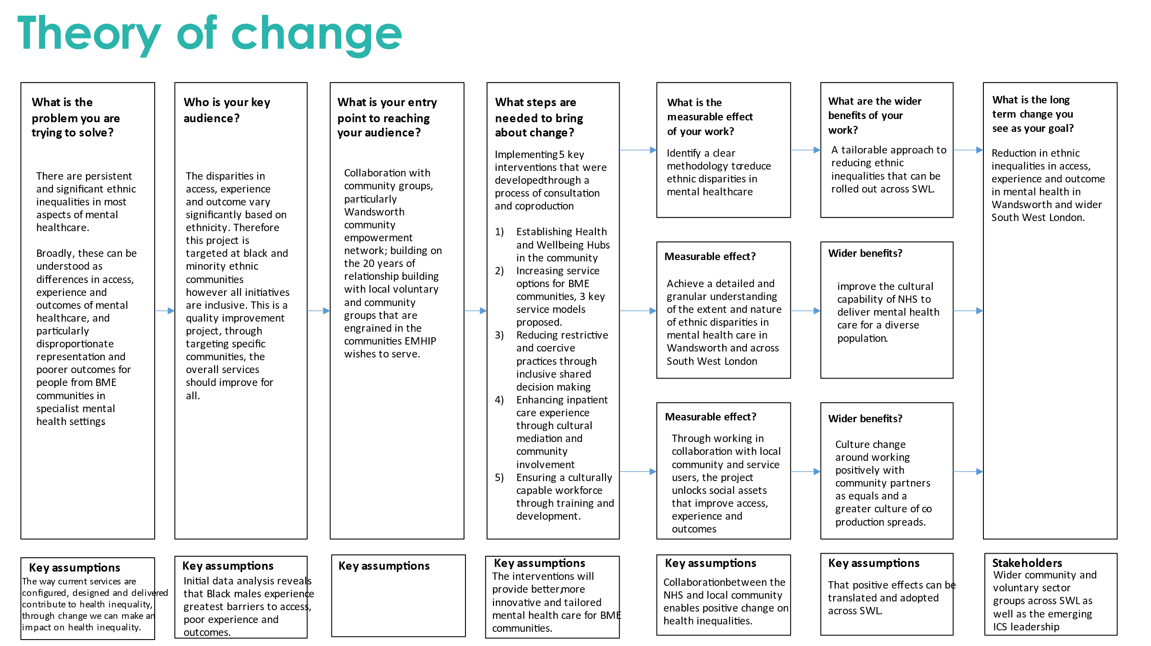

Figure 3. The EMHIP Theory of Change

1. CONTRACT SCOPE

The EMHIP partnerships of SWL ICB, South West London St Georges Mental Health Trust, Wandsworth Community Empowerment Network and SWL ICB, SLaM and Croydon BME Forum wish to identify an external partner to provide robust objective evaluation to complement the existing continuous improvement and evaluation mechanisms in place for the projects being undertaken and piloted in Wandsworth and Croydon.

The evaluation brief is to specifically focus on measuring impact and value for money.

Much of the implementation of the EMHIP projects are at an early stage, set to complete initial 12-month pilots by March 2025. Therefore, much of the evaluation will be undertaken during the implementation, enabling live feedback and iteration of the theory of change. The evaluation will be key to identifying whether the approaches of EMHIP are successful in achieving the desired reductions in health inequalities in mental health services and inform the future direction of mental health services in South West London.

## 3.1 TIMEFRAME & DELIVERY

The evaluation design and approach should be co-designed between the successful Evaluation Partner and the wider partners in EMHIP. Therefore, the evaluation approaches used will be determined collaboratively and could include, but are not limited to; interviews, focus groups, workshops, surveys, analysis of data and performance information, case studies, social cost benefit analysis, social cost effectiveness analysis, most significant change. We are open to different methods and approaches. We would also expect the evaluation partner to work collaboratively to undertake the sustainability scoring.

This evaluation will support and complement the existing data analysis developed through the system wide EMHIP Dashboard tool, providing live information on health care use broken down by ethnicity, and the testimonies, feedback, and insights brough through the LEAP. The EMHIP dashboard contains primary care data, secondary care and mental health data available by borough, PCN or GP practice level. It is a live dashboard, providing updates over time. We would expect the external evaluation to include a review or reference our existing research and information and to build/add value to what we already know.

Timeframe for the procurement process and for delivering the evaluation is as follows:

|  |  |
| --- | --- |
| **Activity** | **Dates** |
| Publicise Market engagement questionnaire (MEQ) and issue PIN | 15th November – 1st December 2023 |
| MEQ Submission deadline | 16:00 1st December 2023 |
| Issue advert and ITT documentation | 11th December 2023 |
| Bidder Clarification Event | w/c 1st January 2024 |
| ITT Bidder Response Submission Deadline | 26th January 2024 |
| ITT Bid evaluation stage | 29th January – 29th March 2024 |
| Notification to Bidder regarding Contract decision | 1st April 2024 |
| Service commencement | 6th May 2024 |
| Evaluation design sessions | May 2024 (suggest 2 x 2 hour workshop) |
| Check-in sessions during Evaluation process | Bi-monthly 2 hour meeting |
| Evaluation results and dissemination planning | Suggest 2 x 2 hour workshops |
| Project complete | 5th May 2025 |

This timeline is mapped against the timeline of the projects that are delivering in the EMHIP programme, demonstrating that this is evaluation during the implementation for many projects.

## OUTPUTS AND OUTCOMES

Through undertaking external evaluation, the EMHIP partnership (through their monthly cross organisation delivery group) wish to have robust and reliable responses to the key evaluation questions and to fundamentally have confidence in whether the EMHIP methodology and approach is successful in achieving reduction in health inequalities.

Throughout the 12 months of the evaluation, the EMHIP delivery group wish to receive continued feedback and updates, to directly improve the EMHIP delivery in real time.

A desirable output would be a template/toolkit that can be used to support an evaluation of any future projects, to ensure the correct and appropriate data is collated at the start of any future projects.

The main output will be an externally facing research report, accessibly written, and including an executive summary collating the main findings. We expect to present the final report and discuss with our wider stakeholders at one of the key EMHIP delivery groups or other identified meeting.

## KEY ATTRIBUTES OF AN EXTERNAL EVALUATION PARTNER

* SWL ICB are specifically looking to appoint an independent external partner to undertake the evaluation. It is important that the Evaluation Partner has no conflicts of interest related to SWL, EMHIP Wandsworth or EMHIP Croydon and can be objective and impartial to the evaluation results.
* Expertise in measuring systemic racism and oppression within mental health services and wider expertise and experience in measuring and evaluating efforts to reduce and eliminate health inequalities.
* Understanding and experience of critical theory and or/ political economy of health inequalities is essential.
* Evidence of delivering evaluation in genuine coproduction including skills in empowering, addressing power imbalances and lack of trust in healthcare services for some of our ethnic minority communities. .
* Ability to form strong working relationships with our EMHIP programme team, to join our meetings and to contribute constructively.
* Ability to join and access the EMHIP intervention communities in SWL in person regularly throughout the contract duration.