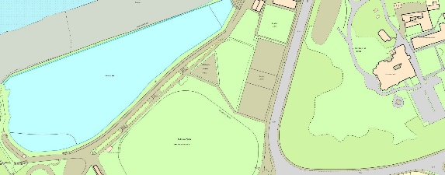
Current Facilities
The existing skatepark was built around 2000 and is constructed of metal and timber. It has been heavily used and the equipment is reaching the end of its useful life.
Access to the Site
Access is from Elton Road across the Salthouse Field and North Somerset Council’s Land.
The contractor will be expected to protect the land and member of the public using the area.
The Site.
The Skatepark is located at Salthouse Fields, Elton Road, Clevedon. Nearest Postcode BS21 7RH.
The land is owned by North Somerset Council, and the skatepark area leased by Clevedon Town Council.
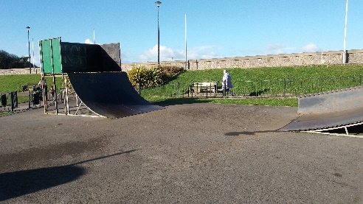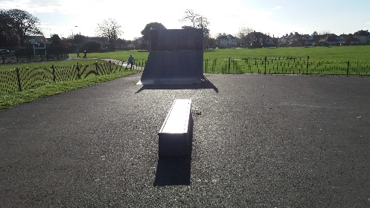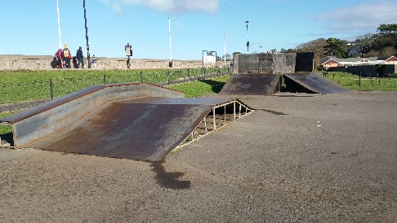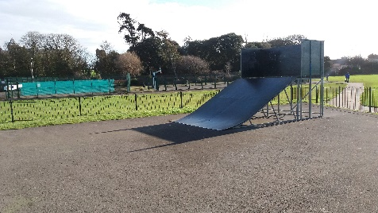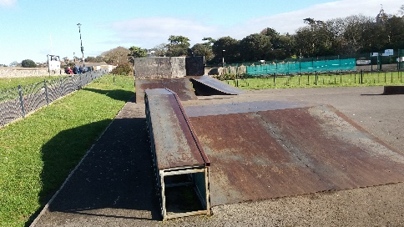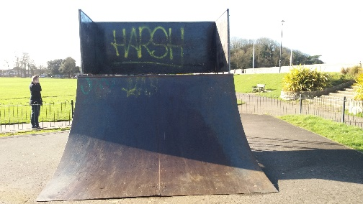

The Project
The project is to replace the existing Skatepark with a purpose- designed concrete facility, utilising the full extent of the current site. The vision for the new Skatepark is as follows.

- The Users
- The facility must accommodate skateboards, scooter, skates.

- Progression
- The facility must provide the opportunity for absolute beginners of any age and ability. This includes young people with disabilities, such as wheelchair users.

- Users with more skills and experience must have opportunities to test themselves on challenging elements of the site.

- Transition
- The facility must have a flow which allows for laps of the site, not just a simple back and forth between equipment, which is one of the limiting factors of the current site.

- Street Theme
- The facility needs to incorporate some elements of street -skating.

- Design Concept
- It is important that the skatepark has a unique look and feel, both as a skatepark and as a public space. Tenderers are encouraged to suggest design concepts which reflect the character of the Town and the location.

Images of types of desired structures

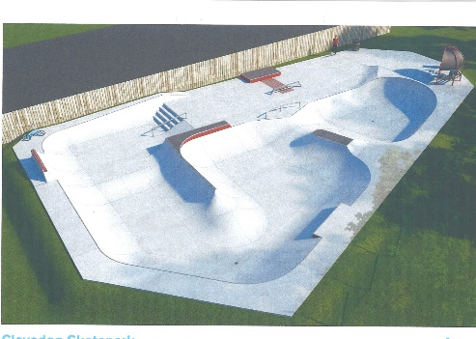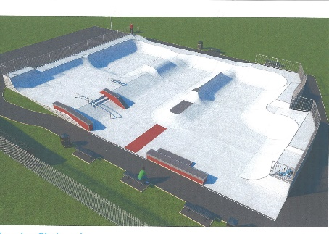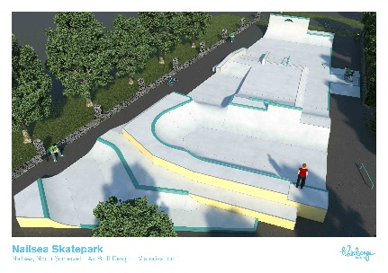

Removal of Existing Equipment
The tenderer should include costs to dismantle and dispose of the existing skatepark, in line with current legislation.

Fencing
The current site is fenced using bow top 1-meter high fence with single entrance gate. Tenderers should include provision to renovate or remove/replace the fencing as appropriate. Consideration must be given to the proximity of the Bristol Channel and the effect of sea spray.

