Clarification Questions and Responses – Procurement Support Tender
Updated 28th February 2025
Question | Response
Has Pioneer Group had any support in the development of the tender documentation from an external consultancy or externally contracted resources, and if so, will this party be permitted to bid for the contract? | No. The Pioneer Group has drafted this tender without support or any external consultancy or externally contracted resources.
Do we need to register interest. | No. If you wish to submit a bid. Please complete the paperwork attached to the tender.
- Do you have a Procurement Team in house?  - Appendix 1 – Specification, It states, you have conducted analysis of procurement requirements over the next 2 years? Would you be able to provide this list to us for visibility please? | No – The Pioneer Group does not have an in-house Procurement Team.  We have provided this information within the overarching tender documentation.  It can be found in section 1.2 “Overview of the Contract” of the Invitation to Tender.
Contract Notice  The estimated contract value is £60,000. Is this £20,000 per annum over the initial 3 year term as stated in section 1.5 of the ITT? | This is an estimated total contract value for the three-year term.
Bidder Interviews. Will they be in person?  How much notice will be provided?  What format will the interview take – presentation/questions etc.? | Bidder interviews will be held virtually.  Bidders will be provided notice of invitation to attend interviews week commencing 17th March 2025.  The interview will take the form of a presentation covering the below areas as set out in the tender:  - Service Delivery  - Contract Management  Questions will be asked by the interview panel on the content of the presentation.
Form of tender – how many low/medium/high tenders, and how many consultancy days, will be used to calculate the Total Contract Sum? Will this be an annual sum or a 3 year sum? This is important to ensure all bids are based on the same estimated volume of activity. | As set out in the Invitation to Tender (Appendix 3).  Pricing will be evaluated per submission i.e. one occurrence in the low/medium/high complexity. Pricing on retainer will be calculated per day i.e. one occurrence.
Public liability covers damage and personal injury. £10 million cover seems disproportionate for this procurement. We carry £5 million public liability cover. Is this acceptable? | We confirm that a £5m public liability cover is acceptable.
We carry £1 million professional indemnity cover. Is this acceptable? | We confirm that a £1m professional indemnity cover is acceptable.
Specification  - Roles and responsibilities for tenders. Can you confirm Pioneer will undertake the evaluation of bids (with appropriate guidance from the consultant)?  - Section 3.1 states “the following summary reports”. We cannot see any reports listed.  - Section 3.4 review meetings. Will the meetings be in person or remote? | The Pioneer Group will evaluate the bids in-house. There will be no support from a consultant.  This is a typing error. Section 3.1 should read “A summary report must be produced annually summarising the procurement activities of the association over the preceding 12 months, highlighting contracts, awards, levels of financial commitment and any other notable issues  The Pioneer Group will agree with the preferred bidder the method of the review meetings. Meetings could be held virtually or in person depending on the needs of the Pioneer Group.
As the Method Statement scoring criteria has a range of scores available, can you please define the difference between the scores for each range, i.e. how will evaluators differentiate between 1 and 2, 3 and 4, 5 and 6, 7 and 8 as well as 9 and 10?  When completing the Bidder Price are you expecting the table to contain the day rates for each of the identified complexities? | The scoring methodology allows assessors to score and compare submissions of all bids and award points as they see fit. It is intended to allow for individual submissions to score maximum points where the quality of the submission or answer is close to that of a competitor.  Pricing will be evaluated per submission i.e. one occurrence in the low/medium/high complexity. Pricing on retainer will be calculated per day i.e. one occurrence.
Can you please confirm the budget for this opportunity? Is the £60k, a value per annum or for the entire initial contract or annual? Please clarify the Budgets for all aspects? | This is an estimated total contract value for the three-year term.
Clause 1.2 of the ITT states initial 24 months of the agreement the expected activity. The Initial Term of the agreement is 3 years. Can you confirm what procurement activity will take place in the 3rd initial year? | The Pioneer Group’s business plan and strategy is not defined for 2028-29 at this moment but bidders can expect a similar rate of activity in the third year (the tower block refurbishment will not be included as this is a one-off procurement activity).
Can you confirm that beyond the initial 3-year term, that a cost review mechanism would be in place? | We can confirm that The Price will be subject to a review on the Review Date and thereafter on each anniversary of the Review Date. Any adjustment in the Price shall be by agreement between the Company and the Supplier and shall not exceed the percentage adjustment of the CPI over the previous 12 months.  This is set out in Appendix 6 Draft Conditions of Contract and will apply to all annual renewals.
Please confirm if any additional costs such as, “Publication on Delta” would be an inclusive or an additional chargeable cost? | This will need to be included as part of the costs.
In Appendix 3, point 11. Bidders Submitted Rates, it states “Pricing to be entered per occurrence and not total association requirements”, can you please clarify the pricing required as the complex procedure has no upper band. | We have provided you with the estimated contract values in section 1.2 (and a breakdown of the specification in Appendix 1) therefore bidders should be able to come to a conclusion on how complex these will be and therefore the costs associated.
Please can you confirm that the procedure will be undertaken as necessary under the Procurement Act 2023 regulations? | This is fully compliant with the PCR 2015 as it was published prior to the 24th February when the Procurement Act 2023 goes live.  Bidders should note that this is a below threshold tender but for completeness and to comply with Pioneer Group’s internal practices, we are following the PCR 2015 process.
Appendix 1 – Specification, can you confirm that the requirement is for a minimum of three (3), Face to Face, Procurement training sessions per annum, (One split into 3 sessions)? | We confirm that the requirement is for three face-to-face training sessions per annum. This is to allow for smaller staff group’s and to provide a training at specified levels i.e. Executive Leadership Team and Senior Management Team/ Operational Management Team and front-line staff.
Can you confirm where all documents and relevant tender information will be stored? i.e. Bidders document storage or Tenderers documents storage? | Information will be stored on the Tenderers document storage.
Please can you send an updated clarification log with all questions and answers, dated? | The updated clarification log will be uploaded as clarification questions and responses are received. The overall log will be updated with a date.
Please can you confirm if the “Expert Witness” detailed in Appendix 1 would be an inclusive cost or an additional chargeable cost as part of the contract? | In the unlikely event that this is required this would be an additional chargeable cost as part of the contract.
Please can you confirm if the values in the table in clause 1.2 of the ITT are estimated annual values? Or whether they are full contract lifecycle values i.e. IT Disaster Recovery £30k per annum x 3 years = £90k. | We can confirm that the values in the table in clause 1.2 of the ITT are estimated total contract values.
Please can you confirm your understanding as to why TUPE (Clause 1.9 of the ITT), would not apply to the incumbent work force? | The Pioneer Group can confirm that TUPE does not apply.  The services are currently provided by an external third party whose work is not predominately taken up by the Pioneer Group.
Method statement question 4.1 is titled “Feedback, Defects and Complaints”. The question mentions feedback but there is no mention of Defects and Complaints in the question | Bidders are expected to reference how they would deal with defects and complaints more broadly within the quality of services delivered to their clients.
Are you able to tell me who the incumbent is please?  We just wanted to know if there was a current provider or if this is a new contract | We don’t see the relevance of this question, please elaborate.  We can confirm that there is a current provider.
Please can you confirm if the interviews will be online or face to face  Please can you confirm if the £60k contract budget is for 3 years? If so, can you confirm any likely project volumes and their level please? | The interviews will be held online.  This is an estimated total contract value for the three-year term. The volume of activity is set out 1.2 “Overview of the Contract” of the Invitation to Tender
Do you have any existing procurement processes in place that need reviewing or has this already been done.  Who would be the client-side (internal) point of contact with regards to updates & reporting for the successful bidder  You mention using delta (or similar) as portal for tendering purposes; does Pioneer have licenses for e-tendering portal or is your expectation that the successful bidder will provide a portal?  Is this indicative published contract value for this opportunity to cover the initial 3 years, or to include any possible extensions  Noting that you have indicated TUPE doesn’t apply to this opportunity, do you currently use an external provider for procurement support | Yes, procurement process will need reviewing in line with the recent changes to Procurement legislation.  All communication in relation to the bids will be through the governanceassuranceteam@pioneergroup.org.uk mailbox. If successful you will be given the internal contact details at that time  Pioneer does not have licenses for e-tendering. Our expectation is that the successful bidder will provide a portal.  It is envisaged that the Contract with the Successful Bidder shall last for an initial period of 3 years, with an option to extend at the Pioneer Group’s sole discretion for up to 2 further years, plus a further 2 years giving a total potential period of 7 years.  Yes, we currently have an external provider for procurement support.
Section 1.2 contains a table of indicative procurement requirements. Are you able to clarify the complexity category (Low, Medium or High) for each of the indicative procurement projects listed in the table? | The table provide indicate contract values and activity for the first three years, we would expect bidder to advise us on what would be the preferred procurement route – Low/Medium or high.
Scope of Contract (1): We have noticed that there is an element on site support required in Categories 2 (Medium) and 3 (Low). Can we please clarify whether or not on site support in mandatory for these elements in both of these Categories? Would the Pioneer Group consider proposals to provide the on site elements in both of these Categories remotely? | The Pioneer Group expects the level of onsite support to be as set out in Appendix 1.
Expert Witness (3.3): Please clarify what is meant by "Expert Witness"? | “Expert Witness” means in the unlikely event of a challenge of a procurement process, legal advice is needed and you will be expected to support the process. For example, you would be the expert witness.
Are bidders allowed to suggest a portal solution for use in this requirement other than Delta? | Yes, the Pioneer Group is open to suggestions around alternative portals.
Just looking at 1.2, I'm not clear on the volumes. Can you clarify please  The scope of the Contract is the provision of specialist support and advice relating to procurement activities across the association in relation to but not limited to:  - Property Maintenance Activities  - Procurement of goods and services  - Procurement of specialist IT Services such as Disaster Recovery  - Major utilities including gas and electricity  - Legal Services  - Insurance support/consultants  The key requirements of the Contract are as follows:  - Maintaining statutory compliance  - Ensuring Procurement activities are complaint  - Achieving value for money  - Achieving high levels of contract performance  The table below illustrates the indicative procurement requirements of the association over the initial 24 months of this contract. This list is not exhaustive.  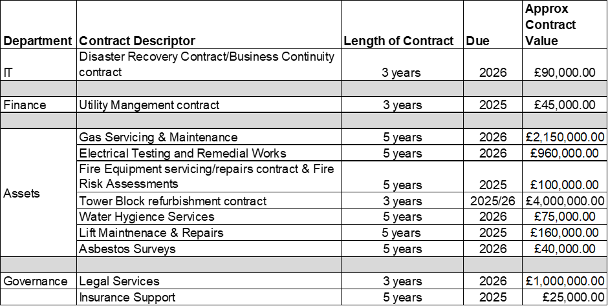  A single Contractor is required to deliver the entire scope of the Contract. | In relation to volume, the scope of the contract is to support the Pioneer Group to procure contracts as listed in the table in 1.2. We anticipate the total value of the procurement advise (this tender) is estimated at £60,000 over three years.  The reference to a single supplier, is our desire to only work with a single procurement specialist.
With regards to query 4, contract value – can you further clarify that the budget published is to include all possible extensions, or just for the initial period of 3 years?  With regards to clarifications in general, are there CQs from other interested parties that will be shared with all bidders (which we appreciate will include our own)? | We can clarify that the sum is for the initial three year period.  All clarifications and responses are updated on Contract Finder with the date that the updates were made.
We have seen the latest clarification responses dated 27/02/2025. Can you confirm a further update will be published if any further questions are submitted before the clarification deadline of 28/02/2025. | We can confirm that further updates will be posted as we receive and respond to clarifications. A final update will be posted after 12:00noon on the 28th February which is the deadline for clarification questions.
Specification section 3.4 Review Meetings. Can you confirm the purpose of the review meeting is to review the performance of the services provided by the appointed consultant. Can you confirm the meeting will not include the performance of Pioneer’s other contracted suppliers/contractors/service providers. | The Pioneer Group confirms that the purpose of the review meeting is to review the performance of the service provided by the appointed consultant.

