Appendix 2
BROTHERS IN ARMS
The Sherwood Rangers from D-Day to VE Day
AIM
The aim of the exhibition is to demonstrate something of what it was like to be in a British independent armoured brigade tank regiment during 1944-1945. It was certainly not for the faint-hearted. Statistically, those actually serving in the Regiment’s front line tank squadrons had a zero chance of getting through those 11 months unscathed.

This exhibition will show how they lived and fought, the equipment they used, the development of armoured tactics, some of the main events and battles in which they took part and reveal the dangers they faced.

It will primarily focus on a handful of individuals who served and fought with the Sherwood Rangers.

INTRODUCTORY PANEL
A brief history of the Nottinghamshire Sherwood Rangers Yeomanry,(SRY) including its experiences from 1939-1944. This will chart its transformation from mounted cavalry to highly successful armoured unit.

HUMAN EXPERIENCE OF WAR
The exhibition will be driven by real people who fought with the SRY during this period. Those chosen to be featured are because they have left numerous letters, documents, oral testimonies, or are still alive. These characters will be used throughout the exhibition to illustrate the themes.

A number will be highlighted e.g.

Lt-Col Stanley Christopherson
Became Commanding Officer on 11 June after Regimental HQ was hit and CO and others killed. Material - extensive papers, maps, letters, medals, photographs.

Major John Semken
Commander of A Squadron. Material - oral testimony - interviews by the IWM and various TV companies.

Captain Bill Wharton
Troop leader in B Squadron. Material - very moving wartime letters, plus photographs.

Lt. Stan Perry
Troop Leader in C Squadron. Material - oral testimony – JH interview, and only troop commander from SRY still alive (and in rude health). Also, dress uniform, photographs.

Lt. David Render
Troop leader in A Squadron. Material - oral testimony JH, plus other interviews, photos. Filmed interview too in HD.

Lt Harry Heenan
Troop leader in A Squadron. Material - extensive wartime letters. Killed in Action (KIA) 25 September 1944.

Sgt George Dring
Troop Sergeant in A Squadron. Legend of the SRY. Material - Photos, some letters and documents, citations etc.

Trooper Arthur Reddish
Lap gunner in C Squadron. Material - self-published memoir, other writing, photos.

Trooper Ernie Leppard
Material - oral testimony IWM, plus other writing, photos.

Padre Captain Leslie Skinner
Material - casualty records, diary, photographs, letters.

SEASONAL THEMES
The exhibition could be split into the four seasons:
SUMMER
AUTUMN
WINTER
SPRING
Each seasonal section will include period maps and a plotted history of the main events and the battles in which the SRY were directly involved.

TOPICS
Within each seasonal section will be different themes and features.

TACTICS
Evolving tactics. The experience of the North Africa campaign was invaluable, but much of the tactical doctrine they had learned there had to be discarded the moment they landed in Normandy.

Much of the responsibility for this rested on the shoulders of the commanding officers, squadron commanders and troop leaders. These evolving tactics and the challenges of operating closely with infantry will be explored.

DRESS
Battledress, battledress tankers’ overalls, the winter Pixie suit, No. 1s.

We will need examples of all of these. I have Pixie suit and I am keen for people to be able touch this and see what the material is like etc.

MAKE-UP OF AN ARMOURED REGIMENT

Fighting Element

Although an armoured regiment such as the Sherwood Rangers had a war establishment of some 698 men in all, less than half actually served in tanks. The main fighting component were the three squadrons, each divided into five troops of three and with four tanks in squadron headquarters. This amounted to 95 men per squadron, of which 15 would be in each troop. In all, however, a squadron had 158 men, although 58 of those were in the administrative troop and siphoned off into the supply echelons. Each squadron had an attached armoured recovery vehicle, with a winch, tow chain and other equipment for pulling out a bogged or stricken 30-ton Sherman tank. There was also a Scout wheeled armoured car, five 15-cwt trucks, twelve 3-ton trucks and a single Universal Carrier tracked vehicle per squadron. Then there was Regimental Headquarters, which had a further four tanks, and Headquarters Squadron, which had no tanks, but four 4-wheel drive cars, eight 15 cwt trucks, two 3-ton lorries, at least one Universal Carrier and three motorcycles.

Echelons

However, almost none of the support vehicles would be up front in the vanguard with the armour. Rather, although these vehicles, drivers, clerks and cooks were attached to specific units within the regiment, they were also designated to the various echelons, the support team. Rather like a modern professional sport team, there might be eleven on the pitch, but there are double that number behind the scenes supporting those on the field. In the case of the Sherwood Rangers, the echelons came under the command of Major Roger Sutton-Nelthorpe, one of the few officers still in the regiment like Stanley Christopherson and Stephen Mitchell who had headed off to the Middle East back in early 1940. This meant that apart from the CO, Sutton-Nelthorpe commanded by far and away the most men in the regiment – an establishment of 203, but in reality, he commanded a further 174 – 58 from each of the three squadrons, for although these ‘administrative troops’ were directly supplying the needs of one of the three squadrons, they were part of the regiment’s echelons.

The echelons were further divided. A Echelon tended to be closer to the action and was responsible for delivering the most pressing supplies, namely food, fuel and rations. They might be half a mile to two miles behind the squadrons, although Sutton-Nelthorpe had brought them right up to the northern, reverse, slopes of Point 103 on 11 June. B Echelon oversaw the less pressing supplies – tentage, many of the clerks, and clothing, and was usually further back; over the past few days, B Echelon had been just to the south of Bayeux, about seven miles away. Frankly, there was no need for them to be closer and it helped no-one if they were near the front, both getting in the way and putting themselves unnecessarily in the firing line. Both A and B echelon were divided again, 1, 2 and 3, which denoted their area of particular responsibility.

THE SHERMAN TANK

A superb piece of engineering it was arguably the best all-round tank of the war: mechanically reliable, easy to maintain the field, easy to ship and, at 30 tons, ideal for advancing over Class 40 Bailey bridges, hastily spanned by the Allies over the myriad waterways and ditches as they advanced, and a swift replacement for blown bridges left in the wake of the enemy retreat. They had the most stable gun of any tank at the time, the fastest traversing turret, were the swiftest and easiest to fire and were built in vast numbers.

Tanks were incredibly complex pieces of machinery and for any chance of maintaining them as an effective fighting force in combat, they needed to be as simple as possible with as many interchangeable parts as could be managed. Compared with German tanks, and especially the mighty Tiger and Panther, Shermans maintained this principle brilliantly. More than 49,000 were produced (and an additional 25,000 hulls that were adapted into other roles), compared with 1,347 Tiger tanks and some 6,000 Panthers. As the Sherwood Rangers demonstrated, they were rarely if ever short of tanks for combat and they learned to treat these tanks as their homes as well as their means of bringing firepower to bear, whether it be in high summer, driving rain, or freezing snow.

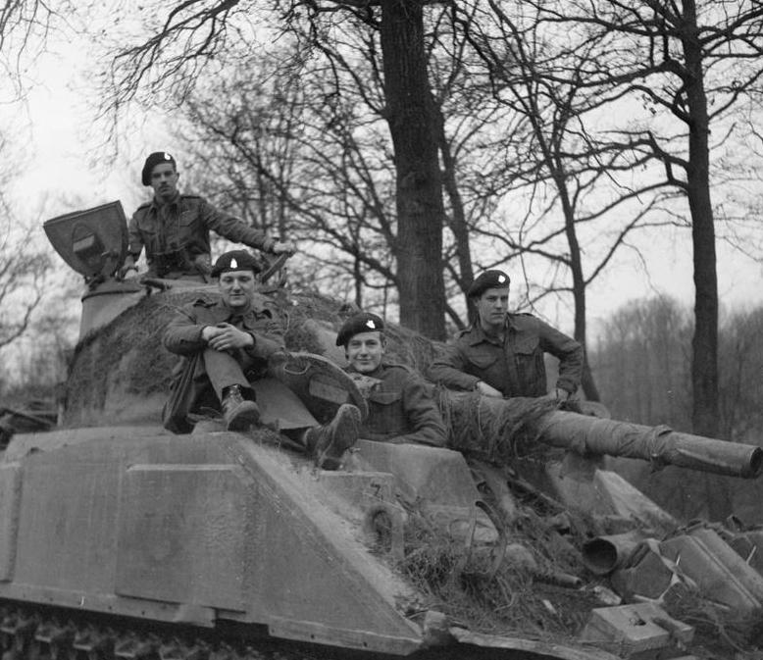

SHERMAN FIREFLY

The brilliance of the 17-pounder – the anti-tank with the greatest velocity of any weapon in Normandy, but its strengths and weaknesses when placed into the hull and turret of a Sherman.

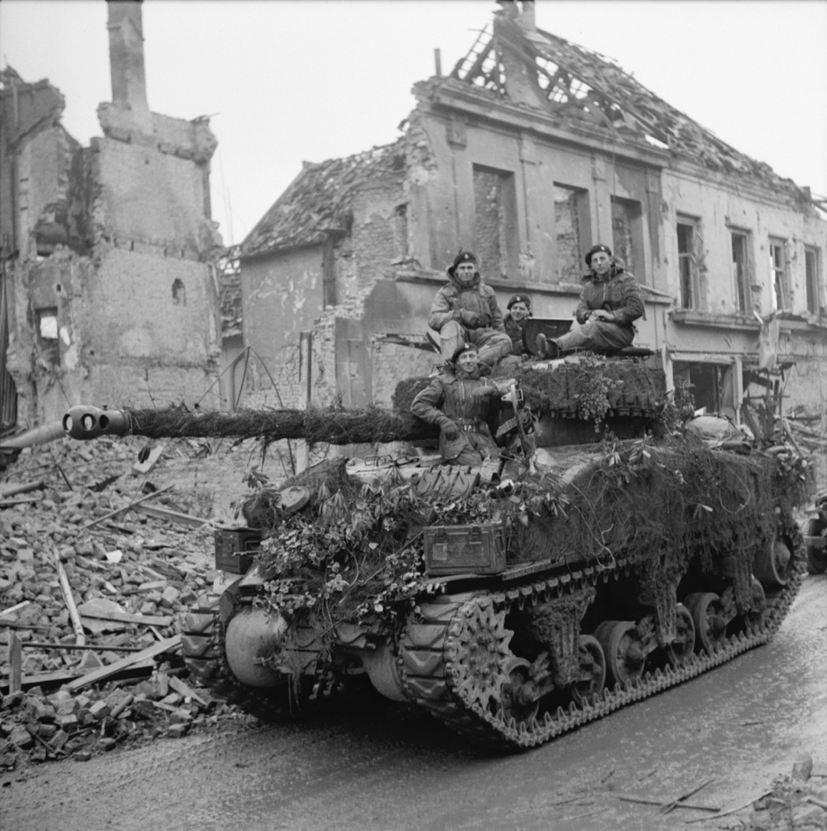

OTHER VEHICLES

Stuart M3 tanks for the Recce Troop, Scout cars, 15 cwt trucks, 3-ton trucks, half-tracks.

Pictures, explanations.

WEAPONRY

Different shells – HE, AP, APDS etc, plus small-arms.
Examples on display would be good.

THE ENEMY

A brief section on the Germans and what weaponry they had: anti-tank guns, mortars, AFVs, small-arms etc.

SPIRITUAL CARE

A section on Padre Skinner – an extraordinary man – and the work he did alongside the Medical Officer (MO), Dr ‘Hilda’ Young. Skinner had a profound sense of duty and buried every single man he possibly could, recording grave sites, writing to kin and so on. He was much loved by the Regiment, as was the MO.

A DAY IN THE LIFE

What was expected of a tank crew on an average day? It depended on when and where, but hours were longer in the summer when the hours of daylight were greater. Snatched food, perhaps 2-3 hours’ sleep, the need to be alert and on edge all the time while in action. Tea.

COURAGE AND NERVE

Casualties were relentlessly high: 36 officers out of 44 in the Regiment lost just in Normandy alone. The bank of courage and how those losing their nerve were dealt with.

I’m keen to stress that for anyone in a tank it was a gruelling business, but for tank commanders the risks were immense. Troop and squadron commanders, especially, shouldered enormously responsibilities and faced the greatest amount of stress and strain.

THE LIGHTER SIDE

Out of line. Humour. Entertainment and leave.

WELFARE ASSOCIATION

This was set up by Myrtle Kellett, wife of the first wartime CO, Colonel ‘Flash’ Kellett, MP. This was established to help keep families informed about what the regiment was doing but also to help provide emotional and financial support for those SRY men in need and for families of the bereaved or those struggled to come to terms with wounds. The work they carried out was extraordinary and Myrtle Kellett a fascinating character.

AUDIO

I’m keen to have some voices that people can listen to – some of the individuals listed above.

Also, I’d like to recreate a real conversation between a tank crew at the height of battle. Visitors will be able to put on a pair of period headphones – perhaps? – and listen to the crew talking to one another over the intercom. Other squadron voices and even regimental voices will cut in over the net. The sounds of battle will be heard: the rumble of the tank, shells, mortars and small-arms nearby and their own guns in operation. I know the people to do this for us.

FILM

There is a very large amount of film footage of the SRY. It would be good to have this on a loop somewhere. Most is IWM.

ARTEFACTS

I can provide various uniforms and bits and pieces, plus a real Sherman tank painted in SRY colours.

The SRY Association is very keen to support the exhibition. They hold the Welfare Association correspondence, for example.

They also have Stan Perry’s No. 1 uniform.

PHOTOGRAPHS

I’ve got access to a number of photographs but have also been doing a lot of research using contemporary aerial photographs. Copyright for these is the National Collection of Aerial Photography in Scotland, but they are incredible.

