Environmental Enforcement Contract Soft Market Testing Prospectus. July 2017 VFinal

Introduction

This soft market testing exercise concerns the renewal of an innovative joint contact for environmental enforcement.
Harrow, Brent and Ealing councils have joined together to deliver a more efficient service, widening the scope of environmental enforcement activity, sharing of overhead costs, expertise and allowing greater flexibility.
This contract is for the provision of Enforcement Services by way of the issue of fixed penalty notices in respect of a range of environmental and highways related enforcement legislation including but not limited to the:
- Environmental Protection Act 1990;
- Clean Neighbourhoods and Environment Act 2005;
- Dogs (Fouling of Land) Act 1990 and 1996;
- Anti-Social Behaviour Act 2003;
- Refuse Disposal (Amenity) Act 1978 and 1987
- Anti-social behaviour, Crime and Policing Act 2014;
- Highways Act 1980
- London Local Authorities and Transport for London Act 2003
- Town and Country Planning Act 1990
- In 2016/17, over 20,000 fixed penalties were issued for littering and fly tipping across the participating borough areas.

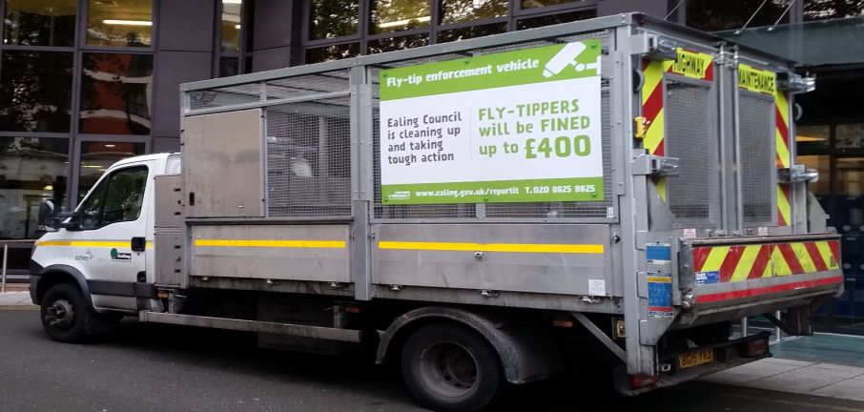


With the proposed widening of scope, the number of environmental enforcement related fixed penalty notices will significantly increase and at the moment it is intended that the proposed contract will be a framework providing the opportunity for other Councils to join.

Areas for discussion

The Councils would like to explore with suppliers the following aspects of this significant and imminent procurement:-
- Payment mechanism for the contract
- Affordability thresholds
- Technical Innovation
- Procurement route
- Contract structure
  - Risk partition
- Performance monitoring and enhancement
- Optimal contract term
- Expansion of client base
- Expansion of the service base
- Technology renewal with time
- Mobilisation and service set up
  - How much time do you need to mobilise?

Applying

If you would like to see us to discuss this opportunity please write in no more than 1000 words describing your interest in the procurement, your past experience in the field and the points you would like to discuss.
Soft market testing is planned to take place on the 22nd 23rd and 24th August 2017 in Ealing. Each party would have 3 hours with a common agenda and meeting will be held in Ealing Town Hall,
If you are not seen please rest assured this will not disadvantage you in the forthcoming formal procurement. All parties which express an interest will receive feedback from the soft market testing event before the OJEU notice is published (marking the start of the formal procurement procedure)
Please see your submission to McKenziE@ealing.gov.uk, Assistant Director (Street Services) by 3rd August 2017.

Project Management

The procurement is being run on a project managed basis and the Council has engaged a dedicated Programme Manager to ensure the programme remains deliverable. There is a Board in place to exercise robust governance and to ensure that communication channels between the Council and bidders remain robust.

Feedback to potential participants

Feedback will be given to those participating in the forthcoming soft market testing exercise. This will be on an anonymised basis and we will ensure that information of a commercially confidential nature will not be included in feedback.
Once the formal procurement process begins, Ealing Council will keep participants informed at appropriate stages of the procurement.

Freedom of Information

The Council is subject to the Freedom of Information Act 2000 and the Environmental Information Regulations 1992 and may be obliged, when requested, to disclose information you provide to them even though it may be regarded as confidential. However, the exemption from disclosure applying to information which, if disclosed, would or would be likely to prejudice the commercial interests of any person including the Council (including such information relating to a procurement exercise) will apply, provided that the public interest in maintaining the exemption outweighs the public interest in disclosing the information.

Queries

Where we receive queries in relation to this prospectus and we believe the response will be of general interest we will circulate the query and response to all the parties that have expressed an interest.

Canvassing

Participants should note that canvassing or lobbying (defined as communications with the Council or individual stakeholders) outside the channels identified in the Prior Information Notice) might affect their ability to engage with the procurement process. Attention is also drawn to the provisions of the Bribery Act 2010.

Indicative Procurement Timescales

Environmental Enforcement Procurement V2 7th July 2017 | Duration in working days | Start | Finish
Universal start date | 0d | Wed 31/05/17 | Wed 31/05/17
Pin and prospectus preparation | 32d | Wed 31/05/17 | Thu 13/07/17
PIN published | 0d | Thu 13/07/17 | Thu 13/07/17
Reasonable response time | 15d | Fri 14/07/17 | Thu 03/08/17
Consideration of responses | 5d | Fri 04/08/17 | Thu 10/08/17
Soft market testing on pre- arranged dates | 3d | Tue 22/08/17 | Thu 24/08/17
Board meeting | 0d | Mon 28/08/17 | Mon 28/08/17
Further analysis of findings | 5d | Tue 29/08/17 | Mon 04/09/17
Document preparation and governance | 20d | Tue 05/09/17 | Mon 02/10/17
OJEU issued | 0d | Mon 02/10/17 | Mon 02/10/17
Response time | 35d | Tue 03/10/17 | Mon 20/11/17
PQQs returned | 1d | Tue 21/11/17 | Tue 21/11/17
PQQ evaluation | 20d | Wed 22/11/17 | Tue 19/12/17
Contingency | 0d | Tue 19/12/17 | Tue 19/12/17
Firms selected | 0d | Tue 19/12/17 | Tue 19/12/17
Feedback period (standstill to be at the end) | 5d | Wed 20/12/17 | Tue 26/12/17
Invitation to tender (restricted procedure) | 1d | Wed 27/12/17 | Wed 27/12/17
Firms preparing tenders | 30d | Thu 28/12/17 | Wed 07/02/18
Tenders received | 0d | Wed 07/02/18 | Wed 07/02/18
Tender evaluation | 30d | Thu 08/02/18 | Wed 21/03/18
Draft result | 1d | Thu 22/03/18 | Thu 22/03/18
Cabinet deadline (Ealing)- approx | 30d | Fri 23/03/18 | Thu 03/05/18
Cabinet meeting (Ealing)- approx | 1d | Fri 04/05/18 | Fri 04/05/18
End of call in/ implementation | 10d | Mon 07/05/18 | Fri 18/05/18
Standstill | 10d | Mon 21/05/18 | Fri 01/06/18
Contracts engrossed and sealed | 20d | Mon 04/06/18 | Fri 29/06/18
Mobilisation | 40d | Mon 04/06/18 | Fri 27/07/18
Contingency | 0d | Fri 27/07/18 | Fri 27/07/18
New contract live | 1d | Mon 30/07/18 | Mon 30/07/18

