###### blue logo

###### 1 August 2024

###### West Sussex County Council – Early Market Engagement and Soft Market Testing for Supported Accommodation Housing Pathway (16-25yrs)

**Background**

West Sussex County Council (WSCC) would like to engage with suppliers prior to a procurement which will commence later this year for the requirement of providing a **Supported Accommodation Housing Pathway to 16–25-year-olds**.

This notice IS NOT the commencement of the procurement procedure, neither is it a call for expressions of interest. This notice is released to gather more information to further inform our specification and to alert the market about a Supplier event on 11 September 2024 and invite the suppliers to complete the Questionnaire. A separate notice and information will be provided when the actual procurement exercise starts later in the year.

This notice includes a questionnaire at Appendix A which we would encourage you to complete.

Your responses to the questionnaire may be used to further develop the specification.

This exercise will also help us to assess the level of interest from registered social landlords; review the innovative options for delivery of services and inform the process by which we will select potential providers.

Your responses are **not “evaluated’’ and scored**, or shared outside WSCC. Any subsequent reports, if generated as a result of responses to this questionnaire, will be anonymised and any commercially sensitive information will be treated as confidential.

* The deadline for **return of the questionnaires** is on **Wednesday 28 August 2024**, although a prompt response would be very much appreciated before this date. It is anticipated that a formal procurement for this requirement will commence in November 2024.
* Please return your responses to Questionnaire to the Council, via email to the following address: [strategic.housingCYPL@westsussex.gov.uk](mailto:strategic.housingCYPL@westsussex.gov.uk)

**In order so that you can prepare relevant responses to the questions in Appendix A, please read the below information which we have provided from the draft Specification which is work in progress.**

**Brief Overview of the Requirement**

The responsibility for commissioning of supported accommodation for young people aged 16-25 (foyers etc.) was moved over to Children, Young People and Learning (CYPL) from Adults & Health in January 2023.

Currently there are 7 Foyer services and transitional housing (step down) across the county with 3 providers.

* 227 Young people in service
* 46% are Care Leavers
* 79 waiting list/open referrals which 46 are Care Leavers

Foyer services are 24hr staffed accommodation.

Transitional services are staffed in the daytime with less support as the young person gets ready for independent living.

The current contracts were put in place when these young people were under the remit of Adult Care., they are now under Children and Young People’s (CYP) care, and more is needed to ensure these young people get the right support, at the right time.

Since moving over to CYP, commissioning has held a deep dive into the services young people, current providers, housing, health, and education. The review of the contracts and services showed that these services are no longer meeting the needs of the young people who need the service. We must design services that prevent future homelessness, reduce health inequalities, and maximise opportunities to access education and employment. At this time young people are not being empowered to thrive and contribute to society.

Results show that young people are facing challenges with mental health, debt, affordability and lack of education and employment.

**Scope**

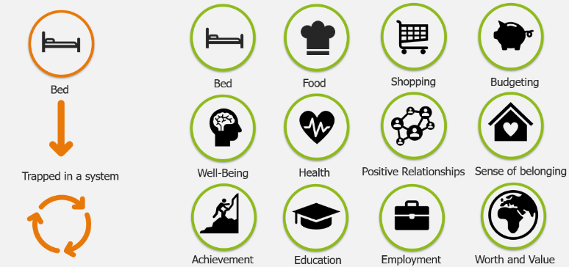The redesign will be a ‘One West Sussex’ offer and includes a housing pathway which will prevent future homelessness. The redesign will be co-produced with key partners including a new funding model.

16–25-year-olds requiring supported accommodation and a housing pathway will be at the centre of the service which aims to prevent the risk of immediate and future homelessness, reduce health inequalities and maximise opportunities to access education and employment. It will encompass collaborative working, tailored pathways, a route to sustainable independent adulthood.

**Our Requirements for the upcoming procurement:**

Providers will be required to be:

1. Registered Social Landlords.
2. Where the service is provided to under 18+ year old young people, Ofsted Registration will be mandatory.
3. Accommodation will be required within walking distance (of no more than a 20-minute walk) of public transport, food stores and a doctor’s surgery.
4. The service is planned to be delivered from July 2025.

# Accommodation: (Related to questions 1-3)

All accommodation is to be fully furnished, equipped, and Foyer settings must have a communal space.

We will be looking to commission services in key areas across the county. Below is an early indication of the need for these key areas.

|  |  |  |  |
| --- | --- | --- | --- |
| **Area** | **Number of Young People to accommodate in:** | | |
| **Foyer Setting** | **Transitional** | **Emergency** |
| Bognor Regis | 10 | 5 | 8 beds for  18+ year olds (via housing dept) |
| Worthing | 40 | 20 |
| Lancing | 7 | 7 |
| (Shoreham | 11 | 7 |
| Horsham | 50 | 15 |
| Crawley | 40 | 15 |
| Chichester* | 20 | 10 |

*If funding allows to include specific accommodation for Vulnerable Males, Female Only, transitional housing for Parent and Child (under 25)

**Personal Service Charge** (Related to question 5)

Young people are experiencing inconsistency with personal charges depending on the area they are accommodated. It is important to keep this to help young people learn managing outgoings, however it can be a contributor to debt when they are circumstances which impact their benefits. To overcome this, we will be proposing a capped personal service charge of £x per person per week is affordable to cover personal charges for:

* Heating
* Electricity
* Water Rates

# Maintenance of Buildings: (Related to question 6)

Buildings are a home for these young people and the upkeep and maintenance reflects the value and worth we have of our young people.

Aside from being compliant with all housing acts and regulations, a turnaround for repairs, maintenance within 5 working days.

In order to keep a high standard of accommodation and avoid delays in upkeep to the young peoples’ home the general maintenance e.g., decoration and DIY tasks need to be separated from skilled repairs e.g., building repairs, replacement of kitchen and bathrooms etc.

# Keywork: (Related to questions 7+8)

Keyworker time will be ring fenced, meaning the priority for the role of a keyworker is to provide individualised keyworker support. They should be protected against dealing with daily operation, the day-to-day staff will be available to support in daily challenges.

In Foyers where there is 24-hour staffing, young people will be allocated 4 hours a week of dedicated time with a keyworker. In transitional and in the first six months of independent living, young people will be allocated one hour a week of dedicated time with a keyworker.

Keyworker time will be to develop a clear independence pathway for young people, alongside tenancy ready pathway along with identifying the right options and planning for the young persons to move on. Action plans and SMART objectivities will be created to identify barriers and increase opportunity.

The environment of the sessions is vital to the young person’s progress and can be used in a variety of settings, e.g.:

* Support at job centres.
* Walk and talk.
* Activities to promote building trusting relationships.
* Support with appointments.

In addition to independence pathway for young people, alongside tenancy ready pathway, WSCC are seeking to offer a development pathway which supports, engages and progresses young people into the sustained employment, education or training. The pathway will be developed in collaboration and partnership with young people, providers, keyworkers, Adult Education, Careers provision and the University of Chichester.

This is an optional route for young people as we understand this may be a big step for young people.

The potential Education and Employment pathway (under development) is set out below:

**Step 1:**

Adult education, Careers and the University will visit young people regularly for coffee and a chat to build relationships and trust.

**Step2:**

Adult education, careers and the University will work with young people, key workers, and providers to provide gentle drop ins covering themes that are important to the young people. This may be but not limited to life skills, e.g., confidence, motivation, crafts, sleep, resilience, employability skills.

**Step 3:**

Adult education, careers and the University will work with young people, key workers, and providers to help young people understand the opportunities available to them. This includes qualifications, apprenticeships, bridging course which provides an access route to study at the university, identifying a career path rather than a job.

Not all young people will be ready to engage in dedicated keyworker sessions or may already be in a position where they need less support. Unused time from keyworker sessions can be banked as long as:

* Evidence shows that different approaches have been taken to engage the young person and the right people have been around the table to support the young person.
* If young person does not need the time, then evidence should show why, e.g., progress is good.

Banked time can be swapped for additional time with other young people or to hold group activities which contribute to young people progressing.

It is expected that providers will build relationships with other organisations, voluntary sector and grass root organisations to provide a community of support around the young person.

# Day to Day Staffing (Related to questions 9)

The day-to-day staffing consists of staff that are needed for the day to day running of the service. The role of the day-to-day workforce includes day to day running of the service, operational and crisis management.

Keyworker hours are **not** included in the day-to-day staffing.

What does day to day staffing look like?

* Service Manager
* House Managers
* Deputy House Managers
* Day staff (keyworkers will be on site throughout the week)
* Cleaners
* Night staff (minimum of 2-night workers no lone working in 24/7 only)

**Retaining staff** (Related to questions 8)

The aim of protecting keyworker time and ensuring appropriate staffing for day to day running of the service is to ensure staff workloads and wellbeing is balanced so young people:

* Get the right support at the right time.
* Have key relationships with staff from beginning to end.

We plan to offer, a level 4 qualification in trauma informed practice and delivering bespoke pathways which will be available to staff over the contract period. The outcome is staff feel confident and recognised with the knowledge and support they provide young people. The bespoke pathway section will be tailored to barriers keyworkers face and evidenced strategies and tools to plan effective pathways.

**Quality Assurance**

Expectation to have own internal QA procedures which is robustly followed by managers. In addition to this WSCC will undertake six monthly QA visits to inform continual service development, identify strengths and include areas to improve which could result in time specific action plans and more frequent visits. The QA of the services will be in line with the specification. Part of the QA process will be meeting KPI’s and reporting on progress of these.

**Joint working**

Evidence will be required of joint working with all involved with the young person e.g., PA and SW, Housing, commissioning, JCP, WAMHS, Adult Social Care, family, Health and Public Health.

**Emotional Wellbeing Case workers**

Many young people in these services have complex needs and have experienced childhood trauma. To support our young people, we will aim to provide emotional and wellbeing case workers who will form part of the delivery model:

The model will look to include:

* 3 case workers in the South of the county, 3 in the North, and 2 covering transitional.
* 1:1 support in services
* 1:1 support out and about e.g., Jogging, Walk and Talk, attending appointments
* Group support.
* Group staff supervisions.
* A group of icons with text

  Description automatically generatedAdvice for staff regarding Young People

**The**

**Approach**

**The**

**Support**

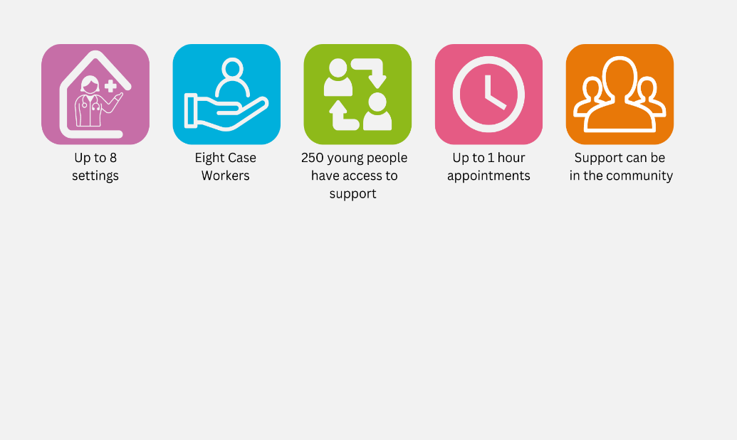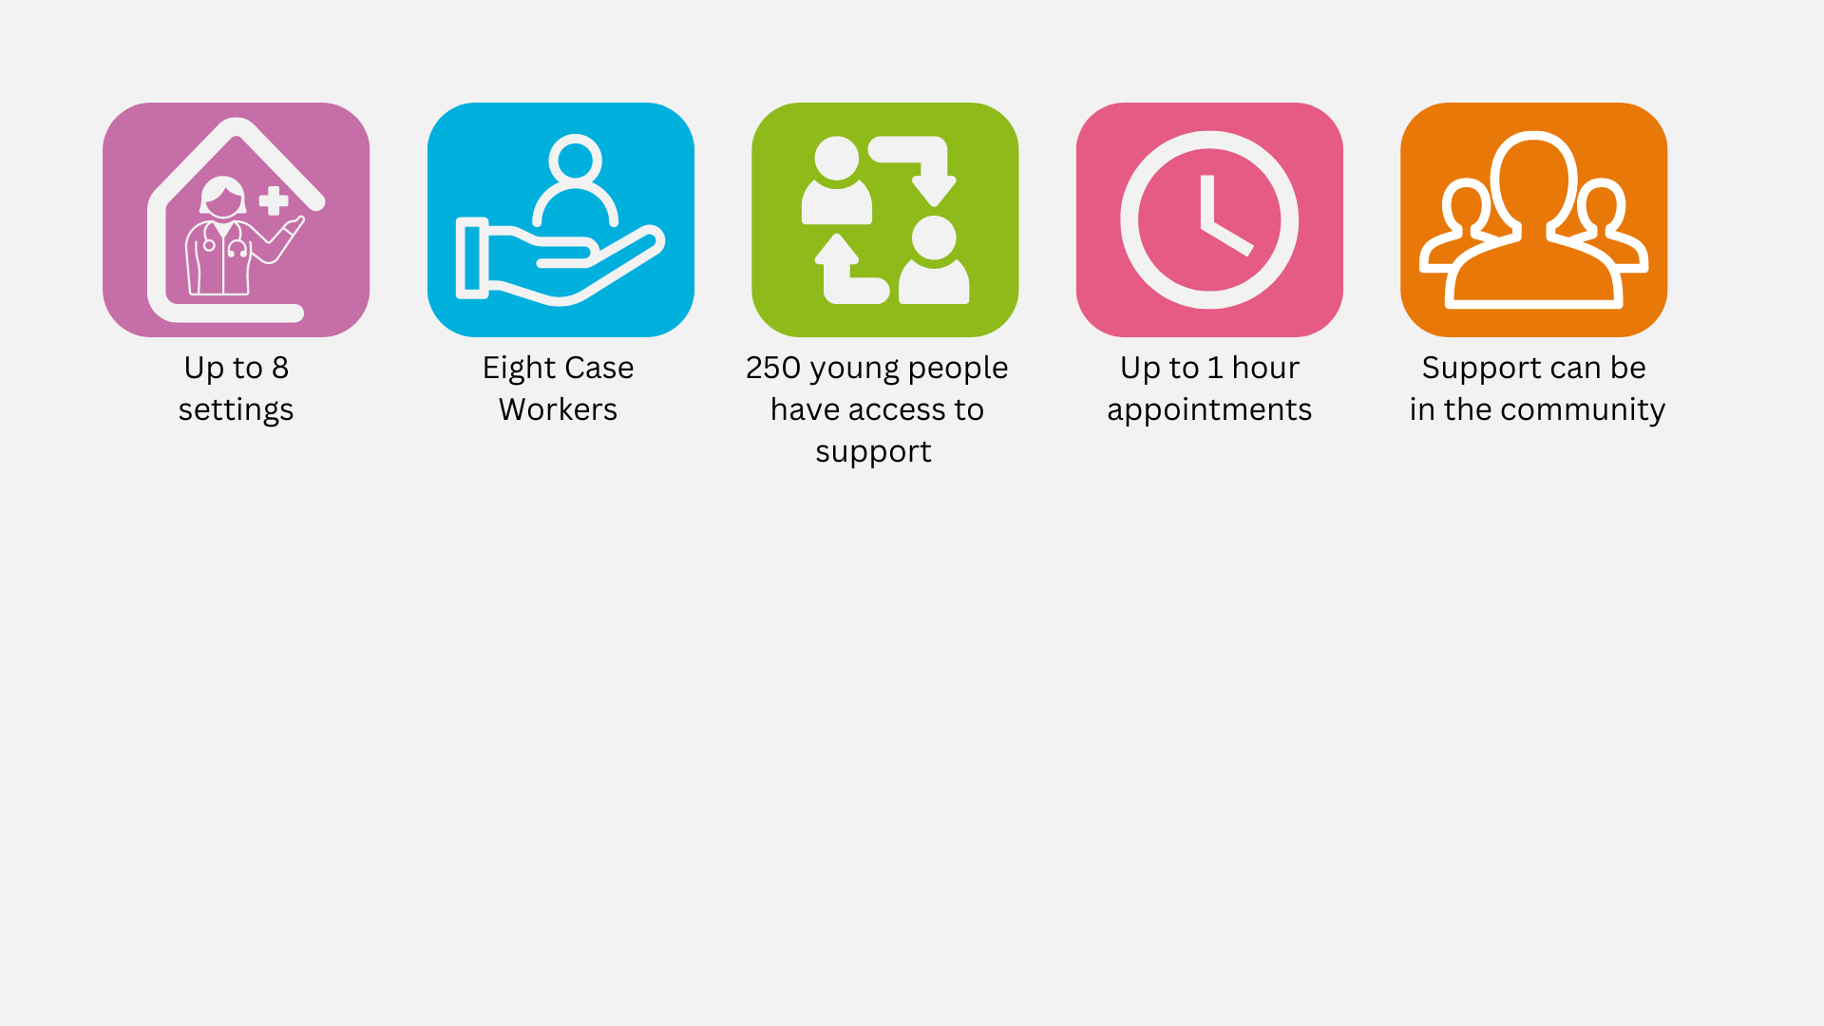

The redesign will be part of the wider ‘Village Through Commissioning’ Model. This is currently a successful approach used within framework for 16–18-year-olds and our strategic housing project.

The ethos is to raise children and young people in a community who work together, following the same values, aims and morals to ensure every child and young person is safe, heard and nurtured to aspire and succeed.

The Village aims and values:

**Appendix A Market Testing Questionnaire – provided as a separate document.**

End.