Network Tower – Supporting Information
The North London Foundation Trust network is made up currently of two separate networks. These were built for the separate legacy organisations. The network architectures are broadly similar though each has used differing vendor solutions to achieve their LAN, WAN, WLAN and Perimeter Security objectives. It is also important to know that HSCN, Internet and Cloud connections are provided to the southern and northern networks separately as it stands.
The Current network is depicted in the following diagram:
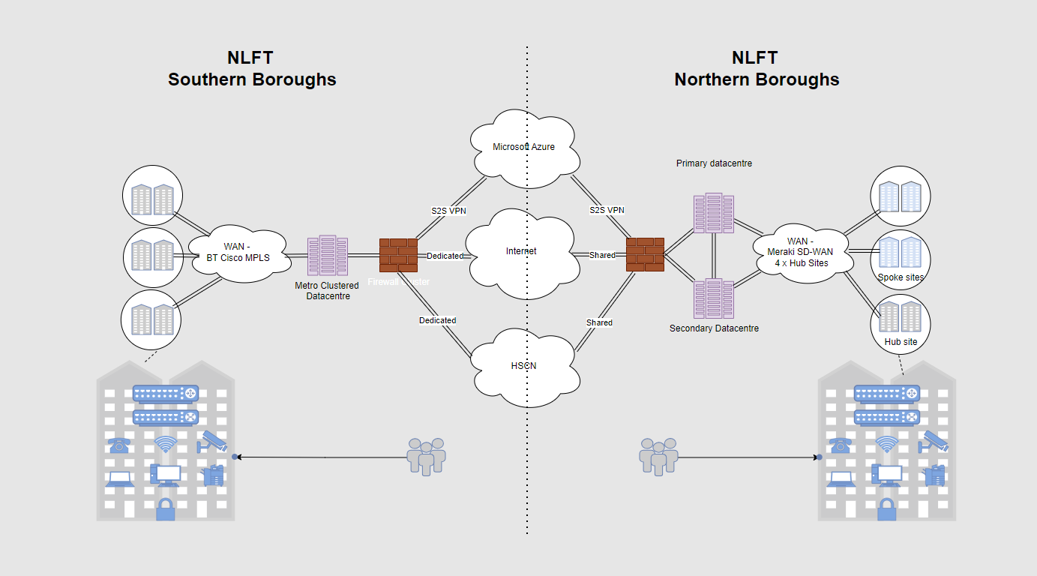
The tactical network Solution (In implementation) provides a bridge between the two legacy networks using a site-to-site VPN, with IP networks allowed on a case by case basis beyond the initial implementation and migrations. The following diagram depicts the network bridge:
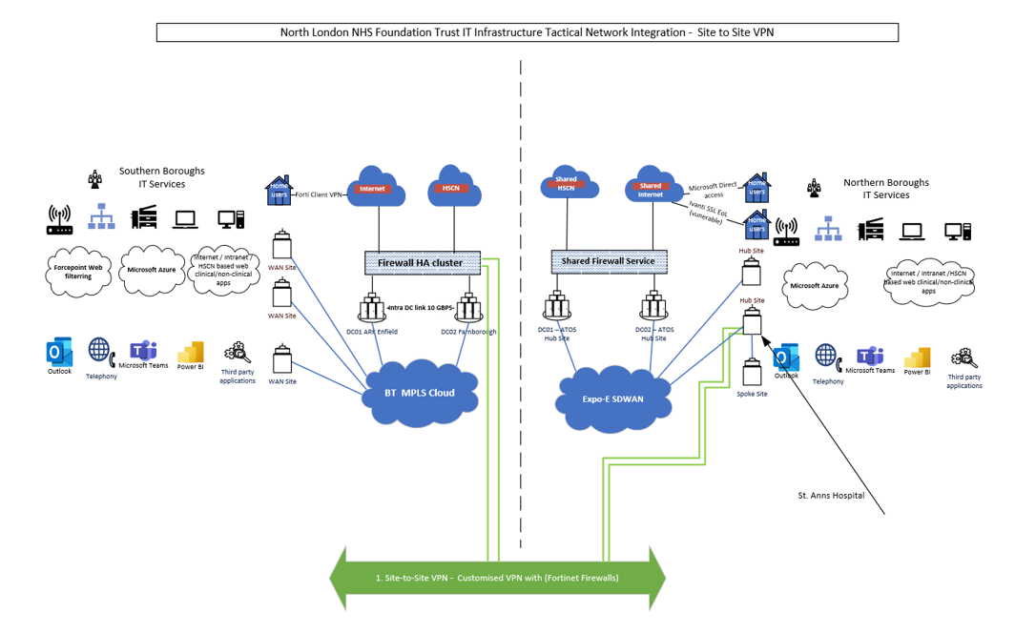

A List of network assets (Approximate numbers)
Type of Asset | Northern Boroughs (Legacy BEH) Qty | Southern Boroughs (Legacy C&I) Qty
Firewalls | 4 (Shared Infrastructure) | 3
Routers | 54 | 57
Switches | 328 | 275
Wi-Fi Controllers | 4 | 8
Wi-Fi Management, Monitoring, Authentication | 4 Clearpass Servers  2 Airwaves Servers | 4 ISE Servers  1 Catalyst Center
Access Points | 558 | 398

An initial SWOT analysis has been completed:

