

www.gov.uk/naturalengland
Request for Quotation

Request for Quotation
Beachy Head East MCZ – acoustic survey

You are invited to submit a quotation for the requirement described in the specification below.

Please confirm, by email, receipt of these documents and whether you intend to submit a quote.

Your response should be returned to the following email addresses by:

Email: Paula.daglish@naturalengland.org.uk
Date: 07/09/22
Time: 15:00
Reference: BHE MCZ 22

Ensure you state the reference number and ‘Final Submission’ in the subject field to make it clear that it is your response.

Contact Details and Timeline
Paula Daglish will be your contact for any questions linked to the content of the quote pack or the process. Please submit any questions by email and note that, unless commercially sensitive, both the question and the response will be circulated to all tenderers.

Acoustic Survey.

This element of work is expected to begin as soon as possible, and the final outputs need to be complete by mid-February 2023.The proposed milestones and outputs are:

Action | Date
Date of issue to Contact Finder | 25/08/22
Deadline for clarifications questions | 05/09/22
Deadline for receipt of Quotation | 07/09/22
Intended date of Contract Award | 12/09/22
Intended Contract Start Date | 14/09/22
Intended Delivery Date / Contract Duration | 20th January 2023 submission of draft report.  10th February 2023 submission of final outputs and report.

* Where there is no availability within these timescales, NE would be pleased to understand timescales and availability for the survey to be undertaken.

Glossary
Unless the context otherwise requires the following words and expressions used within this Request for Quotation shall have the following meanings (to be interpreted in the singular or plural as the context requires):

“Authority” | Means the Department for Environment, Food and Rural Affairs acting as part of Natural England
“RFQ” | Means this Request for Quotation and all related documents published by the Authority and made available to suppliers
“Contract” | Means the contract to be entered into by the Authority and the successful supplier.

Conditions applying to the RFQ
You should examine your response to the RFQ and related documents ensuring it is complete prior to submitting your completed quotation.

Your quotation must contain sufficient information to enable the Authority to evaluate it fairly and effectively. You should ensure that you have prepared your quotation fully and accurately and that prices quoted are arithmetically correct for the units stated.

The supplier by submitting a quotation is deemed to accept the terms and conditions in the RFQ. Failure to comply with the instructions set out in the RTQ may result in the supplier’s exclusion from this procurement.

Acceptance of Quotations
By issuing this RFQ the Authority does not bind itself to accept any quotation and reserves the right not to award a contract to any supplier who submits a quotation.

Costs
The Authority will not reimburse you for any costs and expenses which you incur preparing and submitting your quotation, even if the Authority amends or terminates the procurement process.

Mandatory Requirements
The RFQ includes mandatory requirements and, if you do not comply with them, your quotation will not be evaluated.

Clarifications
The Authority reserves the right to discuss, confidentially, any aspect of your quotation with you prior to any award of Contract to clarify matters.

Amendments
The Authority may amend the RFQ at any time prior to the deadline for receipt. If it amends the RFQ the Authority will notify you in writing and may extend the deadline for receipt in order to give you a reasonable time in which to take the amendment into account.

Conditions of Contract
The terms and conditions: Condensed Terms and Conditions will be included in any contract awarded as a result of this RFQ process. The Authority will not accept any material changes to these terms and conditions proposed by a supplier.

Specification
The Authority is Natural England. The Authority’s priorities are to secure a healthy natural environment; a sustainable, low-carbon economy; a thriving farming sector and a sustainable, healthy and secure food supply. Further information about the Authority can be found at: Natural England

Specification

- Introduction

Background to survey including reasons and desired outcomes:

Beachy Head East (BHE) Marine Conservation Zone (MCZ) was designated in 2019 under the Marine and coastal Access Act (2009) and covers an area of 19,486.51 ha between Beachy Head lighthouse in the west and Hastings Pier in the east. The MCZ extends just beyond 6 nautical miles offshore (Figure 1). For boundary coordinates for BHE MCZ please see: BHE MCZ boundary map (publishing.service.gov.uk)

Figure 1: Survey Area – Beachy Head East MCZ

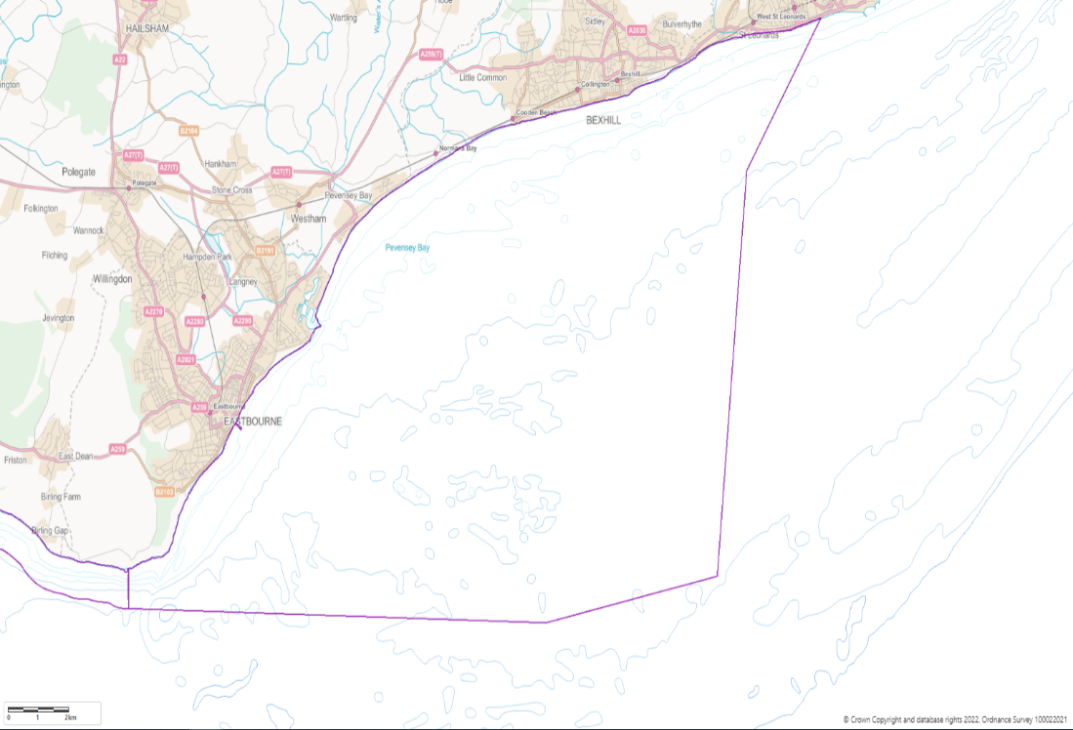
Coordinates of the MCZ can be found here: Beachy Head Marine Conservation Zone boundary map (publishing.service.gov.uk)

Beachy Head East has a sandstone/chalk reef system which provides niche habitats for a wide range of species. Between Beachy Head point and Holywell, a chalk reef extends from the subtidal area up to the coast and white cliffs, forming sheltered rockpools at low tide.

Further offshore the high and moderate energy circalittoral rock features provide habitats for a wide variety of animals including hydroids, bryozoans, sponges, star fish, sea squirts and anemones, due to the varying conditions and habitats that can be found in these areas (Department for Environment, 2019), (Seasearch, 2018), (Seasearch, 2017).

The proposed acoustic survey will contribute to evidence gathering to support condition assessment for the MCZ which is a statutory requirement for Natural England to undertake every 6 years.

This survey will gather acoustic information on the seabed within the BHE MCZ. The evidence gathered in this survey will seek to identify locations for further camera work to be undertaken at a later date. The surveys will improve the coverage, scale and quality of ecological evidence (specifically subtidal benthic habitats). Detailed survey and analysis will enable us to understand the distribution and extent of the designated habitat features of the site. Evidence gathered will feed into our natural capital understanding of not only biodiversity but other ecosystem services.

  - Survey area
Beachy Head East MCZ was designated as a Marine Conservation Zone and complements the UK’s suite of Natura 2000 and SSSI sites and overall MPA network.

The largest underwater chalk seascapes are predominantly found in Kent and Sussex, including those within the Beachy Head East site. The features of conservation interest for the MCZ site are:

• High energy circalittoral rock
• Littoral chalk communities
• Moderate energy circalittoral rock
• Peat and clay exposures
• Ross worm (Sabellaria spinulosa) reefs
• Short snouted seahorse (Hippocampus hippocampus)
• Subtidal chalk
• Subtidal coarse sediment
• Subtidal sand

Full site details are available on the NE designated sites webpage so please see Beachy Head East MCZ (naturalengland.org.uk) for more information.

The acoustic survey will cover subtidal benthic habitats within BHE MCZ. Natural England have been working with key partners including Sussex IFCA to increase understanding of habitat distribution within the site. Since designation, it has been increasingly clear that, although evidence was sufficient to designate features within the site itself, it is not sufficiently comprehensive to undertake a condition assessment of the features of the site. It is also not currently possible to accurately assess the impacts of certain activities due to uncertainty over the extent of feature habitats. Therefore, to ensure site features are protected, conservation advice for the site is precautionary (as required under the Marine and Coastal Access Act 20209). The purpose of the acoustic survey is to obtain data that can be reviewed to identify likely locations for further camera survey work to be undertaken at a later date to confirm habitat presence and extent.

.
1.2 Previous surveys

Previous surveys undertaken within BHE MCZ include:

- Seastar Survey Limited - 2012. Marine underwater video and stills analysis Beachy Head East Recommended Marine Conservation Zone (rMCZ);
- Curtis et al 2014 - Surveys undertaken by DEFRA during the designation process;
- Sussex Wildlife Trust (SWT) - Seasearch, S. W. T. S. 2017. Beachy Head East rMCZ: Seasearch dives (August 2017):
- SWT 2018 - Seasearch Survey in Beachy Head East rMCZ;
- Sussex IFCA and ZSL 2020 – Video Transects of Sabellaria and chalk features (not yet published)
A package from the Marine Evidence database can also be provided upon request. Figure 2 shows locations of subtidal features within the MCZ.

Figure 2: Beachy Head East MCZ Feature Map

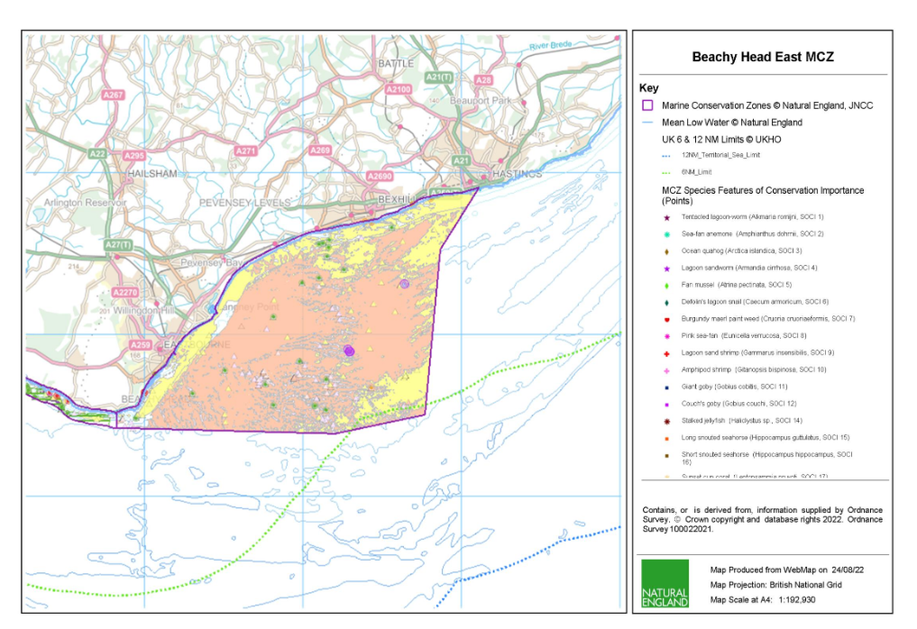

Further information on features available from: Beachy Head East MCZ Feature Maps (publishing.service.gov.uk)

Please note that, where possible, these datasets should be incorporated into the report provided for this project, however the methodology should not necessarily be followed, and the contractor is invited to suggest a survey plan.

Please note that, where possible, these datasets should be used to inform the interpretation of the acoustic survey. The outputs of this survey may be used by NE for a number of different purposes, including Condition Assessment, the formulation of Conservation Advice and to improve our understanding of Ecosystem Assets pursuant to the Natural Capital approach. Therefore, ideally datasets must be comparable with historic data and methodologies to enable analyses, however different and novel approaches will be considered where a rationale is provided.

- Aims & Objectives

2.1 Aims

The aim of this project is to undertake a comprehensive acoustic survey in the Beachy Head East MCZ to help with identification of the extent and distribution and quality of subtidal features to enhance our understanding of the site.

Natural England wishes to commission subtidal acoustic survey work during the Autumn of 2022 (September to October) in order to inform further camera survey to be undertaken in Spring 2023 (information on this phase of the survey will be issued in a separate RFQ).

The surveys together will gather robust evidence on the distribution and extent of habitats and features (sediments, rock, biogenic reef, peat and clay exposures). The project will deliver a detailed map of features at a range of EUNIS levels (broader than just broad scale habitats). Natural England will interrogate and analyze the detailed evidence collected (as part of a separate exercise) to inform Condition Assessment, the formulation of Conservation Advice and the construction of an Ecosystem Asset baseline for the area in question.

Please note – this RFQ is for an autumn acoustic survey. If the timing of the survey is not feasible due to time constraints, please provide availability for an acoustic spring survey.

The information gathered must be of sufficient quality to provide a comparison with previous surveys (where possible) relating to subtidal habitats according to methodologies outlined in JNCC common standards guidance (JNCC, 2004).

In brief, Natural England are seeking potential contractors to pay particular attention to survey design so that quantitatively robust data is acquired which will permit rigorous statistical analysis and support robust condition assessment judgments.

2.2 Objectives

The specific objectives of this contract are to:

In collaboration with Natural England, plan, undertake and report on subtidal acoustic survey techniques (and ground truthing) in order to inform camera survey in the spring. The surveys together will contribute to the condition assessment of the Beachy Head East MCZ.

Side scan sonar imagery will be gathered and used to suggest suitable ground truthing (using a combination of drop-down video transects and still photography) sample locations.

An accurate bathymetry of the site (order 2) is also required.

Overall outputs of the combined approach:

- Identify and map the extent and distribution of subtidal seabed habitats within the agreed sample area.
- Using previous survey and habitat information and the acoustic survey information gathered, provide a survey report and suggest likely candidates for video transect and camera work.

Under this specification contractors must:

- Develop, agree and implement, in collaboration with Natural England, a survey plan to collect data suitable for undertaking further camera assessment of the direction of change in seabed condition.
- In agreement with Natural England, implement a statistically robust survey design to enable future collection of compatible data, permitting quantitative long-term analysis. This should seek to build on any previous work listed (please refer to section 1.2) and, where possible, enable temporal comparisons to be made with previous datasets overall objective is to provide an ecosystem asset map comprising the location and quality of intertidal habitats.
- Where possible, ensure that newly collected data is analytically compatible with historical survey data.
- Provide fully detailed “standard operating protocols” for the work undertaken to ensure that methods can be repeated in the future.
- Produce a concise, evidence-based technical report detailing the work undertaken, reporting the survey and analytical findings, discussing these in the light of any previous data.
- In discussions around the findings of this work, observations made regarding condition, drawing upon “expert judgement” in addition to the collected and analyzed data, must be clearly identified and presented separately from the core results of this survey work.
- Provide all data to the relevant standards set out in section 4.1.
- If relevant, a MESH data confidence assessment for each seabed habitat map should be calculated and provided in a ‘MESH confidence scoresheet’ *.XLS file. The confidence assessment process is described, and a template provided in the following MESH resources The MESH Confidence Assessment Scheme.

- Methods

3.1 Development of a suitable sampling design

A sampling design needs to be developed for this work. This should seek to build on any previous work listed and, where possible, enable temporal comparisons to be made with previous datasets.

In developing an appropriate sampling strategy contractors should not be bound to simply repeat the previous methodology undertaken; rather they should seek to implement an improved approach which enables a comparison with existing data but at the same time delivers Natural England’s requirements for a more statistically robust approach outlined above.

3.2 Pre-survey deskwork

Before the survey is carried out the contractor will discuss any pre-survey work with the Nominated Officer, including:

- Clarification of roles, responsibilities, and expectations
- Acquisition and checking of sources of relevant information and gathering of local advice in preparation of a project plan
- Review existing information provided by Natural England or any datasets known to the contractor.
- Ways of working and close collaboration with NE in developing project plan, particularly selection of survey sites, taking account of NE/EA pre-survey scoping work, and finalising survey design and methodologies.
- Ensure that up to date charts are used to position sample sites away from cables, pipelines or any other coastal infrastructure. Should any coastal infrastructure exist within an area to be sampled then a buffer should be used to ensure that sampling activity does not cause damage, and this should be clearly displayed within the survey plan. Should coastal infrastructure be found during fieldwork then any sample sites should be relocated, and the Nominated Officer informed

3.3 Site access
The Nominated Officer should be contacted prior to commencement of any fieldwork.

Contractors should allow for the inclusion of Natural England staff on surveys wherever feasible. The Nominated Officer will liaise with the contractor regarding the availability of Natural England staff to join the survey, where available.

Contractors must ensure that vessels or equipment do not contact the seabed. Where contact with the seabed is necessary, a MCZ assessment would require approval to cover the activity.

3.4 Field survey

Provide detailed description of proposed survey methodology:

NE will discuss the survey plan and acoustic overlap with the contractor.

Camera ground truth locations (if taken during this campaign) should be:
- Located either side of a change in seabed characteristic;
- Representative of the range of sediments of interest.

Survey work under the contract should be scheduled to be completed by the end of October 2022, however potential contractors should provide contingency dates should the planned survey be affected e.g. by weather downtime.

Contractors must clearly state their availability and capability to carry both this single contract and any subsequent work they may consider bidding for (although not costed for under this RFQ) in combination within the given timescales.

Surveys will be carried out in accordance with the technical specification provided above. Alternative approaches will be considered if they meet the aims and objectives of the contract, demonstrate efficiencies and are agreed with NE prior to survey commencing.

3.6 Invasive Non-Native Species

Invasive Non-Native Species (INNS) are considered to be one of the top five pressures directly driving biodiversity loss globally. Prevention is the key focus, particularly in marine environments. The contractor shall be aware of and work in accordance with standard good practice biosecurity measures to avoid spread of INNS:

- Equipment, clothes and boots should be clean before carrying out any work on site
- When on or near water it is important that equipment is drained after use and as far as possible dried
- Boats to be used in survey work should have their hulls cleaned on a regular basis. Best practice guidelines should be followed as outlined by The Green Blue

INNS species previously recorded in this region and/or to particularly look out for during this survey. See GB non-native species secretariat.

The contractor must report any records of INNS observed on site on Marine Recorder and to the Natural England project officer as part of the survey report. Any species currently listed as ‘alert’ species should be flagged immediately to the GB Non-Native Species Secretariat http://www.nonnativespecies.org/alerts/index.cfm. More information and guidance including ID guides can be found at www.nonnativespecies.org and the Marine Aliens Project.
3.7 H & S Requirements

All risk assessments need to be seen and signed off by the Nominated Officer (ideally when presented with then project plan), as part of the contract management process. Risk assessments need to be provided by the contractor. Surveys will be done out of season, risks around reduced daylight and poor weather etc. need to be highlighted.

3.8 Weather downtime & contingency

Survey windows should be allocated in accordance with the best tides available. Contractors will be expected to check weather regularly (daily) prior to agreed survey windows. If contractors have 48 hours' notice of impending poor weather, then they will be expected to make alternative arrangements for the duration of the poor weather and reschedule survey work to be completed at a later date. If contractors have not yet mobilised, then Natural England does not expect to be charged for any weather downtime. It is the responsibility of the contractor to contact Natural England in the event that impending poor weather is putting the survey at risk.

Natural England does not envisage paying for downtime or contingency time for intertidal contracts, but in the event of unforeseeable weather events, a maximum of 1 day may be paid.

In the event of uncertainty or other unforeseen events that impact upon the ability of the contractor to undertake the survey, the Natural England Nominated Officer should be contacted immediately.

- Outputs – Products and Timescales
This contract shall be managed on behalf of the Authority by Paula Daglish.

The project outputs will follow the objectives set out in this tender (Section 3) and refer to available guidance for writing Natural England Technical publications.

Suppliers are to fill in the costing template below in application for the RFQ.

4.1 Reporting and analysis

Draft reports should be provided in electronic MS Office Word *.DOCX format for comment. A template and guidance exist for writing Natural England commissioned reports and will be sent to the contractor upon award of the tender. All reports should retain a clear suggested citation stating that it is a ‘Report to Natural England’.

Data must be interpreted, analysed and presented in light of the overarching hypotheses stated above. Contractors should pay particular consideration to the data and GIS required formats for information compatibility including MEDIN metadata standards and Marine Recorder provision.

All interpreted products following data analysis should accompany the draft report; these will include:
- All GIS datasets need to be provided in ESRI ArcGIS format compatible with ArcGIS 10.2 and have attached metadata.
- All GIS files containing habitat data for each individual survey need to be produced to the MESH translated habitat Data Exchange Format (DEF) to the most detailed EUNIS habitat level possible. MNCR (v15.03) data should be added to the ORIG_HAB column. The GUI provided by Natural England for each survey will be used, and as much information as possible (e.g. survey name, originally assigned feature/habitat name etc.) from the original dataset, as well as any documentation provided (where available) should be included in the resulting datasets to maintain a useful audit trail. As specified in the MESH DEF, data files must be provided as ESRI Shapefiles or as a feature class data within a geodatabase using the WGS1984 geographic coordinate system and (lat/long coordinates. If not included in the GIS data layers listed above all sampling locations, vessels tracks, and links to data obtained should also be included as a single GI layer.
- A MESH data confidence assessment for each habitat map should be calculated and provided in a ‘MESH confidence scoresheet’ *.XLS file. The confidence assessment process is described, and a template provided in the following MESH resources The MESH Confidence Assessment Scheme.
- Accompanying metadata for the data set must meet the MEDIN metadata discovery standard. Metadata derived as part of this project must be submitted to Natural England in an XML file which Natural England will archive through Data Archive Centres (DACs). Guidance ‘MEDIN Evidence for Contractors’ will be provided to the winning contractor.
- Copies of the original data spreadsheets or databases are to be provided in the appropriate Microsoft Office format
- Stills photographs to be provided in their raw format on CD/DVD or USB compliant external hard drives.
All sample data (e.g. grab sample analyses, video/still photography analyses, PSA analysis and biotope lists, biological taxon data) need to be entered into Marine Recorder NBN data and an exported snapshot file of the data should be provided for QA. Natural England will provide licence keys for Marine Recorder. Natural England will supply a ‘Marine Recorder guidance for contractors’ document to successful contractors.

The contractor must report any records of Invasive and Non-Native Species observed on site on Marine Recorder and to the Natural England project officer as part of the survey report. Any species currently listed as ‘alert’ species should be flagged immediately to the GB Non-Native Species Secretariat Species alerts. More information and guidance including ID guides can be found at GB non-native species secretariat.

Copies of the original data spreadsheets or databases are to be provided in the appropriate Microsoft Office format. However please be aware that using MEDIN marine biodiversity data guideline spreadsheets (available online under the marine biodiversity tab at MEDIN data guidelines) will ensure that biological taxon data is prepared correctly for entry into Marine Recorder and will facilitate the efficient entry of data into this system and the data archiving process in general. Natural England welcomes and supports the provision of raw data spreadsheets in the MEDIN format and expects that all raw datasheets will contain the mandatory fields in the MEDIN guidelines, regardless of their format.

Standard survey imagery (stills and video) is to be provided in their raw format electronically or on USB compliant external hard drives (to be provided by the contractor).

High quality imagery which has been selected to form part of the image reference collection for the survey need to be labelled appropriately, including the habitat/species which is represented. These should be provided as a separate folder on the storage device to the standard survey imagery.

All data products and electronic files must be appropriately named so they sufficiently describe the contents and are not purely a numerical value. All products should be named appropriately so that they can be clearly linked to the report/project.

Any species lists submitted will be compliant with current taxonomic names and synonyms (e.g. Marine Species of the British Isles and Adjacent Seas (MSBIAS), World Register of Marine Species (WoRMS))

Video and still camera filenames must include the recording start date and time. Position data must be included within the overlay information.

We will raise purchase orders to cover the cost of the services and will issue to the awarded supplier following contract award. Upon completion of the Phase I and II Autumn field surveys the first payment will be made, second payment after the Autumn deliverables, third on completion of the Spring fieldwork, and the final payment on completion of Spring deliverables.

4.2 Timeline for project delivery:

Acoustic survey
 | Acoustic Survey
Agree sampling design | End September 2022
Survey to be complete | 31st October 2022
Process data | Nov 22 – Jan 23
Produce report with recommendations for further video transect and camera work | 10th February 2023

Natural England would expect to discuss and review timelines with the successful contractor in the start-up meeting and throughout the duration of the contract. Any delays to this timetable should be discussed with the Natural England Project Officer and delays not outside the control of the contractor will be penalised.

- Other
In support of this contract NE will provide the winning supplier with:

- Project support from dedicated Nominated Officer
- Opportunity to feedback and discuss progress and the project
- Supporting GIS datasets (if required) under licence for use in this contract:
  - Base map data from Ordnance Survey
  - Aerial photography from Next Perspectives
  - S-57 vector data from the UK Hydrographic Office (in ArcGIS format) *
  - Raster charts from Oceanwise (Not to be used for Navigation)
- Additional reports to help with the analysis and report, such as those listed in Section
Please see the following site for information on how to acquire GI information https://www.gov.uk/how-to-access-natural-englands-maps-and-data

The intellectual property rights and copyright for all products (including photographs) will lie with Natural England. Natural England aims to make all data available under the Open Government Licence at the end of the project via www.data.gov.uk and the MEDIN Data Archiving Centres.

5.1 Supporting Documents

To assist contractors in developing their tender submission we will provide background reports and summary output documents with this specification:

Curtis, M., Downie, A., Diesling, M. and Stephens, D. 2014. Beachy Head East rMCZ Post-survey Site Report: Department for Environment, Food & Rural Affairs (Defra).
Marine Conservation Zones: Beachy Head East - GOV.UK (www.gov.uk)
Jenkins (2018), Advances in assessing Sabellaria spinulosa reefs for ongoing. Available at: https://eur03.safelinks.protection.outlook.com/GetUrlReputation
Gubbay (2007), Defining and managing Sabellaria spinulosa reefs: Report of an inter-agency workshop 1-2 May, 2007 . Available here.
Fariñas-Franco et al., (2014)
Holt et al., (1998).
Pearce et al., (2013).
Limpenny et al., (2010)
Bussell and Saunders, (2010).

- References

Davies, J., Baxter, J., Bradley, M., Connor, D., Khan, J., Murray, E., Sanderson, W., Turnbull, C. & Vincent, M., (2001), Marine Monitoring Handbook, 405 pp, ISBN 1 85716 550 0. Available online at: http://jncc.defra.gov.uk/page-2430

JNCC (2004), Common Standards Monitoring Guidance for Marine, Version August 2004, ISSN 1743-8160. Available online at: http://jncc.defra.gov.uk/page-2236

Wyn, G., Brazier, P., Jones, M., Roberts, S., Cooke, A., Lough, N. & Uttley, C. (2000). CCW Handbook for Marine Intertidal Phase 1 Survey and Mapping, 107 pp. Marine Science Report No. 00/06/01, February 2000, Countryside Council for Wales, UK.

- Contract Award Criteria

We will award this contract in line with the most economically advantageous tender (MEAT) as set out in the following award criteria:

Criteria | Weighting | Scores
Cost | 30% | Ranked in cost order
Availability/ capacity |  | Pass/fail
Quality of proposal based on the survey design meeting the requirements of the new proposal, number of samples, statistical rigour and power of the design. | 30% | Using scoring criteria set out below
The ability of the sampling strategy to be replicated in future years or for other applications and to provide a survey report | 10% | Using scoring criteria set out below
Relevant expertise and skills of team | 25% | Using scoring criteria set out below
Quality Assurance measures | 5 % | Using scoring criteria set out below

For a score of 100: Excellent - Response is completely relevant and excellent overall. The response is comprehensive, unambiguous and demonstrates a best-in-class thorough understanding of the requirement and provides details of how the requirement will be met in full.

For a score of 70: Good - Response is relevant and good. The response demonstrates a good understanding and provides details on how the requirements will be fulfilled.

For a score of 50: Acceptable - Response is relevant and acceptable. The response provides sufficient evidence to fulfil basic requirements.

For a score of 20: Poor - Response is partially relevant and/or poor. The response addresses some elements of the requirements but contains insufficient / limited detail or explanation to demonstrate how the requirement will be fulfilled.

For a score of 0: Unacceptable - Nil or inadequate response. The response fails to demonstrate an ability to meet the requirement.

7.1 Disclosure

All Central Government Departments, their Executive Agencies and Non-Departmental Public Bodies are subject to control and reporting within Government. In particular, they report to the Cabinet Office and HM Treasury for all expenditure. Further the Cabinet Office has a cross-Government role delivering overall Government policy on public procurement, including ensuring value for money and related aspects of good procurement practice.

For these purposes, the Authority may disclose within Government any details contained in your quotation. The information will not be disclosed outside Government during the procurement.

In addition, the Authority is subject to the Freedom of Information Act 2000 and the Environmental Information Regulations 2004, which provide a public right of access to information held by public bodies. In accordance with these two statutes, the Authority may be required to disclose information contained in your quotation to any person who submits a request for information pursuant to those statutes.

By submitting a quotation, you consent to these terms as part of the procurement.

7.2 Disclaimers
Whilst the information in this RFQ and any supporting information referred to herein or provided to you by the Authority have been prepared in good faith the Authority does not warrant that this information is comprehensive or that it has been independently verified.

The Authority does not:
- make any representation or warranty (express or implied) as to the accuracy, reasonableness or completeness of the RFQ;
- accept any liability for the information contained in the RFQ or for the fairness, accuracy or completeness of that information; or
- accept any liability for any loss or damage (other than in respect of fraudulent misrepresentation or any other liability which cannot lawfully be excluded) arising as a result of reliance on such information or any subsequent communication.

Any supplier considering entering into contractual relationships with the Authority following receipt of the RFQ should make its own investigations and independent assessment of the Authority and its requirements for the goods and/or services and should seek its own professional financial and legal advice.

Protection of Personal Data

In order to comply with the General Data Protection Regulations 2018, the contractor must agree to the following:

- You must only process any personal data in strict accordance with instructions from the Authority
- You must ensure that all the personal data that we disclose to you, or you collect on our behalf under this agreement are kept confidential.
- You must take reasonable steps to ensure the reliability of employees who have access to personal data.
- Only employees who may be required to assist in meeting the obligations under this agreement may have access to the personal data.
- Any disclosure of personal data must be made in confidence and extend only so far as that which is specifically necessary for the purposes of this agreement.
- You must ensure that there are appropriate security measures in place to safeguard against any unauthorised access or unlawful processing or accidental loss, destruction or damage or disclosure of the personal data.
- On termination of this agreement, for whatever reason, the personal data must be returned to us promptly and safely, together with all copies in your possession or control.

General Data Protection Regulations 2018
For the purposes of the Regulations the Authority is the data processor.

The personal information that we have asked you provide on individuals (data subjects) that will be working for you on this contract will be used in compiling the tender list and in assessing your offer. If you are unsuccessful the information will be held and destroyed within two years of the award of contracts. If you are awarded a contract, it will be retained for the duration of the contract and destroyed within seven years of the contract’s expiry.

We may monitor the performance of the individuals during the execution of the contract, and the results of our monitoring, together with the information that you have provided, will be used in determining what work is allocated under the contract, and in any renewal of the contract or in the award of future contracts of a similar nature. The information will not be disclosed to anyone outside the Authority without the consent of the data subject, unless the Authority is required by law to make such disclosures.

Appendix 1: Technical Questions
Quotes will be evaluated for both technical and commercial merit using the evaluation criteria below to determine which quote is the most economically advantageous.

Ref:
Project:
Technical questions – 70%

- 1. Please supply a proposed schedule of work, stating the timescales you will be able to execute and deliver the products specified above. See Section 4.1 Timeline for project delivery – Pass/Fail

- 2. Provide a statement on your availability & capacity to mobilise a survey team - Pass/Fail.

- 3. Provide CVs for the survey team. C.V.s should demonstrate appropriate skills for intertidal survey work – 30 %

- 4. Provide a summary of your survey design methodology – 30 %

- 5. Report proposal including data analysis and survey report – 10 %

SUBMITTED BY:
Contractor name
Address
Email
Telephone
Fax

