What to do next 
LaunchPad and Link Building

OPEN PROCEDURE - OJEU REFERENCE: TBC - Our Tender Ref: 909LaunchPad

You must register with our procurement portal via the In-Tend System:

This can be done by using the link below:

https://in-tendhost.co.uk/universityofexeter/aspx/Home

This is free to use.

Submitting your Tender – via In-Tend
This ITT will close at 26/April/2017 – 12:00 hrs GMT. It is the Bidder’s responsibility to ensure that their completed bid is uploaded, in full, no later than the date and time above. Tenders will not be considered if the complete information called for is not provided by the closing date and time stated in this document.

Anticipated Timescales
Notification to any changes to the procurement timetable shall be made via the FX Plus Procurement Portal.

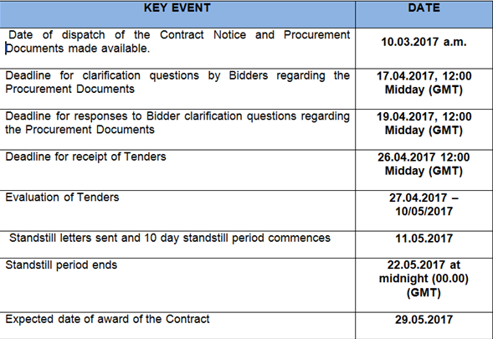
It is the responsibility of each Bidder to ensure that it allows sufficient time to complete the upload of its tender including all of the required documentation.
https://in-tendhost.co.uk/universityofexeter/aspx/Home
All Correspondence or any matters relating to this tender will be conducted through the In-Tend System. Thank you, FXPLUS Procurement.

