Chiseldon Parish Council

The Old Chapel, Butts Road, Chiseldon, Wilts SN4 0NW
 01793 740744
email: clerk@chiseldon-pc.gov.uk
website: www.chiseldon-pc.gov.uk



Procurement Requirements

Note – this procurement procedure must adhere to S135 of the Local Government Act 1972 and the Public Contracts Regulations 2015. These are legal requirements. (See end of document)

All tenders must adhere to Chiseldon Parish Councils standing orders for contracts. Required by S135 of the 1972 Local Government Act

Date of tender: | 06.04.23
Description/Spec of Work required: | The design and build of 2 layby provisions within Chiseldon Parish – Windmill Piece and Draycot Foliat. Maps at the bottom of this document.  The service should provide:  - Site visit to both sites with Clerk or Cllr  - Initial drawings of proposed plans  - Revised drawings if required based on council feedback  - Liaise with all relevant departments at Swindon Borough Council to get permissions for works to proceed.  - To liaise with Swindon Borough Council on any extra work required– surveys or inspection holes etc. To provide the council Clerk with full information of what is required and additional quotes if needed within 2 working days.  - Deliver work to the standard specified within a set time scale once work starts. To be agreed with contractor and council  - To not engage in any extra work or incur further costs to the council without express permission of the Parish Council  - To work within the agreed budget approved by the council  - Provide 2 examples of work recently carried out within a 50 mile radius  - Provide the contact details of 2 customers who will provide a reference.  - Liaise with Council Clerk at all stages of work and reply promptly to enquiries. (within 2 working days)  - To alert the Clerk promptly (within 2 working days) of any delays or issues with the project.  - Ensure all relevant insurance documents for your work are provided to the council before work starts.  - Contractors should ensure they receive the trial bore holes information from Windmill Piece for gas and electric supplies before quoting – from the Clerk.
Deadline for submission: | 06.06.2023
Contractor to complete:
Contractor Name:
Contact details:
Details of works to be provided:
(please provide drawings and diagrams seperately on paper/email if required)

Available start date:
Costs:
**

VAT to be added to your quote: | Y/N (please circle)
Special considerations:

Experience of working with Parish Councils: | It is desirable for this contract for the contractor to list any work carried out on behalf of a Parish Council or for Swindon Borough Council. Please list any experience below:
Any other information of relevance:

** If the estimated cost is over £25000 then the contract Finder website & other light touch rules must apply by law. (See 2015 regulations)

Windmill Piece – indicative area highlighted:

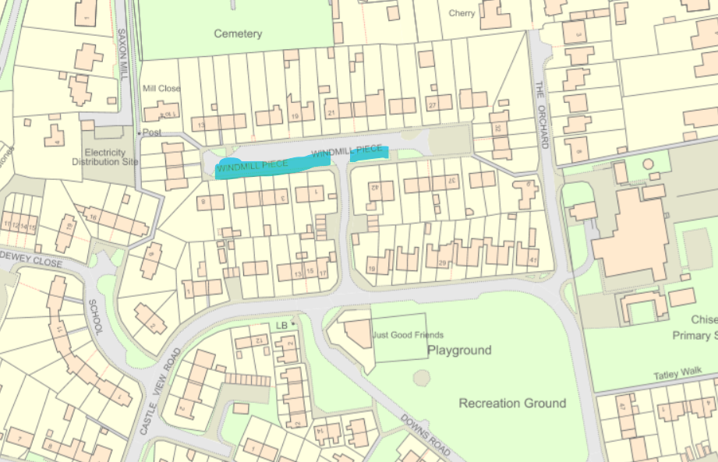

Draycot - indicitive area highlighted:

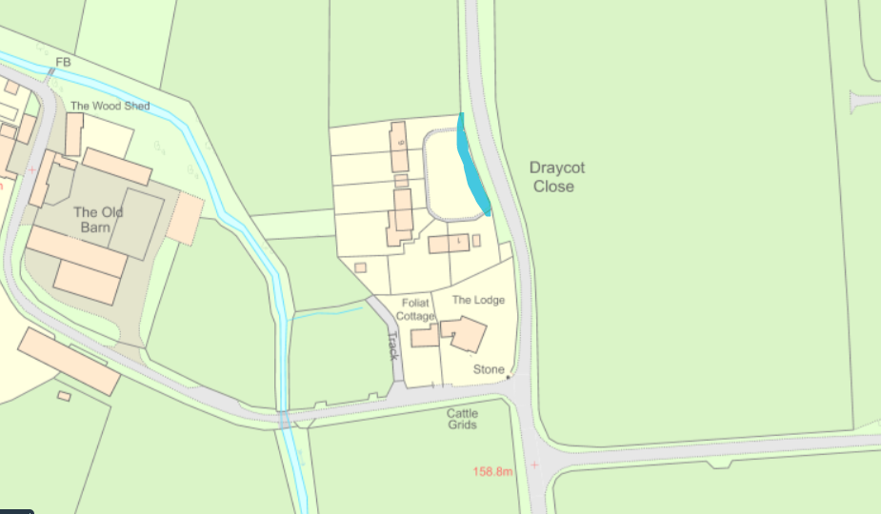

Local Government Act 1972 S135:

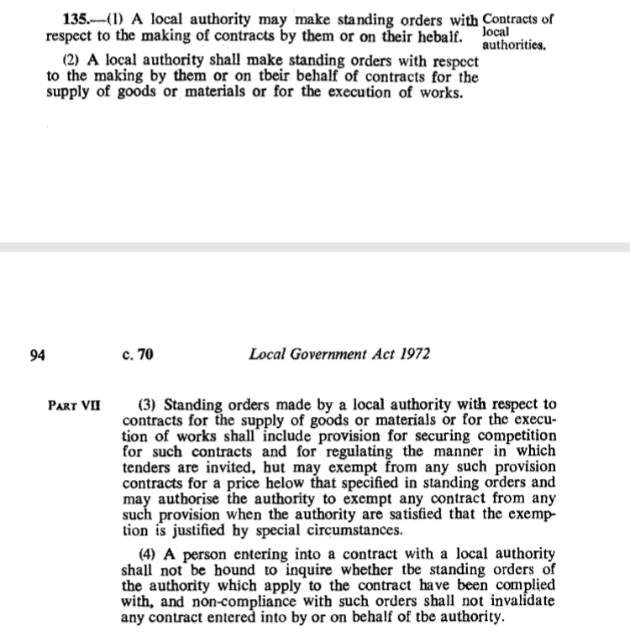
NALC Legal Topic Note 87 – Procurement available on request.

Public Contracts Regulations 2015 available on request.

Document format approved 11th November 2019
Docment format approved Full Council Oct 2022. Minute 22/63

