E-tendering portal guidance

Of interest to organisations that want to access to our e-tendering portal.

Contents

- Technical Requirements.
- How to register on the Department for Education Agency e-tendering portal.
- How to retrieve username details and a forgotten password
- Expressing an Interest in an ITT/PQQ
- How to add a user to your Bravo e-tendering account
- Hints and tips.

Technical Requirements

The eSourcing Suite is accessed over the internet and should operate using any standard web-browser.

It is strongly recommended that you use the following internet browsers which are supported by Bravo Advantage 16:
- IE10 and IE 11 (Note that IE9 will function, but is not recommended)
- Google Chrome
- Mozilla Firefox (ESR) 31+
- Safari 8 for MacOS 10.10

Note
If you do not hold an account on the e-tendering portal you will need to register. You may complete registration at any time but you will not be able to access the PQQs or ITT’s unless you do so. The registration page that you complete to register on the e-tendering portal is not the PQQs or ITT’s that you are required to complete as part of the pre-qualification or tendering process.

How to register on the Department for Education e-tendering portal

- If you already hold an account on the e-tendering portal it is important that you use your existing account when accessing the PQQs and continue to use this account in the future. If you are not sure whether your organisation already has an account or you require a password reset, email help@bravosolution.co.uk rather than attempt to re-register.
- If your organisation does not hold an account, please register on the e-tendering portal. Please be aware that the first thing you will have to do is to read and agree to the eSourcing Service User Agreement. Please note that amongst the points to which you are agreeing is to ensure that your registration details are kept up to date as these are the only means by which the DfE will contact you with regard to procurement Projects

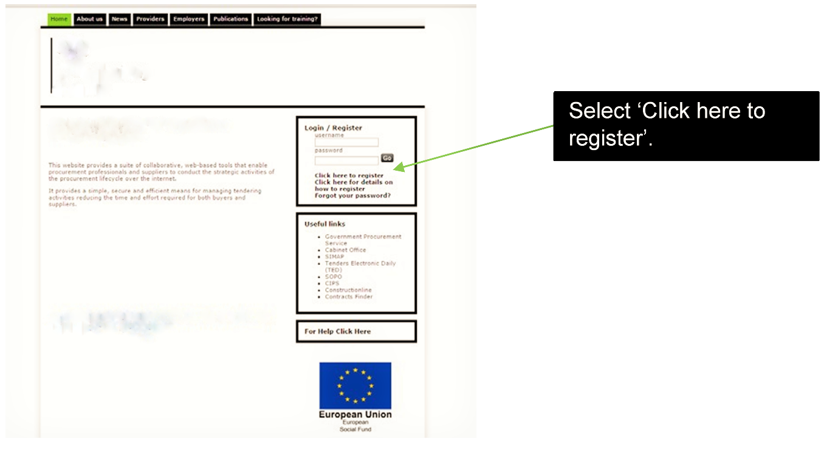

3. You are then directed to the registration form, which has two sections.
i. Organisation details.
ii User details.

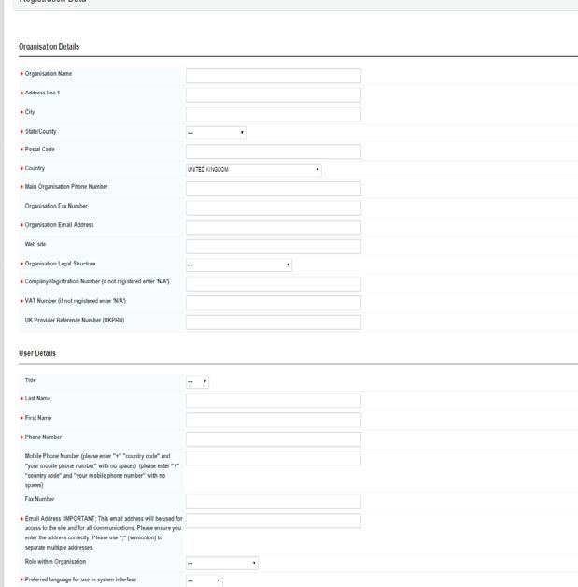

Complete the form
and check that all
your details are
correct, then save the
form.

Your name on the Bravo e-tendering portal must match your legal name. Do not abbreviate it.

You can add more
than one email
address to receive
alerts by adding a
semicolon (;) after
each address you
enter.

- You will then receive an email from Bravo Solution containing your chosen username and a unique password. They will send this to the email address you entered as part of your registration.

Tip: If you have not received the registration email, please check your ‘spam’ or ‘junk’ folder: anti-spam software may have blocked it. Add the sender to your ‘safe sender’ list to prevent future messages from being blocked.

- When you log into the e-tendering portal for the first time you will need to change your password; you have then successfully registered on the e-tendering portal.

Tip: It is your responsibility for keeping your registration details up to date, the Department for Education cannot alter Bravo registration details on your behalf.

How to retrieve username details and a forgotten password

If you have forgotten your username or password, you will need to send an email to help@bravosolution.co.uk as Bravo Solution manage the e-tendering portal. A member of the team will then help you get back into the system.

Expressing an Interest in an ITT/PQQ
Enter https://education.bravosolution.co.uk into your web browser
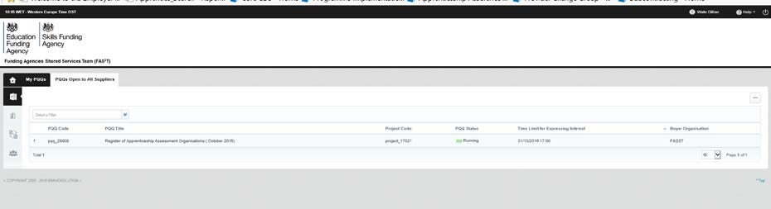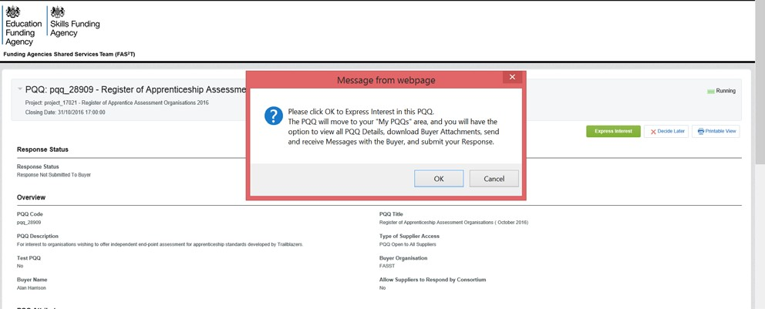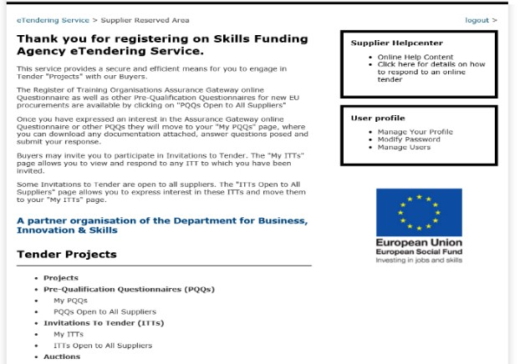

Click Express interest

Select either “My PQQ’s or My ITT’s

On the main page,
select the ‘PQQs/ITT’s open
to all suppliers’, option

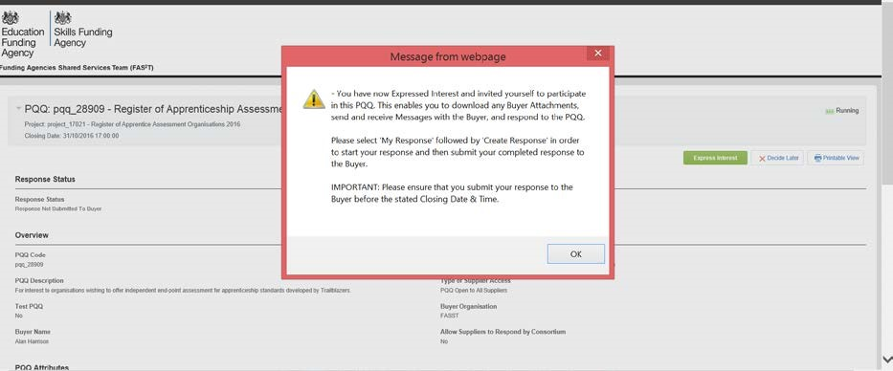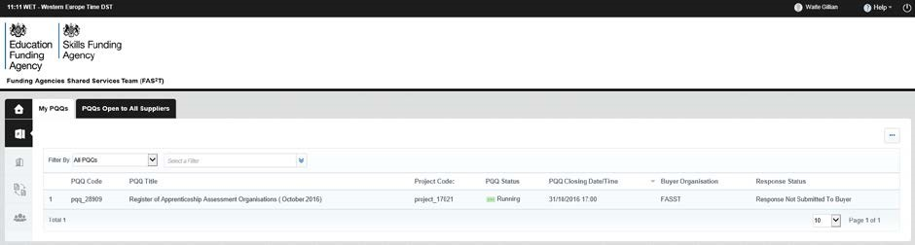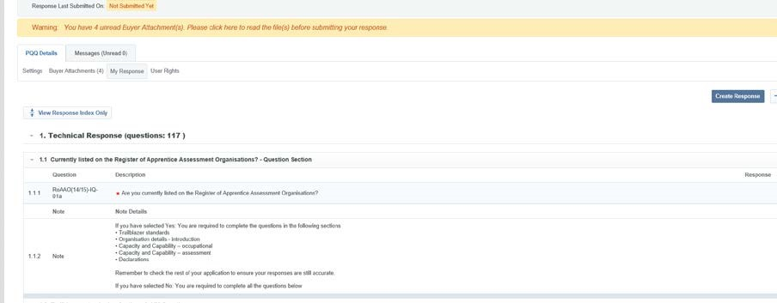

Click OK then click
‘the relevant PQQ or ITT on “My PQQ’s or My IITT’s
Or ITToror

Click Create
Response and
complete the
application

Tip. Remember to submit your final responses before the closing date and time.
We also send messages to you through the message board, and you are able to respond in the following way:

- Log on to the e-tendering portal and select ‘My PQQs’ option, then select the relevant PQQ.

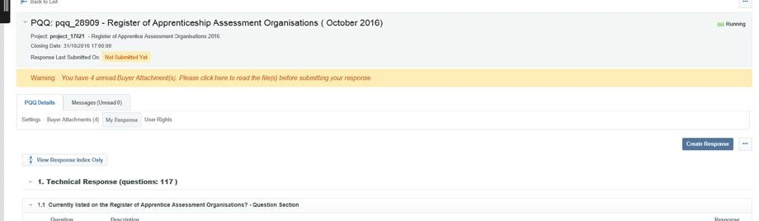

To view your received messages,
hover your mouse
over the ‘
Messages Unread
’ tab and click ‘
Received
Messages
’

- You will then be able to view your messages, including when the message was sent, when you opened the message and when you replied.

How to add a user to your Bravo e-tendering account

To ensure you do not miss any information sent through the e-tendering portal, we recommend that you add another user/s to your organisation’s registered account.
These users will then receive any automated email alerts.

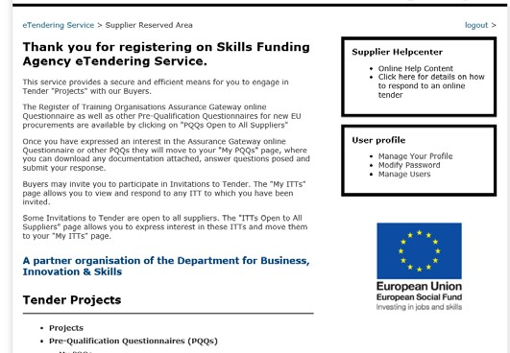

On the main page, click
‘
Manage Users
’.

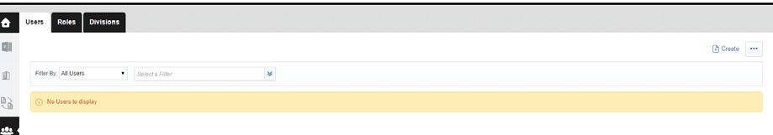

Click ‘
Create
’
.

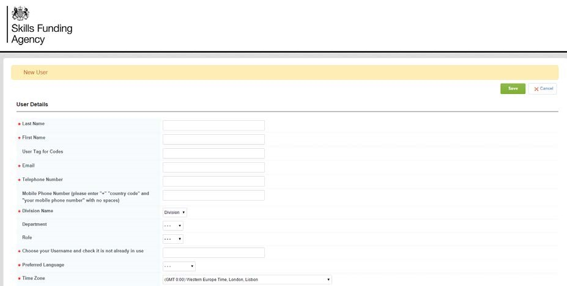

Complete the ‘
user details
’
fields. Once you have checked
the details are correct, click
‘
save
’
.

Now that you have added a new user, you will need to assign the appropriate rights to their user account.

Select ‘View User Rights’.

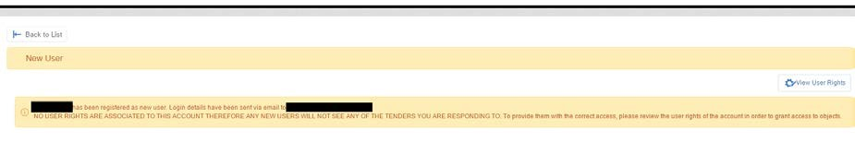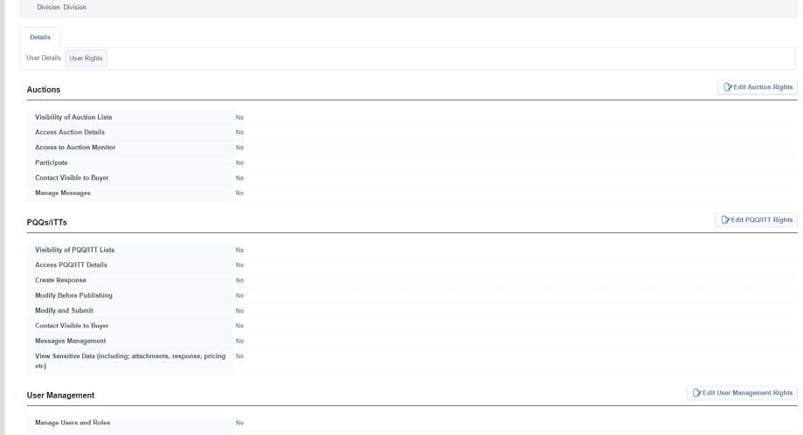 Note Please do NOT amend the ‘Edit auction rights’, ‘Edit supplier rights’, ‘Edit management rights’ or ‘edit directories rights’ options.

Select ‘Edit PQQ/ITT Rights’.

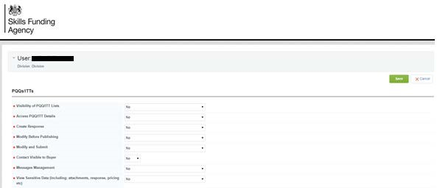

You can select the
appropriate user rights from
the dropdown lists. Once
you have completed your
selection, review the rights
you have selected and click
‘Save’.
Access rights

See PQQ/ITT:
Ability to view active procurement opportunities through the ‘PQQs/ITTs Open to all Suppliers’ links. (Note: If there are no opportunities available at a certain point in time, nothing will be visible.)

View PQQ/ITT Details:
Ability to click on active procurement opportunities through the ‘PQQs/ITTs Open to all Suppliers’ menu, and view details.

Create response:
Ability to express an interest and begin the process of completing a PQQ/ITT.

Modify before publishing:
Ability to log in and make amendments to active PQQ/ITT responses.

Publish and modify:
Ability to submit a response on behalf of your organisation and make amendments to PQQs/ITTs.

Contact visible to the buyer:

If we need to contact you, the contact details of this user will be visible to us.

Messages management:
Ability to access message boards of a PQQ/ITT. The user will be able to review messages that we send and also send messages to us.

View sensitive data:

Ability to view attachments that you upload as part of your responses to PQQs/ITTs. For example, organisations charts that you upload when completing an application to the register of apprenticeship training providers.

Company name and name changes

Your name on the Bravo e-tendering portal must be your full legal name with no abbreviations. If there is a change to your organisation name, with no other legal or organisational change, you must amend your details on the portal.
To do this you must take the following actions.
Ensure your legal name has been updated on the Companies House website if you are a limited company or Charities Commission website if you are a charity.
Your name as it stands on the bravo e-tendering portal
Full legal name (your new name)
Companies House number (if applicable)
Charity number (if applicable)
Sole trader / partnership (Yes/No)
When we have received and validated the evidence, we will authorise Bravo Solutions to change the name.
If you are in the process of completing an application, please prioritise the completion of your application. You can request that your name is updated on the e-tendering portal after you have submitted your application.
Hints and Tips

Your name on the Bravo e-tendering portal must match your legal name. Do not abbreviate it.

Emails sent to users from the eSourcing Suite will come to the registered user email address for further competitions. Please ensure that your email filter is set to accept them.
For security reasons your access to the portal will 'time out' if inactive for c15 minutes. Any unsaved information or amendments that you have made will not be stored. This is to maintain security of your account and cannot be changed.
Keep your e-tendering portal login secure. If you have lost your password, access the website and click onto "Forgotten your password?" and follow the instructions.
If you have not received the registration email, please check your ‘spam’ or ‘junk’ folder: anti-spam software may have blocked it. Add the sender to your ‘safe sender’ list to prevent future messages from being blocked.

