Contents
A. INVITATION TO TENDER PAGE 2
B. STANDARD CONTRACT CONDITIONS PAGE 3
- Officer
- Extent of Work
- Site Details
- Site Access
- Workmanship and Equipment
- Additional Erection/Installation
- Duration of Contract
- Payment to Contractor
- Termination of Contract
- Insurance
- Subcontractor/Employee Verification
- Health and Safety
- Notes to Tenderers
C. SPECIFICATION OF WORKS PAGE 5
D. SCHEDULE OF WORKS PAGE 7
E. SITE PLANS PAGE 8
F. TENDER FORM PAGE 12
G. DECLARATION & COMPANY DETAILS FORM PAGE 13
H. EVALUATION PAGE 14

A. INVITATION TO TENDER
1. Gaydon Parish Council ("the Council") hereby invites tenders for the carrying out of the Service of
Grass Cutting in accordance with the Contract documents attached, which comprise:
A. Invitation to tender
B. Standard contract conditions
C. Specification of works
D. Schedule of works
E. Site plans
F. Tender form
G. Declaration & Company Details Form
H. Evaluation
2. The Prices submitted must indicate the rate for carrying out each element of the Contract.
3. Prospective Contractors should ensure that they are completely familiar with the nature and extent of the obligations to be accepted by them, if their tender is accepted.
4. Any queries regarding the interpretation of any part of the Contract documents should be addressed to the Officer by no later than two weeks before the closing date.
5. The tender shall be submitted ONLY on the attached Form of Tender.
6. Prospective Contractors should note that the Council is not bound to accept the lowest, or any tender.
The Council’s decision is final and no correspondence will be entered into on the reasons why a tender has been rejected.
7. The successful tender together with the Council's written acceptance shall form a binding agreement in the terms of the Contract documents.
8. If having examined the tender documents you wish to submit a tender you should:
a) Fully complete and return the following documents:
i. Tender Form
ii. Declaration & Company Details Form
b) Return tenders and all related documentation by 24th February by post to the
Gaydon Parish Council, School House, Kineton Road, Gaydon, Warwickshire, CV35 0EP
c) Please note that the package containing the tender must be clearly marked “Tender for grass cutting contract” on the outside.

B. STANDARD CONTRACT CONDITIONS
Officer
The Officer will be the Parish Clerk
Extent of Work
The work will comprise cutting the grass on four amenity spaces managed by the Council. (See site plans attached)
Grass Cutting: The height of cut to be appropriate for the use of each space and as agreed with the Officer.
Works will also include strimming around play equipment, outside furniture, path edges, trees, bushes, fences, hedges and all other authorised site fixtures and fittings. GPC will require grass removal from all play safety surfaces as well as footpaths and seating areas by sweeping or blower. Although a specific number of cuts has been set for the tender these may be varied according to seasonal grass growth and by agreement with the Officer Only.
Site Details
The sites are:
- G1 Village Green
- G2 Cemetery
- G3 Gaydon Meadow/Play area
- G4 Phonebox
Before tendering the Contractor is advised, at his/her own discretion, to visit the sites to satisfy themselves as to the full extent of the Contract Specification. No claims arising from failure to do so will be accepted.
Site Access
G1 Gaydon Meadow
Upon commencement of the contract the contractor will be issued with the key to the gate. The contractor will return the key to the office at the termination of this agreement. All other locations are easily accessed.
Workmanship and Equipment
The workmanship must be of the highest standard and shall conform to all relevant British Standards, Specifications and Codes of Practice.
Additional Erection/Installation
The Council may at any time add or remove outside fixtures and fittings (play equipment, benches, planting etc.) during the period of the Contract and no application from the Contractor to adjust the Contract price will be considered.

Duration of Contract
The duration of the Contract will be ONE YEAR commencing 15th March inclusive, with annual performance reviews. Tenders are to be priced on a per cut basis. There will be no opportunity to alter the rates tendered during the full term of the contract.
Payment to Contractor
The Contractor will submit a monthly invoice, by the 20th of the following month for it to be paid before the end of that month, throughout the cutting season for all work carried out. Invoices submitted during August will not be paid until September due to there being no Parish Council meeting that month. Invoices submitted after the 20th of the month will not be paid until the following month unless the Officer has enough time to include them on the Parish Council Agenda.
Alternatively, the total value of the contract will be split into 12 equal payments to be agreed with the contractor, depending on preference.
Termination of Contract
Either party may, without reason, terminate the Contract, in writing, giving no less than Three Months’ Notice.
Insurance
The Contractor is required to have a minimum of £5,000,000 public liability insurance. A current Certificate of Insurance to this effect must be produced to the Officer prior to commencement of the Contract and annually thereafter. The Contractor shall indemnify the Council against any claim or proceedings for any injury or damage to any property or persons or animals as a result of negligence, poor workmanship or failure to notify the Council of any action likely to cause injury or damage to a third party. Any damage caused to any property during the performance of this contract must be reported to the Officer immediately and any costs involved to rectify the damage will be the responsibility of the contractor.
Health and Safety
The Contractor shall always comply with all relevant statutory requirements (including Health and Safety at Work Legislation) in carrying out the services described in this agreement. All works will be carried out in accordance with the Safety at Street Works and Road Works: Code of Practice 2013.
Notes to Tenderers
i. Attention is drawn to the Form of Tender and Standard Contract Conditions. These documents must be read in conjunction with the Specification of Works, Plans and Schedule of Works. Contractors are advised to carefully read all documentation.
ii. The prices to be included in the Form of Tender are to be the full inclusive value of the work described, including all profit, costs and expenses, and all general risks, liabilities and obligations, but EXCLUDING VAT (if applicable)

iii. A price shall be inserted against each item on the Form of Tender for each element of the contract tendered for.
iv. No alteration to the text of the Form of Tender is to be made by the Contractor tendering. Should any alteration, amendment, note or addition be made, the same will not be recognised and the reading of the printed Schedule will be adhered to.
v. A regular inspection will be carried out by the Council throughout the period of the Contract to ensure the work is completed in accordance with the Specification of Works.
vi. Invoices presented for payment must include a schedule of the works completed including the dates of the work.
vii. Contractors are asked to contact the Officer if any clarification is required.
C. SPECIFICATION OF WORKS
1. Prior to cutting or trimming any area, the Contractor will ensure that the site is free of any significantly large stones and all paper, tins, bottles and other debris on the cutting area.
2. The Contractor will also inspect each site for areas of ground sinkage/potholes and areas of potential hazard and will inform the Council immediately of any such potential hazards.
3. The Contractor will always, during the period of the Contract, ensure that all machines engaged in grass cutting operations are sharp and properly set, so as to produce a true and even cut. Any damage or areas of grass not cut to the approval of the Council from such lack of maintenance will be made good by the Contractor at his own expense and to the satisfaction of the Council.
4. The Contractor will at all times during the period of the Contract ensure that machines are properly guarded and maintained so as to present no danger to the operator, surrounding structures, vehicles or any person in the vicinity of operations. The Contractor will provide his staff with all safety equipment, (boots, reflective vests etc.), and will ensure that staff always use these when they are engaged in work for the Council.
5. During the period of the Contract no growth regulators of any form will be applied to any area of turf without the Council sanctioning such an operation in writing, in advance.
6. All grass will be cut cleanly and evenly without damaging the existing surface and with enough overlap between passes of the cutter.
7. The Contractor will complete one area of grass cutting before moving onto the next, and immediately after cutting a scheduled area, the Contractor will ensure, where applicable, that all grass clippings and other arising’s are cleared from all paved areas, playground equipment safety surfaces, paths and public footpaths, etc., by sweeping or using a blower.
8. Soft vegetative growth, such as clover will be deemed to be part of the Contract where it falls within large areas of grass.

9. Since it is not possible to predict accurately the precise number of mowing’s which may be required on any site in any one year, the Schedule of Works includes a minimum number of mowing’s, but the Contractor will be paid on a pro-rata basis for additional cuts, dependent upon the prevailing weather conditions throughout the growing season and at the discretion of the Council.
10. Mowing will take place on the full area of grass at the site (except for Gaydon Meadow and the Cemetery – see maintenance plan) up to all path edges, fencing, play equipment, obstacles and any other boundaries.
11. Areas not cut to the satisfaction of the Council will be re-cut by the Contractor at the Contractor’s own expense.
12. In very wet conditions all operations involving grass cutting shall cease until conditions allow operations to recommence without damaging the surface levels and contours of the ground or grass cutting “divots” from the machine rollers or cutters.
13. Should the Contractor cause damage to the surface or levels of the ground, or create divots during grass cutting operations, the Contractor will at his own expense reinstate such damage forthwith to the satisfaction of the Council.
14. Mowing will be carried out as close as possible to fixed obstructions. Moveable obstructions can be removed to facilitate cutting and replaced before the Contractor leaves the site.
15. Mowing around obstructions including seats, trees, fence lines, posts, stones and kerbs and the like, and in the proximity of margins, will be undertaken using methods, tools and machines as appropriate to ensure neat edges to paths etc.
16. If used, strimmers must not be allowed to damage any trees, shrubs or equipment, benches etc. or permanent or removable fittings; particular attention should be paid to the wooden supports for play equipment.
17. All persons operating grass cutting machinery must be appropriately trained, and the Council reserves the right to ask the Contractor to provide adequate proof that his operators are well trained, conversant with Health and Safety legislation and competent in their operating methods.
18. All grass cuttings, where collection is required, are to be composted in each location.
NOTE: None of the sites have access to toilets or running water – so the contractor will need to make their own arrangements for their staff welfare.

D. SCHEDULE OF WORKS
Area G1 – Village Green (Cut & Collect) & Strim
1. There are to be a minimum of 15 cuts of the areas covered by site plan Area G1.
2. The first cut being in late March, then fortnightly, with the final cut in early October, according to seasonal growth patterns.
3. To include strimming around the flagpole, bus stop, telegraph pole and bench and other obstructions including wooden stakes, and the various edges of the site.
Area G2 – Cemetery, Cut & Strim
1. There are to be a minimum of 16 cuts of the area covered by site plan Area G2.
2. The first cut being in late March then fortnightly thereafter, with the final cut in early October, according to seasonal growth patterns. One annual cut in July/August will also include the central ‘Meadow/unimproved area’ and will also need to have all clippings removed.
3. To include strimming around gravestones, signs and other obstructions including trees and the various edges of the sites. This should be completed monthly and clippings removed and composted.
4. All footpaths, seating areas, entrances etc. to be cleaned off by sweeping or blowing after each cut/strim.
Area G3 – Gaydon Meadow (mown pathways through orchard) and cut & mulch and strim around play equipment, 1 full annual cut and collect.
The first cut being in late March then fortnightly after with the final cut in early October, according to seasonal growth patterns.
1. Orchard: There are to be a minimum of 16 cuts of mown pathways area (including extension of main path to kissing gate. The rest of the grass/meadow is to be left.
2. The Play Area: There are to be a minimum of 10 cuts (to be reviewed) between April and October, a wildlife corridor of 1m from the hedge, treeline, should be left unmown other than during the full annual cut, area approx (40m x 40m). Strimming/cutting of the scrub/bramble at margins to prevent overgrowth also required annually - this will need to be after the nesting season.
3. Central area to be left unmown, unless directed by the Clerk, apart from the annual cut which is to include all areas. Strimming/cutting of the scrub/bramble at margins to prevent overgrowth also required annually - this will need to be after the nesting season.
4. All footpaths, seating areas, entrances etc. to be cleaned off by sweeping or blowing after each cut/strim.
5. 1 full annual cut of the entire area should be completed in July/August and grass collected.

Area G4 – Phone Box (Cut & Strim)
1. There are to be a minimum of 15 cuts of the areas covered by site plan Area G4.
2. The first cut being in late March then fortnightly thereafter, with the final cut in early October, according to seasonal growth patterns.
3. To include periodic strimming around the phonebox, signs and other obstructions including telegraph pole and the various edges of the sites.
4. Crocus bulbs around the phonebox should be left when flowering.
E. SITE PLANS
G1 Village Green, Kineton Road
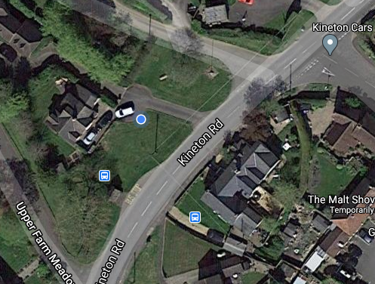

1. There are to be a minimum of 18 cuts of the areas covered by site plan Area G1.
2. The first cut being in late March, then fortnightly, with the final cut in early October, according to seasonal growth patterns. Cut short.
3. To include strimming around the flagpole, bus stop, telegraph pole and bench and other obstructions including wooden stakes, and the various edges of the site. The area adjacent to the wall of the School House should be cut upto approx 50cm of the wall.
4. The crocuses (in front of the bench), daffodils and other flowers should be left uncut until they are over.

Area G2 The Cemetery, Banbury Road
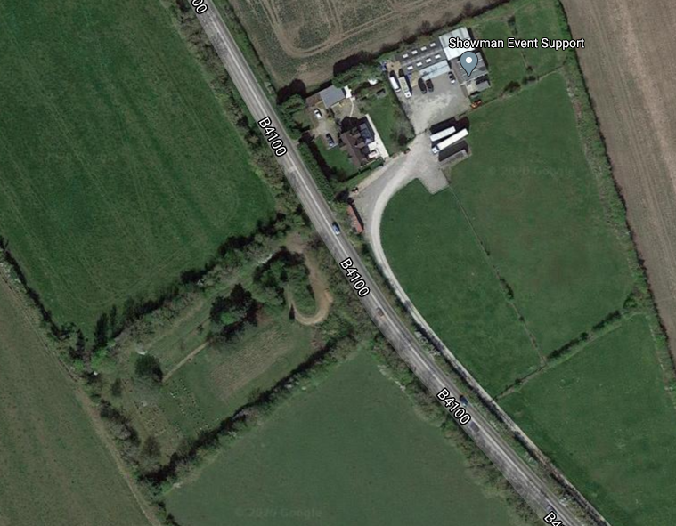

Located just outside the village towards Banbury on the B4100, on the right hand side.

1. There are to be a minimum of 16 cuts of the area covered by site plan Area G2. The first cut being in late March then fortnightly thereafter, with the final cut in early October, according to seasonal growth patterns.
3. To include strimming around gravestones, signs and other obstructions including trees and the various edges of the sites. This should be completed periodically as required.
3. There is a ‘wild area’ to the left of the path which is to be left and strimmed/cut once per annum in July/August. The grass/cuttings will need collecting and composting (available on site).
4. All footpaths, seating areas, entrances etc. to be cleaned off by sweeping or blowing after each cut/strim.
5. Any flowers should be avoided when cutting.

Area G3 Orchard, Play Area, Meadow, Church Lane CV35 0EY

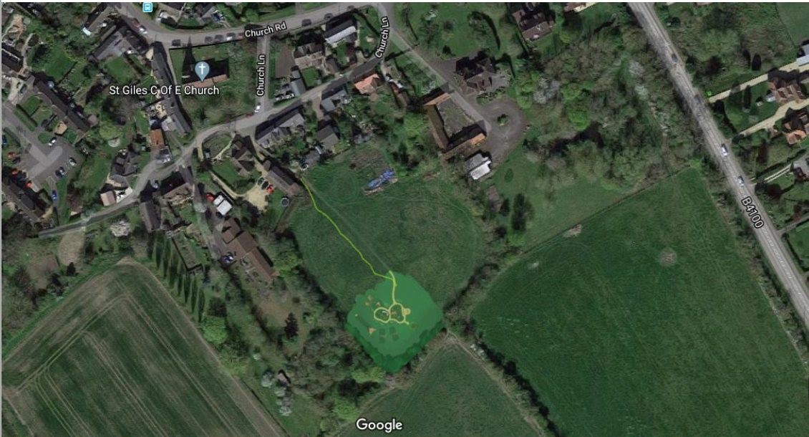Main path: continue path to the kissing gate with a mown pathway, cut short.
Orchard will have a mown grass path leading off from main path to bench and nature trail. Exact route of mown path to be decided with contractor, cut short.
Annually, a complete cut of the area will be required to encourage the wildflowers (in July/August time). Cut short and remove all grass clippings.
Central area left for flexible use – events, sports, picnics etc. Cut annually as above and grass collected. Then cut as and when required for events - as directed by the Clerk.
Play area, to be cut in the summer months, once a fortnight (to be reviewed) from late April to October. Strimming around equipment periodically in spring/summer. Any cowslips or wildflowers to be mown around. Annual complete cut as per other meadow areas with grass collected.

Area G4 Small green by the phone box/library, Church Road

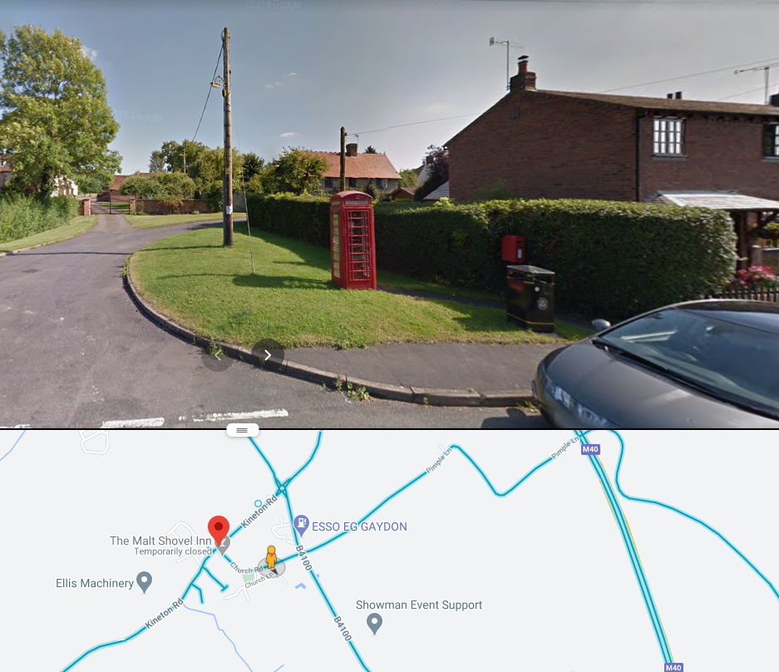
1. There are to be a minimum of 14 cuts of the areas covered by site plan Area G4.
2. The first cut being in late March then fortnightly thereafter, with the final cut in early October, according to seasonal growth patterns. Cut short.
3. To include periodic strimming around the phonebox, signs, bin, including telegraph pole and the various edges of the sites.
4. Leave the area where the crocus bulbs bloom until they are over.

F. TENDER FORM – To be submitted to the Council
Please complete and sign the Tender Form and Declaration & Company Details Form to the Gaydon Parish Council offices by February 24th, 2021 at the latest.

PRICES QUOTED ARE TO BE EXCLUSIVE OF VAT
Contracted Area for 2021/2022 | Number of Cuts  (Frequency) 2 wkly  Minimum | QUOTED PRICE PER CUT | TOTAL PRICE for  2021 Based on  Minimum Cuts
Area G1 – Village Green (Cut & Collect) & strim | 15
Area G2 – Cemetery | 16
Area G3 –  Orchard MOWN PATHWAYS:  Play area: | 16  10
Area G4 – Phone Box/Forge | 14
TOTAL GRASS CUTTING CONTRACT PRICE FOR 2020/21 (assuming no additional cuts and excluding VAT) £
Please complete if you have not been previously used by Gaydon Parish Council in the performance of a similar contract then please provide details of 2 references who can be contacted to provide support for your application:
Referee 1 |  | Referee 2
Name |  | Name
Position |  | Position
Company Name |  | Company Name
Contact Number |  | Contact Number
Contact Email |  | Contact Email
Annual Contract Value |  | Annual Contract Value

G. DECLARATION & COMPANY DETAILS FORM – To be submitted to the Council
Please complete and sign the Tender Form and Declaration & Company Details Form to the Gaydon Parish Council offices by X at the latest.
I/We agree to complete the work in accordance with the Invitation to Tender, Standard Contract Terms, Specification of Works, Schedule of Works and location plans.
I/We understand that Gaydon Parish Council is not bound to accept the lowest or any Tender or part thereof and that the Council will not be responsible for any expense incurred in preparing this Tender.
I/We certify that the amount of the Tender has not been calculated by agreement or arrangement with any other person, firm or company and that the amount of the Tender has not been communicated to any person and will not be communicated to any person until after the closing date for the submission of Tenders.

Company or Business Name: ................................................................................................................
Business correspondence address .......................................................................................................
Postcode: .............................

VAT Reg No. (if applicable) .........................................................
Contacts: Landline : ..............................................
Mobile : ..............................................
Email : ..............................................

By signing and submitting this tender form you agree that you fully understand the commitments and requirements contained therein and, if successful are willing to be bound to the contract as expressed therein.

Signed: ...........................................Print Name: ............................................ Position:
Dated: .............................................

H. EVALUATION
Bids will be evaluated in accordance with the Gaydon Parish Council’s Financial Regulations using the following criteria and weighting:
Criteria | Possible Score
Price (The full and final cost over the full term of the contract. To consider affordability and the commercial stability of a reasonable return for the supplier). | 50 out of 100
Quality (The supplier’s ability to perform the contract to the highest standards.  Evidence of the supplier’s relevant knowledge and experience. Feedback received from References). | 25 out of 100
Compliance (The supplier’s compliance with all Health & Safety and employment laws and regulations). | 25 out of 100

