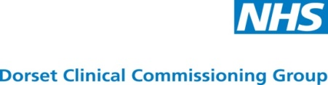
Integrated Urgent Care Access, Advice, Assessment and Treatment Service
Expressions of Interest for Market Engagement Event

NHS Dorset Clinical Commissioning Group (CCG) wish to engage with prospective providers who are interested in working with the CCG to design the future service model and discuss potential provider structures for an Integrated Urgent Care Access and Advice Service.
The market engagement meeting will take place on Thursday 28 September 2017 in the Main Hall at the Dorford Centre, Bridport Road, Dorchester, Dorset. DT1 1RR. Refreshments will be available from 8.45 – 9.15am. This will be followed by a presentation and discussion. Individual allocated time slots OF 20 minutes will begin at 11.20 am.
If you are interested in attending this meeting or are unable to attend but would like information sent to you please express your interest by completing and returning this form to bisprocurement@dorsetccg.nhs.uk no later than 12.00 midday on 21 September 2017. Attendance at the Market Engagement Meeting will be limited to two individuals from each representative organisation. Please provide name and role of attendees.
Contact name:
Organisation name:
Organisation address
Contact number:
Contact email address
Attendee 1:
Name and position
Attendee 2:
Name and position

I can /cannot attend the Market Engagement Meeting on 28 September 2017
*delete as appropriate

Please indicate your preferred time slot to meet with the commissioners by marking the relevant slot with an X in the below the time. We will try to give you the timeslot you wish for, however they will be given on a first come first serve basis.
TIME SLOT | PREFERRED TIME
11.20 – 11.40am
11.45 – 12.05am
LUNCH WILL BE PROVIDED
1.00 – 1.20am
1.25 – 1.45am
1.50 – 2.10am
2.15 – 2.35am
2.40 – 3.00am
3.05 – 3.25am
3.30 – 3.50am

