**Call-Off Schedule 4 (Call Off Tender)**

**Section 1: Evaluation of the GLD Employer Brand Requirements**

| **Required Services**  **Please provide a submission outlining how you will provide the services required (as stipulated in the specification Section 1: GLD Employer Brand).**  Maximum Word Count: 750 words. Page limit on attachments: 10 pages. | **Additional proposals for delivering the services including full details of any alternative methods will be considered alongside your original proposal:**  **Include the details below in your submission and any additional information you consider to be relevant, however *standard marketing material will not be considered*.**   * 1. how you are going to manage the services to be supplied, including details of the person(s) who will liaise with the Client’s Contract Manager for the purpose of reviewing the performance of the Contract   2. details of the experience and qualifications of the other key personnel to be involved in delivering the required services   3. the experience and expertise that makes you best placed to deliver this commission and explain how this will be applied to enable the successful delivery of the outputs detailed in the requirements. Include your approach to show how you will use recruitment market insights to shape the EVP and Marketing Plans and how you will identify the approach to delivery across regions, audience groups and all marketing channels. Please provide up to two case studies which best demonstrate how you have set up and delivered EVPs and Marketing Plans to support the delivery of challenging recruitment schemes including your approach to lessons learned and continuous improvement. At least one of the case studies should include the approach you used to develop a social media strategy, including how you identified social media trends   4. your experience of providing expert advice in this area   5. detail how you will deliver this in an Implementation & Delivery Plan, ensuring that the Plan is detailed with all timelines and milestones for mobilisation and ongoing management of the requirements. As a minimum your Plan should include a list of tasks/actions with start and finish dates and a responsible person for both the mobilisation and ongoing management phases |
| --- | --- |

**Response:**

REDACTED TEXT under FOIA Section 43 Commercial Interests

**Section 2: Evaluation of the Recruitment Market Insights**

| **Please provide a submission outlining how you will provide the services required (as stipulated in the specification Section 2.01: Develop recruitment market insights).**  Maximum Word Count: 500 words. Page limit on attachments: 3 pages. | 1. **Include the details below in your submission and any additional information you consider to be relevant, however *standard marketing material will not be considered*.  Additional proposals for delivering the services including full details of any alternative methods will be considered alongside your original proposal:**     1. how you are going to manage the services to be supplied, including details of the person(s) who will liaise with the Client’s Contract Manager for the purpose of reviewing the performance of the Contract    2. details of the experience and qualifications of the other key personnel to be involved in delivering the required    3. the experience and expertise that makes you best placed to deliver this commission and explain how this will be applied to enable the successful delivery of the outputs detailed in the requirements    4. your experience of providing expert advice in this area. Please provide up to two case studies which best demonstrate how you have set up and delivered a market insights function to support the delivery of challenging recruitment schemes including your approach to lessons learned and continuous improvement    5. detail how you will deliver this in an Implementation & Delivery Plan, ensuring that the Plan is detailed with all timelines and milestones for mobilisation and ongoing management of the requirements. |
| --- | --- |

**Response:**

REDACTED TEXT under FOIA Section 43 Commercial Interests

**Section 3: Design and Delivery of the Recruitment Schemes**

REDACTED TEXT under FOIA Section 43 Commercial Interests

**TMP QUALITY ACCREDITATIONS**

REDACTED TEXT under FOIA Section 43 Commercial Interests

**ACCOUNT MANAGEMENT**

REDACTED TEXT under FOIA Section 43 Commercial Interests

**APPLYING OUR EXPERIENCE & EXPERTISE IN PERMANENT LEGAL RECRUITMENT**

REDACTED TEXT under FOIA Section 43 Commercial Interests

**ENGAGING THE LEGAL RECRUITMENT MARKET**

REDACTED TEXT under FOIA Section 43 Commercial Interests

**PEAK DEMANDS**

REDACTED TEXT under FOIA Section 43 Commercial Interests

**CASE STUDIES**

REDACTED TEXT under FOIA Section 43 Commercial Interests

**DIGITAL MANAGEMENT SYSTEM**

REDACTED TEXT under FOIA Section 43 Commercial Interests

**APPLICATION & SELECTION PROCESS**

REDACTED TEXT under FOIA Section 43 Commercial Interests

**EXPRESSIONS OF INTEREST LIST**

REDACTED TEXT under FOIA Section 43 Commercial Interests

**ONLINE TESTS**

REDACTED TEXT under FOIA Section 43 Commercial Interests

**EXPERT ADVICE IN DELIVERING RECRUITMENT SCHEMES**

REDACTED TEXT under FOIA Section 43 Commercial Interests

**IMPLEMENTATION**

REDACTED TEXT under FOIA Section 43 Commercial Interests

| **Please provide details of your proposed systems and procedures for managing candidates through the recruitment process, including:**  Maximum Word Count: 750 words. Page limit on attachments: 3 pages. | 1. how you will ensure that all staff and associates dealing directly with candidates and the Client have a full understanding of the graduate and qualified recruitment processes 2. how you will ensure that Disability Confident and ‘a great place for veterans’ scheme candidates, and candidates requiring reasonable adjustments at the sift and/or interview stage, are identified and managed appropriately 3. how you will provide support for candidates experiencing difficulties completing the online application process or online tests e.g. due to technical, accessibility or disability issues 4. your knowledge and experience in the area of undertaking minimum eligibility and pre-employment checks e.g. ensuring that applicants meet the Civil Service nationality requirements 5. how you will provide access to the online tests currently used, and access to alternative online tests and tools |
| --- | --- |

**Response:**

REDACTED TEXT under FOIA Section 43 Commercial Interests

**UNDERSTANDING THE GRADUATE AND QUALIFIED RECRUITMENT PROCESSES**

REDACTED TEXT under FOIA Section 43 Commercial Interests

**ENSURING A FAIR AND INCLUSIVE SIFT AND INTERVIEW STAGE**

REDACTED TEXT under FOIA Section 43 Commercial Interests

**SUPPORTING CANDIDATES’ COMPLETE ONLINE APPLICATION PROCESS AND ONLINE TESTS**

REDACTED TEXT under FOIA Section 43 Commercial Interests

**EXPERIENCE IN MINIMUM ELIGIBILITY AND PRE-EMPLOYMENT CHECKS**

REDACTED TEXT under FOIA Section 43 Commercial Interests

**PROVIDING CANDIDATES ACCESS TO ONLINE TESTS**

REDACTED TEXT under FOIA Section 43 Commercial Interests

| **Please include details of your** **expertise and experience in the assessment field, particularly in relation to:**  Maximum Word Count: 500 words. Page limit on attachments: 3 pages. | 1. Graduate lawyer permanent recruitment 2. Qualified lawyer permanent recruitment 3. assessing the potential of applicants in their various fields (understanding that we will be recruiting graduates from a pool of applicants who may have no legal experience/legal qualifications at the point of applying) 4. advising on equality issues in the context of recruitment and selection processes 5. advising on the suitability/compatibility of tests, exercises, and tools 6. conducting pilot testing, predictive validity exercises etc., where for example, new tests, tools and exercises are being considered 7. running assessment centres 8. delivering similar recruitment services to other public or private sector organisations 9. experience in handling FOI, Subject Access Requests, and DPA requests in line with legislative requirements |
| --- | --- |

**Response:**

**EXPERIENCE DELIVERING ASSESSMENTS FOR PERMANENT GRADUATES AND QUALIFIED LAWYERS**

REDACTED TEXT under FOIA Section 43 Commercial Interests

**ASSESSING APPLICANTS**

REDACTED TEXT under FOIA Section 43 Commercial Interests

**INCREASING WORKFORCE EQUALITY**

REDACTED TEXT under FOIA Section 43 Commercial Interests

**ADVISING ON THE COMPATIBILITY OF TESTS, EXERCISES, AND TOOLS**

REDACTED TEXT under FOIA Section 43 Commercial Interests

**CONDUCTING PILOT TESTING**

REDACTED TEXT under FOIA Section 43 Commercial Interests

**HANDLING FOI, SUBJECT ACCESS REQUESTS, AND DPA REQUESTS**

REDACTED TEXT under FOIA Section 43 Commercial Interests

| **Please provide details of your proposed systems and procedures for managing candidates through the interview and assessment processes, including:**  Maximum Word Count: 750 words. Page limit on attachments: 3 pages. | 1. your proposed systems and processes for providing the required interview and assessment services 2. supplying a diverse pool of suitably trained independent professional assessors 3. booking in candidates and assessors (independent and Client) 4. providing suitable accommodation and details of the contingency arrangements that should be in place in the event of: (This is not an exhaustive list and is open to interpretation) - train strikes/travel disruptions - loss of electricity - unavailability of assessment venue - evacuation of candidates during assessments - loss of scheduled assessors 5. managing candidates who will require reasonable adjustments, and your experience of providing a range of reasonable adjustments 6. ensuring that interviews focus on the criteria specified and that there is consistency in the assessments being made 7. producing candidate feedback reports (examples of the type of feedback reports produced for other Clients to be included) 8. technological advances that you are aware of that might offer possible alternative options for delivering the services required; and how you will ensure that the Client is kept informed of developments and advancements in recruitment and assessment practices and related technology 9. proposed systems and processes for the provision of statistical and management information relating to all stages of the recruitment process (examples of reports to be included) |
| --- | --- |

**Response:**

**SYSTEMS AND PROCESSES FOR INTERVIEW AND ASSESSMENT SERVICES**

REDACTED TEXT under FOIA Section 43 Commercial Interests

**SUPPLYING A DIVERSE POOL OF SUITABLY TRAINED ASSESSORS**

REDACTED TEXT under FOIA Section 43 Commercial Interests

**BOOKING ASSESSMENTS**

REDACTED TEXT under FOIA Section 43 Commercial Interests

**PHYSICAL AC**

REDACTED TEXT under FOIA Section 43 Commercial Interests

**REASONABLE ADJUSTMENTS**

REDACTED TEXT under FOIA Section 43 Commercial Interests

**ENSURING A CONSISTENT AND FOCUSED INTERVIEW ON THE CRITERIA SPECIFIED**

REDACTED TEXT under FOIA Section 43 Commercial Interests

**CANDIDATE FEEDBACK REPORTS**

REDACTED TEXT under FOIA Section 43 Commercial Interests

.

**TECHNOLOGICAL ADVANCES RECOMMENDATIONS FOR GLD**

REDACTED TEXT under FOIA Section 43 Commercial Interests

**MANAGEMENT INFORMATION (MI)**

See supporting attachment for MI information.

| **Please detail your professional view on the Graduate and Qualified lawyer recruitment and selection processes. Can you suggest alternative tests, tools, exercises or processes that you feel may have the potential to be more effective in terms of helping to identify, in a more cost-effective, robust, fair and non-discriminatory way the best candidates for the role, at both the sifting and assessment stages?**  Maximum Word Count: 500 words. Page limit on attachments: 0 pages. | Please include in your answer the relative advantages and disadvantages of all options and compare them with the current processes and tests provided in the Data Room - 01-Data Room Index v0-3 AA_v0.1 030822 |
| --- | --- |

**Response:**

**Reviewing the end-to-end assessment process**

REDACTED TEXT under FOIA Section 43 Commercial Interests

**Increasing Diversity & Inclusion (D&I)**

REDACTED TEXT under FOIA Section 43 Commercial Interests

**Trainee Recruitment**

REDACTED TEXT under FOIA Section 43 Commercial Interests

**Redesigning Interviews**

REDACTED TEXT under FOIA Section 43 Commercial Interests

**Candidate drop-in sessions**

REDACTED TEXT under FOIA Section 43 Commercial Interests

**Interview Question Bank**

REDACTED TEXT under FOIA Section 43 Commercial Interests

**2.2 Social Value Section**

**Fighting Climate Change:**

**Effective stewardship of the environment**

Maximum Word Count: 500 words -

Detail how, through the delivery of the contract, you plan to create and run effective guidance for effective stewardship of the environment through the delivery of the services.

**Response:**

REDACTED TEXT under FOIA Section 43 Commercial Interests

**CREATING A WORKFORCE THAT SUPPORTS OUR ENVIRONMENTAL POLICY**

REDACTED TEXT under FOIA Section 43 Commercial Interests

**Equal opportunity**

**Tackle workforce inequality**

Maximum Word Count: 500 words -

Detail how, through the delivery of the contract, you plan to increase overall diversity and inclusion within in the contracted workforce

**Response:**

REDACTED TEXT under FOIA Section 43 Commercial Interests

**Wellbeing**

**Improve Community Cohesion**

Maximum Word Count: 500 words –

Detail how, for the contracted workforce, awareness for both mental and physical wellbeing will be continuously raised

**Response:**

REDACTED TEXT under FOIA Section 43 Commercial Interests

**TMP WELLBEING**

REDACTED TEXT under FOIA Section 43 Commercial Interests

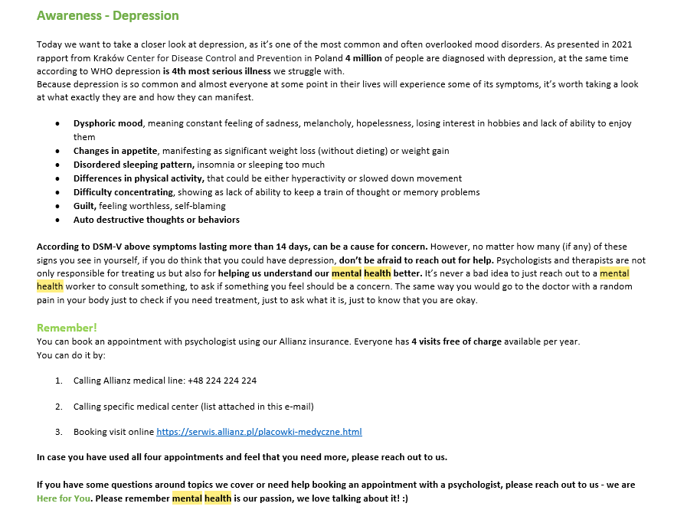



**OUR COMMITMENT TO GLD**

REDACTED TEXT under FOIA Section 43 Commercial Interests

**COVID-19 Recovery**

**Help local communities to manage and recover from the impact of COVID-19**

Maximum Word Count: 500 words –

Detail how, through the delivery of the contract, you will provide work or volunteering opportunities for those that have been affected by COVID-19.

**Response:**

REDACTED TEXT under FOIA Section 43 Commercial Interests