Hounslow integrated consultant led community pulmonary rehabilitation, home oxygen assessment and specialist nurse support service

Memorandum of Information

TRANSFORMING HEALTHCARE IN NORTH WEST LONDON

People living and working in North West London want a healthcare system that supports them to understand their health and wellbeing, provides high quality personalised care at a time and in a place convenient to them, and for this care to be coordinated and simple to understand. We know our system faces challenges in meeting these needs: our population is ageing; people are living longer with more conditions; care is fragmented; we have workforce shortages; there aren’t enough services based in the community.

The NHS Five Year Forward View (October 2014) emphasises the need to break down barriers in how care is provided; with far more care delivered locally, supported by specialist centres for more complex needs. The provision of a more integrated respiratory care in the community is a step towards meeting this objective of care closer to patients and primary care and will have significant benefits; providing a more convenient service to patients and helping to relieve the pressure on secondary care services, focusing the most complex respiratory diagnostics and treatments in secondary care.

For many years, the NHS has been increasing its focus on improving the provision, access and quality of care provided outside of an acute hospital setting. NHS England Guidance (2013) highlights that in order to meet the needs of our population, it is not possible to maintain the current duplication and fragmentation of care which drains resources and does not offer consistently high quality and cost effective care. The guidance states that; ‘without transformational change in how services are delivered, a high quality, yet free at the point of use health service will not be available to future generations.’

The NHS Five Year Forward View (October 2014) emphasises the need to break down barriers in how care is provided; with far more care delivered locally, supported by specialist centres for more complex needs.

The provision of a more integrated respiratory service in the community is a step towards meeting this objective of care closer to patients and primary care and will have significant benefits; providing a more convenient service to patients and helping to relieve the pressure on secondary care services, focusing the most complex respiratory diagnostics and treatments in secondary care.

Respiratory diseases are a major cause of morbidity and mortality and place significant demand on NHS resources. Chronic Obstructive Pulmonary Disease (COPD) accounts for a substantial number of deaths in Great Britain: it has consistently given rise to between 25,000 and 30,000 deaths each year over the last 25 years with 15% of those admitted to hospital dying within 3 months of admission, 25% dying within 12 months and 50% dying within 2 years. The number of people suffering from the disease at any given time (prevalence) is difficult to estimate because of different definitions of the disease and under-diagnosis. One recent estimate suggested that there are currently 900,000 diagnosed cases in England and Wales and that, allowing for under-diagnosis, the true prevalence could be 2.8 million.

In England, COPD is the second most common cause of emergency admissions and one of the most costly inpatient conditions to be treated. It is estimated that the direct cost of providing care in the NHS for people with COPD is almost £500 million a year, more than half of which relates to hospital care. The estimated annual cost of treating people with mild COPD is £149 and £1,307 for a person with severe COPD. COPD is a term used to describe a progressive and irreversible decline in lung function which results in reduced airflow in the lungs.

The national aspiration is to reduce the number of people with COPD dying prematurely. It requires proactive care and management at all stages of the disease, with a particular focus on disadvantaged groups and areas with high prevalence. The aim is to improve respiratory health and wellbeing of all communities and to minimise inequalities between communities.

The 2011 Outcomes Strategy for COPD and Asthma recommends a proactive approach to prevention, early identification, diagnosis and intervention. Integration is required across the NHS, Public Health and Social Care services to achieve the goal of a positive, enabling, experience of care and support right through to the end of life.

LOCAL STRATEGIC PRIORITIES

The commissioning of a Hounslow Integrated Consultant Led Community Pulmonary Rehabilitation, Home Oxygen Assessment and Specialist Nurse Support Service will support Delivery Area 2 (DA2) of the North West London Sustainability and Transformation Plan (STP).

As well as cross-over into other areas of deliverables within DA2 of the STP, the Hounslow respiratory service will by 2022 be aimed at supporting the achievement of Part C deliverables, these have been stated with the STP as:

Local Context
      - Chronic obstructive pulmonary disease (COPD) prevalence: Hounslow CCG has a registered prevalence rate of 1.04% (3,225 patients) which is 0.1% lower than the overall London prevalence rates.
- Based on Public Health Outcome Framework (PHOF), in 2011 the estimated prevalence of COPD in Hounslow was 2.72%, which means there are at least 4,900 more patients in Hounslow who have not been diagnosed or are not registered with a GP yet
- Non – elective admission for COPD: 451 ( 2015/2016) and 456 (2016/17)
- Readmission rate for COPD : Number of COPD patients who have more than two admissions in one year is 78 resulting in total of 259 admissions (2016/17)
- Rightcare also identifies non- elective admission spent for COPD patients is an area for improvement for Hounslow CCG, when benchmarked with other 10 similar CCGs
- Hounslow Pulmonary Rehabilitation (PR), Home Oxygen Assessment and Community-based respiratory nursing services (HO) were initially contracted in September 2012 for patients with Chronic Obstructive Pulmonary Disease (COPD) MRC 3 – 5.
- The contract with the incumbent provider, having been extended to its full lawful term, expires on the 31st March 2018.
- The recommendation is to include the current services (Pulmonary Rehabilitation, Home Oxygen Assessment and Community-based respiratory nursing services) with some additions and changes, including increased investment in case management and service integration.
- The total current contract value is £1,820,000 over 5 years with an average of £363,000 per year.
HOUNSLOW DEMOGRAPHIC INFORMATION

Hounslow CCG is a membership organisation, made up of all 49 GP practices serving a registered patient population of 305,000 people in Hounslow. We manage an annual budget of £345 million, across an area diverse in terms of wealth, deprivation and health. Hounslow GPs are making decisions about local health services using their local knowledge to shape services and target resources where the need is greatest. They use their experience and knowledge to influence and shape the decisions the CCG makes.

Locations across the borough of Hounslow GP surgeries can be found on the map below:
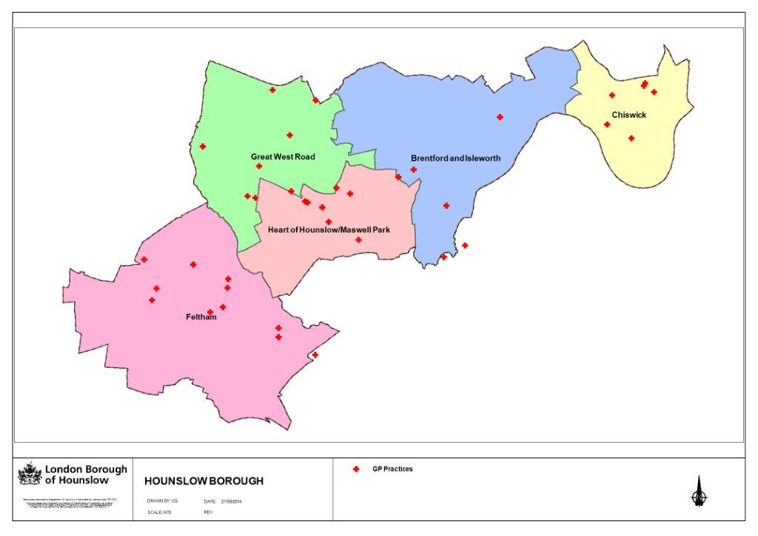
OVERVIEW OF THE SERVICE

Aim of the service

The overall aim of the Hounslow integrated consultant led community pulmonary rehabilitation, home oxygen assessment and specialist nurse support service is to provide all eligible patients with a service that meets their needs and achieves the outcomes.

Please put the aim of the service in from the service specification

The following service provisions for patients with chronic respiratory conditions are covered in the service specification:

- Pulmonary Rehabilitation Service
- Home Oxygen Assessment Service
- Community-based specialist Nursing and consultant Service
- Chest Rehabilitation

The locally defined outcomes of this service will include:

- Reduction in the number of A&E attendances and Non-Elective admission (NEL) for patients with chronic respiratory conditions e.g. COPD
- Improved health outcomes for patients with chronic respiratory conditions e.g. COPD i.e. fewer exacerbation, less absence through illness and less hospitalisation
- Improved patient awareness and self-management of their own chronic respiratory conditions e.g. COPD condition, i.e. more independent management of their own condition.
- Improved patient satisfaction of the integrated consultant led community Pulmonary rehabilitation, home oxygen assessment and specialist nurse support service
- Improved GP awareness of chronic respiratory conditions, diagnosis and treatment
- Integration with other services i.e. hospitals, social services, voluntary sector, health and social care, other community services and mental health services.

For further and more detailed information, please see the draft service specification.

COMMERCIAL INFORMATION

The Contract to be offered to the successful Bidder at the end of this Procurement will be for a duration of three years, which is intended to run from 1st April 2018 until 31st March 2021 with the possibility of one extension of up to two years, subject to any restrictions placed nationally by NHS England or the Department of Health.

As advertised, the anticipated, maximum total contract value (is £1,820,000 over 5 years)

Indicative activity baselines
 |  |  |  |  | Optional Extension | Optional Extension
 | Year 1 | Year 2 | Year 3 | Total 3 Years | Year 1 | Year 2
 | 2018-19 | 2019-20 | 2020-21 |  | 2021-22 | 2022-23
Pulmonary Rehabilitation | 453 | 607 | 626 | 1,686 | 638 | 638
Home oxygen assessment | 280 | 280 | 280 | 840 | 280 | 280

