 | 

Annex A
Technical Questionnaire
Substance Misuse Recovery Programme in Wales

Contents
1. Introduction 3
2. Scoring Methodology 5
3. Mandatory Declarations 1
4. Technical Criteria Questions 3
TC001 – Delivery Model 4
TC002 – Workforce 5
TC003 – Service Delivery 6
TC-004 – Service Continuity 8
TC-005 – Implementation 9

Introduction

  - This document allows us to assess your quality of delivery for Substance Misuse Recovery Programme.
  - The document is split into 2 sections;
    - Mandatory Declarations
      - Please populate the checkbox table selecting ‘Yes/No’ from the drop down in the end column, and entering any additional information in the bottom row;
      - If you state "No", you must provide an explanation, detailing which areas of the specification you cannot comply with, and how you propose to mitigate these failings to ensure there will be no gaps in service delivery. The Authority shall assess the mitigation provided and may, at its discretion, request additional information in relation to the submission where this requirement has not been substantially met and;
      - reserves the right to disqualify the Provider from the Call-Off Competition, in accordance with 1.2.1.2.
    - Technical Criteria
      - Please provide a written response in the section marked ‘Response’ on each table
  - Bidders should complete all sections within this document if they wish to bid for Substance Misuse Recovery Programme.
  - The Methodology given within table 1 below will be used for the evaluation of the quality criteria unless otherwise specified within the response requirement.
  - Bidders should fully explain their answers and provide evidence backed up with examples to the question specifics. Bidders should aim to give the evaluator confidence that they can deliver the proposed service with features and benefits to MoJ. Unsubstantiated claims will not be given higher marks. Under no circumstances include any marketing information, materials and/or handbooks within your bid unless specifically requested to do so within the Limitation boxes.
  - Bidders should always provide their best possible proposal and answers for each individual question.
  - The Bidders Responses to each of the Award Criteria questions will be scored and weighted as shown in each individual question. These scores will determine the most economically advantageous Tender.
  - A statement that a particular requirement will be met is not in itself sufficient. Such Responses, or Responses that are ambiguous, may be taken as failing to meet the Requirement. Detailed information regarding how, when and to what extent a Requirement can be met must be provided where appropriate. Furthermore, if any requirement or part of a requirement cannot be met, this must be stated explicitly along with the reason why.
  - Bidders should be mindful that each criteria question may be evaluated in isolation. Where a bidder has already provided information that addresses a specific requirement in another question, this information should be re-stated, not simply referenced. Please note that any Response simply making reference to handbooks, marketing material or accreditations and not describing how this will be applied to the Requirement will not be accepted.
  - Please provide Responses clearly and concisely in a question answer format.
  - Word Count – All word counts stated for each specific question must be adhered to, if a response exceeds the relevant side limit, or the Authority determines a Supplier has included additional text as including but not limited to those identified in para 1.8, the additional text will not be considered by the Authority and will not be taken into account for the purposes of evaluation or moderation.
  - The technical evaluation will be split into a Mandatory Declaration checklist, and five (5) Technical Criteria sections which have been weighted accordingly;
  - The Weightings of these sections will total 100% the weighting of each question is detailed below in the relevant section of the criteria, the response to each question will be evaluated and scored based on either;

      - a pass/fail basis

      - a weighted score with a minimum quality threshold; or

      - a weighted score without a minimum quality threshold;

      - an overall Technical threshold of 60% will also apply

  - If a Bid does not achieve an overall Technical Score of 60%, the Authority reserves the right to exclude that Bidder from the Call-Off Competition.
  - The Questions listed below will be evaluated against the criteria and scoring matrix detailed.

Scoring Methodology
  - The methodology given in the table below will be used for the evaluation of the award criteria unless otherwise specified within the Response requirement.

QUALITY THRESHOLD SCORE (%) | ASSESSMENT | INTERPRETATION
100 | Exceptional | The Supplier's response:  (a) meets all of the minimum stated criteria in an exceptional manner with a robust proposal that provides full confidence of an overall extremely effective solution, including the relevant ability, understanding, expertise, skills and/or resources  OR  (b) meets all of the minimum stated criteria in an acceptable manner with a proposal that provides full confidence effective solution, including the relevant ability, understanding, expertise, skills and/or resources, AND provides evidence of factor(s) that will add exceptional value beyond what is described in the criteria.
86.6 | Very Good | The Supplier's response:  (a) meets all of the minimum stated criteria in a very good manner with a robust proposal that provides full confidence of an overall very effective solution, including the relevant ability, understanding, expertise, skills and/or resources  OR  (b) meets all of the minimum stated criteria in an acceptable manner with a proposal that provides full confidence effective solution, including the relevant ability, understanding, expertise, skills and/or resources, AND provides evidence of factor(s) that will add significant value beyond what is described in the criteria.
73.3 | Good | The Supplier's response:  (a) meets all of the minimum stated criteria in a good manner with a robust proposal that provides full confidence of an overall effective solution, including the relevant ability, understanding, expertise, skills and/or resources  OR  (b) meets all of the minimum stated criteria in an acceptable manner with a proposal that provides full confidence effective solution, including the relevant ability, understanding, expertise, skills and/or resources, AND provides evidence of factor(s) that will add some value beyond what is described in the criteria.
60 | Acceptable |  | The Supplier's response:  meets all of the minimum stated criteria in an acceptable manner with a proposal that provides full confidence in an acceptable solution, including the relevant ability, understanding, expertise, skills and/or resources. There may be minor concerns which are easily resolvable and in any event which do not have a material impact on the overall acceptability of the proposal.
40 | Minor Reservations |  | The Supplier's response:  does not fully meet one or more of the minimum stated criteria in an acceptable manner and/or meets the minimum stated criteria in an acceptable manner but does not provide full confidence in an acceptable solution, including the relevant ability, understanding, expertise, skills and/or resources causing some minor reservations in one or more areas which may be resolvable but, if not, may have a material impact on the overall acceptability of the proposal.
20 | Major Reservations |  | The Supplier's response:  does not fully meet one or more of the minimum stated criteria in an acceptable manner and/or meets the minimum stated criteria in an acceptable manner but does not provide full confidence in an acceptable solution, including the relevant ability, understanding, expertise, skills and/or resources, causing one or more major reservations in one or more areas are unlikely to be resolvable but and may have a material impact on the overall acceptability of the proposal.
0 | Unacceptable |  | The Supplier's response:  does not meet one or more of the minimum stated criteria in an acceptable manner and/or contains insufficient information to provide full confidence in an acceptable solution, including the relevant ability, understanding, expertise, skills and/or resources, causing major reservations in one or more areas that are not resolvable and will have an impact on the overall acceptability of the proposal.

Mandatory Declarations
MD-001 | Question Area |  | Requirement – Select Yes/No
MD-001 | Service Description | 1 | Please can you confirm you have reviewed ‘Schedule 2.1 – Services Description’ and confirm that you understand and can deliver on the requirements and outcomes therein? |  | Yes
MD-001 | Digital & Technology and Information Assurance | 2 | Please can you confirm you have reviewed, understood and will be compliant with Schedule 2.3 (Standards) and Schedule and 2.4 (Information Security and Assurance) of the Framework Agreement? |  | Yes
MD-001 | Digital & Technology and Information Assurance | 3 | Please can you confirm your Users of the Customer Approved Systems will be operating from a device and infrastructure compliant with the Authority information security requirements as detailed in schedule 2.3 and 2.4 of the framework agreement and using a modern Internet browser (as detailed at www.gov.uk/help/browsers) |  | Yes
MD-001 | Digital & Technology and Information Assurance | 4 | Please can you confirm your organisation will be compliant with the requirements of Security Level 1 (SL1) as set out in Schedule 2.4 prior to Call-off Commencement Date? (note; this includes accreditation to Cyber Essentials Basic). |  | Yes
MD-001 | Digital & Technology and Information Assurance | 5 | If the Authority, at its sole discretion, determines additional Information Assurance is required of the Provider of this contract at any stage during the contract term, please can you confirm your organisation will be able to comply with SL2?  Please can you also confirm your organisation will upgrade to Cyber Essentials Plus, and comply with Service Level(s) SL/3/4 of Schedule 2.4. If the Authority, at its sole discretion, determines additional Information Assurance is required of the Provider of this contract at any stage during the contract term  Please note; Dependent on the aggregate number of data across all contracts currently being delivered by the Supplier, accreditation to Cyber Essentials Plus (or equivalent, in line with schedule 2.4) may also be required. See the Framework Agreement Schedule 2.3 Standards and Schedule 2.4 Information Security and Assurance for more information. It shall be the responsibility of the Supplier to monitor and self-declare this. |  | Yes
MD-001 | Digital & Technology and Information Assurance | 6 | Please can you confirm your organisation will submit to the Authority for approval an Information Security Management Plan for the Service being delivered within one month of award of Call-off Effective Date. |  | Yes
MD-001 | Workforce | 7 | Please confirm compliance with regards to vetting requirements within PI 2014/03 |  | Yes
MD-001 | Workforce | 8 | Please confirm compliance with regards to vetting requirements within PI 2014/23 |  | Yes
MD-001 | Workforce | 9 | Please confirm compliance with regards to vetting requirements within PI 2014/60 |  | Yes
MD-001 | Workforce | 10 | Please confirm that you have appropriate processes in place to effectively carry out a relevant transfer under TUPE, including accuracy and timeliness of payroll and pension payments with no disruption to transferring staff, and replication of contractual terms as necessary. Please note that all Providers must respond to this question in line with the documentation provided in this Tender process, and that no other consideration(s) should be taken into account. |  | Yes
MD-001 | Workforce | 11 | Please confirm that you will appropriately engage and communicate the outcome and implications of this competition with your employees, and where relevant, Trade Unions and/or transferring staff. |  | Yes
MD-001 | Workforce | 12 | Please confirm that you will have sufficient staff in place to deliver the services from service commencement? |  | Yes
MD-001 | Workforce | 13 | Please confirm that all staff will be adequately trained and experienced to deliver the service by the service commencement date? |  | Yes
MD-001 | Pensions | 14 | Please can you confirm that you have reviewed ‘Schedule 9.1B’ and confirm that you understand and will comply with TUPE and associated statutory protection requirements therein? Please note that all Providers must respond to this question in line with the documentation provided in this Tender process, and that no other consideration(s) should be taken into account. |  | Yes
MD-001 | Estates | 15 | Please confirm your compliance that services will be delivered in a way that supports environmental sustainability, in accordance with Schedule 2.3 of the Framework Agreement? |  | Yes
MD-001 | Estates | 16 | The Provider shall have a duty of care to provide a facility that meets basic H&S standards and is accessible to People on Probation and Provider Personnel with protected characteristics (in the main, physical impairments) and takes into account the specific needs of users of the service in question. Please can you confirm that you will comply with this requirement? |  | Yes
MD-001 | Estates | 17 | Please can you confirm that your estates solution will deliver an appropriate number of suitably geographically dispersed sites that reflect the needs of the service? |  | Yes
MD-001 |  | 18 | Please can you confirm your organisation will be compliant with the Legal and Regulatory Requirements as outlined in Appendix 1 – Supplier Own Site Suitability Review? |  | Yes
MD-001 |  | 19 | Please can you confirm your organisation will be compliant with the Best Practice Requirements as outlined in Appendix 1 – Supplier Own Site Suitability Review? (where this isn't possible please confirm you will comply with the below question to pass this mandatory question). |  | Yes
MD-001 |  | 20 | Where you can not comply with the above question, please confirm you agree that adequate consideration has been applied and where necessary, mitigations are in place or are in development, and will be agreed by the Authority? |  | Choose an item.
MD-001 | Social Value | 21 | Please provide a statement below to describe how your organisation will or does support health and wellbeing, including physical and mental health, in the workforce.  Your response to this question should be a maximum of 500 words and IS FOR INFORMATION ONLY and shall not be scored in the evaluation  [enter response to 22 here - 500 words max]  Forward will provide person-centred mental and physical health and wellbeing (H&W) support to the workforce and service users (SU), working collaboratively with prison and community stakeholders. H&W is a fundamental element of our substance misuse programme’s design and delivery, with facilitator and participant guides and structures to support all those working and participating within a therapeutic community.  - SUPPORTING THE WORKFORCE  Forward employees feel supported with regards to wellbeing. In Forward’s 2021-22 staff satisfaction survey 76% (n=390) responded ‘strongly agree/agree’ under the wellbeing theme ‘If I was experiencing poor mental health I would feel confident to raise it with someone at work’. We recognise that our employees deal with physically and emotionally challenging tasks and are exposed to secondary trauma whilst supporting people at their most vulnerable.  Employees can access Forward’s comprehensive benefits package, which promotes wellbeing:  - Free annual Headspace app subscription  - Simply Health cashplan, including Employee Assistance Programme with welfare and legal support line; gym discounts; alternative therapies e.g. acupuncture  - External therapy allowance  - Cycle to work loan scheme  - Continued Professional Development opportunities including training by Forward’s Therapeutic Quality team: expansion of skills promotes personal growth and wellbeing  - Two additional wellbeing days per year  Other H&W and resilience-building support and initiatives will include:  - Individual and group supervision  - Reflective practice sessions and sessions following traumatic incidents  - Access to webinars – e.g. ‘switching off’ delivered externally by Act and Solve Coaching  - Encouragement/support to participate in organisational fundraising/challenge events  - National/international campaigns promotion, e.g. World Mental Health Day, staff provided with links to videos on mindfulness  Success of H&W initiatives will be monitored through:  - Monthly H&W dashboards logged on our HR system Cascade, detailing referrals for counselling (anonymised), Occupational Health, sickness absence including reason, long- and short-term sickness trends.  - Annual staff survey  - SUPPORTING SERVICE USERS  Programme content is underpinned by H&W support for SUs to aid their recovery:  - Timetabled check-ins  - Blend of guided workshops and self-guided in-cell workbooks/exercises including: coping skills (applicable during custody and on release/in recovery); managing negative emotions such as anxiety; strategies for insomnia; physical effects of addiction; mindfulness and grounding exercises  - Psychometric assessments PHQ9 and GAD-7 will monitor and measure symptoms of depression/anxiety (allowing tailored care-planning and support including referrals to other prison healthcare teams/support, e.g. HMP Berwyn mental health café) and provide outcome data to Commissioners  - Physical health needs identification, as part of the programme assessment process (referral routes/links with prison healthcare and Substance Misuse teams), leveraging Forward’s existing provision/relationships within HMP Swansea and Cardiff (embedded with health and resettlement strategic groups) and developing links at HMP Berwyn  - ADDED VALUE  All releases will have access to Forward Connect recovery community – currently supporting 1,600+ recovery programme ‘graduates’ through access to:  - Messaging app for 24/7 peer support preventing relapse  - Online self-help resources (e.g. mindfulness guides, inspirational videos)  - Online/face-to-face meetings, activities and reunions including special interest groups such LGBTQIA+  By end of Year 2 we will have created ‘Forward Connect Wales’/Cyswllt-cyd-Gymry with an estimated 100 members
MD-001 |  |  |  | Enter any additional comments here  N/A

Technical Criteria Questions

  - The tables below sets’ out the Award Criteria and weightings relating to the provision of the Substance Misuse Recovery Programme, please provide your responses to each requirement in the ‘Response’ box, and upload the completed document to ITT_6827 question 1.2.1 in the technical envelope on the Jaggaer esourcing portal.
  - In responding to the technical criteria questions, Bidders are required to provide detail on all the following areas (these are the Authority's "minimum requirements").
  - Bidders should have regard to the appropriate scoring Matrix and the Specification (Schedule 2.1 of the Draft Call-Off Contract) and the wider Draft Call-Off Contract Documentation where appropriate when responding to the question (and should note that since the requirements listed are expected to be covered as a minimum, it may be appropriate for Bidders to include additional information as part of the response to the question in order to achieve a higher score).

TC001 – Delivery Model
Weighting: | 30% | Quality Threshold: | N/A | Limitations
Question: Delivery Model |  |  |  | Up to 2000 words;  The response should be entered in this table in the cell below;  Additional diagrams and tables can be submitted to support your response, however any wording within these shall be included in the overall word count.  Line spacing 1.5  Arial font size 11
The Authority requires the Bidder to understand the requirements of and comply with the entirety of 'Schedule 2.1 – Services Description’ throughout the duration of Call-Off delivery period.
- Please detail your service delivery model and outline how it will meet the aims and objectives of the service specification.
- Describe how your service will facilitate, develop and maintain strong partnerships with a range of agencies to provide a holistic approach to substance misuse, this should include regular liaison with the Person (s) in Prison Offender Manager or Probation Practitioner.
- Detail how you would support the person (s) to transition from your service in custody into a community based programme including any links or partners who will support you with this.

Response
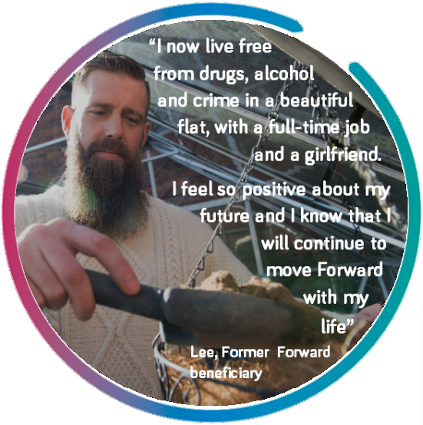
In 1991, Forward (formerly Rehabilitation for Addicted Prisoners Trust, RAPt) was the first organisation ever to deliver an intensive abstinence-based drug recovery programme in a UK prison, funded by Welsh actor in recovery Sir Anthony Hopkins. Over 30 years later, we are proud to be the largest and most experienced provider of abstinence-based recovery models in custodial settings. We deliver evidence-based programmes in 25 prisons helping thousands of people to achieve sobriety, desistance and transformational change - people like Lee pictured opposite. We bring this unparalleled experience and expertise to inform the design and delivery of the recovery programme for prisons in Wales, Y Bont.
Y Bont is based on Forward’s The Bridge, the only prison-based programme currently accredited by the Correctional Services Advice & Accreditation Panel (CSAAP) for men with a medium to high risk of reoffending and a history of substance dependence. It is designed to:
- Build motivation for change and hope
- Develop self-efficacy and build resilience
- Build group cohesion and a sense of community
- Introduce 12-step recovery and complete a detailed review of steps one and two
- Support participants to engage with Narcotics Anonymous (NA) and Alcoholics Anonymous (AA) and other support within prison and upon release

- SERVICE DELIVERY MODEL

At each prison Y Bont will be delivered by a Recovery Practitioner (RP) and a Trainee (with lived experience), each covering 37 hours of service delivery per week, offering four twelve-week cycles per annum including:
- Structured group sessions (3 days a week)
- Speaker sessions delivered by a member of a Twelve Step fellowship
- NA/AA Meetings to support affiliation/sponsorship
- One-to-one sessions (weekly) to work on personalised action plans
- Mid and post programme review sessions reviewing progress/providing feedback (post-programme reviews will identify ongoing support needs with participants assertively linked to NA/AA; Probation Practitioners (PPs) will be invited to attend)
- Through-the gate planning/support to sustain long-term recovery

All programmes materials/delivery will be available in Welsh.

Overview of Y Bont content (3 hours per session) and aims
Week | Group Session | Aims
1 | Intake and orientation | Introduce programme/expectation, Motivational Interviewing (MI) and Cycle of Change
2 | Welcome group | Increase self-efficacy and decrease anxiety
2 | Motivational Enhancement 1 | Discuss the positives/negatives of substance use/offending.
2 | Motivational Enhancement 2: | Increase motivation/commitment to change, self-efficacy and Self-will.
2 | Seeking Safety | Explore safety as a priority in recovery and safer coping skills.
3 | Introduction to 12-step | Introduce concepts of disease model, addictive personality and ego deflation.
3 | Understanding addiction | Explore the basic neuroscience of addiction - pleasure/reward pathways
3 | Insomnia | Explore insomnia and coping strategies.
3 | Live and Let Live | Introduce 12 Step slogan ‘Live and Let Live’.
3 | Group Support | Build peer relationships enabling participants to discuss their journeys/receive encouragement/advice.
4 | Step One | Explain concept powerlessness and its relevance to recovery.
4 | Asking for help | Exploring ways to ask for help, identifying obstacles.
4 | Step One | Understand relationship between unmanageability and addiction.
5 | Just for today | Introducing NA/AA conceptualisation of a daily decision.
5 | Taking back your power | Understand impact of trauma, exploring strengths that have arisen from adversity.
5 | Taking back your power | Introduce powerlessness and the Serenity Prayer.
5 | Coping with triggers | Explore triggers in recovery and the need to cope with these.
5 | Living Clean | Introduce the NA slogan “First Things First”
5 | Group Support
6 | Step Two | Explain Step Two and concepts of ‘insanity’ and ‘Higher Power’.
6 | Creating Meaning | Identify meanings associated with trauma and substance dependence, which could harm/promote recovery.
6 | Mental Health | Increase awareness of links between mental wellbeing and substance use.
6 | Emotional Sobriety. | Reflecting on the link between drug/alcohol use and emotions.
6 | Healing from anger | Explore problems with anger / how anger can impact recovery.
7 | Family and Addiction | Explore effects of addiction on the family.
7 | Honesty | Explore honesty and accept its consequences.
7 | Healthy Relationships | Identify and challenge beliefs about relationships.
7 | Managing anger | Explore triggers to anger.
7 | Group Support
8 | Step Three | Explore step three.
8 | Commitment | Explore experiences with commitment and strategies for keeping commitments.
8 | Impulsivity & decision making | Introduce impulsivity and how it impacts decision making.
8 | Self-care and self-esteem | Introduce self-care and self-soothing / learn skills to improve their self-esteem.
9 | Introduction to Steps 4-7 | Overview
9 | ‘Going to any lengths’ | Strategies for replacing destructive patterns.
9 | Grounding & Mindfulness | Grounding/mindfulness techniques.
9 | Introduction to Steps 8-12 | Overview
9 | Group Support
10 | Red & Green Flags | Introduce relapse prevention training.
10 | Recovery Thinking | Introduce re-thinking tools.
10 | Getting others to support your recovery | Identify forms of support.
11 | Respecting your time | Reflect on priorities in recovery.
11 | Sponsorship in NA/AA | Explain sponsorship and promote benefits.
11 | Getting Active in AA/NA | Identify obstacles to ongoing NA/AA affiliation.
11 | Relapse Prevention Planning | Formulate recovery plans.
12 | Programme review | Review progress and aftercare plans.

Each week concludes with a speaker meeting to provide inspiration/hope, demonstrating recovery is possible and promoting benefits of NA/AA.

Communications with the authority:
- A yearly delivery plan will be provided to the authority.
- The Team Leader will develop a Directory of Services (DoS) shared with the authority prior to call-off commencement and reviewed quarterly with notification of any changes within 5 days, to include:
- Delivery method of service activities
- Advise the court/PPs of activities/interventions available including time/location.
- Provide relevant information to inform referrals.
- If a participant transfers out of contract area prior to completion RPs will facilitate a final session. An end of service report including advice on appropriate next steps will be completed and shared with the PP in Customer Approved System within 5 days.

- PARTNERSHIPS TO PROVIDE HOLISTIC SUPPORT

Forward understand that people need holistic support addressing multiple needs in order to achieve and sustain recovery. We also understand the importance of developing and maintaining effective relationships with prison staff and agencies to develop a shared understanding of substance misuse and the possibility of recovery.

Our existing delivery of community rehabilitation services for accommodation (commissioned by HMPPS Wales) in HMPs Swansea and Cardiff will enable us to leverage existing relationships to establish links with Governors/Directors and Resettlement Managers/Offender Management Unit teams. We will develop similar relationships in HMP Berwyn, identifying key governors/officers e.g. Drug strategy custodial manager. We will build relationships with prison colleagues and promote the benefits of our programme to ensure its success.

We will broker relationships with support agencies in healthcare – (Betsi Cadwaladr University Health Board (Berwyn), Cardiff and Vale University Health Board (Cardiff), Swansea Bay Health Board (Swansea)) and education/employment (Maximus, ITEC).

We will leverage our national mutual aid links and foster relationships with local NA/AA groups to increase access, noting a current waiting list at Swansea. At Berwyn we will work with the chaplaincy, who currently oversea mutual aid and facilitate access to community religious groups.

We will work collaboratively with mental health providers e.g. Prison In-Reach Team (Swansea), Betsi Cadwaladr University Health Board (Berwyn) Cardiff and Vale University Health Board (Cardiff). We will also link into the Mental Health Café at Berwyn, the wellbeing centre and counselling service at Swansea, and in Cardiff the arts and music classes (provided by Education to reduce anxiety), and the Tools for Change Programme (wellbeing and motivation).

To support family ties, which can help sustain recovery, we will refer participants to PACT, and in Cardiff to the Family Matters courses (delivered by Education supporting budgeting, parenting, etc.).

We will link participants into peer mentors for additional support e.g. Health Champions, Mental Health and Substance Misuse Peers at Berwyn, Shannon Trust (literacy support) at Cardiff. Other holistic support links include: Gypsy, Roma, Traveller Channel (Berwyn); Voices From Care Cymru for care leavers (Berwyn); The Sycamore Tree victim programme (Swansea); Veterans support group (Cardiff); and Vision of Hope for people who have suffered abuse and addiction (Cardiff).

We will build and maintain relationships by ensuring we communicate effectively, share information (where appropriate), establish referral pathways and promote our service at prison meetings e.g. drug strategy meetings.

Our practitioners will build effective working relationships with prison offender manager/probation practitioners ensuring regular communication. When rescheduling any elements of the programme, we will inform participants and PPs within 2hrs. We will keep a database recording attendance and for each session facilitators will write a short report on each participant commenting on engagement. Any concerns, including any safeguarding concerns disclosed, will be reported same day to PPs or if not available their line manager. The prison safeguarding procedures will be followed. PPs will receive a mid and post programme report and will be invited to take part in reviews.

- TRANSITION FROM PRISON TO COMMUNITY

Forward brings best practice experience of supporting transition from prison to community – our continuity of care performance in East Kent for prison leavers is an Office for Health Improvement and Disparities exemplar project.

For Y Bont, RPs will co-produce a release plan with each participant, working in partnership with the prison substance misuse providers Dyfodol (Swansea, Cardiff), Betsi Cadwaladr University Health Board (Berwyn), to ensure that release planning is coordinated and not duplicated. The release plan will be shared with the PP, including all referrals and appointments. In Cardiff, we will input into a shared database of community support, building on existing relationships. RPs will attend the multi-agency release meeting at Berwyn and participate in release boards at Cardiff. We will build relationships and referral pathways into the prison resettlement hubs/units at Berwyn and Cardiff where people in prison (PiP) have access to different agencies that provide release support, inviting these agencies into our programme sessions to encourage engagement – e.g. PACT futures and CRC (Cardiff) offer through-the-gate support for substance misuse prison releases.

To assertively support engagement with mutual aid, we will invite NA/AA/CA members into our programme, facilitating sponsorship and providing contact numbers of fellowship members who can meet people in the community and accompany them to meetings. Participants nearing release will also be provided with fellowship details in their local area.

Upon release, the participant’s allocated worker will provide telephone/digital support to the participant for a period of three weeks post release, motivating them to engage in community support services e.g. mutual aid, recovery support services. They will check in with the participant at least twice a week and remind them of any community appointments to support attendance.

For community-based programmes, we have agreed a referral pathway with Cyfle Cymru who will deliver information sessions for PiP engaging on our programme. They provide peer mentoring support on release and tailored support including training, activities and volunteering. Additionally, our RPs/Trainees will establish links and referral pathways with community recovery providers:

Release Prison | Support offered
Berwyn – releases to North West England and North Wales | - Liverpool Forward delivers SHARP (abstinence-based day programme):  - Facilitators will provide taster session prior to release  - Those engaging can access through-the-gate support Forward’s central recovery support team  - Manchester CGL: recovery groups, SMART Recovery, Peer mentoring  - Cheshire West WDP: peer support  - Cheshire East CGL: mutual aid, counselling  - Lancashire Red Rose Recovery: lived experience-led activities, training, peer-led connect group  - The Wells: lived experience-led therapy, peer mentoring, Employment Training and Education, social activities  - North Wales recovery community (Penrhyn House): fellowships, SMART Recovery, Bangor Recovery project, 5-a-side football
Swansea | - Barod: SMART Recovery  - WCADA: 12-step recovery programme primary and aftercare phases
Cardiff | - Living Room Cardiff: peer mentoring, recovery support  - Recovery Cymru: peer-led recovery community in Cardiff/Vale of Glamorgan

Finally, adding value and innovation, all programme graduates will benefit from support in the community from our centrally funded Recovery Support team, including one to one support from a Peer Mentor and membership of our Forward Connect recovery community – currently supporting 1,600+ individuals with:
“In Forward Connect I feel like I have found my tribe, and it has completely changed my whole life” Forward Connect Member

- Messaging app for 24/7 peer support
- Online self-help resources
- Online/face-to-face meetings, activities and reunions
- Benefits such as free tattoo removal

By end of Year 2 we will create a Wales branch of Forward Connect, Cyswllt-cyd-Gymry, with an estimated 100 members.

Total Word Count – (Providers to self-populate) |  |  |  | 1,956 (text) + 44 (diagram) = 2,000

TC002 – Workforce
Weighting: | 25% | Quality Threshold: | N/A | Limitations
Question: |  |  |  | Up to 2000 words;  The response should be entered in this table in the cell below;  Additional diagrams and tables can be submitted to support your response, however any wording within these shall be included in the overall word count.  Line spacing 1.5  Arial font size 11
- Detail your knowledge and experience of working with individuals with substance misuse needs, and how this knowledge and experience informs your Service Delivery Model.
- Please describe how you will strive to utilise personnel with lived experience to deliver services, and detail what training will be made available to ensure consistent service delivery.
- Detail how you will ensure all Supplier Personnel are competently trained, for the duration of the Contract Term, with the appropriate skills and knowledge required to deliver the Services. Include how Supplier Personnel training is up to date in response to any changes to legislation or policy or changes in best practice.

Response
- KNOWLEDGE AND EXPERIENCE
Forward specialise in working with individuals with both experience of the criminal justice system and substance misuse needs. Since pioneering Twelve Step programmes in prisons 30 years ago, we have continued to build our knowledge and experience, working with people across prison, probation and community services.

Our current substance misuse delivery includes:
- Services at 25 UK prisons, supporting over 6,000 men with substance misuse and mental health needs;
- Community services in 9 towns and cities across England supporting nearly 4,000 people;

We are also an established provider of community rehabilitation services for people on probation and alongside personal wellbeing and accommodation contracts currently deliver:
- Dependency and Recovery – supporting people in prison and on probation to access community-based substance misuse support, reaching 7,000 men in London and 1,000 in Hull.

Our diverse understanding of individuals with substance misuse needs underpins our delivery models and how we train and look after our personnel.

Our extensive experience directly informs our proposed recovery programme for Wales, Y Bont, which is based on Forward Trust’s The Bridge. Rooted in the Twelve Step model, The Bridge programme was adapted from our 16-21 week Substance Dependence Treatment Programme (SDTP) to provide a shorter intervention, acting as a pathway to longer term treatment and support upon release, making it ideally suited as a foundation for Y Bont.

Since 2010, the Bridge has been delivered to over 1,800 people in prison (PiP) with continuous adaptations by our specialist Research and Service Improvement Team (RSI) over the years in response to evaluations and service user feedback. For example:
- After analysis showing younger participants were less likely to complete the Bridge than those aged 30+, more interactive and visual materials were designed to encourage engagement from younger service users who respond better to these types of resources.
- After participant feedback highlighted that resources could be improved, additional in-cell packs were created giving participants the option to explore topics they felt particularly relevant.

How our knowledge and experience informs our delivery model

We have identified various dynamic risk factors which we will address both directly through the programme material and through the practice of our personnel in one to one sessions:

Risk Factor | Issue Identified | Y Bont Response / Adaptation
Trauma | - Association between substance misuse/experiences of trauma, which can be worsened and added to by an individual’s substance use and criminal lifestyle  - Symptoms of trauma can interfere with effective treatment engagement, both directly and by undermining participant motivation | - Integrate trauma and addiction treatment with Seeking Safety skills sessions designed to address substance use and trauma symptoms concurrently  - Forward staff are trained to take a trauma-informed approach:  - Realising the widespread impact of trauma  - Recognising the signs/symptoms in clients/personnel  - Responding by integrating knowledge into policies/practice  - Seeking to actively resist re-traumatisation
Impulsivity | - Implicated in development/maintenance of substance use disorders  - Dynamic risk factor for relapse | - Impulsivity addressed across Y Bont content (cravings, triggers, mindfulness)  - Modules on problem solving and decision making designed to counter impulsivity
Deficient Social Support Networks | - Social support and positive social networks hugely beneficial for continued abstinence, largely due to their positive impact on an individual’s self-efficacy for recovery | - Introduction of 12 Step thinking and assertive links into local fellowship groups  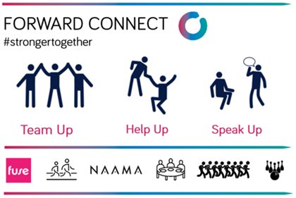  - Membership of our Forward Connect peer support community (currently supporting over 1,600 individuals), connecting participants with a local and national recovery community on release that provides peer support, positive role modelling and resources
Emotion Management | - Negative emotions (such as anger, shame and anxiety) are recognised as triggers for relapse in early recovery | - Modules targeted at improving participants’ emotion regulation skills (e.g. Living Clean: Hungry, Angry, Lonely, Tired)
Motivation | - Low motivation is a key risk factor for relapse and reoffending  - Key to moving through Forward’s theory of change (aligned to Prochaska/Di Clemente Trans theoretical Model of Change, 1982) 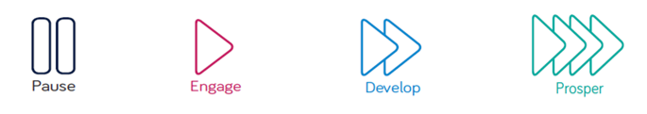 | - Capitalise on opportunity presented by ISFL wings to harness motivation  - Motivational Enhancement Therapy sessions  - Motivational Interviewing in one to one sessions  - Commitment to Twelve Step motivational strategies
Continuity of Care | - Risk of relapse and overdose on release | - Share our expert experience with Welsh prison and substance misuse providers (our Community Service Development Manager recently delivered an Office for Health Improvement and Disparities webinar on ‘Exemplary Continuity of Care Practices’)  - Dedicated and centrally funded Recovery Support Team who support prisoners on release, with Peer Mentoring, wellness programmes, and the Forward Connect recovery community

The RSI will ensure that Y Bont content is enhanced, improved and added to incrementally, responding to diverse local need, via data evaluation, post-programme surveys, and through feedback from the Therapeutic Quality and Training Team (TQT) who audit performance and quality.

- LIVED EXPERIENCE PERSONNEL

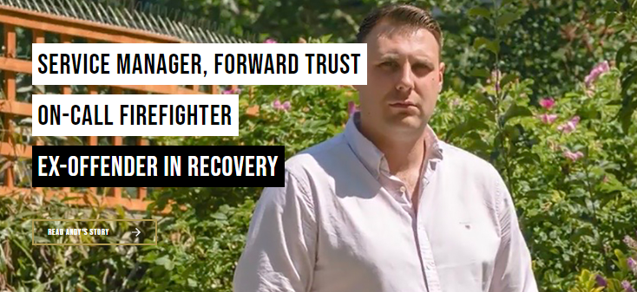
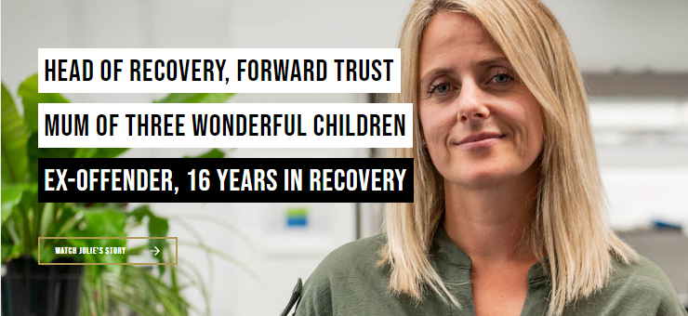
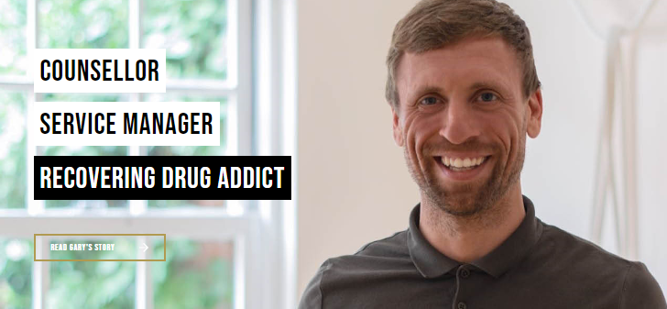
People with lived experience are at the heart of everything we do at Forward. 30% of our 700+ workforce have lived experience, from Recovery Workers up to Trustees and Senior Management (Julie Muir, Executive Director for Recovery pictured below alongside other Forward staff in recovery as featured in our More Than My Past campaign). We understand that whilst professionals provide expert advice, lived experience personnel (LEPs) have unique experiences that afford a distinctive understanding of client needs, bringing real insight and first-hand knowledge. Our extensive experience shows that with effective training and support, a combination of professionals and LEPs delivers the most effective treatment and recovery outcomes.

Specific benefits that LEPs will bring to Y Bont include enhancements to:
- Engagement: a distinctive understanding of participants’ experiences will help LEPs to identify and plan mitigation strategies for participants real or perceived barriers to treatment engagement;
- Motivation: individuals with lived experience can share the benefits of sustained abstinence; such role modelling will provide participants with tangible evidence that people can break the cycle of offending and addiction, thus enhancing self-efficacy;
- Through care: bridging links into local fellowship organisations, whilst observing and maintaining professional boundaries.

Job opportunities for Y Bont will invite applicants with lived experience (specifying a minimum of two years away from prison / in abstinence-based recovery) and be promoted via: local lived experience organisations (such as Adferiad, Cyfle Cymru, Chain Breakers, Recovery Cymru, GIG Cymru); the community substance misuse services (CAIS, The Wallich, Kaleidoscope, WCADA, PACT Futures); and through our links into local fellowships. Forward have a good track record in recruiting and retaining such personnel: in our substance misuse services the percentage of staff with lived experience is often higher than a third (e.g. 40% in our East Kent community service).

Lived Experience Training

Built into our staff model for Y Bont is a Trainee Recovery Worker for each of HMPs Cardiff, Swansea and Berwyn. Forward’s traineeship scheme has operated successfully for over 10 years and is a 12-month salaried placement for people with lived experience, offering experience, training and qualifications to prepare individuals for a full-time salaried position. Trainees are given study-leave (worked around, so as not to impact, programme delivery) to undertake a nationally recognised qualification such as:
“I wanted to become a trainee with Forward Trust to have the opportunity to show others that there is a way out from addiction - to be that living proof for them. I wanted to help those, who helped me, to help others. The traineeship gave me the chance to do this!”

- Level 3 Counselling, Counselling and Psychotherapy Central Awarding Body (CPCAB)
- Recovery Coaching Professional Designation, International Association of Professional Recovery Coaches (IAPRC)
- Apprentice-standard training (e.g. NVQ Health & Social Care)

LEPs receive the same line management and supervision as full-time employees, delivered by an experienced member of service staff. Additionally for LEPs, line managers are trained to cover specific concerns in supervision including:
- Consideration of how the prison environment might be more connected to personal experience
- Open conversation around risk or safety concerns
- Detailed exploration of boundaries and self-disclosure

LEPs are invited to join the Forward Connect peer support network, connecting them with other LEPs in the organisation and providing online resources and support. LEPs are also eligible to use the therapy allowance available to all of Forward’s front line staff to access external supervision from a British Association of Counselling and Psychotherapy (BACP) registered counsellor.

Alongside gaining an external qualification, trainees receive the same training that Forward personnel receive from our HR and TQT teams, detailed below.

- PERSONNEL TRAINING
Forward are committed to professionally develop all personnel to fulfil their potential whilst delivering safe and effective services. We aim to attract, develop and retain the talent we have within the organisation by maximising job satisfaction and increasing the quality of interventions that service users receive by:
- Helping to discover opportunities that challenge, inspire and motivate personnel to grow;
- Enabling personnel to learn in different ways such as online, face to face, via formal qualifications and non-accredited learning;
- Leaders and Managers support personnel to complete training identified by ‘buying in’ to the learning process and ensuring that ‘on the job experience’ allows personnel to apply learning.

Responsibility for personnel training at Forward lies with our dedicated HR Department (with experience in delivering HMPPS training specifications from our other Community Rehabilitation Service contracts) who work with the Charity Learning Consortium (CLC) to produce our mandatory e-learning modules.
Bringing considerable added value to the service in Wales is Forward’s TQT who will provide specialist training in 12-step programme delivery to ensure best practice. The TQT is headed up by Gary Stickings Dip Hyp, Adv Dip. CP Msc, who brings 28yrs of therapeutic practice and experience of managing prison programmes. Gary and his team visit our programme teams every quarter to deliver training as well as audit quality and identify improvements. The TQT have recently worked to enhance all their core training with Dr Tim Leighton PhD, who has been in the addictions field since 1985 as a counsellor, psychotherapist, researcher, teacher and charity executive and whose PhD thesis was on Mechanisms of Change in Drug and Alcohol Treatment Programmes.
All personnel working on Y Bont will undertake the following training:
Training Module | Delivery | Timescale | Frequency
- Data Protection/GDPR  - Mental Capacity Act  - Health & Safety  - Prevent Programme  - Safeguarding (L2)  - Extremism  - Organised Crime  - Risk Awareness  - Dealing with challenging behaviour | E-Learning | Within 5 days | Refreshed Annually
- Diversity, Inclusion & Cultural Competency (including Neurodiversity)  - Boundaries & Professional Practice  - Safeguarding Adults & Children  - Making use of supervision  - Trauma Informed Approach | HR, face to face / blended | Within 1-4 weeks | As required: identified through audit, live observation, or Quarterly Line Management (QLM)
- Drug and Alcohol Awareness  - Harm Reduction | E-learning | Within 1-4 weeks | Refreshed Annually
- 12-Step Awareness  - Relapse Prevention  - Risk Management, recovery planning & client notes  - Assessments  - Y Bont Programme Material  - Pre-Admissions and Motivational Enhancement Therapy (METs)  - Programme Assignments  - Group Therapy and co-facilitation  - Group Goals and Peer Evaluation  - End of Treatment Reports  - Team Process and Team Meetings | TQT, face to face | Within 3 months | As required: identified through audit, live observation, or QLM

Training completion will be recorded and tracked by the HR Business Partner for compliance (monthly reporting to Senior Management Team and Trustees), alerting Service Managers to personnel who need additional intervention, e.g. planning time-bound training sessions to assure 100% compliance. We will share HR training reports/content with the Authority pre-contract commencement, annually/on request thereafter.

Adding value and supporting retention, staff can access Forward’s Apprenticeship Pathway for career development (e.g. Level 3 Team Leader standard). In 2021/22, 1 in 5 Forward staff were enrolled in development opportunities.


Changes in legislation/policy/best practice
Supported by Forward’s RSI Team, the HR Team will monitor changes to legislation, policy or best practice by regularly reviewing and analysing Government (e.g. OHID) publications and briefings, NICE guidelines, research papers and sector briefings (e.g. Drink and Drug News), informing and developing training requirements. Examples include:
- Forward’s new training strategy includes Gambling Harm Awareness (following Commission on Crime and Problem Gambling (2021) recommendation to MoJ for practitioner training);
- When new legislation came into effect regarding Data Protection we worked with CLC to ensure we moved from Data Protection training to GDPR;
- We are currently working with CLC to develop Cyber Security training on the advice of our Data Protection Officer.

Total Word Count – (Providers to self-populate) |  |  |  | 1,983 (text) + 10 (diagram) = 1,993 (total)

TC003 – Service Delivery
Weighting: | 25% | Quality Threshold: | N/A | Limitations
Question: Service Delivery |  |  |  | Up to 2000 words;  The response should be entered in this table in the cell below;  Additional diagrams and tables can be submitted to support your response, however any wording within these shall be included in the overall word count.  Line spacing 1.5  Arial font size 11
- Describe your approach to creating an Individual Assessment and a personalised Action Plan for Person (s) in Prison and detail how you will deliver the interventions that meet the specific needs. The response should include how the service measures and evidences progress made by the Service Users during the intervention period.
- Please detail how your approach will account for Services Users with different learning styles, diverse needs and characteristics, including protected characteristics.
- Please detail how a Person(s) In Prison will follow the journey from the beginning to the end of the intervention, evidencing how you will achieve the outcomes to promote successful completions required for this service.
Response
Forward brings to HMPs Swansea, Cardiff and Berwyn over 30 years’ experience of supporting people in prison (PiP) to achieve lasting recovery. Our approach to assessment and action planning is informed by tools, resources and ways of working that have been tried and tested across the prisons estate, recognising that every recovery journey is unique and personal.

1(a). INDIVIDUALISED ASSESSMENT
We have designed our assessment to avoid duplication (e.g. information collected via Probation and Substance Misuse Service (SMS) providers) and to align with Probation Practitioners’ (PPs) ongoing action plan and outcomes.

Assessments will be carried out in person by Recovery Practitioners (RPs) trained in trauma-informed, compassionate and strength-based practices, with an emphasis on building rapport with PiP. Having gained informed consent, assessment starts with an introduction to the recovery programme, Y Bont, setting out its aims, timeline and expectations including the requirement for drug testing throughout the programme. PiP will have an opportunity to discuss any questions regarding content/materials.

At this key stage in assessing motivation and commitment we will use the Intermediate Outcomes Measurement Instrument (IOMI), co-developed by University of South Wales and commissioned by the National Offender Management Service (NOMS), to measure mediating factors known to contribute to recovery and desistance. Assessment captures a baseline score that will be reviewed through the PiP journey to evidence progress made. Mediators measured include:

- Motivation to change
- Hope
- Agency / self-efficacy
- Impulsivity / problem-solving
- Resilience
- Wellbeing
- Interpersonal trust

The assessment will also identify a range of needs, characteristics, risk factors and baseline measures using validated tools:

- Substance misuse (SM) history: substance type, using patterns, triggers;
- Mental Health (MH): Generalised Anxiety Disorder Assessment (GAD-7) and Patient Health Questionnaire (PHQ-9) to measure depression;
- Learning Style: Visual/Aural/Read-Write/Kinaesthetic (VARK) assessment;
- Protected Characteristics: including support needs;
- Risk: including mitigation plan.
The assessment will be recorded and shared with PPs.

1(b). MY BRIDGE TO RECOVERY/FY MHONT ADFERIAD: PERSONALISED ACTION PLAN (PAP)
Building on the assessment the PAP will be strengths-based and co-produced by RPs and PiP. Starting with how PiPs see themselves, their SM history and their ambitions for the future, PAPs will be individualised to address specific needs/goals and in response to the domains highlighted in IOMI measures.

A tried and tested menu of 9 topics will be used to inform the PAP and provide ‘bricks’ of recovery capital to ‘build the bridge’:
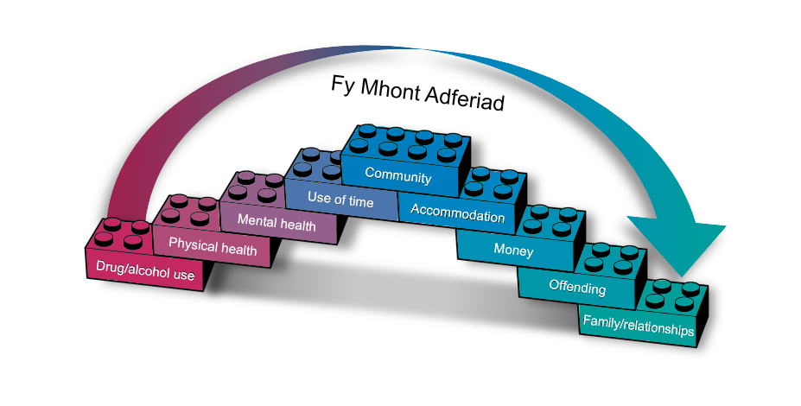
- Drug/alcohol use
- Physical health
- Mental health
- Meaningful use of time
- Community
- Accommodation
- Money
- Offending
- Family and relationships

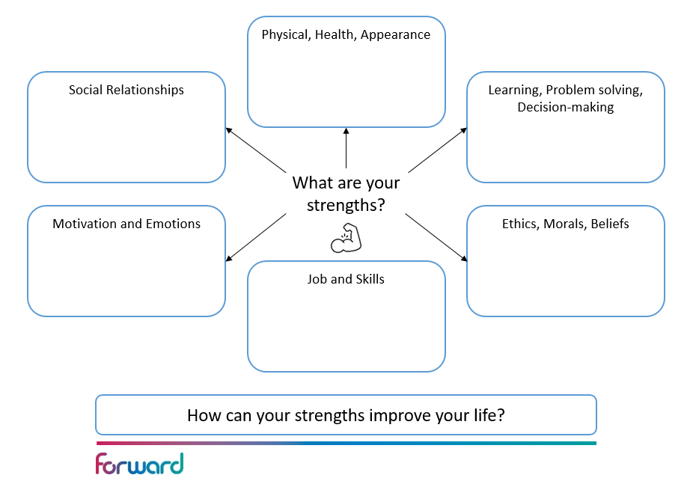
To facilitate engagement and maximise interaction, RPs will use International Treatment Effectiveness Project (ITEP) maps to explore each topic. As a person-centred intuitive resource, the maps are proven to have positive benefits for keyworking interactions (Public Health England, 2013) and are suitable for all complexity levels and neurodiversity. Each map (example opposite) creates a comprehensive picture of areas of strength and need to generate discussion, ideas and goals.

PAPs will thus identify goals for specific improvement: RP and PiP will determine the best activities/interventions to be completed in one-to-one sessions/in-cell, complimenting the content of Y Bont group sessions (e.g. impulsivity & decision making - using further ‘First Things First’ session resources, in-cell packs, further explanation).

Goal achievement will contribute to improved IOMI scores, building confidence and recovery capital for PiPs to achieve the ultimate outcome of lasting recovery and desistance in the community. From the start, aftercare planning will form part of each PAP including release plans, onward referrals, and assertive linkage to 12-step communities.

PAPs will be continuously revisited and reviewed during one-to-one sessions, co-curated between RPs and PiPs, recognising successes and tailoring goals to respond to new challenges or further build on strengths.

1(c). TRACKING PROGRESS
To evidence progress and aid motivation we will track:

- IOMI indicators, mapped at assessment, mid-point review and programme completion (e.g. improvements in scores on resilience)
- Mental health (GAD-7, PHQ-9)
- Reduction in risk level

We will also track:
- Negative drug testing
- Behavioural trends on wing
- Staff/PiP relationships
- Involvement of family (e.g. attending graduation day)
- Successful onward referrals post-release (e.g. housing, 12-step sponsorship)

2(a). DIFFERING LEARNING STYLES
Y Bont has been designed to be adaptable to PiP learning styles and neurodiversity, using a mixture of visual and written tools/tasks and 1:1 support to navigate programme materials. We will achieve a learning inclusive environment by:

- Training staff about differences in learning styles, e.g. visual, aural, reading/written, kinaesthetic
- Tailoring delivery environments/methods e.g.
- Consistent session structure, breaking materials into shorter sections, adjusting room layouts, using visual aids/drawings
- Offering more 1:1 provision where needed, employing a ‘time out’ function
- Providing written/visual materials PiPs can take with them to reinforce/remember learning

2(b). DIVERSE AND COMPLEX NEEDS
We will ensure that PiPs with diverse and complex needs are empowered to engage in Y Bont, considering cognitive, physical and experiential needs (e.g. poor mental and physical health, past trauma). Examples of actions include:

Co-occurring mental health needs
- Embed holistic health/wellbeing advice into interventions and PAPs, e.g. importance of exercise/healthy-eating
- Notify SMS providers and PPs of any suspected unmet need
- Link PiPs with MH peer champions
- Link PiPs into local community networks on release, e.g. social prescribing activities

Ex-service personnel
- Specialist staff training (delivered by the Armed Forces Network, Combat Stress) empowering RPs to identify veterans’ needs (e.g. poor MH, post-traumatic stress disorders)
- Link veterans with wraparound support, e.g. Welsh Veterans Partnership, CAIS All Wales Veterans' Health and Wellbeing Service
- Invite speakers from national and local veteran support agencies, e.g. SSAFA

Foreign national offenders
- Train RPs to explain services in plain language, using materials in appropriate languages and HMPPS-approved translation services
- Link with specialist agencies to overcome challenges such as lack of support network, difficulties accessing services (due to immigration status) on release, e.g. Home Office Immigration worker (HMP Cardiff), Welsh Refugee Council, Migrant Help
- Use trauma-informed approaches to address MH needs, e.g. isolation/separation from family

2(c). PROTECTED CHARACTERISTICS
In line with the Equality Act (2010), we will bring informed and accessible treatment with the following consideration of protected characteristics:

Characteristic | Programme adaptations and partnership working
Age | Young adults (YAs) (18-25): | Partnership working
Age | - Breaking down information into smaller instructions/tasks  - Considering lifestage and social pressures, adapting content to include experiences of YAs  - Training RPs in Adverse Childhood Experience (ACE_ trauma-informed practice | - Chain Breakers (HMP Berwyn) peer mentors to support learning  - Referring to education teams to address unmet educational needs where history of school exclusion/refusal  - PACT to involve YA’s family members  - Care Leavers Association for care leavers on release
Age | Older people (50+):
Age | Recognising higher incidence of memory-related conditions among older people:  - Materials PiPs can take with them to aid memory of session material/content  - Diaries and programme timetables | - Chain Breakers (HMP Berwyn) peer mentors to support learning  - Alzheimer's Society Cymru  - Adult Social Services on release
Gender reassignment/Identity  Sexual orientation | LGBTQIA+
Gender reassignment/Identity  Sexual orientation | - Deliver staff training on LGBTQIA+ inclusive language by Forward Trust Inclusion Lead  - Encourage engagement with post-release Forward Connect online LGBTQIA+ weekly meetings | - Transgender prisoner care boards to ensure sufficient support and safety measures  - Trans Aid Cymru mutual aid on release  - Supporting prison-wide Pride and LGBTQIA+ history events
Race & ethnicity | Black & minority ethnic (BAME) groups
Race & ethnicity | - Recognising mistrust of the Justice system and professionals/authorities among BAME groups  - RPs trained to explore the relationship between ethnicity and offending in terms of identity (e.g. masculinity, gang culture)  - Inviting Forward graduates from the BAME community to share their experience of offending and recovery | - Supporting national and international campaigns e.g. Black Lives Matter, Black History and Asian Heritage months  - BAME specialist MH service (BMHS) on release  - Cultural Diversity training
Race & ethnicity | Gypsy, Roma Travellers
Race & ethnicity | - RPs trained in common barriers, e.g. higher rates of long-term health/MH conditions, poor numeracy/literacy, lack of trust resulting from discrimination  Working with PiPs from GRT community to:  - Understand culture, traditions, barriers, e.g. respecting importance of privacy  - Introduce new GRT PiPs to their RP, explaining their role | - Literacy support (65% of GRT offenders have poor literacy skills compared to 14% of other offenders) via Shannon Trust, Novus Cambria  - Contributing GRT recovery testimonies to GRT TV channel at HMP Berwyn  - GRT support organisations on release, e.g. Gypsies Travellers Wales  - Linking with The Traveller Movement, for advice/guidance and integration with national campaigns, e.g. Stop Shaming
Religion/belief | Multi-faith inclusion
Religion/belief | Exercising an awareness of faith based practice:  - Allowing PiPs to leave sessions to observe prayer  - Adapting programme intensity/timings during religious holidays  - Exploring concept of a ‘higher power’ with PiPs ahead of and during the programme as a person-centred and not Christian conceptualisation of God | - Prison Chaplaincy to link PiPs to faith groups in the community
Disability | Physical impairment
Disability | - Using specialist equipment, e.g. hearing loops  - Accessible delivery space for PiPs with limited mobility | - Encouraging PiPs to disclose conditions to healthcare providers  - Recommending through-the-gate support, e.g. social services, Leonard Cheshire, Disability Wales  - Signposting to disabled accessible fellowship meetings
Disability | Learning difficulty/neurodivergence
Disability | - Specialist training on understanding needs, delivery techniques, ‘soft skills’ (listening, empathy, compassion)  - Additional appointment times for RPs to identify needs/check understanding; using multi-sensory approaches (pictures/storytelling/role-play); written/take-away materials to support with poor memory | - Referring to Mental Health, ADHD/ASD specialists, prison-based learning disability nurse  - Linking with specialist support on release e.g. MENCAP, Learning Disability Wales

3. THE JOURNEY
Our experience of programme delivery informs our approach to building and maintaining the motivation required for successful completions. We will ensure a systematic approach to engagement at each stage of the PiP’s journey, from building hope and belief through to connections for lasting recovery. Set out below are key inputs at each stage:
Promotion and Referral
- Visible programme schedule and expectations on ISFL wing, sharing of inspirational testimonies from previous programme cohorts to inspire motivation
- Meeting PiPs at point of referral to discuss the programme and their expectations

Assessment
- Motivational Interviewing, helping PiPs to take responsibility for themselves and encouraging self-efficacy
- Opportunity for PiPs to ask questions

Intake and orientation
- Overview of Forward’s theory of change (aligned to Prochaska/Di Clemente Trans theoretical Model of Change, 1982)
- Co-creating and agreeing a dis-engagement plan at programme outset, identifying risks areas for disengagement and strategies to overcome them (e.g. communication with RP, significant others)
- Introducing and making a commitment to 12-step motivational strategies

Programme (group and 1:1 sessions)
- Motivational Enhancement Therapy (METS), discussing positives/negatives of substance use/offending, focussing on self-efficacy and motivation
- Reflective ‘time out’ periods, where PiPs can take time out of a session to process any challenging feelings either with a peer or RP
- ‘Lay down’ periods (as opposed to removal from the programme) for those in breach of the group expectations. PiPs will complete programme content outside of the group setting and receive a support plan review with RP/Team Leader to re-enter the programme
- Inspirational lived experience speakers

Mid-point review
- Recognising and celebrating successes
- Additional strategies for PiPs struggling to progress toward their goals

Post-programme review
- Release planning, addressing fears of release and support in the community
- Reflection on progress (completion report provided to probation and SMS)
- Family involvement (e.g. attending graduation)

Aftercare
- 3 weeks post release support via telephone/video calls
- Assertive affiliation with fellowships/abstinent communities
- Referral to Forward Connect mutual-aid network
- Support PiPs to receive community support
- Post-programme support referrals for those remaining in custody (e.g. linking with NA/AA fellowships, resettlement hubs)

PiP’s progress will be evidenced by: routine psychometric measures (in weeks one, six and twelve); qualitative records of changes in ITEP mapping; and post-completion feedback surveys that will inform continuous service improvement strategies.
Glyn’s Journey to Lasting Recovery & Connection:
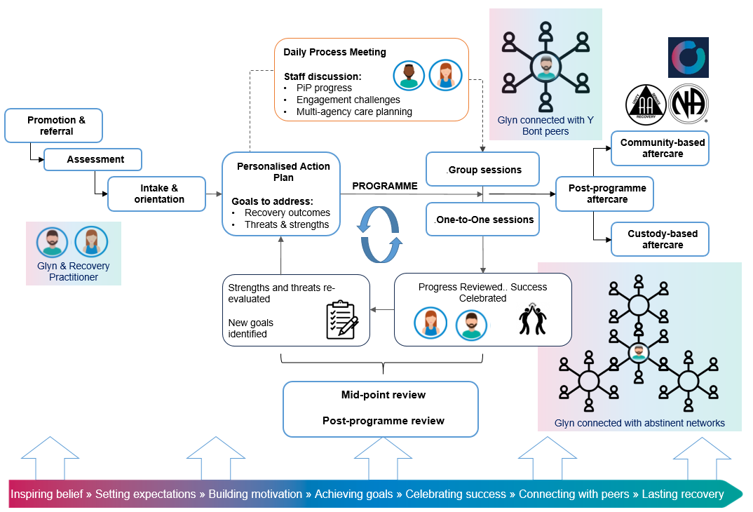
 |  |  |  | 1,866 (text) +134 (diagrams) = 2,000 (total)

TC-004 – Service Continuity
Weighting: | 10% | Quality Threshold: | N/A | Limitations
Question: |  |  |  | Up to 600 words;  The response should be entered in this table in the cell below;  Additional diagrams and tables can be submitted to support your response, however any wording within these shall be included in the overall word count.  Line spacing 1.5  Arial font size 11
Please describe what considerations you will make to ensure service continuity in the event of disruption and changing landscapes, in particular the following staffing events:
- Annual leave;
- Staff sickness;
- Attrition.
(NB: You may wish to use examples and/or case studies of how you have previously handled similar situations).
Response
Forward’s staffing model has been designed to provide resilience and comprehensive cover across the three prisons. Our management, reporting and governance structures will support consistent local level management.
1xFTE Team Leader (TL) based at HMP Swansea will provide managerial resource, supported by centrally resourced Forward Regional Managers (RM) and Head of Custodial Services. Forward’s operational managers will manage workforce resources, considering sufficient capacity/cover within teams, including annual leave, sickness and recruitment.

LOCALISED CONTINGENCIES
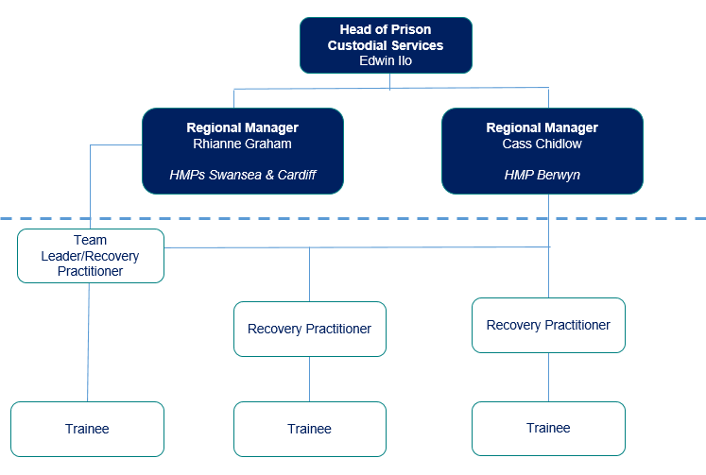
All staff delivering this contract will be security cleared to work in all establishments, to support the mitigations below.
Contingency cover HMP Berwyn: through redeployment of appropriately qualified (including lived experience) and vetted staff (identified for prison clearance during mobilisation) from other Forward services. We deliver substance misuse programmes at HMPYOI Stoke Heath and Liverpool community (both within 45 minute drive).
To mitigate against both planned and unplanned absences, group sessions at HMPs Cardiff and Swansea will be delivered at opposing ends of the regime, e.g. mornings at Cardiff and afternoons sessions at Swansea. This allows a staff member to deliver group interventions at both sites in one day if cover is required, to ensure no gap in service delivery.
Staff working in our current Wales Accommodation Probation contract are security cleared and working in the prisons. The Accommodation Services TL and Service Manager will be available for managerial support in the absence of the TL/RM’s.
- ANNUAL LEAVE / PLANNED ABSENCE
TL will lead weekly resource planning to maximise coverage and respond to need, including:
- Annual leave/absence planned following Forward’s HR policies, including prior authorisation from line manager and maintaining operational efficiency
- Programme timetable and session delivery
- Maternity leave: ensure these positions are backfilled, starting recruitment in advance of maternity leave to ensure cover.

- SICKNESS / UNPLANNED ABSENCE
If staffing falls below minimum requirements (or anticipated), and emergency or contingency cover is required, we will:
- Inform stakeholders (staff/commissioners/Offender Managers)
- Activate local Contingency Plan(s) (agreed during mobilisation), including those outlined above
- Prioritise essential services

- ATTRITION

Staff retention is supported by:
- Competitive employment packages (with annual benchmarking);
- Positive company culture, with open dialogue between staff and managers;
- Strong focus on staff wellbeing, benefits include: Employee Assistance Programme, Occupational Health, subscription to Headspace, generous annual leave and sick pay (increasing with length of service), maternity/paternity/shared parental leave schemes, flexible working to attract part time workers and alternative therapies through Simply Health.
- Succession planning within services to provide development opportunities for employees.
- Learning from staff surveys, and exit interviews.

Recruitment, retention and succession planning
At contract award, in the first instance we will engage with employees on the TUPE list to establish if they are potential candidates for posts in the profile.
Turnover/vacancies reduced through:
- Locally managed recruitment (dedicated HR-Business Partner, Samantha McDowell, experienced in recruiting to Wales Accommodation).
- Proactive rolling localised recruitment strategy: opportunities posted on UK-wide job portals (including Charity Jobs, Indeed, Reed, Criminal Justice Seven) alongside advertising on Welsh national platforms such as that provided by the WCVA, to HMPPS colleagues and graduates of community lived experience organisations.
- Retention/succession planning (e.g. health/wellbeing package, future manager’s training).

DISRUPTION / CHANGING LANDSCAPES
Flexibility in the delivery schedule allows for regime disruptions within the 12 week delivery cycle. Forward have experience of adapting group material into 1:1 delivery where there is a sustained regime disruption, e.g. HMP Rochester during covid-19 lockdown. Where this happens consolidation sessions are held to recap learning and re-regroup participants before continuing with session material.

Total Word Count – (Providers to self-populate) |  |  |  | 568 (text) + 32 (diagrams) = 600 (total)

TC-005 – Implementation
Weighting: | 10% | Quality Threshold: | N/A | Limitations
Question: |  |  |  | Up to 1000 words your response to section 1  The response to section 2 on the Implementation Plan should be submitted as an additional attachment and must be no longer than 2 A4 pages. This must be submitted as a PDF and have a font size of Arial 11.  The response to section 3 on the RAID log should be no longer than 3 A4 pages. The content of the RAID log shall not form part of the word limit above; however, the font must be Arial and size 11. Please submit as a PDF.  The response to section 1 should be entered in this table in the cell below.  Additional diagrams and tables can be submitted to support your response, however any wording within these shall be included in the overall word count.  Line spacing 1.5  Arial font size 11
- Outline the approach you will take to working with the Authority to ensure implementation is successful. Please detail how you will work with the Customer, outlining the required roles and responsibilities of both Parties.
- Demonstrate a detailed implementation plan to include timescales and responsibilities to meet all of the Mobilisation requirements and milestones as described in the Schedule 2.1 Service Description and Schedule 6.1 of the Draft Call-off Contract.
- Please complete a RAID (Risks, Assumptions, Issued and Dependencies) log outlining the key challenges you expect to encounter while implementing the services and how you intend to mitigate these risks and challenges.
Response
Implementation Plan and RAID Log attached in Commercial Response ‘additional attachments area’

Forward will utilise over 30 years of experience of implementing and mobilising contracts across custodial and community settings to achieve a successful implementation of this service to go-live on 02/05/2023. Our plan draws on experience on working with the Authority to implement 14 Community Rehabilitative Services (CRS: Wales Accommodation, Dependency and Recovery, Personal Wellbeing), and current service delivery in 25 prisons. We will adopt a transparent, solution-focused approach.

Our implementation team comprises personnel with experience of implementing CRS, prison drug and alcohol, community drug and alcohol, Information, Advice and Guidance, and IAPT contracts, bringing knowledge, learning and Authority relationships to accelerate activities and mitigate delays/issues. Our Head of Custodial Services (HoCS), Edwin Ilo, will be responsible for:

- achieving our plan;
- providing leadership across the project;
- establishing a transparent, collaborative Authority relationship (single point of contact), regularly reporting progress/risks and communicating contingencies (using Authority obligations tracker).

Skilled Work Stream Leads (WSLs) will deliver detailed requirements supported by comprehensive Work Packages, aligned to the critical path. Evidence for key milestone criteria will be uploaded to SharePoint (document management/storage system), enabling effective/timely tracking/submission to the Authority.

Our established, robust governance structure comprises:
- Weekly WSL check point reviews, feeding into Authority framework/weekly reporting systems, updating on work package progress, identifying/developing responses to challenges/risks, or deviation from planned activities/timescales
- Implementation Board, led by Executive Substance Misuse Director (Jason Moore, former prison governor), conducting formal progress reviews (fortnightly) mapped to Authority milestone requirements, reviewing key risks/issues, supporting with resolutions (e.g. additional resources) and making final ‘go/no-go’ gateway decisions
- Service Management Board, our HoCS will attend meetings/provide monthly progress reports
- Operational Readiness Rehearsal, a test/acceptance walk-through of all activities in preparation for go live, quality assuring key deliverables to inform ‘go/no-go’ decisions
- Robust risk management, based on best practice (PRINCE2) approaches. WSLs will identify/report on risks/issues, assessed for likelihood/impact, RAG (red, amber, green) rated and recorded in our RAID log with mitigating actions. Our HoP will report on the RAID log at Implementation/Service Management Board meetings.

MOBILISATION MILESTONES

IM4 – IT Equipment
Forward will acquire relevant IT equipment prior to contract commencement (within two weeks of contract award to allow for delivery time), engaging hardware suppliers, allocating resources for build/installation, carrying out security checks, and deploying to staff as appropriate.

We will negotiate desk / workspace, e.g. with interdependent departments, such as Probation or Substance Misuse Teams.

Responsible Officer: Khayam Khan, Director of ICT

IM3 – Information Security & Assurance
We will supply our Information Security Management Plan, our Cyber Essential Plus certificate, and evidence of compliance with NCSC Cloud Security Principles. An impact assessment on award will review all aspects of data processing for compliance.
We will liaise with prison Security and IT to request ‘whitelisting’ access to critical websites/online platforms, e.g. Forward’s Sharepoint site.

Responsible Officer: Khayam Khan, Director of ICT

IM2 – Workforce
Recognising recruitment challenges in Wales, we have already developed our recruitment strategy/plan shared with the Authority on contract award.
We will ensure sufficient staff have been recruited 1 week prior to call-off commencement date through robust recruitment planning, with activities started ‘at risk’ pre-award:
- Advertising widely in prisons and with community providers, appealing to experience of/interest in working in either probation or substance misuse; we will invite applicants with lived experience (specifying a minimum of two years away from prison/in abstinence-based recovery)
- Utilising existing partnership with specialist social care recruitment agency Sanctuary Personnel, and advertising via: local lived experience organisations (such as Adferiad/Cyfle Cymru/Chain Breakers/Recovery Cymru/GIG Cymru); and the community substance misuse services (CAIS/The Wallich/Kaleidoscope/WCADA/PACT Futures)
- Sharing opportunities with our bank of 200+ volunteers, an established Forward pathway for people with lived experience to gain employment;
- Attractive employment packages (e.g. 2 wellbeing days plus annual leave)
- Rolling recruitment with interviews booked on receiving applications.

All staff will receive Forward/Ministry of Justice mandatory training and induction during the first 2 weeks of the call-off commencement, with evidence provided to the Authority. A workforce-wide training needs analysis will identify additional training, supervision, and support. Staff training to prepare for therapeutic groups will be delivered intensively during the first 2 weeks, to ensure that there is sufficient staff trained and ready for go-live of programme delivery (lead by Gary Stickings, Head of Therapeutic Quality and Training); ongoing training will take place at regular intervals. Training is recorded on Forward’s HR system – Cascade – for all new and existing staff, and can be shared with the Authority on request.

Responsible Officer: Caroline Thatcher, Executive Director HR

IM1 – Vetting
Our Director of HR, HoCS and Senior Operations Manager (who led CRS recruitment) will select (sifting, assessment centres, interviews) and vet candidates (Probation Instructions 2014/60, 2014/03, 2014/23), maintaining records on our HR system, and set up payroll. We will start the vetting process at appointment to ensure that there is adequate time for staff to go through this process. Forward are experts in supporting potential employees through the online vetting process, with dedicated regional HR Advisors allocated to advise applicants and chase progress.
At mobilisation start, we will commence prison vetting of existing Forward staff identified for contingency cross-deployment, including from HMPYOI Stoke Heath and Liverpool Community Day Programme.
Details of necessary re-vetting will be included on Cascade and notifications automatically generated in good time to employees and line managers; all Forward staff members are regularly reminded of the need to keep their profiles (i.e. personal circumstances) up to date.

Responsible Officer: Caroline Thatcher, Executive Director HR

IM5 – Yearly Delivery Plan
A yearly delivery plan will be written and delivered by us on a date agreed with the Authority during the mobilisation period.

Responsible Officer: Edwin Ilo, Head of Custodial Services

IM6 – Referral Form
We will work with the Authority to develop appropriate referral documentation which will be completed no later than seven days prior to the commencement date.

Responsible Officer: Edwin Ilo, Head of Custodial Services

Final ‘operational readiness’ review: completed two weeks pre-go-live to ensure all day 1 staff will be in post and completing inductions. ICT system/user acceptance testing/final walk-throughs of interventions/operational processes will be completed.

Total Word Count – (Providers to self-populate) |  |  |  | 998 (text)


© Crown copyright 2021
This publication is licensed under the terms of the Open Government Licence v3.0
except where otherwise stated. To view this licence, visit
nationalarchives.gov.uk/doc/open-government-licence/version/3
Where we have identified any third-party copyright information you will
need to obtain permission from the copyright holders concerned.
Any enquiries regarding this publication should be sent to us at:
ProbationDynamicFramework@justice.gov.uk

