**Replacement Sports Pavilion – Briefing Criteria**

Barrington Parish Council (BPC) wishes to replace/refurbish the village Sports Pavilion which it owns. The Pavilion is in poor condition but may nevertheless be suitable for repair and expansion. It is not a listed building but is a significant feature and located in a prominent position overlooking the Village Green and within the Conservation Area. It is accessed via a permitted accessway across the Village Green under licence from the Green Charity.

The Pavilion is currently in use most of the year and used by the Barrington Cricket and Football teams which have an overlapping season. Further use by other groups is envisaged, for example a Tennis Club, once new Tennis Courts are provided in the coming years.

Following a detailed options study, BPC now wishes to drive forward with a replacement/refurbished pavilion and requires an individual or company that can:

• Provide the necessary plans to support a planning application.

• Post-planning to provide building control plans (if required)

• Act as project manager for the construction project

• Act as the designated CDM

Our commitments mean that we need to replace the pavilion ***within*** an overall budget of £450,000.

Any designs therefore must be deliverable as a completed building ready for handover within that budget,

including all fees, materials, site preparation, construction etc.

BPC would like you to present your ideas and costs to deliver this project, your fees should be detailed

separately to the construction costs within the overall total.

The closing date for expressions of interest is 8th March.

**Further Information**

To provide itself with information and context, councillors have visited similar local pavilions, (see examples

below) and consider the basic requirements for the pavilion to be:

• Safe, secure and suitable for all year use

• Suitable for use by multiple different groups (this meaning multiple discreet storage spaces)

• Remain in its current location.

• A meeting room / social area with kitchen for teas etc.

• One Home changing room with showers.

• One Away changing room with showers.

• One Officials’ changing room.

• Toilet facilities

• Disabled access

• Have a façade similar to the existing which overlooks the green / cricket ground.

• Aiming for carbon-neutral, being eco-friendly and energy efficient to minimize energy costs

• Be capable of further extension to the rear as the village sports facilities expand.

Obtaining planning permission will doubtless require information on access and parking provision. A

separate budget allocation will be considered for this aspect and can be discussed with the successful

firm following appointment.

**Barrington Parish Council, February 2024.**

**Example Layout 1**

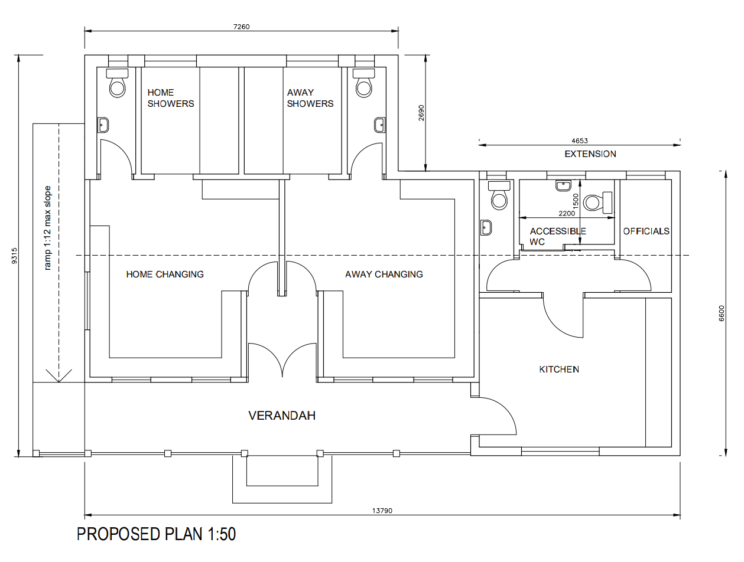

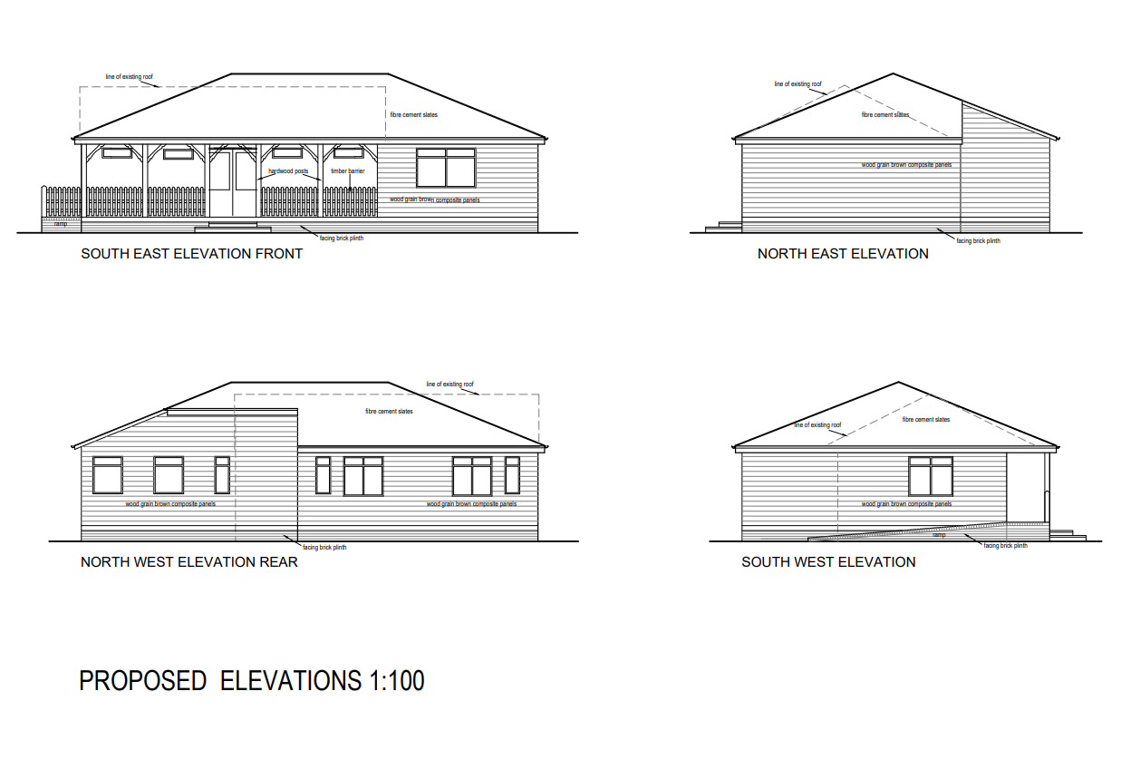

**Example Layout 2**

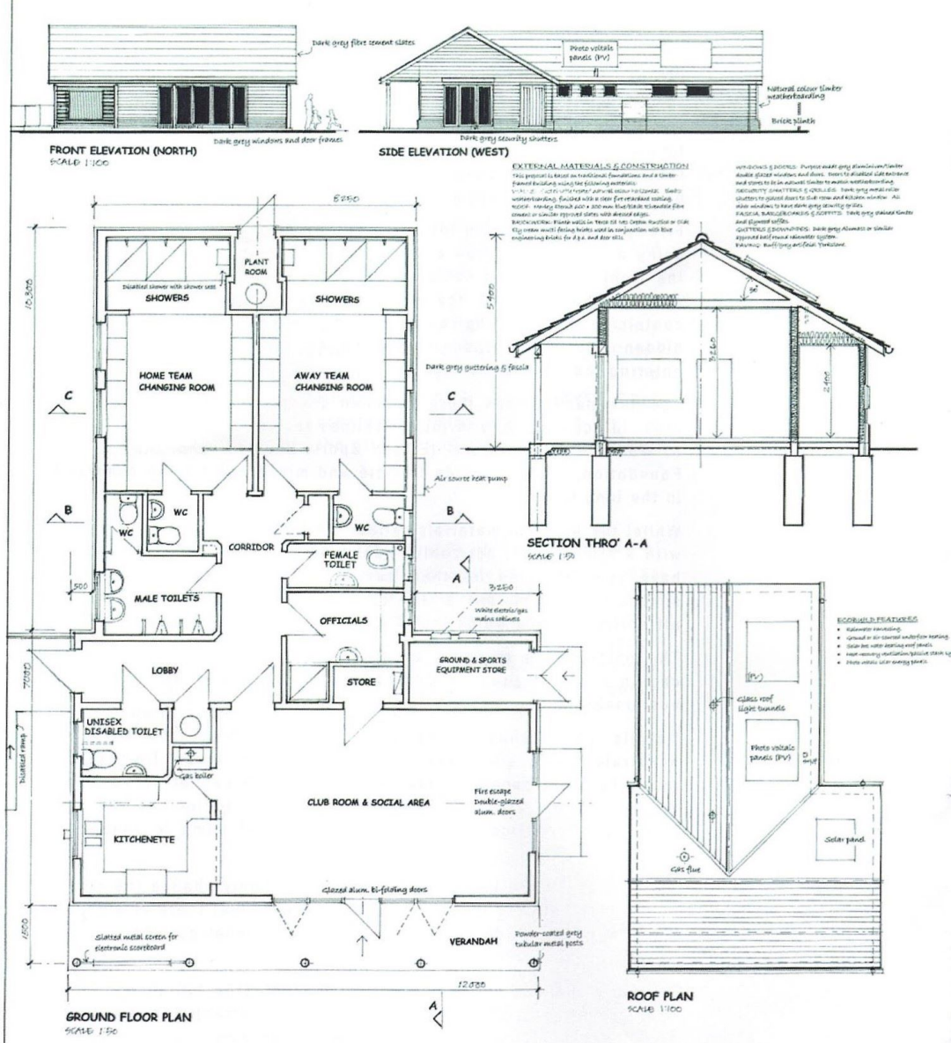

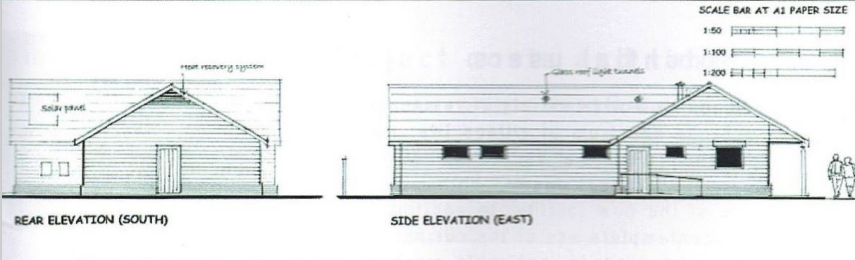

**Current Pavilion**

