**Croydon Personal Independence Co-ordinators Service**

**Memorandum of Information (MOI)**

**NHS Croydon**

**Clinical Commissioning Group (CCG)**

**Contents**

|  |  |  |
| --- | --- | --- |
| 1. | Purpose | 3 |
| 2. | Definition | 3 |
| 3. | Strategic Context | 3 |
| 4. | The Commissioning Organisation | 5 |
| 5. | The Proposed Personal Independence Coordinator Service | 7 |
| 6. | Service Mobilisation | 8 |
| 7. | Governance and Administration | 8 |

1. **Purpose**

The purpose of this Memorandum of Information (MOI) is to support a market testing exercise being undertaken by NHS Croydon CCG (CCCG). The market testing exercise is intended to inform future commissioning plans with respect to the potential future procurement of a Croydon Personal Independence Coordinator (PICs) Service.

The MOI is intended only as a preliminary background explanation for the procurement of the service. It is in no way intended to form the basis of any decision on the terms upon which CCCG will enter in to any contractual relationship.

**2. Definition**

CCCG wishes to inform the potential future commissioning of a PICs service for Croydon residents. The service is intended to deliver safe, high quality and innovative services in line with the CCG’s strategic vision.

**3. Strategic Context**

3.2 Local context

### 3.2.1 CCCG’s vision and strategy

CCCG’s vision, strategic objectives and values are as follows:

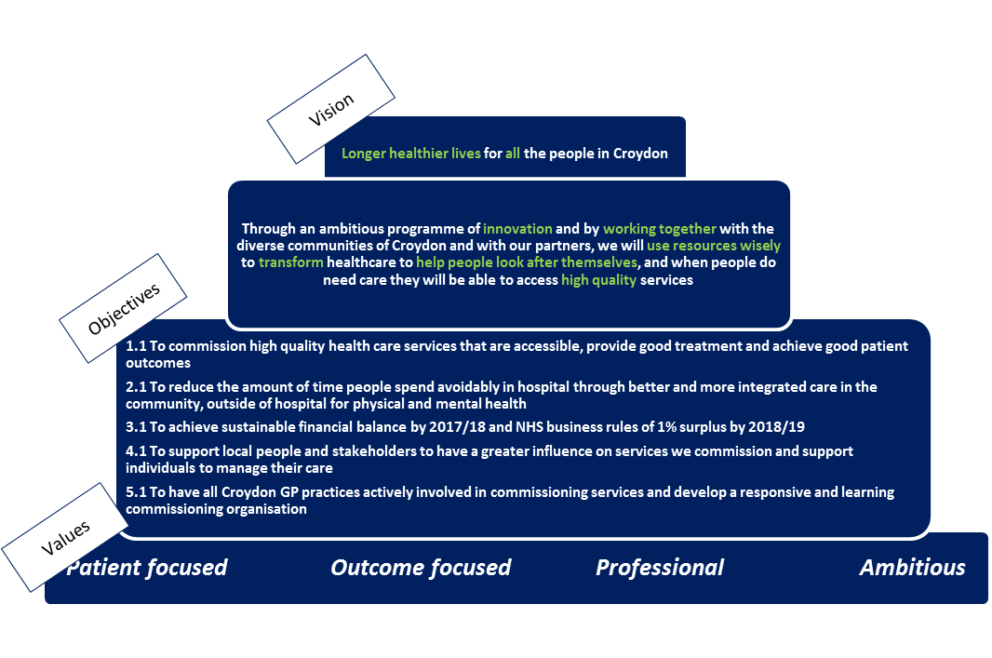

3.2.2 Historic model of care and future vision

The historic model of care and CCCG’s future vision for Croydon patients is as follows:

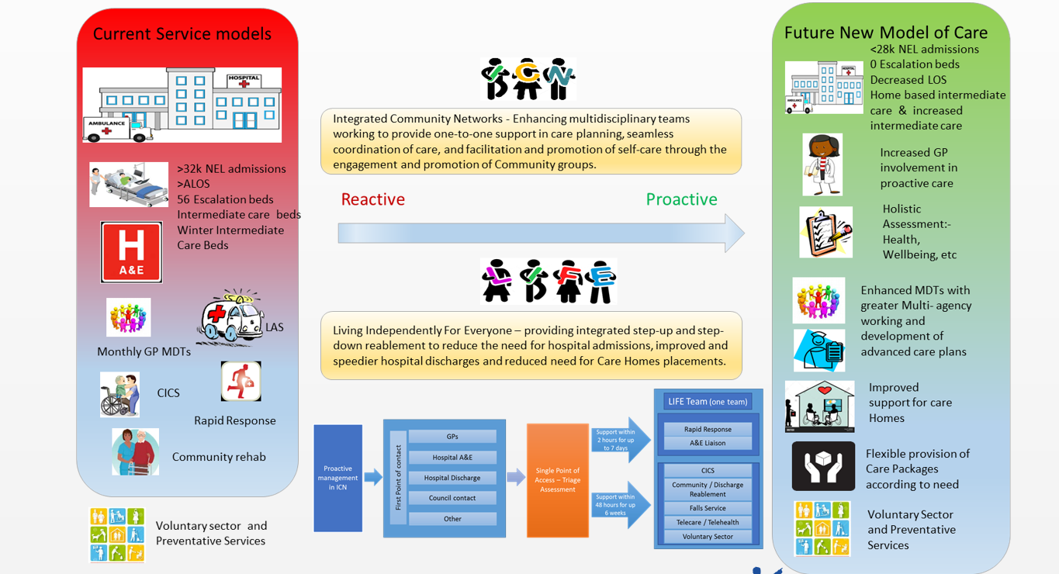

**4. The Commissioning Organisation**

4.1 Croydon CCG

CCCG is a membership organisation made up of all 56 GP practices in the borough of Croydon.​​ CCCG was established in April 2011 as a shadow organisation and received authorisation from the NHS Commissioning Board (now NHS England) in March 2013.  On 1 April 2013, CCCG became legally responsible for commissioning health services for the residents of Croydon.

CCCG manages local healthcare budgets in excess of £465 million and commission a range of Croydon health services on patients’ behalf.  These include hospital, community and mental health services.

Details of CCCG’s member practices can be found at <http://www.croydonccg.nhs.uk/about-us/clinical-networks/Pages/GP-Practices.aspx>.

4.2 Population

Croydon’s population (382,304) is the second largest of London’s 32 boroughs after Bexley. Source: ONS 2016 Population Estimate.

4.2.1 Age

The age distribution of Croydon’s population is as follows:

|  |  |  |
| --- | --- | --- |
| **Age (years)** | **Numbers** | **Percentage** |
| 0-4 years | 28,621 | 7.5% |
| 5-10 years | 32,859 | 8.6% |
| 11-17 years | 32,955 | 8.6% |
| 18-64 years | 237,663 | 62.2% |
| 65+ years | 50,206 | 13.1% |
| Total Population | 382,304 |  |

**Source: ONS, Mid-Year Population Estimates, 2016**

4.2.2 Disability

The 2011 Census identified that there were 53,113 people in Croydon who considered their day to day activities were limited a little or a lot by a disability or long term illness, 65% of whom were aged 50 and over:

|  |  |  |
| --- | --- | --- |
| **Disability category** | **Numbers** | **Percentage** |
| Day-to-day activities limited a lot | 24,380 | 6.7% |
| Day-to-day activities limited a little | 28,733 | 7.9% |
| Day-to-day activities not limited | 310,265 | 85.4% |
| Total of all categories. | 363,378 | 100.0% |

**Source: ONS, Census 2011, Table QS303UK**

4.2.3 Ethnicity

Croydon is an ethnically diverse borough with 55.1% of residents identifying as White and 45.9% identifying as from BME groups (20.1% Black, 16.4% Asian, 6.6% Mixed Ethnicity and 1.8% Other); Source: GLA 2015 Round of Demographic Projections - long-term migration scenario.

4.2.4 Gender

Croydon’s population pyramid shows a fairly even distribution of males (48.6%) and females (51.4%).

4.2.5 Language

82.6% of households in Croydon have English as their main language whilst English is not the main language in 7.9% of households. Source: ONS Census 2011.

4.2.6 Religion

The religion of Croydon residents is reported as follows:

|  |  |  |
| --- | --- | --- |
| **Faith** | **Number** | **Percentage** |
| Christian | 205,022 | 56.4% |
| Buddhist | 2,381 | 0.7% |
| Hindu | 21,739 | 6% |
| Jewish | 709 | 0.2% |
| Muslim | 29,513 | 8.1% |
| Sikh | 1,450 | 0.4% |
| Other Religion | 2,153 | 0.6% |
| No Religion | 72,654 | 20% |
| No Response | 27,757 | 7.6% |

**Source: ONS Census 2011**

**5. The Proposed Personal Independence Co-ordination Service** **(PICs)**

5.1 The current service

Personal Independence Coordinators (PICs) work alongside health and care professionals, adopting a multidisciplinary approach to working with older people who have long term health and social care needs. The PICs provide critical links between formal health and social care services and the wider community support networks to provide a holistic integrated care programme.

These roles are points of liaison between patients, the locality multi-disciplinary teams (MDTs), locality health and social care teams and local non-traditional providers. They support patients in identifying ways of achieving individual health improvement through the delivery of personal goals; connecting with appropriate health services and other non-traditional providers to make best use of community resources to support the delivery of these goals. The service model focuses on improving self-management wherever possible.

The Personal Independence Coordinator programme supports MDT huddles across the borough, which continues to support people at risk of an emergency admission in developing their own person-led care plan to help them maintain their health and achieve their independence goals. MDT huddles place on a weekly/fortnightly basis and are delivered across Croydon’s 53 GP practices.

The PICs also work with volunteer support workers and the core ICN team to help avoid medium to high risk people attending hospital unnecessarily. They will also help medium risk people become better informed about how to maintain their health through the development of their own person-led preventative care plans.

5.2 The current pathway

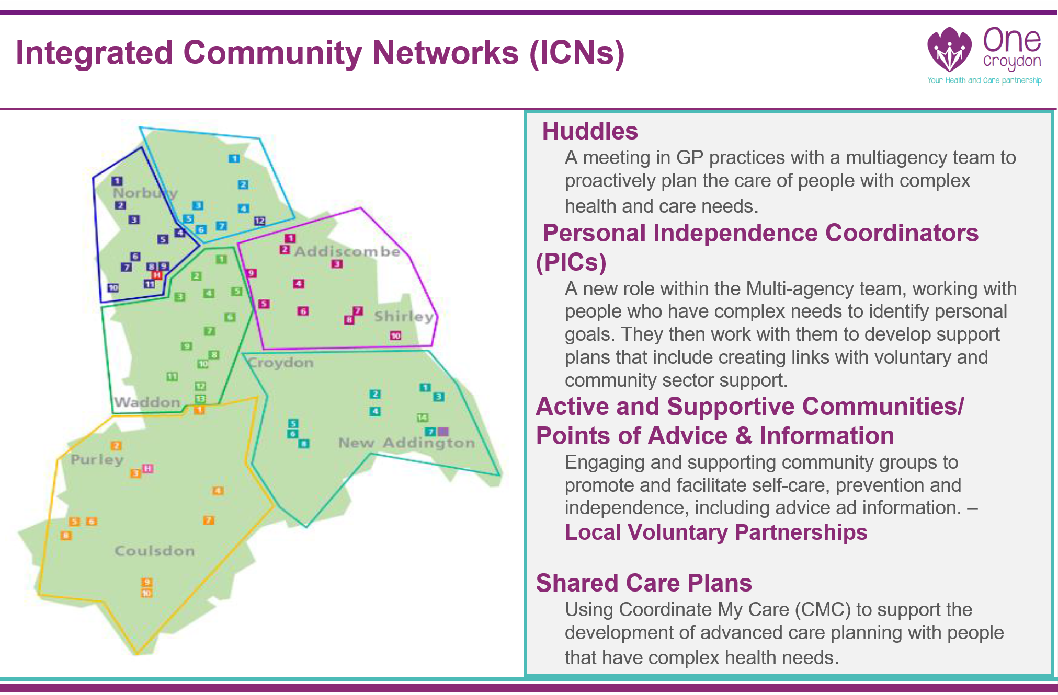

5.3 Scope of proposed new service

The scope of the new service is set out in the attached service specification. The new service will continue to deliver the existing model but will also include important new developments which include:

* Developing a new modular approach to case management, offering new shorter 6 week programmes where appropriate (ie patients requiring health with losing weight)
* Use a health coaching approach which aims to motivate and empower people to improve their health and wellbeing using evidence based health coaching techniques
* Organise and provide sessional group consultation sessions within GP practices on a network basis
* Developing approach for social prescribing as an integral part of the PICs service offer.

The CCG also encourages potential bidders to propose additional enhancements for this service to take account of CCCG’s vision set out above and consider how they would innovate to deliver the specification.

5.3 Anticipated activity & contract value

5.3.1 The **anticipated** activity for the service is as follows:

2026 patient contacts per annum

5.3.2 The **anticipated** contract value for the service is:

£700K - £800K per annum

5.4 Expected service outcomes

It is anticipated that commissioning a new PICs service will result in the following local outcomes among patients. It will help them:

* stay healthy, active and independent for as long as possible
* get access to the best quality care so people can live how they choose
* have support from professionals with specialist knowledge to understand how health and social care affects individuals
* get more care and support tailored to individuals’ needs
* have reduced instances of unnecessary hospital attendances or admissions

5.5 Anticipated contract model

The **anticipated** contract model for the service is a **2 part model** made up of a block funding element and a funding element which should be invested in community based initiatives designed to develop sustainable community support structure. This will be no more than 5% of the contract value.

As such we are keen that proposals received describe how this could be successfully delivered.

**6. Service Mobilisation**

Once the contract has been awarded, a detailed mobilisation plan will be developed by the provider and agreed by CCCG. The plan will include key activities and milestones to provide reasonable assurance that the service will be mobilised on time.

It is envisaged that in order to support the effective set up, mobilisation and implementation for the new service, there will be a provider-side resource with the knowledge, skills and experience to achieve and deliver the service specification.

During the service mobilisation period, the Provider is expected to deliver the following milestones:

|  |  |
| --- | --- |
| **Description** | **Target Threshold** |
| Provider mobilisation lead identified | Contract signature |
| Mobilisation plan developed (including but not limited to mobilisation meetings schedule, locations of service, staffing, information governance, information management and technology, risk and issues logs, communication plan) | 2 weeks after contract signature |

Further milestones will be as per the mobilisation plan developed by the provider and agreed by CCCG.

**7. Governance and Administration**

Further details on the requirements for the PICs Service are provided separately in the draft service specification.

Disclaimer

The information contained in this MOI is presented in good faith and does not purport to be comprehensive or to have been independently verified.

Neither CCCG, nor any of its advisers accept any responsibility or liability in relation to its accuracy or completeness or any other information which has been, or which is subsequently, made available to any potential Bidder, Provider, Bidder Member, Clinical Services Supplier, financiers or any of their advisers, orally or in writing or in whatever media.

Interested parties and their advisers must therefore take their own steps to verify the accuracy of any information that they consider relevant. They must not, and are not entitled to, rely on any statement or representation made by the Commissioner or any of its advisers.

This MOI is intended only as a preliminary background explanation of CCCG’s activities and plans and is not intended to form the basis of any decision on whether to enter into any contractual relationship.

The Commissioner reserves the right to change the basis of, or the procedures (including the timetable) relating to, the Procurement process, to reject any, or all, of the submissions and applications, not to invite a potential bidder to proceed further, not to furnish a potential bidder with additional information nor otherwise to negotiate with a potential bidder in respect of the Procurement, subject to compliance with general EU principles on equal treatment, non- discrimination and transparency and procurement law.

CCCG shall not be obliged to appoint any of the Bidders and reserves the right not to proceed with the Procurement, or any part thereof, at any time. Nothing in this MOI is, nor shall be relied upon as, a promise or representation as to any decision by NHS Croydon CCG in relation to this Procurement. No person has been authorised by the Commissioner or their advisers or consultants to give any information or make any representation not contained in this MOI and, if given or made, any such information or representation shall not be relied upon as having been so authorised.

Nothing in this MOI or any other pre-contractual documentation shall constitute the basis of an express or implied contract that may be concluded in relation to the Procurement, nor shall such documentation/information be used in construing any such contract. Each bidder must rely on the terms and conditions contained in any contract when, and if, finally executed, subject to such limitations and restrictions that may be specified in such contract. No such contract will contain any representation or warranty in respect of the MOI or other pre-contract documentation.

In this section, references to this MOI include all information contained in it and any other information (whether written, oral or in machine-readable form) or opinions made available by or on behalf of the Commissioner, or any of their advisers or consultants in connection with this MOI or any other pre-contract documentation.