**Framework Schedule 6 (Order Form Template and Call-Off Schedules)**

**Order Form**

CALL-OFF REFERENCE: 714795451

THE BUYER: **REDACTED**

BUYER ADDRESS DIO, Commercial Operations, Army Headquarters, Marlborough Lines, Monxton Rd, Andover, Hants SP11 8HJ

THE SUPPLIER: XMA Limited

SUPPLIER ADDRESS:Wilford Industrial Estate, Ruddington Lane WilfordNottinghamNG11 7EP

REGISTRATION NUMBER:02051703

DUNS NUMBER: 298484148

SID4GOV ID:Not Applicable

APPLICABLE FRAMEWORK CONTRACT

This Order Form is for the provision of the Call-Off Deliverables and dated 27th June 2025.

It’s issued under the Framework Contract with the reference number RM6098 for the provision of Technology Products & Associated Service 2.

CALL-OFF LOT(S):

Lot 1 Hardware and Software and Associated Services

CALL-OFF INCORPORATED TERMS

The following documents are incorporated into this Call-Off Contract. Where numbers are missing we are not using those schedules. If the documents conflict, the following order of precedence applies:

1. This Order Form including the Call-Off Special Terms and Call-Off Special Schedules.
2. Joint Schedule 1 (Definitions and Interpretation) RM6098
3. Framework Special Terms
4. The following Schedules in equal order of precedence:

* Joint Schedules for RM6098
  + Joint Schedule 2 (Variation Form)
  + Joint Schedule 3 (Insurance Requirements)
  + Joint Schedule 4 (Commercially Sensitive Information)
  + Joint Schedule 6 (Key Subcontractors)
  + Joint Schedule 9 (Minimum Standards of Reliability)
  + Joint Schedule 10 (Rectification Plan)
  + Joint Schedule 11 (Processing Data)
  + Joint Schedule 12 (Supply Chain Visibility)
* Call-Off Schedules for RM6098
  + Call-Off Schedule 5 (Pricing Details)
  + Call-Off Schedule 9 (Security)
  + Call-Off Schedule 10 (Exit Management)
  + Call-Off Schedule 14 (Service Levels)
  + Call-Off Schedule 16 (Benchmarking)
  + Call-Off Schedule 17 (MOD Terms)

1. CCS Core Terms (version 3.0.11) as amended by the Framework Award Form
2. Joint Schedule 5 (Corporate Social Responsibility) RM6098
3. Call-Off Schedule 4 (Call-Off Tender) as long as any parts of the Call-Off Tender that offer a better commercial position for the Buyer (as decided by the Buyer) take precedence over the documents above.

No other Supplier terms are part of the Call-Off Contract. That includes any terms written on the back of, added to this Order Form, or presented at the time of delivery.

CALL-OFF SPECIAL TERMS

The DEFCONS as per Call-Off Schedule 17 apply.

CALL-OFF START DATE: **19th August 2025 (indicative date, subject to change)**

CALL-OFF EXPIRY DATE: **31st March 2026**

CALL-OFF INITIAL PERIOD: **8 months**

CALL-OFF DELIVERABLES

The requirement is built up of the following:

**Batch 1**

|  |  |
| --- | --- |
| **Item** | **ROM (Rough Order of Magnitude) Quantity** |
| Microsoft Surface Hub 3 - 50 inch | 14 |
| Cart - 50 inch | 14 |
| 50 inch Warranty - 3 years | 14 |
| Microsoft Surface Hub 3 - 85 inch | 2 |
| Cart - 85 inch | 2 |
| 85 inch Warranty - 3 years | 2 |

|  |
| --- |
| Delivery – individual to sites within UK |
| Transportation of devices from delivery vehicle into the internal office location if required. |
| Removal of package where applicable – price for 1 x 85-inch device |
| Removal of package where applicable – price for 1 x 50-inch device |

**Batch 2 – Optional** – Note: Price for information purposes only and not to be evaluated as part of the tender award criteria. This optional batch may be reduced in quantity – confirmation will be provided at the mid contract review meeting. This optional batch will not exceed the value of £200,000.

|  |  |
| --- | --- |
| **Item** | **ROM Quantity** |
| Microsoft Surface Hub 3 - 50 inch | 16 |
| Cart - 50 inch | 16 |
| 50 inch Warranty - 3 years | 16 |
| Microsoft Surface Hub 3 - 85 inch | 0 |
| Cart - 85 inch | 0 |
| 85 inch Warranty - 3 years | 0 |

LOCATION FOR DELIVERY

**Batch 1**

For clarity, the sites that are overseas have delivery locations in the UK.

|  |  |  |  |
| --- | --- | --- | --- |
| **Site** | No/ of deliveries to site | Device requirements | |
| Colchester – CO2 7UT | 1 | 1 X 50 |  |
| Alconbury – PE28 4DA | 1 | 1 X 50 |  |
| Blandford – DT11 8RH | 1 | 1 X 50 |  |
| Wimborne – BH21 6QS | 1 |  | 1 x 85 |
| Westdown Camp – SP3 4RS | 1 | 1 X 50 |  |
| Waddington – LN5 9NB | 1 | 1 X 50 |  |
| Tidworth MPP – SP9 7QD | 1 | 1 X 50 |  |
| Germany – Deliver to WS14 9PY | 1 |  | 1 x 85 |
| Sandhurst – GU15 4PQ | 1 | 3 X 50 |  |
| Lakenheath – IP27 9PP | 1 | 1 X 50 |  |
| Faslane – G84 8HL | 1 | 1 X 50 |  |
| Arbroath – DD11 3SP | 1 | 1 X 50 |  |
| Lossiemouth – IV31 6SD | 1 | 1 X 50 |  |
| Glasgow G2 8EX | 1 | 1 x 50 |  |

**Batch 2 (Optional)**

Sites within this batch would be chosen from the following locations. For clarity, the sites that are overseas have delivery locations in the UK.

|  |  |  |  |
| --- | --- | --- | --- |
| **Site** | No/ of deliveries to site | Device requirements | |
| Lakenheath – IP27 9PP | 1 | 2 X 50 |  |
| Falklands – Deliver to WS14 9PY | 1 | 1 X 50 |  |
| Kenya – Deliver to WS14 9PY | 1 | 1 X 50 |  |
| Germany – Deliver to WS14 9PY | 1 | 2 X 50 |  |
| Portsmouth – PO1 3NH | 1 | 3 X 50 |  |
| Main Building – SW1A 2HB | 1 | 1 X 50 |  |
| Wyton – PE28 2EA | 1 | 1 X 50 |  |
| Andover – SP11 8HJ | 1 | 2 X 50 |  |
| Odiham – RG29 1QT | 1 | 1 X 50 |  |
| Hamworthy – BH15 4NQ | 1 | 1 X 50 |  |
| Folkestone – CT20 3EZ | 1 | 1 x 50 |  |

DATES FOR DELIVERY

Delivery date details - Specific date details are yet to be finalised but high-level delivery dates for Batch 1 sites will be between August 2025 and March 2026. The programme plan is in draft form (see plan on a page below) and subject to change. Orders placed will require delivery no later than 10 working days.

The supplier must comply with DEFCON 129. Upon order, the supplier shall provide a Safety Data Sheet in respect of each Dangerous Good in accordance with the UK REACH Regulations and the Health and Safety at Work Act 1974 (as amended).

Upon order and in advance of delivery the supplier shall provide itemised receipts with serial number(s) to enable the appropriate MS Pro Licence to be assigned.

Within 48 hours of delivery the supplier shall register the device(s) with Microsoft for Warranty purposes.

Plan on a Page – draft form – subject to change

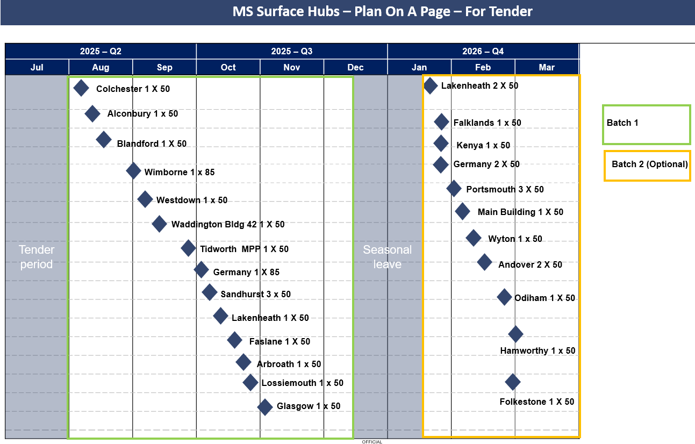

TESTING OF DELIVERABLES

None

WARRANTY PERIOD

The warranty period for the purposes of Clause 3.1.2 of the Core Terms shall be 3 years.

MAXIMUM LIABILITY

The limitation of liability for this Call-Off Contract is stated in Clause 11.2 of the Core Terms. Each Party's total aggregate liability in each Contract Year under each Call-Off Contract (whether in tort, contract or otherwise) is no more than the greater of £5 million or 150% of the Estimated Yearly Charges unless specified in the Call-Off Order Form.

CALL-OFF CHARGES

£153,425.68 (exc VAT) the Charges for the Deliverables for Batch 1. Optional Batch 2 will not exceed the value of £129,361.15 (exc VAT).

The Charges will not be impacted by any change to the Framework Prices. The Charges can only be changed by agreement in writing between the Buyer and the Supplier because of:

* Specific Change in Law
* Benchmarking using Call-Off Schedule 16 (Benchmarking)

REIMBURSABLE EXPENSES

Expenses are not reimbursable and will be owned by the supplier.

PAYMENT METHOD

Payment will be made through CP&F. (Purchase Order number TBC).

BUYER’S INVOICE ADDRESS:

**REDACTED**

DIO CIO-SW Tech PM

**REDACTED**

CIO Customer Service Support, DIO

St George’s House, DIO Head Office

DMS Whittington

Lichfield

Staffordshire WS14 9PY

Electronic submission via Exostar to CP&F Purchase Order

BUYER’S AUTHORISED REPRESENTATIVE

**REDACTED**

Commercial Operations – Policy

**REDACTED**

DIO Commercial Operations – Policy

Army Headquarters

Marlborough Lines

Monxton Road

Andover

Hants

SP11 8HJ

BUYER’S ENVIRONMENTAL POLICY

[JSP 418 Part 1 - Directive (publishing.service.gov.uk)](https://assets.publishing.service.gov.uk/media/5a7e1601e5274a2e87daf749/20141209-JSP_418_Part1_Final-U.pdf)

BUYER’S SECURITY POLICY

[Security policy framework - GOV.UK (www.gov.uk)](https://www.gov.uk/government/publications/security-policy-framework/hmg-security-policy-framework)

SUPPLIER’S AUTHORISED REPRESENTATIVE

**REDACTED**

Contracts Director

[approvals@xma.co.uk](mailto:approvals@xma.co.uk)

Wilford Industrial Estate, Ruddington Lane Wilford Nottingham NG11 7EP

SUPPLIER’S CONTRACT MANAGER

**REDACTED**

Bid Manager

**REDACTED**

Wilford Industrial Estate, Ruddington Lane Wilford Nottingham NG11 7EP

PROGRESS REPORT FREQUENCY

Required for the mid-contract review. Timeliness of delivery to be included within the reports.

PROGRESS MEETING FREQUENCY

The supplier will be required to attend a mid-contract review meeting to assess performance to date and programme the remainder of the requirements. This will either be held online via MS Teams or held at DIO Whittington, at the direction of the authority. Additional meetings only required if the authority deem necessary.

KEY STAFF

**REDACTED**

KEY SUBCONTRACTOR(S)

Not applicable

COMMERCIALLY SENSITIVE INFORMATION

Unit Price

SERVICE CREDITS

Service Credits will accrue in accordance with Call-Off Schedule 14 (Service Levels).

The Service Credit Cap is: £5000.

The Service Period is 8 months (1st August 2025-31st March 2026).

A Service Level Failure is: failure to receipt delivery within business hours on agreed delivery date.

ADDITIONAL INSURANCES

Not applicable

Insurances in accordance with Joint Schedule 3 (Insurance Requirements).

GUARANTEE

Not applicable

SOCIAL VALUE COMMITMENT

The Supplier agrees, in providing the Deliverables and performing its obligations under the Call-Off Contract, that it will comply with the social value commitments in Call-Off Schedule 4 (Call-Off Tender)

|  |  |  |  |
| --- | --- | --- | --- |
| **For and on behalf of the Supplier:** | | **For and on behalf of the Buyer:** | |
| Signature: | **REDACTED** | Signature: | **REDACTED** |
| Name: | **REDACTED** | Name: | **REDACTED** |
| Role: | CRO | Role: | DIO Commercial Operations - Policy |
| Date: | 27/8/2025 | Date: | 4/9/2025 |