Invitation to Tender
Fleet Town Council

Project Brief

Fleet, Richard Close Cemetery:
Woodland Memorials Area

Project Title: Garden of Remembrance, Richard Close Cemetery, Fleet: woodland paths and associated works

Rationale for Work: to improve access to the woodland/grassland area that creates an extension of the cemetery.

Location: Richard Close, Fleet GU51 5YZ

Description of Project
Fleet Town Council (FTC) wishes to extend the capacity of its current cemetery by creating access paths around an area of woodland/grassland where new memorials will be placed.

Required Outcome:
The works deemed necessary to achieve this include, but may not be limited to, the following:
- Design of paths (including “no dig” areas beneath tree canopies) to accessibility standards.
- Construction of the paths including footbridges (2nr), concrete foundations for memorials, and fencing.
- Design and construction of a brick archway to frame the entrance.
FTC requires a contractor to design and deliver the project scheme based on the following information.

Works and Services Required
- Preparation works: removal of vegetation – including felling of two mature/semi-mature trees (one leaning holly, one leaning/suppressed oak). Contractor will gain all relevant consents unless previously sought by FTC
- Design works
  - New paths and paving areas shall
    - Be based on the layout shown on drawing “Phase 1Proposal: Woodland Paths: Drg no 0001 Rev D” and “Garden Areas : Drg no 0002 RevA”..
    - Allow for compliance with Accessibility standards to achieve ramps, curves and slopes suitable for pedestrians and wheelchair users. 1.8m width for central path and 1.2m width for secondary paths. Paving in the “Reflection Area” to be7m diameter. Additional paving in upper Memorials area.
    - Be surfaced using recycled shredded rubber chippings in resin, polyurethane bonding eg Agriflex by Star Rubber Ltd, or similar approved.
    - Not impede surface water drainage across the existing slopes.
    - Be a “no dig” construction method (to be approved) where the path extends beneath tree canopies.
    - Reuse any excavated topsoil to grade out the edges of raised sections of path to smooth flowing contours and to infill any hollows in areas where there is a “no dig” construction. Any surplus material shall be disposed of, off site (in locations as agreed with the site manager).

  - New footbridges shall
    - Be in accordance with Hampshire County Council’s standard specification
    - Tie in with the path layout as shown on the Proposals Plan.
    - Sequencing of works to be key to providing smooth alignment of bridges & paths.

  - New archway shall
    - Create a 1.8m aperture with archway over.
    - Be constructed using bricks to match existing brickwork in the nearby cemetery shelter.
    - Detail design to be approved by FTC prior to installation.
- Installation works
  - Footpath and paving area as to specification above.
  - Footbridges as to HCC specification
  - Concrete foundations for memorials beside path (Garden Blocks) as to manufacturer’s specification and avoiding tree protection areas.
  - Concrete foundation for large Barbican/Columbaria memorial as to manufacturer’s specifications with particular care for tree protection areas.
  - Garden areas (2nr) with concrete foundations for Sanctum 2000 memorials and concrete flag paving.
  - Fence as to BS1722-7 type SPR 11/3 Nailed Post and 3 Rail fences.
  - Brick archway as to specification details and in line with the design aspirations of the Town Council.

Summary
For aspects of the project that require an element of formalised design, the contractor will be required to provide
- drawings to show compliance with the specified criteria, specification and the cost.

For aspects of the project that require installation, the contractor will be required to submit
- a methodology for the implementation of the designs (especially the sequencing of the various components) and the cost.

The contractor will be expected to obtain the necessary consents required for the works eg from the local authority (planning approval) or utility companies.
The contractor will be expected to comply with CDM regulations including updated health and safety information, method statements and provision of maintenance information for the client’s health & safety file.
The contract will be awarded by mid July 2018
Work on-site to commence during August 2018
All work to be completed by 30 September 2018.
Site visit will be offered on Tuesday June 26th, 2018 at 0930 to view works with project officer.

Location Map
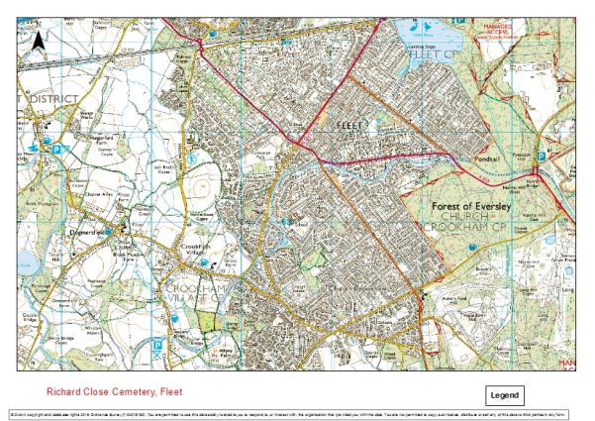
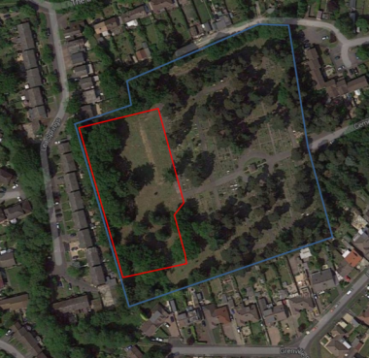
Richard Close Cemetery, Fleet (outlined in blue)
Woodland Paths area (outlined in red)

Site Photographs (indicative terrain)
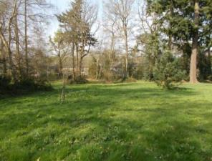

1. View from existing cemetery towards proposed reflection area – the central path will curve down this slope.

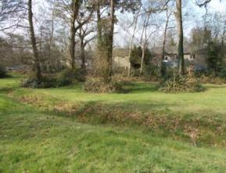
2. View of the dry ditch showing the span to be crossed by the new footbridges.

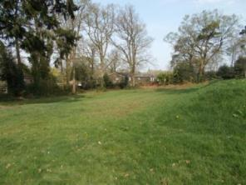

3. View showing the grassy slope where the secondary path will run. Foundations for the Garden block memorials to be laid either side of this path.

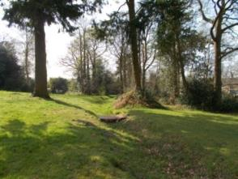

4. View of the dry ditch and the lower woodland area where the secondary path will need to be constructed using a “no dig” method.

Access Information
Access - vehicular / plant / limitations | Largely easy vehicular access depending on weather conditions. The cemetery is open to visitors; the contractor needs to be aware of safety of public users.  The cemetery is open for burials; if ceremonies are to take place nearby, the contractor may be asked to stop work for the duration.
Suggested access route | Via main entrance on Cemetery Road. Alternative access is possible via rear entrance off Richard Close.
Permission required | Yes, consult with Cemetery Manager via Fleet Town council

Consents
Assent to be sought by appointed contractors from Hart District Council and any other required statutory bodies before works commence.

Utility companies will be contacted by the contractor to confirm location of any underground services prior to commencement of excavations

Submissions to include
- Your Project Plan including design statement, method statements and drawings (ref File 2a, 2b, 2c Appendices A to F apply)
- Quality Statements (Part A – File 3) showing confirmation of your understanding of the components of this tender.
- Cost Statements (Part B – File 4).
- Named person as Principal Designer and Principal Contractor or equivalent and Health and Safety information as listed in the preliminaries section of the specification.
- Declarations schedule (File 5).

Standard Specification Clauses
For set up and preliminaries information (including Health and Safety requirements) please refer to the Preliminaries section of the Specification (File 2a)
For detailed technical information please refer to the Specification document included with this package of tender documents. (File 2b)
For additional project specific design information please see the information below and in the attached appendices.
Please use these as a guide with regard your designs and costings.

1. Paths:
Comply with
- Accessibility standards: refer to http://www.fieldfare.org.uk/countryside-for-all/countryside-for-all-good-practice-guide/ Information sheet 2.1 for path gradients, ramps and landings. (Appendix A.)
- Tree protection standards: refer to BS 5837 Trees in relation to construction.
Refer to technical information from the manufacturer for products
- Cellweb/geocell (to be used in the “no dig” areas beneath tree canopies): PRODUCT DATA SHEET details Cellweb® TRP Installation Guide by Geosynthetics Limited Tel: 01455 617 139 Fax: 01455 617 140 Email: sales@geosyn.co.uk. (Appendix B)
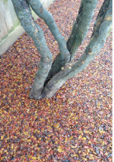
- Construction method: lay geotextile onto existing topsoil/grass (no herbicide) infilling hollows but not reducing the height of any raised areas. Lay Cellweb, expanding and pinning in position as to manufacturer’s instructions. See installation recommendations for dealing with curved path layouts. Infill with angular stone (not Type 1) Type 4/20mm or Type 20/40mm – no fines (to maintain the permeability of the paving)- -overfill by at least 25mm. Do not compact. Encourage settlement with the use of a light roller.

- Agriflex surfacing from Star Rubber Environmental Ltd Tel 01458 253 377 Email: tigermulch@aol.com Address: Belmont House, Aller, Langport, Somerset TA10 0QN. Colour: Autumn. Include for use of Cap Kerbs on timber edging where adjacent concrete memorial foundations to ensure adhesion of rubber surfacing to concrete.
Or similar approved surfacing type
Timber edge only required where surfacing is built up, (in the no dig areas) or where it is adjacent concrete foundations.

2. Memorials:
Refer to drawings and technical information from the manufacturer:
The Columbaria Company, email: columbaria@odlings.co.uk Phone: 01482 387 466
- Foundation design: see product design sheets for
    - Barbican Garden Block memorials (Appendix C)
    - Sanctum 2000 memorials (Appendix D)
    - Sanctum Panorama memorial (Appendix E)
Barbican Garden Blocks

Sanctum 2000 memorials

Sanctum Panorama

3. Bridges: http://documents.hants.gov.uk/countryside/designsandards-bridges.pdf (Appendix F)

4. Fencing
British standard BS1722-7 type SPR 11/3 Nailed Post and 3 Rail fence: 1.1m high; max 1.8m length of post; 3 no rails nailed to posts staggered joints; spacing between rails at posts, from top to bottom: 325, 275mm; spacing between posts 1.8m. Posts set in concrete foundations.
All timber to be pressure impregnated with preservative (not CCA type).

5. Archway
Freestanding brick archway to be designed by the contractor. Submit proposals to include
- at least 1.8m wide aperture.
- At least 2.4m clear height archway
- Width of Pillars either side of aperture to be at least one third the height eg a 1.8m straight height = pillars 0.6m wide; underside of arch apex 2.4m high. 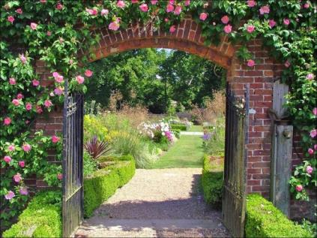


- Alternative design for pillars with eg metal archway may be considered

- Brickwork materials & style to match existing brick cemetery shelter.

6. Water feature
- Stacked stone boulders 5ft high with hollow steel tube to provide support and a pipe for the water to run. To be supplied by Mid Wales Stone company Rhyd, Dolanog, Welshpool SY21 0LJ Phone: 01938 810350 or similar approved.

- Supply water reservoir to fit to the above.
- Pump kit with solar panel to be supplied by Sunstore, Woods Way, Goring-by-Sea, West Sussex, BN12 4QY Tel 01903 213141 or similar approved – include battery and timer. The pump to be Oase Aquaris Solar 1500 fountain or similar approved.
- Fit in position shown on the drawing. Confirm and co-ordinate sequencing of installation with surfacing works contractor.

7. Curved seat
To be supplied by Gaze Burvill Tel 01420 58 84 44 or email info@gazeburvill.com
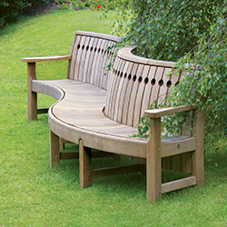
Contractor to include for fixing seat legs into paving area (the circular “Reflection Area” at the base of the slope in the woodland).

