EXPRESSION OF INTEREST ENQUIRY:

WHPC00918 OUTSOURCE REQUIREMENT FOR HSDU

CONTENTS

- INTRODUCTION
- BACKGROUND
- CONTRACT SCOPE
- DETAILED REQUIREMENTS
- SERVICE LEVELS
- CONTRACT MANAGEMENT
- SUSTAINABILITY
- GDPR & PIA
- CONTRACT PERIOD

- Introduction
The HSDU department at Walsall Healthcare NHS Trust (WHT) is responsible for providing decontaminated instruments to facilitate all procedures at Walsall Manor Hospital and other sites as directed by Walsall Healthcare NHS Trust. The sterile service department is in a separate building from the Hospital and Endoscopy sterilisation is within the main body of the hospital. The Department is staffed and operated by the Trust with Facilities and Estate support from Skanska as part of a contract for Hard FM services to the Trust. Addition-specific maintenance and validation support for the sterilizers and washer disinfectors is provided by original equipment manufacturers and Trust-employed authorised person (Decontamination). This department is known locally as the Hospital Disinfection and Sterilisation Unit (HDSU)

The overall objective of this EOI establish market interest from suppliers to secure a modern, efficient, decontamination service, which complies with applicable standards, at a competitive and cost-effective price, enabling the Trust service to provide at current levels of activity and catering for any growth requirements. As a result, the key objectives for the Services required by the Trust are:
- Confidence in the provision of a safe onsite, quality-assured, reliable, and effective sterile service in support of the Trust, and any detailed health community clinical activity
- Delivering flexibility of the Service to meet present and foreseeable demand.
- Providing a long-term solution to decontamination of Medical Devices/Instruments in compliance with the MHRA, all instruments are processed to manufacturers’ specifications.
- Providing of a safe service to all recognised standards and requirements, which meets national best practices.
- Providing a “value for patients” service.
- Providing a reliable turnaround of sterile Instruments and associated equipment ensuring ad hoc and/or emergency requirements can be met within the Trust specified timeframe and include the ability to fast-track designated items.
- Ensuring that there are enough, suitably competent, qualified staff that are fully trained and supervised. Information technology-enabled service and best practice systems with available accurate and real-time data and easily accessible.
- Provision of robust and operational Contingency Plans and Disaster Plans.
“No panic” ethos in that there is always a sufficiency of Instrumentation for the Trust’s staff to have confidence in the service, and Service availability in accordance with the demands of the modern NHS and the Trust’s operating practice.

- Background
The overall objective of this EOI is to establish market interest from suppliers to secure a modern, efficient, decontamination service, which complies with applicable standards, at a competitive and cost-effective price, enabling the Trust service to provide at current levels of activity and catering for any growth requirements. As a result, the key objectives for the Services required by the Trust are:
- Confidence in the provision of a safe onsite, quality-assured, reliable, and effective sterile service in support of the Trust, and any detailed health community clinical activity
- Delivering flexibility of the Service to meet present and foreseeable demand.
- Providing a long-term solution to decontamination of Medical Devices/Instruments in compliance with the MHRA, all instruments are processed to manufacturers’ specifications.
- Providing of a safe service to all recognised standards and requirements, which meets national best practices.
- Providing a “value for patients” service.
- Providing a reliable turnaround of sterile Instruments and associated equipment ensuring ad hoc and/or emergency requirements can be met within the Trust specified timeframe and include the ability to fast-track designated items.
- Ensuring that there are enough, suitably competent, qualified staff that are fully trained and supervised. Information technology-enabled service and best practice systems with available accurate and real-time data and easily accessible.
- Provision of robust and operational Contingency Plans and Disaster Plans.
“No panic” ethos in that there is always a sufficiency of Instrumentation for the Trust’s staff to have confidence in the service, and Service availability in accordance with the demands of the modern NHS and the Trust’s operating practice.
The department provides services for all theatre activities, delivery suites, outpatient clinics, community-based clinics, and Endoscopy. Theatres have extended opening hours until 18:00 hours.
The new equipment purchased needs to be processed in HSDU namely the sterile container systems (tins) and now places more demand on the department, due to the length of time it will.

- Scope of the Contract
The supplier is to provide daily collection and delivery services for all of the instruments for the HSDU service for Walsall Healthcare NHS Foundation trust. This will be on and off-site collection and delivery. All equipment required for the Manor Hospital must be sterilised on site within the Sterile Services department.

Detailed Requirements of Decontamination Services

The following represents an overview of the Services that the service provider must provide via the on-site decontamination facilities for HSDU
- Delivery and Collection of used Instruments/ Medical Devices.
- Logistics to include where appropriate:
- Transportation to and from Services Provider and Trust for outside agencies
- Local distribution to onsite Trust delivery points/ hubs
- Instrument/Medical Device segregation
- Cleaning, weighing, where appropriate, and initial inspection (including necessary disassembly) and disinfection of used Instrument/ Medical Devices.
- Post-disinfection inspection and functionality testing
- Identification of non-conforming Medical Devices (and Instruments).
- Disposal of damaged Instruments
- Assembly (including adding single-use components, implants, and textiles as required)
- Packaging and labelling, including exemptions
- Sterilisation.
- Product release.
- Potential for consumable and instrument purchases
- Track and trace all instrument sets, including loan sets.
- Where required, provide a robust process for the tracking and tracing of high-risk, post-1997, trays/sets; set/Instruments to individual patients.
- Track and Trace and clear labelling to identify Fast Track Items

- Requirements
The Service Provider shall work with the Trust to deliver the decontamination service on site, operating hours, and staffing profile to the Trust activity profile. The Service Provider shall always maintain ten percent 15% additional capacity over the volume of the activity demand, as set out in the activity levels below.

Cat | Category Description | Annual Activity  01/11/22-31/10/23 | Annual Activity contract End (to be confirmed by the Trust  23/24
1 | Supplementary 5 or less | 54669 | 60135
2 | Supplementary >5 | 727 | 792
3 | Trays with up to 10 items | 10708 | 11885
4 | Trays with 11 to 20 items | 11322 | 12567
5 | Trays with 21 to 30 items | 7592 | 8275
6 | Trays with 31 to 40 items | 5720 | 6292
7 | Trays with 41 to 50 items | 267 | 293
8 | Trays with 51 to 60 items | 218 | 244
9 | Trays with 61 to 70 items | 0 | 0
10 | Trays with 71 or more items | 0 | 0
DV | DaVinci | 0 | 0
11 | Loan Kit | 1301 | 1483
TOTAL

External providers will accept responsibility for any lost or damaged equipment from point of collection, processing and delivery.

- Service Levels and Key Performance Indicators (KPIs)
Throughout the Contract Period, for all aspects of the Services that fall within the scope of the Medical Devices Regulations 2002 (MDR), the Service Provider shall maintain registration under the Medical Devices Regulations 2002 or later revisions under United Kingdom law following any United Kingdom exit from the European Union. Furthermore, where required by their chosen route to compliance, the Service Provider shall register with the UK Competent Body. All operations shall be undertaken within the boundaries of a Quality System and comply with all relevant health and safety related and other relevant Laws.
Where a third-party supplier is used for the temporary provision of Services, the third-party supplier’s facility must be registered under the Medical Devices Regulations 2002 (MDR) with the UK Competent Body and comply with all relevant standards as applicable. The Service Provider shall obtain access to information regarding reprocessing of Instruments and other products by the third-party supplier(s) to ensure equivalent standards are maintained. Evidence shall be made available by the Service Provider upon the request of the Trust to substantiate compliance with the Medical Device Directive (MDD) standards.
Where the Trust requires, the Service Provider will provide reasonable access for the Trust to undertake compliance audits giving due notice of any requirement to do so.

Policies and Procedures

The Service Provider shall have policies and procedures that will allow for the safe processing of reusable Medical Devices. These should include but not be limited to:

- Universal infection control procedures
- Decontamination of re-usable Medical Devices
- Tracking and tracing of Medical Devices
- Safe working and the prevention of infection regarding Transmissible Spongiform Encephalopathy
- Safe handling and moving
- Control of substances hazardous to health
- Transportation of used Medical Devices
- Safe disposal of clinical and general waste materials; and
- Manual decontamination of Medical Devices
- All trays and supplementary devices?? should be provided to the Trust as latex-free.
- The Service provider will facilitate access to local audits with respect to policies and procedures
- Track and Trace and clear labelling to identify Fast Track Items Process

It is the responsibility of the Service Provider to ensure that risk and control of substances hazardous to health (COSHH) assessments are regularly carried out and recorded.

The Service Provider will also comply with any local Trust policies around smoking, legionella, fire risk assessment, etc. as deemed appropriate through an agreement between the Service Provider and the Trust.

Quality

The Service Provider shall ensure that:
- Quality assurance records and records relating to the decontamination process are kept secure and available for audit on request by the Trust.
- Paper records will be retained for 21 years, and electronic records will be retained indefinitely.
- All Instrument sets are uniquely identified to allow tracking and tracing throughout the decontamination process to their use on an individual patient.
- Applies best practice industry quality management systems and standards
- Complies with all manufacturer’s instructions

Equipment

The Service Provider shall ensure that (at its own cost):
- All decontamination processing equipment is purchased, installed commissioned, validated and operated in accordance with the relevant applicable European standards, or post Brexit, in accordance with applicable Laws and health technical memorandums. The service provider must ensure full compliance with:
- Medical Devices Regulations 2002 Regulation 14
- ISO 13485: Quality Management System for Medical Device Manufacturing. ISO 13485 is the medical industry's optimal medical device standard, which ensures that all medical devices meet the proper regulatory compliance laws and customer needs.
- EN ISO 13485:2016: is the medical industry's optimal medical device standard, which ensures that all medical devices meet the proper regulatory compliance laws and customer needs including three additional annexes identifying where compliance with the Standard does not adequately address requirements in EU Directives.
- Planned Preventative Maintenance ("PPM") schedules are in place for all decontamination processing equipment and general departmental equipment, (such schedules being in accordance with the Original Equipment Manufacturer (“OEM”) recommendations; and
- Adequate records relating to processing equipment are maintained.

6.4 Trust Equipment
The service provider will take ownership of all existing equipment within the Sterile Services at Walsall Healthcare NHS Trust and will be responsible for the maintenance and life cycling of the equipment unless otherwise agreed with Walsall Healthcare NHS Trust. External providers will accept responsibility for any lost or damaged equipment. (As per section 5 requirements)

For Sterilisation Containers the Service Provider will provide a maintenance management service which will be at the cost of the Trust. The cost will be invoiced by the Contractor to the Trust at cost plus the agreed Management Service Fee. All costs are to be pre-approved by the Trust prior to purchase.
Trust owned instruments and scopes, if damaged will require like for like replacement by the Service Provider.

Acquisition of Instruments and Rigid Containers

Where the Trust and the Service Provider reach an agreement that further Instruments or Rigid Containers are to be purchased the Service Provider shall ensure that:
- All Instruments supplied/purchased where possible from any relevant NHS Supply Chain framework agreement.
- All Instruments are UKCA / CE marked under the Medical Devices Regulation 2002.
- Where possible Instruments can be processed using an Automated washing process under the UK standard settings.
- Instrument suppliers provide training to enable staff to re-process the devices competently; and
- Instrument suppliers aid in the safe disposal of redundant Instrumentation/Medical Devices.

Cleaning and Disinfection

The Service Provider shall ensure that:
- The preferred method of processing is an automated process.
- Adequate personal protective equipment ("PPE") is made available.
- Suitable washing accessories are available for processing Instruments.
- Staff handling contaminated Instruments shall be immunised against Hepatitis B.
- The cleaning and disinfection process maintains Trust Instrument ownership.
- Systems and procedures are in place to identify and separate nonconforming Instruments and products.
- All Instruments, Trays, Rigid Containers, Medical Devices, and transport trolleys are disinfected between uses; and
- Instruments unsuitable for automated washing methods and/or immersion are manually washed in accordance with documented procedures.

Inspection

The Service Provider shall ensure that:
- Initial inspection before cleaning and weighing, where appropriate
- Instrumentation is fully inspected after washing; and
- The reassembly of surgical Instruments is in accordance with manufacturers’ instructions.

Wrapping and Packing

Following sterilisation, there must be a suitable compliant packing solution for the surgical Instruments and other such equipment to ensure they remain sterile and free from damage during storage and transportation to the Trust or their facility. The Provider will provide the required packing solution materials. In addition, the Service Provider shall ensure that:
- Procedures and policies are in place to deal with missing Instruments and the replacement of Instruments in sets.
- The policies and procedures used in the packing room are sufficient to ensure that the integrity of the Tray and set contents is maintained; and
- A completed checklist pre-approved by the Trust is included on or with each set.
- Supplementary/single instruments can be tracked and traced through the process.
- Provide clear labelling of all trays which have been fast-tracked
- Work with the Trusts’ departments to minimise damages and work towards finding low-cost value-for-money solutions.

Sterilisation

The Service Provider shall ensure that:
- Sterilisation methods and equipment are tested and maintained in accordance with the relevant applicable European standards any applicable Laws, and/or health technical memorandums.
- Production records relating to the sterilisation process are maintained and held for a period set out within the Department of Health Records Management Code of Practice for Health and Social Care 2016 or as amended from time to time.

Storage and Cleaning

The Service Provider shall ensure that:
- Processed Instruments and other products are safely and appropriately stored after sterilisation.
- Sterile Instruments and other Medical Devices are stored in a manner that protects their sterility; and
- Trolleys are disinfected each time before being used for the transfer of sterile Instruments and other products

Use (Utilisation of Instruments)

The Service Provider shall ensure that:
- When new Instruments are acquired by the Service Provider or the Trust, training on the correct assembly and disassembly of the Instrumentation is provided by the manufacturer to the employees; and
- Suitable and adequate technical information on decontamination issues and related legislation will be provided to the Trust and/or the Service Provider’s employees as appropriate before purchase.

Turnaround Times Rates

The Contractor shall assume the following rates for the different Turnaround Times as percentages of overall Surgical Instrument throughput at the Services Commencement Date.
Fast Track Standard- tray returned within 4 hrs | 5%
Fast Track Light- tray returned within 12 hrs | 5%
24hr | 90%

In the case of Fast Track and Fast Track Lite requests premium rates apply. It is in the interest of the Trust and the Service Provider to ensure that unnecessary Fast Track and Fast Track Lite requests are kept to a minimum to avoid disruption to re-processing and the avoidance of premium charges.

Fast Track rates will be reviewed regularly at monthly Operational Management Meetings (Band 7) and in the event the assumed rates are exceeded shall be escalated to the Joint Management Board (JMB)

Deliveries

Trays and Supplementary Instruments will be delivered in Transport trolleys or Tote box containers as appropriate and will have the Destination and Status clearly identified including if a Fast Track item is contained within. Transport trolleys will be delivered locked and Tote boxes will be sealed with a green tamper-proof seal. All instrumentation will be processed at Walsall Manor Hospital decontamination services and will be delivered to all sites as p the below timetable.
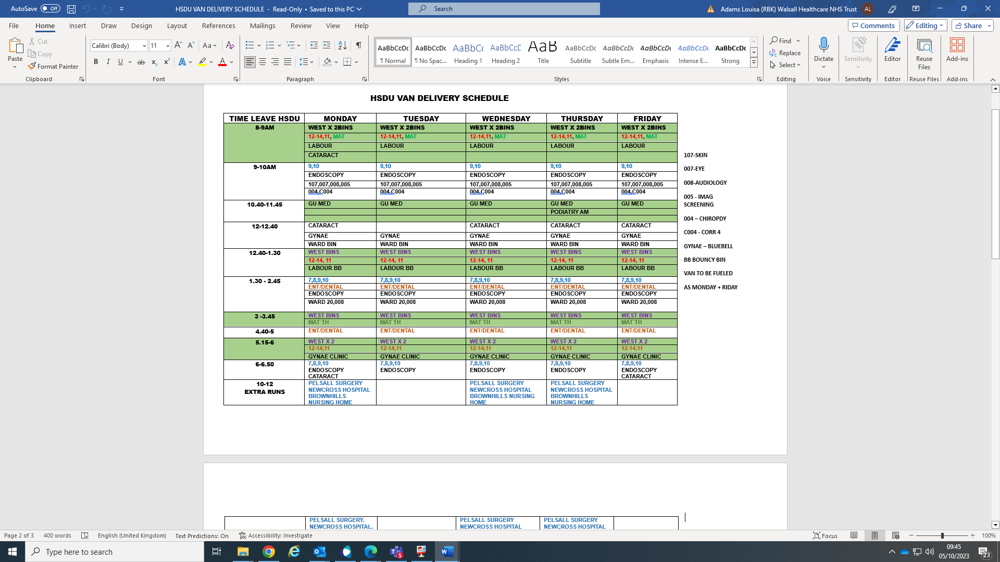
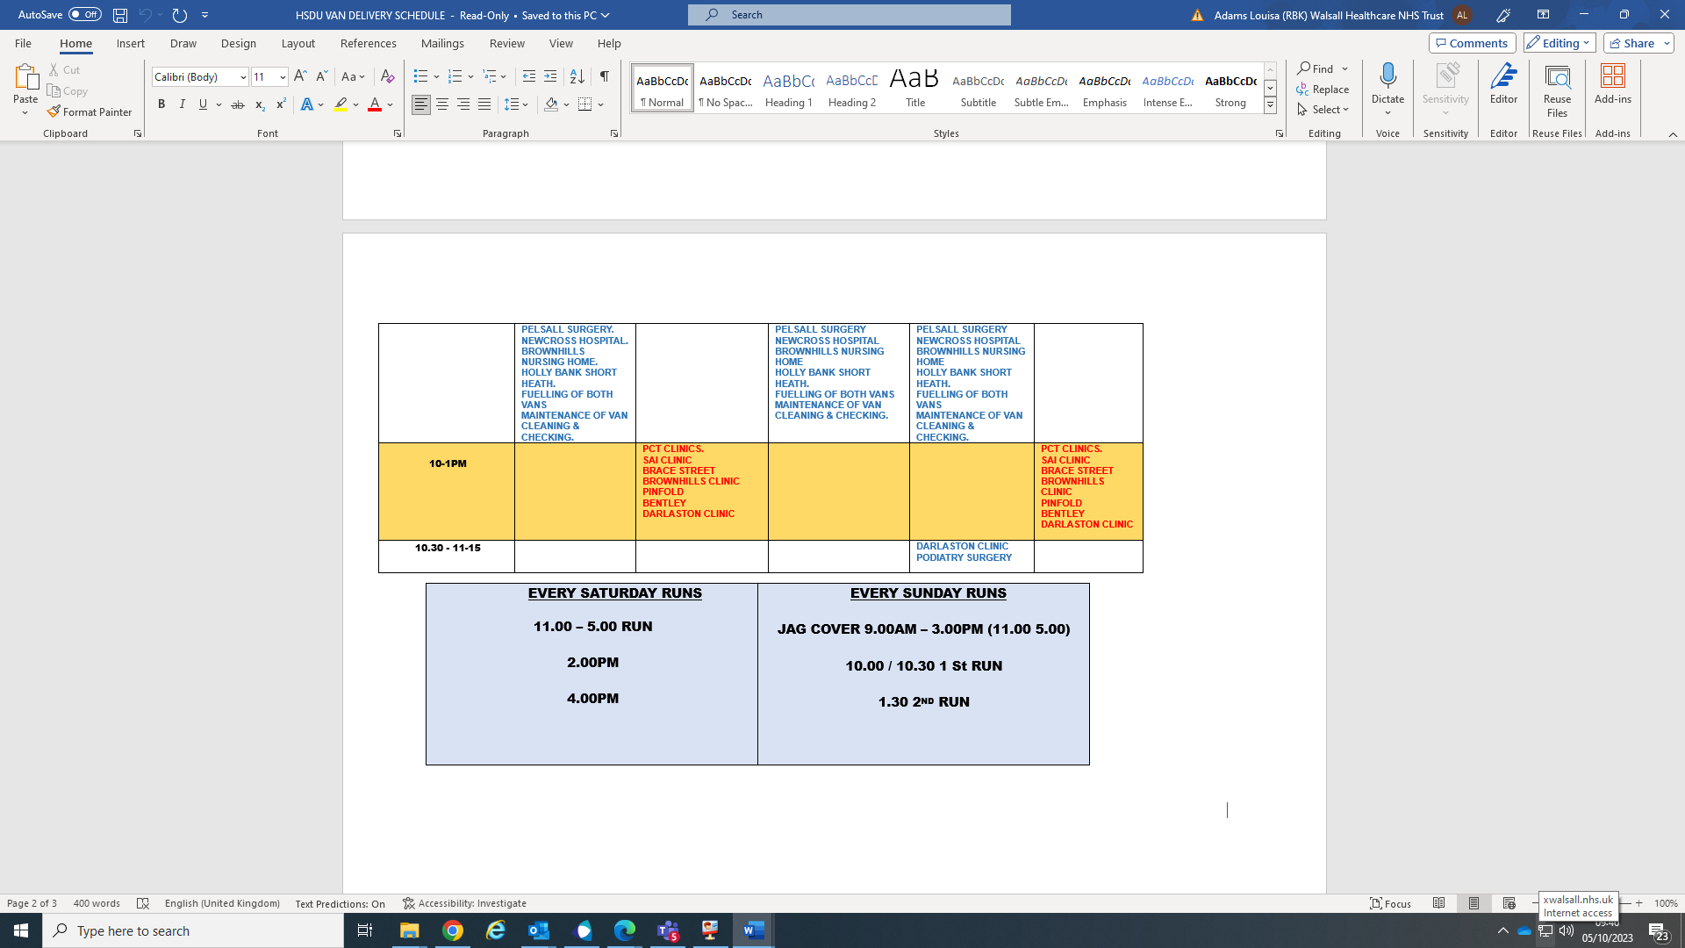

Staff, Training and Qualification Requirements

The current Trust employees within HSDU are required to be TUPE’d across. The roles and associated whole time equivalent (WTE) will be:
Decontamination Programme Manager 1 WTE at Band 8A
Deputy HSDU Manager 1 WTE at Band 4
Supervisors 4.06 WTE at Band 3
Drivers 2.5 WTE at Band 3
Sterile Technicians 16.88 WTE at Band 2

To ensure personal safety, safety of others and general safety, it is essential that personal at all levels should have a sound general knowledge of decontamination principles and processes. The Trust is committed to ensuring that contracted services continue to work towards the Trust aspirations for being an employer of choice.

The Trust is also committed to improving equality and diversity employment opportunities throughout the contact. This will be reported and monitored through the contract management framework annually.

- Contract Management and Review
The Trust, and the Service Provider will work closely through the contract term under the principles of a contract management framework outlined in the tender specification.
The Contract Manager is the Clinical Theatre Services Manager.
The service provider will be required to report monthly via the Trust decontamination meeting performance metrics (KPI’s) including but not limited to:
- Turnaround time including performance against Fast Track and Fast Track lite targets
- Non-conformities
- Incidents of holes
- Incidents of debris
- Incident relating to the end-to-end process
- Staff training compliance

The overall scope of the contract is to deliver a best-in-class decontamination instrumentation service, on time and at a high quality.
A 12-month review will be required by the service provider to include:
  - Includes the Trust Service Performance Delivery
  - Yearly KPI trends
  - Annual Budget summary
  - Staff Turnover – monitoring
  - Staff Training & Development Reporting
  - Serious incident reporting incl. Corrective Action Plans
  - Equality & Diversity Contract Monitoring
  - CIP – In contract efficiencies programme
  - Future year CIP efficiencies target – proposal
  - Business Continuity Plan, Testing and Auditing
  - Sustainability – Report
  - Social Value – Report against targets (Apprenticeships)
  - Audit Reports and PPM schedules

- Sustainability & Ethical Requirements

The Services Provider will ensure that any activities in delivery of this contract, consider sustainability and ethical procurement issues, including but not limited to:
- The environmental impact of services throughout the contract, including during mobilisation and contract exit.
- The sustainable use of utilities during operations.
- The reduction of waste generated during contract delivery
- The potential to improve social value to the local and wider community.
- The identification and minimisation of ethical supply chain issues, including:
- Modern Slavery & Human Trafficking
- Bribery & Corruption
- Assisting the Trust to meet any carbon reduction commitments.
- SME involvement in the delivery of services
- Anti-discrimination and equality requirements.
- Improved efficiencies during the contract term that decrease any environmental or external impacts.

The Services Provider will provide updates to the Trust on current and planned initiatives to improve the service’s environmental performance and improvement in other areas listed above.

The service provider will be responsible for ensuring that any supply chain provider works to the same standards as the Service Provider in areas of sustainability and ethics.

Transition (Implementation) Plan
- General Data Protection Regulation (GDPR) and Privacy Impact Assessments (PIA)
The successful applicant will be expected to complete the below documents, following a Mini-competition procedure against a Framework.

- DPIA
- SAF
- Data sharing agreement
- Contract Period
Following a Mini-Competition Procedure against a Framework the expected Contract start date is 1 April 2025 and expires 31 March 2028 with two 12-month extension options.

