

Hilton Parish Council

Hilton Village Hall, Peacroft Lane, Hilton.DE65 5GH

Tel Office: 01283 730969

Email: clerk@hiltonparishcouncil.org.uk

Invitation to Tender
Reference: HPC002 issued 26 April 2021

Hilton Parish Council has a requirement to provide footpaths alongside the Mease road, outside the Mease Pavilion. Bids are invited in conformance with the enclosed tender documentation. If you would like to be considered for this contract, please read through the document carefully and submit your tender in accordance with the specified procedures. Should you have any queries or require clarification on any point, please contact the undersigned on the above email address.

General Requirement
Bids are invited for the construction of footpaths to Derbyshire County Council specification in the area shown in the drawing below (Project). For reference, the post code of the Mease Pavilion is DE65 5LS.
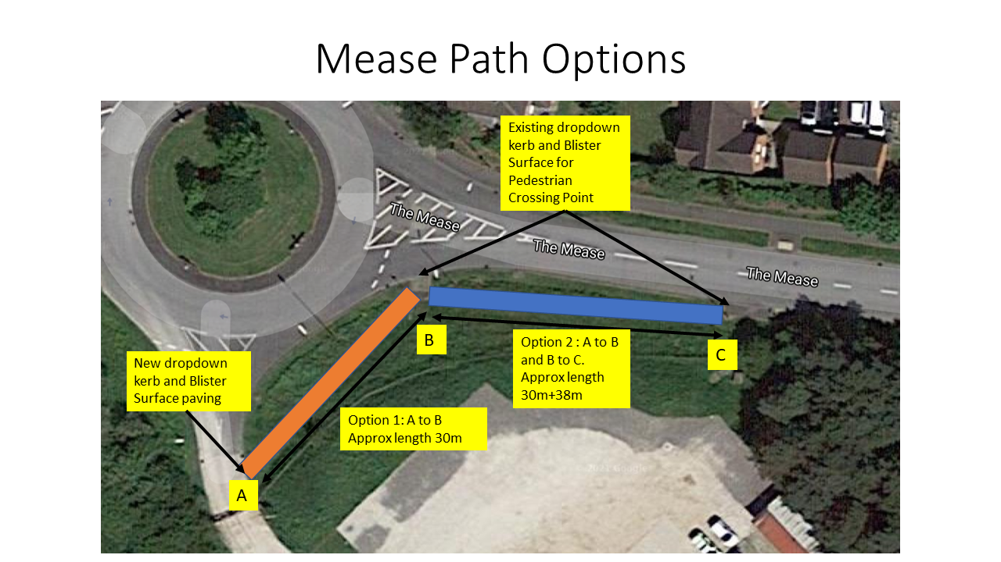
- This will be a turn key Project. The successful bidder will be required to provide all the resources necessary to bring the Project to completion.
  - The successful bidder will obtain all necessary approvals for the work from Derbyshire County Council and any other agency that needs to be involved.
  - The successful bidder will arrange for and manage all necessary traffic management that is required whilst the work is ongoing.
  - On acceptance by the Parish Council and/or Derbyshire County Council, the successful bidder will remove all their equipment, excess material and waste and make good the wider area used during the construction.

note: The Parish Council can provide parking and storage of equipment for the duration of the Project in the car park shown in the picture above.

2 The bid will comprise a fixed price, timescales and guarantee for each of option 1 and 2 as shown in the picture above and detailed as follows:
  - Price for the construction of a 2 metre wide, tarmac footpath with dropdown kerbs and blister surface paving at the Mease Pavilion entrance end (A in picture) and joining up with the existing dropdown kerbs and blister surface paving at the Mease road end (B in picture), shown as option 1 above in full compliance with Derbyshire County Council Highways Department specification for residential footpaths. The price will include the provision of all labour, material, equipment, signage and traffic management.
  - Price for the construction of a 2 metre wide, tarmac footpath with dropdown kerbs and blister surface paving at the Mease Pavilion entrance end (A in picture) and joining up with the existing dropdown kerbs and blister surface paving at the Mease road end (C in picture), going via location B in picture, shown as option 2 above in full compliance with Derbyshire County Council Highways Department specification for residential footpaths. The price will include the provision of all labour, material, equipment, signage and traffic management.
  - The bidder will provide drawings for both options, compliant with Derbyshire County Council Highways Department requirements for such drawings.
  - The bidder will provide timescale plans for each option, preferably in GANTT chart form, showing the duration of the Project. Any dependencies on weather or other requirements beyond the control of the bidder will be highlighted
  - The bidder will guarantee that the completed footpath and any remedial work will be to Derbyshire County Council’s requirements and will have the same guarantee of longevity before maintenance for wear and tear is required, as provided to Derbyshire County Council. If Derbyshire County Council require any further work, this is to be carried out by the successful bidder at no charge to the Parish Council.

Tender Documentation
All bidders are required to complete all the following sections fully and honestly.
If questions are left unanswered, this will be deemed a fail in the bidding process.
If the Parish Council subsequently discovers any discrepancy in the bidder’s response, the bidder will be eliminated from the bidding process. If any such discrepancy is discovered after the contract is awarded, then depending on the nature of the discrepancy, the successful bidder may have the contract terminated with immediate effect and at no cost to the Parish Council.

Information of the Bidder

- Please confirm that your company has the financial capability to take on this Project Yes/No
- Please confirm that your company has Employer’s Liability insurance, Public Liability Insurance and Professional Indemnity Cover and provide the level of such cover Yes/No
  - Employer’s Liability £XXm
  - Public Liability £XXm
  - Professional Indemnity £Xm

- Please confirm that your company or its directors has/have not been the subject of any proceedings which would automatically eliminate your company from the bidding process including bankruptcy, administration, court proceedings of a criminal nature etc. This list is not exhaustive. Yes/No
- Please confirm that your company has not been involved in any dispute with other customers for a similar contract in the last three years Yes/No
- Please confirm that your company complies with all current employment and business legislation Yes/No
- Please provide details below of your company’s experience in delivering this type of Project

Pricing
All prices submitted are to be in Pounds Sterling and exclusive of VAT

1 Fixed price excluding VAT for option 1 as detailed in 2.1 above £xxx

2 Fixed price excluding VAT for option 2 as detailed in 2.2 above £xxx

Timescales
1 Please confirm that a plan as specified in 2.4 above will be provided from Commencement date to Project completion Yes/No

2 Are there weather considerations that could disrupt the plan? Yes/No
If Yes, please state below what those considerations are

3 Please confirm that any necessary changes to the agreed plan will be discussed and agreed with the Parish Council before a revised plan is issued
Yes/No

Business Requirements
The Parish Council and the successful bidder will complete the Appendix to this Tender which, upon execution, will become the contract between the Parish Council and the successful bidder.
The Parish Council and the successful bidder will each appoint a Project co-ordinator who will be the point of contact between the Parish Council and the successful bidder. The Project co-ordinators will have the authority to make binding decisions on both parties under the terms of the signed contract.

- Please detail how compliance with Derbyshire County Council requirements will be demonstrated.

- Please state if access to the car park is required Yes/No

Submission of Quotation
Quotations should be submitted by email to: clerk@hiltonparishcouncil.org.uk by no later than 24 May 2021.
The tender reference number must be put in the Subject box of the email.

Quotations received after the closing date will not be considered.

If you wish to query or have clarified any aspect of this tender documentation, then please allow sufficient time for the Parish Council to respond before the deadline for submission and in all cases no later than five working days before the deadline.

After the receipt of the quotations, they will be viewed by a sub-committee of the Parish Council on 25 May 2021. The sub-committee of the Parish Council will ensure compliance of all bids with the tender documentation requirements. The sub-committee will then evaluate the bids against its award criteria. Please note that the Parish Council does not have to select the lowest quotation.
During this evaluation, the Parish Council may seek clarification of certain inputs.
The Parish Council also reserves the right to seek another round of bidding from a short list of bidders.
The Parish Council will notify the successful bidder by email

All pages of this tender document must be returned and will form the final contract for the successful bidder, when signed as such by the Parish Council.

Bidders must not take part in any publicity activities with any part of the media about this tender process without getting the Parish Council’s written agreement first. This includes the Parish Council’s agreement on the format and content of any publicity.
This tender documentation is made available in good faith. The Parish Council give no warranty as to the accuracy or completeness of the information contained in it. The Parish Council also disclaim any liability for any inaccuracy or incompleteness. The Parish Council reserve the right to cancel this tender process at any point.
The Parish Council are not liable for any costs resulting from any cancellation of this tender process or for any other costs that bidders may incur by tendering for this contract. Bidders must obtain at their own expense all the information that they need for the preparation of their tender.
Bidders will be deemed to fully understand the processes that the Parish Council must follow under relevant European and UK legislation, particularly The Public Contracts Regulations 2015 and Public Contracts (Amendment) Regulations 2009.
I DECLARE THAT TO THE BEST OF MY KNOWLEDGE THE ANSWERS SUBMITTED IN THE TENDER DOCUMENTATION ARE CORRECT. I UNDERSTAND THAT THE INFORMATION WILL BE USED IN THE EVALUATION PROCESS TO ASSESS MY ORGANISATION’S SUITABILITY TO TENDER FOR THE PARISH COUNCIL’S REQUIREMENT. SHOULD THE COUNCIL DISCOVER ANY DISCREPANCIES OR THAT I HAVE BEEN DISHONEST WITH THE ANSWERS THIS WILL RESULT IN THE ORGANISATION TO WHICH I HAVE COMPLETED THIS QUOTATION FOR, BEING REJECTED FROM THE TENDER PROCESS OR IF AWARDED A CONTRACT WILL HAVE THE CONTRACT TERMINATED WITH IMMEDIATE EFFECT AND NO COST INCURRED TO THE COUNCIL. Signature is mandatory, failure to do so will result in your bid being deemed non compliant which will result in your bid being disqualified from this tendering process.
Name:
Position (Job Title):
Date:
Telephone number:
Signature:
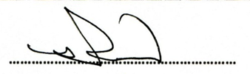
This tender and any resulting contract will be governed by the laws of England and Wales.

Signed for and on behalf of Hilton Parish Council

Name Russell Pollard
Position Cllr/ Responsible Financial Officer
Date 26th April 2021

Appendix

On selection the successful bidder will agree the following terms and conditions as part of the final contract between Hilton Parish Council and the successful bidder.

Acceptance
Hilton Parish Council will accept the completion of the footpath to the agreed specification by its own inspection and the provision of any necessary paperwork from Derbyshire District Council Highways Department which shows compliance with all their requirements.

Payment
Upon acceptance, the successful bidder will present an invoice to Hilton Parish Council for the fixed price agreed in the tender for the completed work. The invoice to contain all the information required by Hilton Parish Council.
Hilton Parish Council will settle the invoice by BACS transfer no later than a period of 14 days from the date of presentation of a valid invoice.

Changes to Specification
If, during the carrying out of the work, any issue arises that requires a change to the agreed specification or timescale in the Tender, then the two project representatives will agree what change is necessary. The change will be agreed in writing. If the agreed change results in an adjustment to the fixed price, this will be agreed by the two project representatives and the new fixed price will be deemed to be that of the tender and contract.

Dispute
In the unlikely event of a dispute between the two project representatives who are unable to resolve the dispute, then the dispute will be escalated to the Full Hilton Parish Council and the successful bidder’s senior management who will attempt to settle the dispute. As a last resort either Hilton Parish Council or the successful bidder has the right to seek resolution through the law.

Indemnities
The successful bidder shall indemnify and keep indemnified Hilton Parish Council against all actions, proceedings, costs, claims, demands, liabilities, losses and expenses arising in breach of this contract, to the extent that any such loss or claim is due to the breach of contract, negligence, wilful default or fraud by the successful bidder, save to the extent that the same is directly caused by or directly arises from the negligence, breach of this contract by Hilton Parish Council.
Limitation of Liability
Neither the successful bidder nor Hilton Parish Council shall be liable to the other for any indirect or consequential loss arising under this contract.

Freedom of Information
The successful bidder acknowledges that Hilton Parish Council is subject to the requirements of the Freedom of Information Act and will provide all necessary assistance and cooperation as reasonably requested by Hilton Parish Council to enable Hilton Parish Council to comply with the Freedom of Information Act.

Termination for Breach
Hilton Parish Council may terminate this contract with immediate effect if the successful bidder remains in unremedied breach of the contract after reasonable notice from Hilton Parish Council of such breach.

Force Majeure
Neither the successful bidder nor Hilton Parish Council will be liable for any delay in or from performing any of its obligations under this contract by circumstances beyond its reasonable control. The party in delay shall notify the other party as soon as reasonably practicable, in writing of the reason, likely duration and the effect on its ability to perform any of its obligations under the contract; and use all reasonable endeavours to mitigate any such effect.
Executed as a Deed

Signed for and on behalf of Hilton Parish Council ……………………………………………………

Name ……………………………………………………

Position ……………………………………………………

Date ……………………………………………………

Signed for and on behalf of [the successful bidder]……………………………………………………

Name ……………………………………………………

Position ……………………………………………………

Date ……………………………………………………

