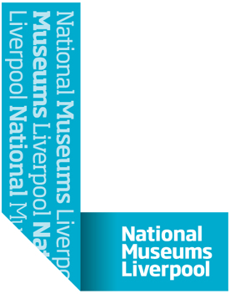

Attendance Policy

Principles

As your employer, NML expect you to attend work in line with your contracted hours.

NML accept that there are occasions when absence is unavoidable and we endeavour to support our employees in achieving a healthy work-life balance.

If your absence reaches a level that NML feel has an operational impact (known as NML trigger levels), this will be addressed with you by your manager. If your attendance levels do not improve sufficiently, formal action may be considered.

This policy explains your obligations to NML, and our obligations to you, when you are unable to attend work due to illness.

Procedure

If you are ill

Tell us you are not coming into work
On your first day of illness, you must phone your manager or agreed point of contact to tell them that you are going to be absent from work. You need to notify your manager before the time that you would normally start work. If you cannot contact your manager you should leave a message with another member of your team. If this is not possible, contact HR.

In exceptional circumstances, if you are too unwell to telephone (for example in case of hospitalisation) a relative or friend may telephone on your behalf.

You need to let your manager know the reason for your absence, how long you expect to be absent for, and any work related issues that may need dealing with while you are off work.

Your manager will let you know when they next expect to hear from you. You need to keep them up to date with your situation.

A notification of sickness form will be completed by the person you speak to and sent to HR, to record your absence and the details of your call as appropriate.

If you do not come into work when expected, and you have not contacted your manager, your manager will contact you to find out why you are not in work. If you can not be contacted, and you do not contact us, your absence will be considered unauthorised, and you will not be paid for the time you are absent.

Self Certify or a doctor’s note?
If you are ill for seven calendar days or less you self certify your absence by providing the details on our sickness declaration form when you return to work.

If you are ill for eight calendar days or more you need to send your manager a doctor’s note or hospital note to provide medical certification. If you don’t send us any medical certificates to cover your absence from the eighth day we may consider your absence unauthorised, and withhold your pay.

A doctor’s note (Statement of Fitness for Work) may also state that you are fit for work but with recommendations. You need to notify your line manager of this, who will work with HR to ensure NML meet your doctor’s recommendations, as far as, is reasonably practical.

- Coming back to work
If you have been off work due to illness for half a day or more you will complete a sickness declaration form on your first day back in work.

You will then meet with your manager on your first day back for a return to work chat to catch up with what has been happening while you were off, to ensure you are well enough to be back and undertake your role, to discuss any concerns or issues you may have, and to review your attendance.

Agreed with PCS and Prospect | August 2013
Approved by the Executive Team | September 2013
Approved by the Board of Trustees | October 2013
Revised | August 2013
Review date | August 2017

