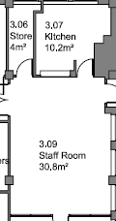127 Dale Street

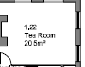North Street

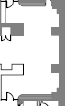 world 52m2

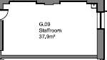 Walker Art Gallery

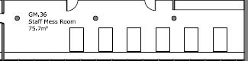 Maritime Museum

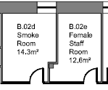 Lady Lever

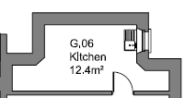Sudley House

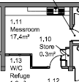 Juniper street 1

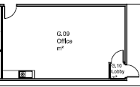 Juniper street 2

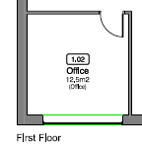22 Johnston Street

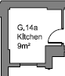county sessions

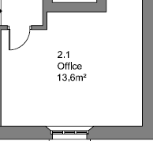 Piermasters house

MOL 6.92m x 4.53