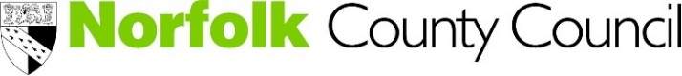
Go Digital Programme
Digital Tools
Digital tools include (but are not limited to):
Management software e.g. CRM (Customer relationship management) or management information system online | Data analytics such as Google Analytics
Data/file storage in the cloud (e.g. Dropbox, Google Drive, OneDrive, iCloud, etc.) | Mobile internet and technologies
E-commerce (buying from suppliers and/or selling online to customers) | E-commerce (buying from suppliers and/or selling online to customers)
Search engine optimisation | Website
Billing customers using online software (e.g. Xero, Sage Cloud, Quickbooks, etc.)  VOIP/Internet telephones | Virtual/online meetings
Online collaboration tools (e.g. Troll, Basecamp, Slack, etc.) nline collaboration tools (e.g. Troll, Basecamp, Slack, etc.) | Digital procurement (applying for tenders/work online)
Online learning schools/courses | Digital HR tools
Connection speeds | Security and data protection measures eg. Firewalls, malware protection, backed up files, encrypted data
There will also be tools specific to certain sectors for example booking platforms for the visitor economy.

