

Expression of interest

Title: T Levels Transition Programme Phased Implementation Research
Project reference: DFERPPU/2019/012
Deadline for expressions of interest: 5pm on 12/08/19
Word limit: 1,000

Summary
EOIs are being sought for research into the T Level Transition Programme to inform future roll out. The research will focus specifically on providers views of the preparation and implementation phases of phased implementation, including the provider support package, early adopter development fund and level of support providers recieved. Alongside this the research will also explore the views of learners and those implementing the programme.

Background
T Levels are new two year technical programmes being introduced from 2020 for young people aged 16 to 19 in England. They have been developed with employers and will combine classroom study with workplace experience, from which students can progress directly into work or further study. T Levels, alongside apprenticeships, will provide young people with a high-quality technical alternative to A levels. Not all young people will be ready to start a T Level at age 16. A tailored transition programme for T Levels will provide a solid preparation phase that will give students the opportunity to develop the academic skills, technical skills, knowledge and behaviours required to progress to a T Level, and to successfully complete it. This will ensure that students who would not otherwise have been able to access a T Level are well prepared to commence their chosen T Level and are more likely to successfully complete it.
The Department intends to provide a guiding framework which will set out key components that are nationally set, with flexibility for providers to package their T Level Transition Programme at a local level to meet the needs of their students. As with other study programmes it will be available for young people aged 16 to 19 and for young people with Education, Health and Care Plans up to academic age 25.

The programme will be introduced through a phased implementation approach, working with the early T Level providers, to explore the effectiveness of different approaches. Initially we will have two rounds of phased implementation, leading up to delivery in September 2020 and September 2021, ahead of national roll out. Each round will consist of 3 phases: advisory panels, provider preparation year and implementation year. Thirty-seven providers have signed up to be involved in the first round. The Association of Colleges (AoC), working with their partners, The Challenge Network, have been appointed as the delivery agent to help support phased implementation; their role is to provide support to providers in preparing for and delivering the programme. An Early Adopter Development Fund will also be available to providers taking part in this first round of phasesd implementation. The funding is for one year only, to enable these early providers to support the Department to co-create high quality courses.

Phased implementation approaches for round one and round two:

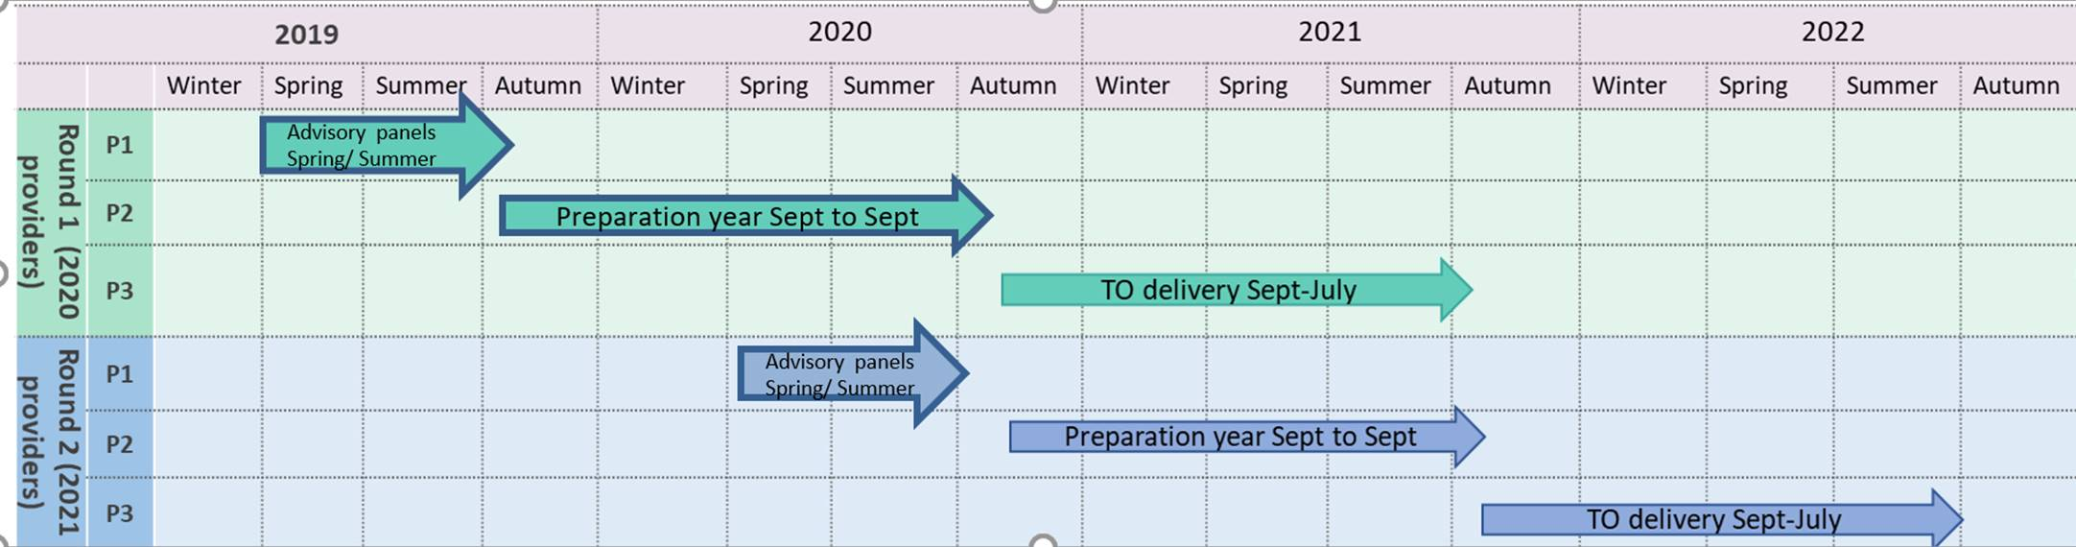

Research aims
The overarching aim of this research is to understand how the T Level Transition Programme support package (including the guiding framework, the delivery agent’s support and the early adopter fund) is being used by providers to plan, design and implement their T Level Transition Programme.

The high level aims for this research are:
Provider preparation year
- To understand providers views on the usefulness of the advisory panels and the guiding framework which the panels produced.
- To understand how providers felt about the support programme, including whether they felt ready at the end of the preparation year for implementation.
- To understand the challenges providers faced in implementing the T Level Transition Programme.
- To understand how providers felt about the early adopter fund and what they spent it on.
- To understand the systems and processes providers put in place to build readiness for implementation.

Implementation year
- To understand provider’s views on the perceived usefulness of the guiding framework in the implementation year.
- To understand the the challenges providers faced in implementing the T Level Transition Programme, including lessons learnt to inform their approach going forwards.
- To understand providers provider’s views on the level of support they received during the implementation year.
- To understand providers views on the different approaches to the T Level Transition Programme, including level of support needed for each approach.
- To understand learner’s views on the T Level Transition Programme.

Methodology
The department has set out a proposed approach for this research below. However, we will invite potential bidders to propose an alternative approach to meet the aims of the project at full tender stage.

Round 1 of phased implementation
Provider preparation year (September 2019 – July 2020)
We expect the fieldwork in the provider preparation year will be conducted in two phases:

- Initial interviews (Late November – December 2019)
We envisage an initial phase of hour-long face to face interviews with a sample of providers who have signed up to be involved in the first round in late November/December. The purpose of this stage of interviews is to explore provider’s views of the guiding framework examples and the role of the panels.

- End of year interviews (May – July 2020)
We propose hour-long telephone interviews with a target sample of all 37 providers at the end of the preparation year and with a sample of the delivery agent support staff. These interviews will find out about provider’s views on the challenges of preparation, providers perceived preparation levels and the spending of the early adopter fund.

Implementation year (September 2020 – July 2021)
We envisage telephone interviews with a target sample of all 37 providers at the end of the implementation year and a sample of the delivery support agent staff to understand the challenges of implementation and the usefulness of the providing framework. Focus groups with learners across the three main approaches for the programme being tested are also suggested.

The department anticipates the successful contractor will analyse the data from the interviews and focus groups thematically. Management information will also be analysed across both phases of work, the delivery agent and Education and Skills Funding Agency (ESFA) will collect this information and provide this to the the successful contractor for analysis.

Round 2 of phased implementation
We envisage the approach for the research into round 2 of phased implementation will be lighter touch. We will provide the specification for research for round 2 to the contractor in early 2020 and will invite suggestions for methodological approaches at that point. We envisage that this would involve some qualitative data collection and analysis as well as analysis of management information.

Timing
The department is procuring a contractor to cover round one and two of phased implementation. There will be two review clauses in the contract where the department will reserve the right to decide whether to take the contract forwards. The first review clause will be in early 2020 and the second will be in September 2021 where the department will decide whether to extend the contract to September 2022, subject to the spending review.

Activity | Timing
Expression of interest (EOI) issued | 31/07/19
Deadline for EOIs | 12/08/19 (5pm)
Invitations to tender issued (ITT) to shortlisted organisations | 19/08/19
Deadline for tenders to be submitted | 09/09/19 (5pm)
Contract awarded | By 20/09/19
Inception meeting (London) | W/C 23/09/19
Work begins | W/C 30/09/19

Assessment criteria
Expressions of interest will be assessed against the following criteria; which are equally weighted at this stage.
- Evidence of suppliers' knowledge of the policy area.
- Evidence of suppliers' capacity and capability to carry out the work.
- Evidence of suppliers’ experience in carrying out similar research in relevant policy areas. This includes assessment of the suppliers’ expertise and experience in qualitative research and quantitative data analysis.
Word limit: 1,000 words
Closing date for EOIs: 5pm on 12/08/19
Send your EOI form to: eve.schofield@education.gov.uk

How to submit an expression of interest
You must submit an expression of interest (EOI) in order to be considered to be invited to tender. To do so, please complete the NEW EOI Form which can be found under attachments. A submission of an EOI does not guarantee an invitation to tender and the Department does not routinely advise organisations that they have not been successful in being invited to tender. Feedback is however available on request.
All contracts are let on the basis of the Department’s Terms and Conditions, also attached. You are encouraged to check these before submitting your expression of interest, as these form part of your contractual obligations.
© Crown copyright 2019

https://assets.publishing.service.gov.uk/government/uploads/system/uploads/attachment_data/file/779002/T_Level_action_plan_2018.pdf
https://www.gov.uk/guidance/t-levels-next-steps-for-providers#t-level-transition-programme

