Photos of solar pump locations
Photo 1 – TL96871279 (Bale field)
Photo showing existing chamber which will be altered prior to installation to accommodate the solar pump

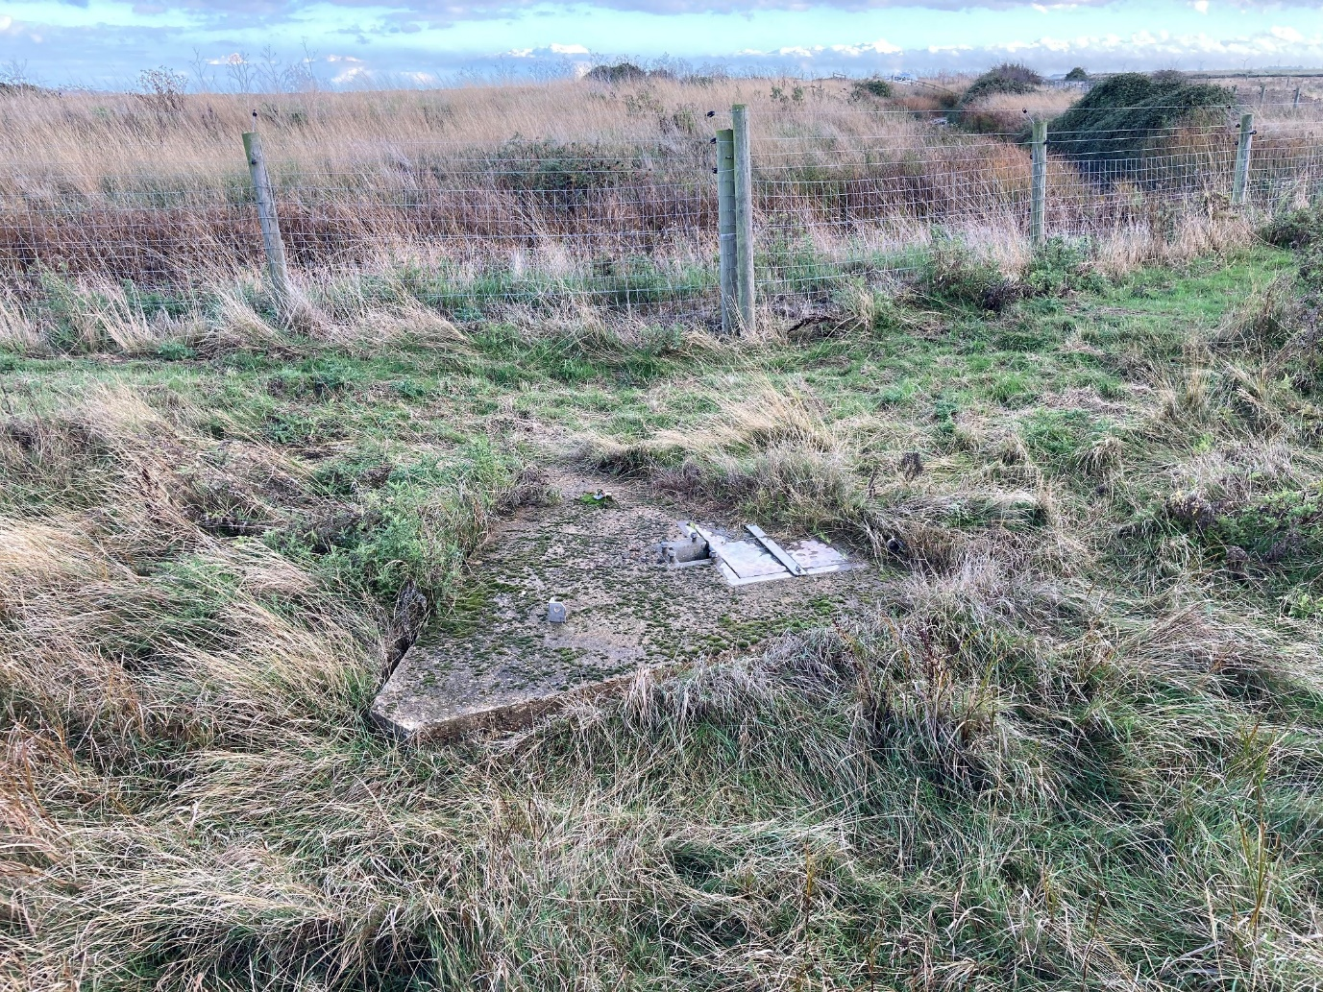

Photo 2 - TL97271240 (Joyces Head)
Showing reeds growing in front of a bank where solar pump will be installed.
A section of the bank will be cut, with galvanised sheet piles (or similar) driven in to stabilise the bank to accommodate the solar pump.

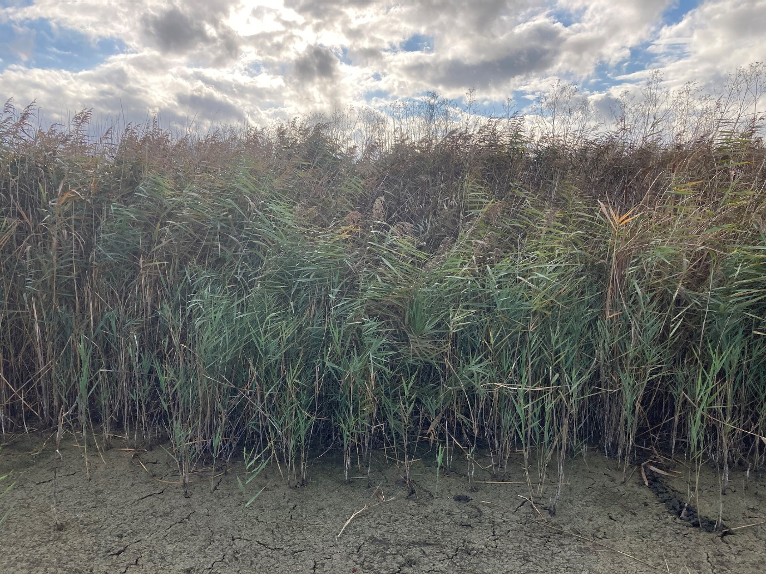

Photo 3 - TL97271240 (Joyces Head)
Photo taken from top of the bank.

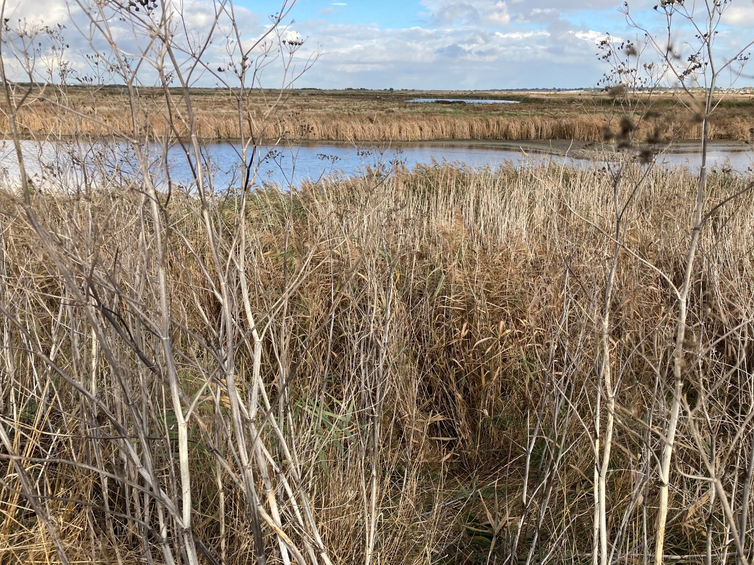

Photo 4 - TL96011297 (Salcott)
Photo showing ditch in which solar pump will be installed.
A section of the bank will be cut, with galvanised sheet piles (or similar) driven in to stabilise the bank to accommodate the solar pump.

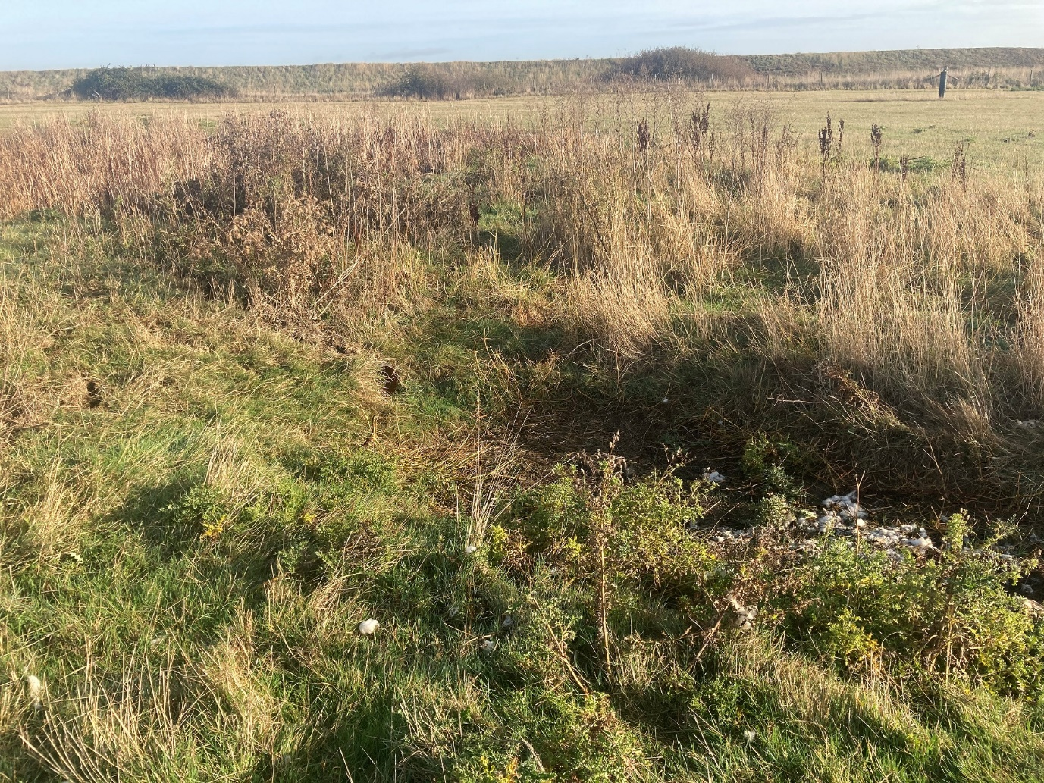

Photo 5 - TL96181279 (Salcottstone Brook)
Photo taken from bankside of river where solar pump will be installed.
A section of the bank will be cut, with plastic sheet piles (or similar) driven in to stabilise the bank to accommodate the solar pump.

