INSERT INTO REQUIRED FORMAT/LOGOS ETC
Lancashire and South Cumbria ICS
Suicide Prevention Training Specification
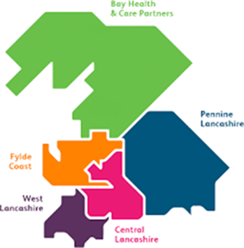

Contents

Section | Title | Page
1 | Introduction:
 | Context
 | National Strategic Background
2 | Lancashire and South Cumbria Integrated Care System Current Suicide Profile
3 | Training requirements:
 | Aims and objectives
 | Risk factors
 | Current delivery
 | Targeted populations
 | Key employers
 | Innovation fund
4 | Signs of success:
 | Outputs
 | Outcomes
 | Pathway development
Appendix 1 | Lancashire and South Cumbria ICS Logic Model
Appendix 2 | Key documents
Appendix 3 | Funding weighting

1 - Introduction
Context
This specification is focussed on the delivery of an all age suicide prevention training (including mental health and self-harm) across the Lancashire and South Cumbria Integrated Care System (L&SC ICS). Commissioners view this as a key element of placed based prevention in the mental health agenda.
Suicide Prevention, is one of the cross cutting work streams within the L&SC ICS. The vision for the Lancashire and South Cumbria Suicide Prevention plan, which was endorsed and agreed in November 2017, is “Lancashire and South Cumbria residents are emotionally resilient and have positive mental health”.
L&SC ICS has developed an action plan based on national guidance and local information as a vehicle to deliver the Governments national target of a 10% reduction in suicides by 2021. The L&SC Suicide Prevention Logic Model (see appendix 1) has 5 pillars:
- Leadership
- Prevention
- Intervention
- Post Vention
- Intelligence
L&SC ICS has been successful in securing nation investment from NHS England who are investing in 8 ICSs (STPs) of 44 nationally. The delivery of suicide prevention training must focus on:
a) Prevention beyond secondary services: place-based community prevention work targeting; middle-aged men and/or primary care support
AND/OR
b) Reduction within services via quality improvement: self-harm care within acute hospitals and/or generally within mental health services. This should account for people with diagnoses of personality disorder
National Strategic Background
Suicide is rising, after many years of decline. Suicide rates in England have increased steadily in recent years, peaking at 4,882 deaths in 2014. The rise is most marked amongst middle aged men. Suicide is now the leading cause of death for men aged 15–49. Men are three times more likely than women to take their own lives - they accounted for four out of five suicides in 2013. A quarter of people who took their own life had been in contact with a health professional, usually their GP, in the last week before they died. Most were in contact within a month before their death.
More than a quarter (28 per cent) of suicides were amongst people who had been in contact with mental health services within 12 months before their death, amounting to almost 14,000 people in the ten years from 2003-2013. However, suicides amongst inpatients in mental hospitals have significantly declined over the same period, as a result of better safety precautions.
Suicide is the second leading cause of maternal death, after cardiovascular disease.
Mental Health Five Year Forward View (FVFV) https://www.england.nhs.uk/wp-content/uploads/2016/02/Mental-Health-Taskforce-FYFV-final.pdf
Recommendation 3: The Department of Health, PHE and NHS England should support all local areas to have multi-agency suicide prevention plans in place by 2017, reviewed annually thereafter and supported by new investment.

Lancashire & South Cumbria Integrated Care System
Designed to bring together the NHS, Local Government, Communities and Community Organisations; the key strategic partners are:
- NHS England- North West Coast Strategic Clinical Network
- Clinical Commissioning Groups (CCGs) - Greater Preston, Chorley and South Ribble, East Lancashire, West Lancashire, Blackpool, Fylde and Wyre, Morecambe Bay, Blackburn with Darwen
- Local Government - Lancashire County Council, Cumbria County Council, Blackpool Council, Blackburn with Darwen Council
- NHS Acute and Community Trusts - Lancashire Teaching Hospitals NHS Foundation Trust, University Hospitals of Morecambe Bay NHS Foundation Trust, East Lancashire Hospitals Trust, Blackpool Teaching Hospitals NHS Foundation Trust and Lancashire Care NHS Foundation Trust
- VCFS sector
The L&SC ICS is made up of 5 Integrated Care Partnerships (ICP's) Localised Health & Care Economies who form and facilitate partnerships with local communities and community organisations. See diagram 1 below:
Diagram 1 – L&SC ICP's

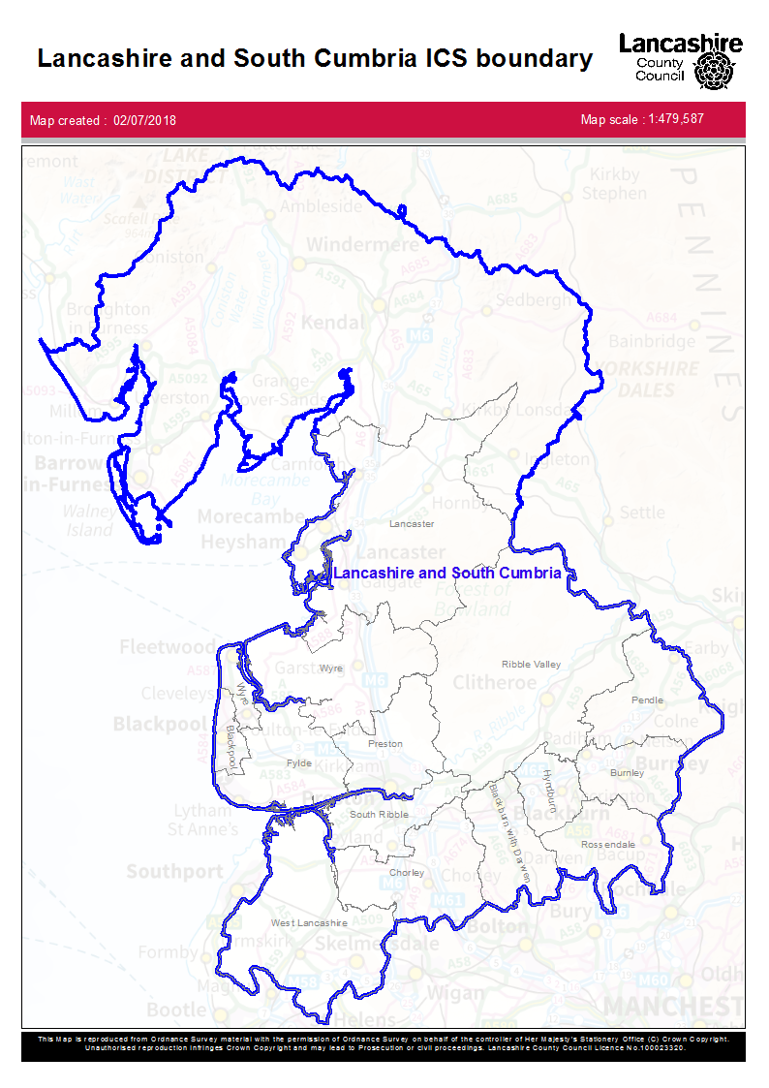
The geographical area of L&SC ICS includes the following districts:

- Barrow-in Furness
- Blackburn with Darwen
- Blackpool
- Burnley
- Chorley
- Fylde
- Hyndburn
- Lancaster
- Millom & Environs
- Pendle
- Preston
- Ribble Valley
- Rossendale
- South Lakeland
- South Ribble
- West Lancashire
- Wyre

Table (1) Deprivation Score (IMD 2015)

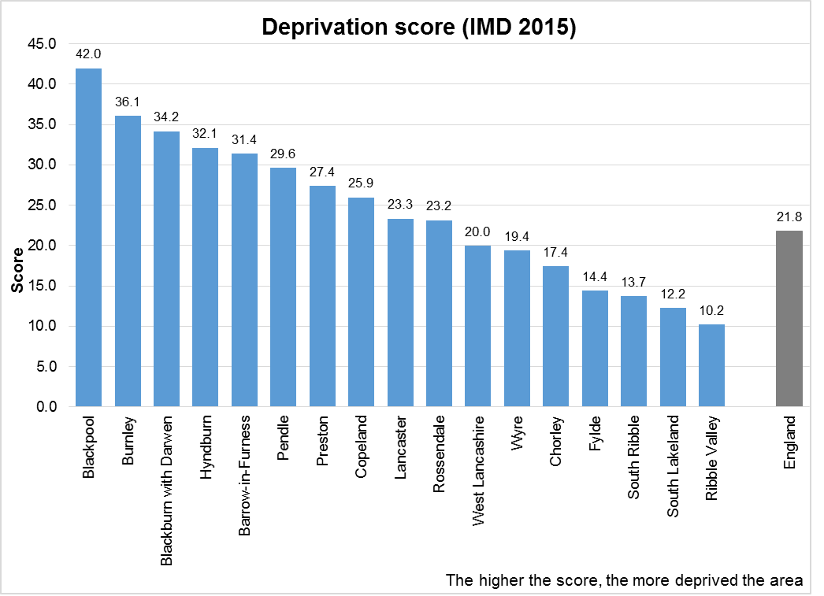

CCG | Registered patients (April 2018)
BLACKBURN WITH DARWEN CCG | 174,986
BLACKPOOL CCG | 173,268
CHORLEY AND SOUTH RIBBLE CCG | 183,432
EAST LANCASHIRE CCG | 381,783
GREATER PRESTON CCG | 209,377
MORECAMBE BAY CCG | 345,853
WEST LANCASHIRE CCG | 113,697
FYLDE & WYRE CCG | 177,378
Lancashire & South Cumbria STP | 1,759,774
Source: NHS Digital
Table 2: Registered patient by area

2 Lancashire and South Cumbria ICS Current Suicide Profile
The L&SC ICS has established a Suicide Prevention Oversight Group which will work across the ICS to achieve the national target of a 10% reduction in suicides by 2020.
The data presented below focusses on Suicide rates in and across the L&SC ICS and the main findings of Local Authority level suicide audits across the ICS footprint.
L&SC ICS is ranked 4th nationally for the rate of suicide (age standardised per 100,000 population, 2013-15) with a rate of 12.2. This compares to a range between 15 and 7 across England.
On the same basis the ICS is ranked 5th for male suicides with a rate of 18.6 and 8th for female suicides with a rate of 5.9.
Male deaths are highest in the 30-44 and 45-59 age groups with rates of 27 and 24.5 per 100,000 population. Female deaths also peak in these same age ranges with rates of 7.4 and 7.9 respectively.
Table (3): The L&SC ICS ranks as follows across the age ranges compared to other ICS's:
Age range | National STP ranking
10-29 | 11th
30-44 | 5th
45-59 | 8th
60-74 | 9th
75 and over | 18th

Within the ICS footprint Blackpool (16.0), Hyndburn (15.3) and Preston's (13.7) suicide rates are significantly higher than England. Blackpool and Preston share 21% of all suicide deaths across the ICS local authorities. Nationally Preston is ranked 4th, Blackpool is ranked 7th and Hyndburn is ranked 11th out of all 326 upper tier and district authorities. The local authorities of Barrow-in-Furness, Blackburn with Darwen, Chorley, Copeland, Fylde, Hyndburn, Lancaster and Ribble Valley appear to be showing an increasing rate; the England rate is showing signs of stabilisation.
Self-harm is known to be a significant risk factor in suicides. Within the ICS nine local authorities have rates of emergency hospital admissions for intentional self-harm that are significantly worse than England. Blackpool (578.9 per 100,000) and Barrow in Furness (342.9) are the two local authorities with clearly higher rates than the rest of the ICS; the England rate is 185.3.
Each of the local authorities within the ICS has conducted suicide audits over recent years. Whilst not identical in methodology, the audits have raised a number of emerging themes that are common across each. The stand out common themes are as follows:
- Depression/mental illness
- Alcohol and substance misuse
- Self-harm
- Relationship breakdown
- Financial difficulty
The suicide rate amongst men in Lancashire & South Cumbria is higher than in other age groups and females, as follows:
Table 4: Lancashire and South Cumbria STP Suicide Rates 2013-2015
2013-2015 suicide rate Lancashire & South Cumbria STP
Age | Male | Female | All persons
10-29 | 8.9 | 4.5 | 6.7
30–44 | 27 | 7.4 | 17.1
45–59 | 24.5 | 7.9 | 16.2
60–74 | 16.7 | 4.0 | 10.2
75 and over | 14.9 | 5.1 | 9.2

3 Training requirements
Communities and service providers are more skilled to identify individuals at risk of suicide and respond appropriately, as such we need to target training to communities, service providers, local workplaces and other settings to maximise the impact of training delivered.
Suicide prevention, mental health awareness and well-being is a priority for L&SC ICS, with recognition that there is no health without mental health.
Levels of well-being are lower and prevalence of mental illness is higher in the L&SC ICS than nationally.
One element of this work-plan is to increase the skills and capacity of the wider public health workforce within partner organisations and communities, particularly the children and young people's workforce, and to support an assets approach to improving well-being.
Aims and objectives
The L&SC ICS wish to implement a training programme to increase capacity to support people to address the psycho-social determinants of their mental health within a whole system approach to mental health. The programme will increase community capacity for well-being by:
- To establish an approach to training that delivers consistency and best practice.
- To co-produce in collaboration with those with lived experience, communities, work places and aligned professionals to ensure meaningful and targeted training is delivered.
- Improving the engagement of individuals, communities and health professionals in public mental health initiatives.
- Increase resilience in communities and workplace settings in relation to mental health and suicide awareness.
- Raise awareness of risk factors and high risk groups across the age spectrum.
- Raise awareness of specialist interventions e.g. Cluster management
- Reduce inequalities in accessing information and increasing awareness of the mental health and well-being and the Five Ways to well-being.
- Reducing the number of people escalating through the mental health care pathway.
Specific programme objectives include:
- To develop, promote and co-ordinate training programmes to equip individuals and professionals working in multiple settings to recognise emotional distress and develop well-being promoting skills and increase knowledge of mental health and suicide prevention.
- To develop and deliver Universal, targeted and specialist levels of training.
- A training programme to be developed and delivered based on the weightings in Appendix 3 using evidence-based training packages wherever possible e.g. existing packages such as ASIST OR new training programmes developed by providers.
- Reduction in Self Harm is one of 3 long term outcomes that the L&SC is aiming to achieve. Self-harm is known to be a significant risk factor in suicides. Within the STP nine local authorities have rates of emergency hospital admissions for intentional self-harm that are significantly worse than England.
- Training must be evidence based on and respond to local data.
- Targeting of specific work places and or organisations know to employ target groups.
- General workforce development across the ICS
- Training in local communities to improve community resilience, this must include VCFS, community groups and community members.
- To co-ordinate the bookings and delegate information as appropriate for the course.
- To evaluate the impact of the training programme on health professionals’ knowledge, confidence to deliver support and information, and increased capacity.
- To support the evaluation of the training programme in partnership with XXX University.
Risk factors for suicide
- Family history of suicide.
- Family history of adverse childhood experiences (ACEs).
- Previous suicide attempt(s).
- History of mental illness, particularly clinical depression.
- History of alcohol and substance abuse.
- Local epidemics of suicide.
- Isolation, a feeling of being cut off from other people.
- Loss (relational, social, work, or financial).
- Physical illness.
- Easy access to lethal methods.
- Poor help seeking due to stigma.

Current Provision
Current provision across the L&S ICS is by locally commissioned providers delivering a range of local and international programs, often utilising freelance trainers. Diagram (X) below highlights what is currently available.
NOTE: That the Universal offer of Zero Suicide Alliance and Mind Ed are not included in the scope of this commission.
Table 5: The geographical area of L&SC ICS includes the following districts/Local authority | Part of STP
Barrow-in-Furness | Whole
Blackburn with Darwen | Whole
Blackpool | Whole
Burnley | Whole
Chorley | Whole
Copeland | 6 LSOAs
Craven | 3 LSOAs
Fylde | Whole
Hyndburn | Whole
Lancaster | Whole
Pendle | Whole
Preston | Whole
Ribble Valley | Whole
Rossendale | Whole
South Lakeland | Whole
South Ribble | Whole
West Lancashire | Whole
Wyre | Whole

Diagram (2): Current training offer across L&SC ICS

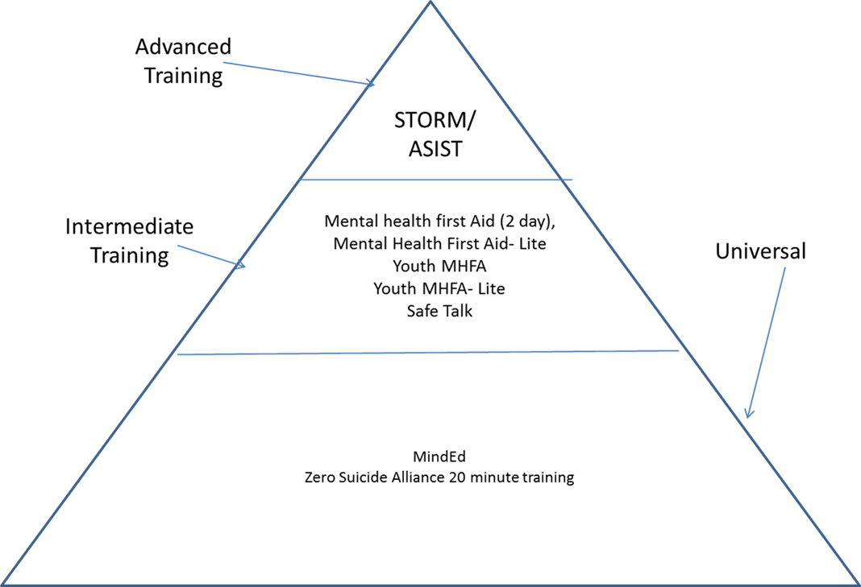

Targeted population
Commissioners expect providers to explicitly target children and young people, middle aged men and young women as key at risk groups.
Commissioners expect providers to target both work place and community settings to ensure we raise awareness of mental health, self-harm and suicide and build resilience across communities.
The provider(s) will deliver place based community focused workforce development interventions, targeting:
- Those in contact with vulnerable/potentially high risk adults, in particular middle aged men experiencing deprivation
- Those in contact with CYP at risk of self-harm and suicide as this is ultimately the way to reduce acute self-harm presentations – starting with schools (as about 3 children in every classroom are likely to have a diagnosable mental health problem) – NB I’ve attached the paper I took to the Cumbria LSCB in case it helps describe demographics and best practice interventions for CYP)
- Primary care support (e.g. in ICCs or equivalent)
The providers must target the following settings and or organisations as a minimum requirement:
- Building and Trade contractors
- NHS – hospital and integrated care communities, primary care (optometrists; pharmacists; dentists; GPs)
- Blue light services
- Local Authorities
- Telecoms industry
- Prisons and Youth Justice Settings (in conjunction with statutory and commissioned providers)
- Sellafield
- BAE systems
- Schools, University campuses and Colleges (in conjunction with existing interventions to avoid duplication; please liaise with local Public Health teams regarding other commissions).
- Sports clubs and venues
- Voluntary, Community and Faith settings
- Veterans
- Maternity and Peri-Natal Teams
- Early Years and Nurseries
A particular emphasis focus for the first 6 months of the plan targeting those areas that have the highest suicides (Preston, Blackpool and Hyndburn).

Key employers in L&S ICS
- Blackburn with Darwen Council
- Blackpool Council
- Blackpool Teaching Hospitals
- British Aerospace
- British Nuclear Fuels
- Community Rehabilitation Company
- Cumbria County Council
- Cumbria Trust?????
- District Councils – See section X
- East Lancs Teaching Hospitals
- Lancashire County Council
- Lancashire Care Foundation Trust
- Lancashire/ Cumbria Constabulary
- Lancashire / Cumbria Fire and Rescue
- National Probation Service
Innovation Fund
Commissioners have reserved a fund in the overall funding allocation for the development of innovation/innovative practice over and above the core delivery of this specification. Providers will be able to discuss with commissioners and bid into this fund following the initial round of grant funding for Suicide Prevention Training.
4 Signs of Success
Outputs:
- Number of training sessions
- Number of people trained
- People trained in Suicide Prevention (specify number)
- People trained in the impact/risk of Self Harm (specify number )
- Number trained in mental health awareness
- Suicide Prevention awareness training is integrated in to mandatory training for all stakeholders e.g. module within safeguarding training
- Training is targeted at male dominated employers e.g. BT, BAE, Sellafield, building and trade companies
- All localities in Lancashire & South Cumbria have a Suicide Prevention training programme
- Number of events during Suicide Prevention Day

Outcomes
- % who are trained who report and demonstrate improved knowledge, skills and confidence in identifying individuals at risk and in responding appropriately
- % of people who report that they are more aware of who is at risk of suicide and of the ways in which suicide can be prevented
- Decrease in suicide rates across the ICS

Pathway development
The training providers will be expected bring added value to their delivery by working with the ICS Suicide Prevention Training Co-ordinator to deliver training across the ICS in line with data, demand and targeted requirements.
The providers will need to work with partners including ICS Suicide Prevention Training Co-ordinator and local public health teams to ensure that training outcomes are sustainable and that organisations develop pathways for access to relevant information and onward referral when appropriate.
Developments for 13 July
Commissioners are keen to develop this specification on the bidder day in order to understand from provider experience, the best way to commission in order to drive the maximum value from the investment.
- The volume of training that can be delivered
- The cost ratio of delivering training at scale
- Should we commission:
  - in 'lots' eg each Integrated Care Partnership (x5)
  - By theme
  - By target group

Appendix 1 L&SC ICS Logic Model
INSERT - Logic Model
Appendix 2 Key Documents
INSERT LINKS - key National Strategic documents:
• Public Health England Suicide Prevention Planning Guidance- October 2016
• 3rd Progress report of the Preventing Suicide Government Strategy- January 2017
• Health Select Committee Recommendations- January 2017
• National Suicide Prevention Alliance- NSPA Strategic Framework 2016-19

Appendix 3 Funding weightings
The weightings for delivery across the ICS are as follows:
Lancashire County Council - XXX
South Cumbria - XXX
Blackpool - XXX
Blackburn with Darwen - XXX

