

TENDER REF: TT000068

TENDER FOR THE PROVISION OF

PROMOTIONAL DISTRIBUTION SERVICES

Briefing Document

Documents prepared by:

Susan Albanese
Procurement Executive
The ACC Liverpool Group

Contents

1 Overview
2 Vision
3 Values
4 Aim & Objectives
5 Scope of Services
6 General Information
7 Procurement Documents
8 Your ITT Submission
9 Selection Criteria
10 Next Steps

1. Overview

We are The ACC Liverpool Group – operators of a world-class event campus located on the banks of Liverpool’s world heritage waterfront and home to Echo Arena, BT Convention Centre, Exhibition Centre Liverpool and TicketQuarter. The ACC Liverpool campus is a family of venues, experiences and services for the local, national and international events market.

The versatile BT Convention Centre facilities include a 1,350 seat auditorium, 18 breakout rooms, 3,725m2 of exhibition space and a range of sustainable credentials having been designed to produce half the CO₂ emissions it would without any environmentally-friendly measures.

Sister venue Echo Arena Liverpool is an 11,000-seat arena with 22 hospitality VIP Boxes, The Liverpool Collection Lounge (due to open in September 2017) and a packed programme of entertainment and sporting events throughout the year.

In September 2015, The ACC Liverpool Group expanded its offering with the opening of Exhibition Centre Liverpool, adjacent to BT Convention Centre and Echo Arena, providing an additional 8,100m² exhibition facility, taking the total to 15,225m² of interlinked and flexible event space.

A pedestrian link bridge connects the new and existing venues making it the only purpose-built interconnected arena, convention centre and exhibition facility in Europe. A 216-bedroom Pullman hotel, which forms part of the development, opened in February 2016.

The ACC Liverpool Group works closely with Clients helping to ensure the success of their events and delivering the best possible service. All of the Supplier’s staff will be required to be pro-active in providing a first class, customer focused service to all Clients.

Our vision is to be a successful world class arena, convention centre and exhibition centre that serves its customers to the best of its abilities and attracts visitors to Liverpool, thereby contributing to the long term growth and prosperity of our enterprise, our city and its people.

2. Vision

The unique skill of what The ACC Liverpool Group does is in the complexity of bringing together many diverse individual groups of people with different expertise and experiences, to create seamless, coherent and impactful events that deliver a unique experience for Clients and visitors.

The awarded Contractor(s) must be a true partner and work closely with ACC Liverpool to promote continuous improvement and help ACC Liverpool enhance their brand and service quality through the provision of high quality, pro-active and innovative products and services.

3. Values

The ACC Liverpool Group’s brand values are:-

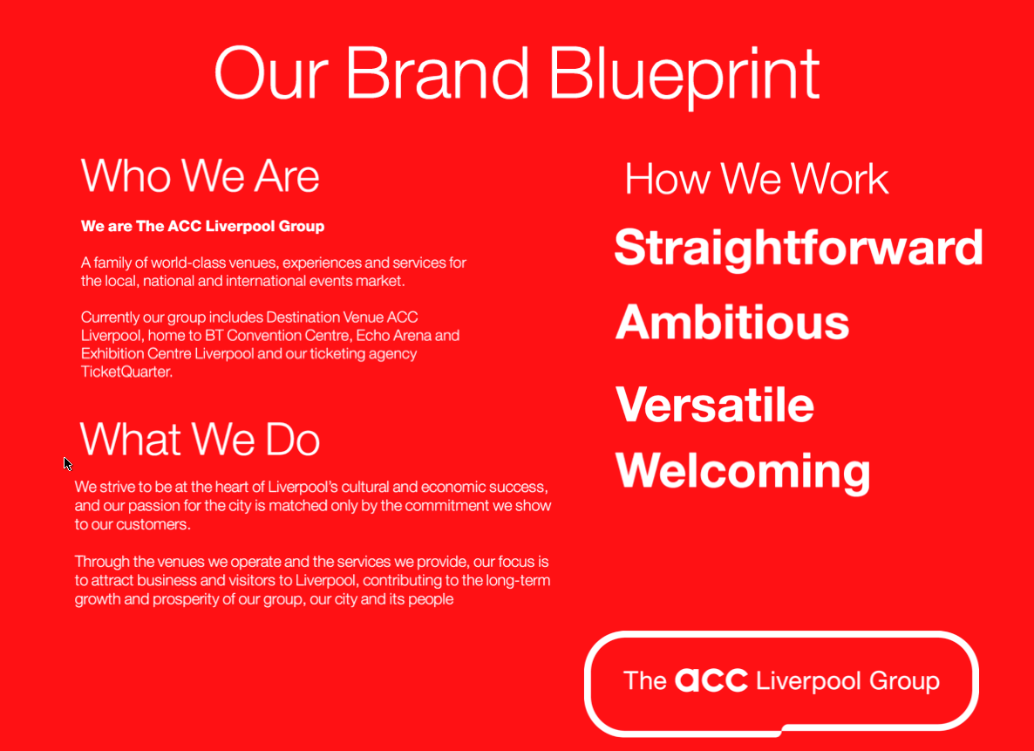

4. Aim and Objectives

The overall aim of this tender is for The ACC Liverpool Group (ACC Liverpool) to secure a relationship with a supplier or number of suppliers (the Contractor(s)) for the provision of Promotional Distribution Services.

The Customer’s Consumer Marketing Team distributes approx. 15-20k “What’s On” leaflets every 6 weeks to establishments around Liverpool and the surrounding areas promoting events taking place in the Echo Arena and/or events managed through Ticket Quarter, ACC Liverpool’s event ticketing agency. This number is dependent on the time of year with Christmas time being the busiest period. This number is expected to increase when more places to distribute are identified.

In addition to the regular quarterly produced “What’s On” leaflets, we also distribute flyers for particular shows ranging from comedy to family, sport and entertainment. This is on an ad hoc basis depending on the requirements of the Client and whether they wish to use this service for their shows.

We are looking for a Contractor(s) to work with ACC Liverpool to provide a service where distribution for a particular demographic, i.e. family, can be requested and the Contractor would have the knowledge, or will build up the knowledge, to be able to target distribution in areas/establishments best suited to that demographic. This knowledge would also include the ability to determine the approximate number of flyers that would be needed for that particular show. ACC Liverpool and the Contractor(s) would discuss and agree the final areas/establishments for distribution and the number of flyers to be issued.

The Contractor’s objectives when appointed should include:-

- supporting our vision and values
- meeting our and our clients range of requirements as detailed in the Scope of Services and
- providing us with a professional and timely service.

5. Scope of Services

The Contractor(s) will be required to provide the following range of services:-

- To support Business to Consumer (B2C) marketing campaigns for Echo Arena and Exhibition Centre Liverpool shows and deliver various quantities of flyers for different types of shows with different audiences across Echo Arena and Ticket Quarter brands
- To deliver the flyers to the appropriate areas and establishments depending on the type of audience for the event including cafes, bars, transport hubs, student unions, etc.
- To offer a range of services including flyer distribution, door drops, promotional work, posters (A2 and A3), outreach, shop drop and hand to hand. Contractors may offer any or all of the services required
- To cover areas across Liverpool, South Liverpool, and the Wirral and occasionally further afield including Manchester, North Wales, Lancashire, and Cheshire
- To compile a list of relevant businesses and locations depending on the type of events, i.e. family, comedy, sport, older generation, kids, music, hipster, etc. Contractors should also be able to demonstrate how they would action this distribution plan and continuously update it
- To have legitimate access to a number of sites with flyer stands
- To provide a comprehensive quotation within 24 hours of the request being sent confirming ability to adhere to the brief and including a detailed list of location and establishments according to the type of show and the quantity of flyers each area will need
- To provide an order acknowledgement within 24 hours of the Purchase Order being issued
- To pick up from the riverside entrance of the ticketing office and be able to load up to 20,000 flyers at any one time
- To be able to provide continuity in terms of the reliability of staff that are distributing
- To be responsible for all promotional material handled
- To pride themselves in their high standards when delivering the flyers and have the consumer in mind when distributing. Placement of the flyers is important as if they look untidy this reflects on the event
- To remove old out of date flyers. It will be an ongoing requirement to keep ACC Liverpool aware when flyers need topping up, etc.
- To provide photos of the flyers for each location via email within 24 hours of job completion
- To ensure any changes to the way the services are being delivered are brought to ACC Liverpool’s attention and are agreed prior to implementation
- To explore new areas and establishments for our flyers including potential places for an “Echo Arena” promotional box to be installed. (Promotional boxes would be provided by either the Contractor or the Client following consultation)
- To have a proactive approach and consistently feedback to us
- To hold public liability insurance (see Document 2 – General Conditions of Contract for further details).
Performance will be measured against expectations agreed between the parties. If performance levels fall below minimum agreed, we will be obliged to take a formal review of the contract.

6. General Information

The duration of the Framework Agreement will be two years with an option to extend for a further period of twelve months, at the sole discretion of the Customer. The contract start date is anticipated to be on 1 June 2018.

The Customer can give no guarantee as to the volume and frequency of the Services to be undertaken as this will vary depending on the requirements of the venue.

This appointment will be on a non-exclusive basis. The Customer may use others to provide the same requirements as available from the appointed Supplier if the solution provided on each occasion is not acceptable to the Customer.

Sustainable methods of transport are paramount to be able to pick up and deliver large quantities of flyers/ promotional material.

7. Procurement Documents

The documents provided as part of this tender process are detailed below:-

Document 1 – Briefing Document (this document)

Document 2 - Terms and Conditions

8. Your ITT submission

Now we have outlined the details of the Contract, we would like to know a little more about your organisation and the skills you could potentially bring to this Contract. Listed below are a number of areas we would like you to cover in your submission:
Section A - Organisation information

Question | Please provide your response below
Full name of your organisation
Trading name of organisation (if different from above).
Date of formation
Registered number if a limited company (please supply a copy of the certificate of incorporation and any certificate of change of name)
Registered address of organisation and address of principal trading office
Contact for this tender – name and role within your organisation
Phone number
Fax number
E-Mail Address
Address and phone number of office from where business would be conducted in support of any after sales service if different from 1.5 and 1.6 above.
Full names and addresses of all directors/company secretary/ partners/associates or proprietor.
Have any of the persons named in 1.10 above been subject to bankruptcy proceedings or been involved in an organisation which has been subject to liquidation proceedings or had receivers appointed? If yes, please give details.
Have any of the persons named in 1.10 above, been convicted of any criminal offence, apart from minor traffic offences? If yes, please give details.
If your organisation is a member of a group of companies, give the name and address of the holding company.
If your organisation is a member of a group of companies, is the holding company in a position to guarantee your performance of the contract?

Section B – Experiences
Question | Please provide your response below
Please provide details of your experience to date, in particular contracts/orders fulfilled within the last two years of a similar nature.
Has your organisation ever had a contract/order cancelled due to failure to deliver? If yes, please provide details.
Has your organisation ever suffered a deduction for liquidated and ascertained damages in respect of any contract/order within the last 3 years? If yes, please provide details.
Is there any material non-employment related litigation (pending, threatened or determined) or other legal proceedings against your organisation that may affect your organisation's ability to deliver the contract/order? Exclude County Court proceedings and debt collection below a threshold of £5,000. If your answer to this question is “yes” please provide a detailed statement of such litigation or proceedings.

Section C - Financial Details

Question | Please provide your response below
Please state the full name and contact details of the person in your organisation who is responsible for financial matters.
Please provide a statement of turnover for the nearest 12 month period.
Are there any outstanding claims or litigation against your organisation with regard to systems and/or service delivery? If yes, please give details.
Please state the name and address of your bankers.
Please supply your VAT registration number.

Section D - Professional Conduct

Question | Please provide your response below
Has your organisation or any employee committed a criminal offence relating to the conduct of your business or profession? If so please provide details.
Is your organisation currently involved with any legal proceedings (including arbitration) with any other organisations including local authorities?
Are there any issues, currently or likely, in relation to your organisation that may give rise to any conflict of interest? If so, please provide details.

Section E – Your Services

1. Details of the range of services you can provide;

2. Details of the types of establishments you distribute to;

3. Details of who will be responsible for service delivery of this Contract, their experience and expertise;

4. Details of how you will conduct the distribution depending on the type of establishment that will need to be covered for each show

5. Details of your service delivery plan, including amongst other things, management of the Contract, ongoing delivery of the Services, communication with the Customer.

Section F – Intention to Sub-Contract Part of the Services
Please indicate whether your organisation intends to sub-contract any element of this Contract. If so, please provide details of sub-contractors. If sub-contracting the work how much notice would we get of who is doing the job?

Section G – Additional services
Please provide details of any additional product or service offerings which you feel would be relevant and how they could be utilised by ACC Liverpool. You may also provide an outline of those factors which differentiate your organisation from those of your competitors
In addition to this, please demonstrate how you will ensure a value for money service.

Section H - Costs
Please provide a price breakdown based on applicable rates, e.g. cost per thousand for flyers and cost for distributing by day, evening, weekend and also what locations are applicable to each of these rates.

Your proposal should include the cost breakdown for 1k, 2k, 5k, 10k, 20k, 30k and 50k flyers and should be a fixed cost.

If your service offers promotional staff how much per day, evening, weekends, etc. and what hours are applicable to each of these rates. What are the costs based on?

9. Selection Criteria

Tender submissions will be evaluated by the panel detailed below:-

Kofi Ohene-Djan Consumer Marketing Manager

Aisling Muge Consumer Marketing Executive

Susan Albanese Procurement Executive (Tender Facilitator)

The evaluation panel will use the following guidelines, listed in no particular order, to select a contractor:-
- depth of experience and expertise in provision of distribution and promotional services
- range of services
- distribution locations
- competitiveness of pricing
- ability to offer value added services
- compatibility with ACC Liverpool’s vision, mission and brand values
- what actions will they put in place to improve intelligence of distribution, locations, quantities and take up of leaflets
- proactive approach and feedback with us.

10. Next Steps
Please see below an indicative project timetable (these times may be subject to change):-

2 May 2018
Procurement Documents added to Contracts Finder and ACC Liverpool Group Website and advertised on LinkedIn.

4 May 2018
Confirmation of participation in the tender process. Please confirm your intention to provide a tender submission via email to purchasing@accliverpool.com

16 May 2018
Deadline for tender submissions is 12 noon.

Please submit your ITT response by 12 noon via email to purchasing@accliverpool.com

Tender submissions will be evaluated and a short list of tenderers invited to present and interview with the evaluation panel.

Week commencing 21 May 2018
Presentations and interviews at the ACC Liverpool Group for shortlisted tenderers.

Week commencing 28 May 2018
Award confirmed and contract documentation issued. Mobilisation work to commence.

1 June 2018
Contract begins.

