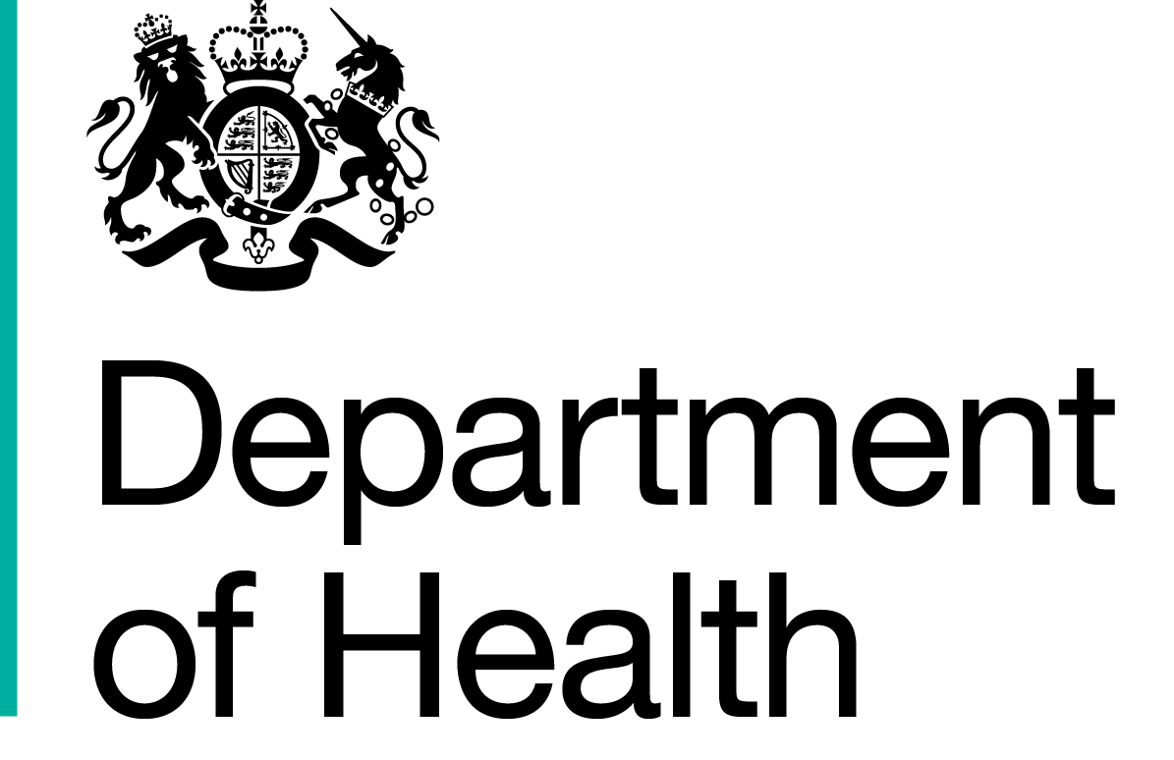
Commercial Medicines Unit (CMU)
Medicines, Pharmacy & Industry
2 Floor, Rutland House
Runcorn,
WA7 2ES

All messages regarding the
Offer documentation should be sent via the Bravosolution Website

www.dh.gov.uk

1st December 2016
Supplier Address

Dear Supplier

Proposed Framework Agreement for NHS Pharmaceutical Products
Reference number: CM/PHG/15/5467
Period of framework agreement: Dates detailed below with options to extend up to a maximum period of 48 months
Potential periods of call-offs under the framework agreement:

Oral Products (100%)
All Regions: 01/03/2017 to 28/02/2019 (24 months)
Hospital Only Products (33%)
All Regions: 01/03/2017 to 30/06/2018 (16 months)

Notification of framework agreement award decision

Thank you for submitting an offer in respect of the above procurement exercise. The evaluation of the offers in relation to the procurement exercise has now been completed by the Commercial Medicines Unit on behalf of the Secretary of State for Health acting as part of the Crown (‘Authority’).

I am pleased to inform you that those elements of your offer dated XXXXXX listed in the award schedule (Appendix Two to the framework agreement) have been successful. All other elements of your offer (if applicable) were on this occasion unsuccessful.

The Public Contracts Regulations 2015 (the ‘Regulations’) apply to the evaluation of offers submitted by Offerors to participate in this framework agreement. As notices of this nature are being sent to all Offerors today by electronic means the Authority must provide for a mandatory minimum 10 day standstill period, before concluding the framework agreement. In accordance with the Regulations we will not conclude the framework agreement with the successful Offeror(s) before midnight on 12th December 2016. You should note also that even on expiry of the standstill period the Authority will not be bound to conclude the framework agreement with you or any other Offeror. Therefore your appointment to participate in the framework agreement under reference remains subject to the Authority entering into a legally binding contract with you.

This letter constitutes notice under Regulation 86 of the Regulations. Accordingly we attach certain information on the award decision for this procurement exercise. This notification comprises the following documents (if any of these are missing please contact us immediately via the Bravosolution messaging portal)

- This covering letter
- Parties appointed to the framework agreement (Appendix 1)
- Framework agreement including Participating authorities
- Framework agreement – award schedule
- Award criteria and debrief explanation
- Award debrief
- Supply chain notification form
- Framework agreement - award schedule (redacted for publication)

However, please note that this letter does not constitute a legally binding acceptance of the elements of your offer that are listed in the award schedule.

The Authority aims to conclude the framework agreement after expiry of the standstill period. In preparation for this, we enclose a copy of the framework agreement. Please print two (2) copies, sign but do not date these documents (CMU cannot accept photocopied, cyclostyled or electronic signature) and return them to us at the above address by 23rd December 2016 together with a copy of your indemnity insurance certificates. These documents will not be legally binding until they are signed and dated by the Authority.

We will contact you after the end of the standstill period to confirm whether or not the framework agreement has been concluded.

Transparency

As stated in the Invitation to Offer dated 22nd July 2016 issued by the Authority the content of any framework agreement resulting from this procurement exercise will be published in accordance with the Government’s policies on transparency as expounded in the guidance published by Cabinet Office.

Please find enclosed a copy of the information we intend to publish which relates specifically to your organisation in respect of it being selected to participate in this framework agreement.

If you have any concerns with regard to the information the Authority intends to publish then please advise us in writing, via Bravo, no later than 12th December 2016. Where you do not wish for us to publish the information, your written advice should clearly state the reason for this in accordance with information that is exempt from publication under the Freedom of Information Act 2000 (FOIA). The applicable section number in FOIA should be included and where the proposed exemption is classified as a qualified exemption under FOIA, please indicate how you have determined that the result of the public interest test applicable under FOIA would be that the information is exempt. If we do not hear from you by that date with all the information required under this paragraph, we will proceed with publication.

Please note that where you are selected as a participant in any framework agreement that we conclude in the future, our intention is to provide you, at such a time with a copy of any information that we propose to publish which specifically relates to your organisation. The information that we decide to redact could vary from procurement exercise to procurement exercise. In effect, the enclosed information is not intended to communicate a precedent of the information that we will publish under the transparency agenda.

Yours sincerely

Sarah Blackman

Sarah Blackman
Procurement Specialist

https://www.gov.uk/government/policies/buying-and-managing-government-goods-and-services-more-efficiently-and-effectively

