Soft Market Testing Brief – Operating / Coaching Provision of Three Park Tennis Venues in Bristol

Context

Bristol City Council (BCC) and The Lawn Tennis Association (LTA) have been working on a project to refurbish the park tennis facilities in Bristol. Three of these sites have been selected for the first phase of redevelopment. The council are looking to speak to organisations who may be interested in operating these courts and providing the coaching delivery service to the public.

Bristol Park Tennis Facilities

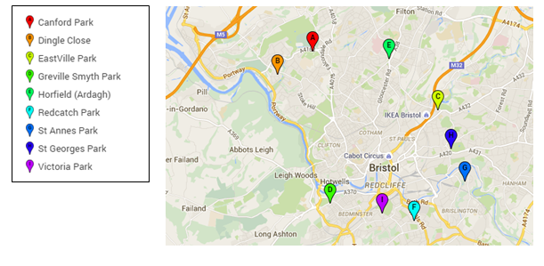
Figure 1: Park Tennis Venues in Bristol

BCC are the owners of nine tennis facilities in public green spaces across the city. The three sites that have been selected for this project are:

- A - Canford Park (8 Courts), Westbury on Trym.
- H - St Georges Park (5 Courts), St Georges
- C - Eastville Park (2 Courts), Eastville,

What is required?

An organisation would potentially need to take the entire responsibility for managing the courts on behalf of BCC and conduct all customer relationship services, including bookings, financial transactions, marketing, coaching provision and measurement / reporting. The successful organisation would be assigned a liaison contact at BCC and the LTA to support the organisation in completing this work.

Proposed Structure of the Agreement

BCC would like to engage in an agreement with an organisation that can provide this service on behalf of the council. BCC will consider all options including suggestions made within the soft market testing exercise. Please refer to questions 7 & 10 (financial and legal viability) on the soft market testing questionnaire.

Refurbishment and Use of Access Technology

These three sites will undergo resurfacing or repainting (as required) in the coming months. As part of the process new gates and access technology will be introduced to allow the courts to be managed remotely. The LTA can potentially supply an internet connected gate system that works with the LTA relationship management software ‘clubspark’. This allows a player to book a court via a website and receive a 4 digit code to open the gate at the time of booking.

