**Prior Information Notice Questionnaire – EMA Accelerator – Electromagnetic Activities Programme**

**Purpose:**

The purpose of this Prior Information Notice (PIN) questionnaire is to:

* Share information on Dstl’s current thinking regarding future collaborative working with current and potential industry, academic and Suitably Qualified Experienced Personal (SQEP), in relation to Electromagnetic Activities (EMA) Science & Technology (S&T) research.
* Obtain views and feedback on this from the market, including responses to the questions detailed in this document.
* Provide the ability for the market to highlight areas of opportunity/innovation that Dstl are not currently aware of.
* Use the feedback and information to inform and support the development of Dstl’s future Business Case(s) and Procurement strategy.

This PIN questionnaire is not a request for a full proposal or bid nor should it be taken to be a call for competition, it is purely to obtain information from early engagement with the market. Any information provided will be treated as a public disclosure which will provide Dstl with the right to free and unrestricted use of it. If you have any concerns with regards to this, please do contact us so that we can discuss this with you.

**Background:**

The Dstl EMA Programme has the mandate to conduct S&T research to identify and develop Generation after Next (GAN) Electromagnetic Warfare (EW) concepts and technologies. As such the programme is looking into conducting GAN S&T research in all areas of EW and has specific focus areas on Integration and Synchronisation of EMA and development of GAN Electromagnetic Attack (EA) capabilities

To support this undertaking the EMA Programme is considering the need for a new service delivery construct to deliver the required EMA S&T research. With focus on taking GAN technology on a route to exploitation we are looking for wide industry and academia collaboration that will facilitate the identification of suitable topics of research, a rapid and flexible contracting mechanism, technical assurance in managing delivery, whilst enhancing UK national SQEP and prosperity in this field of work.

The aims for the new delivery construct include:

* Provide a collaborative group environment for development and conduct of EMA S&T research
* Accelerate the development of GAN EMA concepts and technologies
* Ensure wide involvement of industry and academia in the delivery of GAN EMA S&T research
* Develop future EMA S&T SQEP for the UK.
* Allow efficient and timely delivery of EMA S&T research by both supporting development with end-to-end delivery and assurance of tasking’s.

We have termed the desired new construct as the **EMA Accelerator (EMAA).**  The list below provides features we are currently considering to form part of the collaborative arrangement which we welcome your comments and feedback on:

* Provision of leadership and support from Industry and/or Academia
* Support to Statement Of Requirement development (SoR)
* Support and consultation on industry wide EOI (Expression of Interest), PQQ (Pre-Qualification Questionnaire), ITT (Invitation to Tender), ITN (Invitation to Negotiate)
* A construct to support a range of appropriate pricing methods such as Firm, Fixed, Ascertained Costs.
* Supports the organic development of SQEP, including the ability to access the wide-ranging industry and academic base
* Provides end-to-end Management of Task delivery
* Provides a fast and efficient route to market
* Allows selection of appropriate quality assurance level, dependant on tasking and outputs
* Provides opportunities for staff from Dstl and Industry to work collaboratively at each others’ premises.

The list is not exhaustive and Dstl welcomes any feedback on different models and ways of working in the Questionnaire.

**Scope of EMAA**

The ambition is to initially invest over a period of up to 5 years (including extension options, starting around January 2025). It is hoped that this will allow development of an enduring breadth and depth of capacity and capability for the supplier base. The EMAA is expected to be led by a single provider who enables access to a diverse range of subject matter experts.

The figure 1 below provides a visual representation of the suggested collaborative group working environment involving the combination of a Leadership team, a Consultation Group and a Delivery group. The successful lead supplier would sit with Dstl in the Leadership team. The Consultation Group would consist of Dstl and a sufficient number of different Industry representatives to cover the range of required EMA research. The representatives on the Consultation Group will need to have a technical focus as they will be involved in the discussions and development of SoRs as well as recommendations on delivery. The Delivery Group comprises all the Industry/Academia suppliers delivering the required EMA S&T taskings. It should be noted that we are looking to ensure that this group is as wide as possible to ensure we are harnessing all capabilities. The successful Supplier will be expected to set-up, maintain and develop the Delivery Group and undertake all the necessary end-to-end contracting for the required EMA S&T taskings.

The EMA Accelerator is expected to support EMA taskings which fall in the TRL 1-6 range. However, it is envisaged that the primary focus of research taskings will be in TRL ranges 1-4, with only the most promising developments to be accelerated to TRL 6.

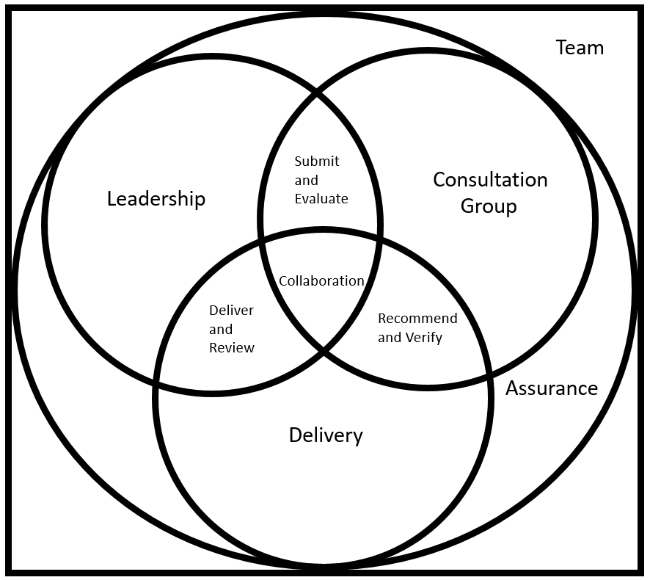

Figure 1

**Governance of the EMAA**

Current view is that decision making and governance will be provided by the Leadership Team drawn from Dstl (covering contract and project management; technical and contextual advice) and the Supplier (covering collaboration, SQEP development, consultation and support, supplier engagement, service delivery, and exploitation management). The list is not exhaustive and Dstl is open to ideas on how this arrangement should look. This Team would be guided by strategic direction from Dstl (EMA Programme) and the supplier working with Dstl will have day to day responsibility to manage the pace, scope and volume of outputs required. Initial thinking on the critical success factors is that EMAA will be incentivised via:

* Value for money;
* Pace, volume and agility of delivery of outputs;
* SQEP development and retention in industry
* Improvement of the EMA research capacity and capability.
* Proven assurance that outputs are fit for purpose (this could be Dstl, EMAA team members or Industry. Dstl is willing to consider all ideas).

There is an additional expectation that the EMAA will be available to users outside of the EMA Programme, including other defence science and technology programmes delivered by Dstl. Though the service will be limited to UK Government-based users, outputs from the work may be shared with the UK’s international partners.

**Miscellaneous:**

Dstl is also interested in receiving responses that are alternative approaches for the EMA Accelerator and/or those that represent constructs that have synergies that will improve further the approach suggested above.

**Prior information Notice Questionnaire**

Please complete the below questionnaire and provide information, which Dstl may seek to clarify and discuss further to support our understanding and inform the future development of the Business Case and Procurement Strategy. Please keep answers brief, a maximum of 2 paragraphs with explanation(s) and suggestion(s) where appropriate.

|  |  |
| --- | --- |
| **Organisation name** |  |
| **POC name and email contact details** |  |
| **Overall viability**  What are the challenges identified to the viability of this approach over the anticipated time frame? Please share your rationale. | |
| **Challenges to delivery**  Do you perceive any challenges to delivery, risks or issues with the proposed design and operation? Please share your rationale. | |
| **Reducing barriers to entry**  What would you consider to be barriers to entry from the perspective of either the successful Supplier or the Suppliers within the Delivery Group? | |
| **Boundaries**  Please state your views about where the boundaries shown in figure 1 of the EMAA have been positioned. Would a changed boundary provide a better solution? Please share your rationale. | |
| **Governance**  What challenges and opportunities do you perceive in relation to the proposed approach to governance? | |
| **Costing options**  What would you consider to be the constraints and risks to; costing the construct, submitting a cost breakdown and overall price, if the requirement progressed to a competitive procurement? | |
| **Enabling collaboration**  Please state views about what collaborative enablers need to be present for this type of construct. | |
| **Likelihood of tender submission**  Would you be interested in submitting a tender if the EMAA requirement progressed to a competitive procurement? If so, please advise on your potential roles (e.g. chosen Lead Supplier, Consultation Group member, member of the Delivery Team). | |
| **Any other comments or observations**  Please share any additional comments or observations you have including any clarification of detail or intent you would like to see emerge if EMAA progresses. | |

**Your completed Prior Information Notice Questionnaire should be returned via the Defence Sourcing Portal as detailed in the Prior Information Notice advert.**

**Questions and Answers:**

1. Is a response required to this PIN questionnaire in order to be selected for any future Procurement activity?

A. No - this stage is for the purpose of obtaining information to support Dstl’s understanding of what could be available from the market and to support business case and procurement strategy planning. This is not a call for competition. Should a future procurement result from the PIN advert this will be run in a fair and open competition in accordance with the appropriate Procurement Legislation.

1. Does the Questionnaire response have to cover the scope of all EMA Accelerator areas of interest?

A. No - we are interested in responses that cover the scope of the EMA Accelerator in order to understand the breadth of current opportunities.

1. Our organisation is focused on programme / project management capable of managing engagements EMA Accelerator - is this of interest?

A. Not at this stage; this PIN questionnaire is focused on feedback directly from organisations with existing capabilities in the areas of research.

4. What is meant by TRL levels?

TRLs can be considered as described in the Table below, with TRLs 1-6 being the primary interest associated with this PIN advert:

**MOD TECHNOLOGY READINESS LEVELS AND THEIR DEFINITIONS**

|  |  |  |
| --- | --- | --- |
| **9** | Actual Technology System qualified through reliability and maintainability demonstration in service. | Application of the technology in its final form and under mission conditions, such as those encountered in operational test and evaluation and reliability trials. Examples include using the system under operational mission conditions. |
| **8** | Actual technology system completed and qualified through test and demonstration. | Technology has been proven to work in its final form and under expected conditions. In almost all cases, this TRL represents the end of Demonstration. Examples include test and evaluation of the system in its intended weapon system to determine if it meets design specifications, including those relating to supportability. |
| **7** | Technology system prototype demonstration in an operational environment | Prototype near or at planned operational system. Represents a major step up from TRL 6, requiring the demonstration of an actual system prototype in an operational environment, such as in an aircraft or vehicle. Information to allow supportability assessments is obtained. Examples include testing the prototype in a test bed aircraft. |
| **6** | Technology system/subsystem model or prototype demonstration in a relevant environment. | Representative model or prototype system, which is well beyond the representation tested for TRL 5, is tested in a relevant environment. Represents a major step up in a technology’s demonstrated readiness. Examples include testing a prototype in a high fidelity laboratory environment or in simulated operational environment. |
| **5** | Technology component and/or basic sub-system validation in relevant environment. | Fidelity of sub-system representation increases significantly. The basic technological components are integrated with realistic supporting elements so that the technology can be tested in a simulated environment. Examples include “high fidelity” laboratory integration of components. |
| **4** | Technology component and/or basic technology sub-system validation in laboratory environment. | Basic technology components are integrated. This is relatively “low fidelity” compared to the eventual system. Examples include integration of “ad hoc” hardware in a laboratory. |
| **3** | Analytical and experimental critical function and/or characteristic proof-of-concept. | Analytical studies and laboratory studies to physically validate analytical predictions of separate elements of the technology are undertaken. Examples include components that are not yet integrated or representative. |
| **2** | Technology concept and/or application formulated. | Invention begins. Once basic principles are observed, practical applications can be postulated. The application is speculative and there is no proof or detailed analysis to support the assumptions. Examples are still limited to paper studies |
| **1** | Basic principles observed and reported. | Lowest level of technology readiness. Scientific research begins to be evaluated for military applications. Examples might include paper studies of a technology’s basic properties. |