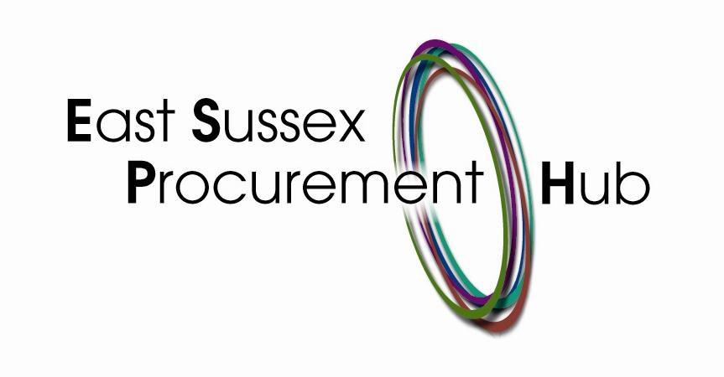

Rother District Council, on behalf of the East Sussex Joint Waste Partnership – Delivery of Waste & Recycling Services – Stakeholder and Market Engagement

Instructions for Participants

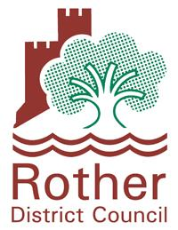

Market Engagement in the Delivery of Waste, Recycling and Street Cleansing Services
MARKET ENAGEMENT QUESTIONNAIRE

Instructions

Rother District Council, on behalf of the East Sussex Joint Waste Partnership, wishes to understand the current operational issues and working practices in the Waste and Recycling industry to inform the specification, payment mechanisms and risk sharing arrangements prior to going to tender. At present, the current Waste, Recycling and Street Cleansing Contract provides a service to circa 200,000 households with the Eastbourne Borough Council area receiving weekly residual waste collections and Hastings Borough Council, Rother District Council and Wealden District Council receiving alternate weekly collections (AWC) with all districts receiving AWC kerbside recycling. Included in this service is a fortnightly, opt-in Garden Waste Service. The service also includes the delivery of a bulky waste service, residential clinical waste collections and street cleansing. Hastings and Eastbourne are primarily urban in nature, and Rother and Wealden urban/rural. The districts also have significant beach areas important for tourism.

Please read the document and if you feel that your organisation is able to contribute to this Market Engagement exercise please complete the questionnaire as contained in this document and return via email to procurement@rother.gov.uk by 28th July 2017.

Please note that this is not a call for competition.

The following objectives are pertinent to this market engagement exercise
- An understanding of what East Sussex Waste Partnership are aiming to deliver;
- The ability to innovate and add value;
- An thorough understanding of the current marketplace; and
- The overall value added in helping to scope the project.

For the avoidance of doubt, this communication is for the purpose of conducting stakeholder and market engagement, and will not formally begin any procurement process or constitute any commitment by the East Sussex Waste Partnership and Rother District Council in the undertaking of any such procurement exercise.

Stakeholder and Market Engagement

East Sussex Waste Partnership and Rother District Council is at an early stage in development of its proposals for the delivery of waste, recycling and street cleaning services and seeks input from the market as to what might be the most potentially advantageous way of packaging and scoping any future procurement opportunity.

This exercise will also provide an opportunity for East Sussex Waste Partnership to obtain insight into how the market may approach the delivery of the services in question. It also gives useful early insight into the likely level of interest from that market.

Stakeholders and market providers will not be prejudiced by any response or failure to respond to the Questionnaire or attendance to any future marketing events. Market providers must also note that a response to this communication does not guarantee an invitation to participate in any future tender opportunity that may be conducted. Any procurement for the supply and services by the East Sussex Waste Partnership will be carried out strictly in accordance with the Public Contracts Regulations 2015.
The East Sussex Procurement Hub in association with Rother District Council has developed a questionnaire (attached at the end of this document) that they would like market providers to complete.

As stated previously the outcome of this market engagement exercise will seek to shape the future delivery of the formerly referred service provision.

Objectives
- Rother District Council wishes to engage with the market and undertake a market engagement exercise to establish the current issues and opportunities facing the market in the delivery of these services.
- The Council wishes to market test the possible procurement options and packaging to gain a better understanding of the following:
- How service providers might approach delivery of the service
- Contract length- short, medium and long term and estimate of costs
- Views on procurement route
- Specifications
- Potential Risk and Risk allocation
- The Council wants to use the results of this exercise to help it shape the future contract and to ensure it provides a procurement package that is attractive and helpful to potential bidders.
- If you would like to participate in the Market Engagement Exercise please contact procurement@rother.gov.uk. The closing date for receipt of completed responses is Friday 28th July 2017.
- Depending upon the range and number of responses Rother District Council may select a representative sample of interested parties for follow up meetings or discussions. Selection is at the discretion of Rother District Council.
- Please note that this communication has been issued by Rother District Council purely for information seeking purposes and does not form part of the procurement process. Interested parties should note that a response to this does not guarantee an invitation to tender. Conversely, not participating in the market testing exercise will not exclude any party from any involvement in any subsequent procurement process. Rother District Council is not liable for any costs, fees or expenses incurred by any provider participating in the market engagement exercise.

Before commencing a procurement process, Rother District Council on behalf of the East Sussex Joint Waste Partnership wishes to undertake a market sounding exercise and would welcome the views of providers on the questions set out below. We would like to receive feedback on the following and any other comments that you may have.

- What would be your general level of interest in bidding for a waste services contract? Have you delivered services of this nature across a partnership of authorities previously?
2. What would be the ideal length of contract for delivery of these services? And your views
on possible extension/renewal and how this is managed?
3. What are your views on the ownership of the integrated IT system to support any
Contract? Should this sit with the contractor, or with a designated Authority within the
Partnership? What do you see as the advantages and disadvantages of both
approaches?
4. What is your experience in delivery of a subscription Garden Waste Service? Some of
the Authorities may levy a charge for this service. What would be your preference for
managing this subscription/charging system – should this responsibility lie with the
Contractor? Or individual Authorities? What do you see as the advantages and
disadvantages of both options.

5. What is your preferred approach to recycling ownership and risk within the contract? If
responsibility for collection, transfer, bulking, haulage, MRF processing and final sale of
recycling lay with the contractor, how would this affect contract pricing? Are you in
favour of an income or profit share mechanism assigned to this aspect of the contract?
Are there other approaches that could work? Please detail and explain the
possible effects on contract pricing. What are your thoughts on separating out the
ownership of recycling from the collection contract, with bulking, haulage and processing
of recycling material handled through a separate contract?
6. In terms of roles and responsibilities what are your views and experience regarding the
Communications and Public Relations aspect of this Service and its management? At the
commencement of a new contract there may be a service change requiring
communication, advertising and promotion; what is your previous experience of how
this has been handled?

7. What are your views regarding the Customer Service arrangements that support the
Service, including the roles and responsibilities. Do you have any experience of delivery
of this aspect of the Service in a similar contract? What do you see as the advantages
and disadvantages of this responsibility sitting with the contractor, or with individual
Authorities?
8. Should the contract be split into lots, how would your approach to tendering change?
There are several options for different Council areas to be managed together or
separately and for collection services and street cleansing services to be managed
together or separately. We would welcome your thoughts on how this might affect
pricing.

How would costs be modelled where a partnership is made up of councils that are urban
only and mixed urban/rural authorities?

9. What would be your minimum mobilisation period for a contract of this nature and
size?
10. What would you see as the key challenges and risks in delivering on a contract of this
nature and size?

We would be grateful if responses to these questions could be submitted by 28th July 2017. Responses should be sent by email to: procurement@rother.gov.uk

Please note
Market providers will not be prejudiced by any response or failure to respond to this soft market testing/sounding exercise and a response to this communication does not guarantee any invitation to participate in any future public procurement process that the Commissioning Authority may conduct.

Any responses provided will not be treated as commercially confidential and may be used by the East Sussex Waste Partnership and Rother District Council in the development of any service specifications and utilized for the purposes of undertaking any subsequent procurement exercises, but no organisation will be individually identified.

