DWP Test & Learn Dynamic Purchasing System (DPS) Application guide
This guide is designed to walk you through the process of making an account on DWP’s e-procurement portal so that you can then apply to be accredited onto the Test and Learn DPS.
Our e-procurement portal is designed by Bravo solutions so is commonly referred to as simply Bravo.
As a brief background into the Test and Learn DPS; the DPS has been developed to cover a range of projects that could potentially support those with complex barriers to employment to move into sustainable work. This will primarily, but not exclusively, mean individuals with a disability or health condition.
The provision presents opportunities for businesses to apply for tender opportunities, with a focus on innovation and local specialist support, and to support and test the development of new approaches for employment support.
The DWP Test and Learn DPS is key to building evidence to support the delivery of future provision, at both national and local level.
Future tender opportunities will be made available on the Test and Learn DPS, but only to DWP accredited suppliers.

Guidance and assistance in the use of the Bravo system can be found by contacting Bravo Solutions directly using the details below:
Freephone helpdesk (0800 069 8630), available Monday-Friday 8am to 6pm (UK time in English language only);
help@bravosolution.co.uk
If your issue is regarding the DPS itself or your application, please get in touch via the internal messaging system or by our shared inbox:
CD.TEST-LEARN@DWP.GSI.GOV.UK
Contents
Making an account on Bravo 2
Finding the Test & Learn DPS on Bravo 4
How to submit a response to the Test & Learn DPS 7
T7 Category Confirmation – Applying for Service Lines 10
Checking Your Accreditation Status 12
FAQ 14

Making an account on Bravo
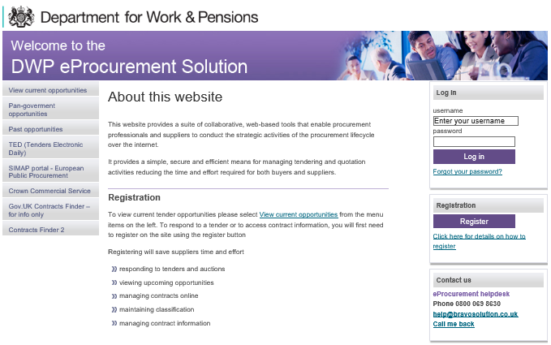
Above is the login page for our e-procurement solution AKA Bravo. The link for this page is:
https://dwp.bravosolution.co.uk/web/login.shtml
On the side hand side of the page is the three main points of interest:
Log in section- After you have made an account this is where you will access Bravo, if you have acted as a supplier for DWP previously you may already have an account. The ‘forgot your password?’ section can also be used if you have forgotten your username.
Registration section- If you do not currently have an account this is the section you need to register an account, the ‘click here for details on how to register’ links to a slideshow made by Bravosolutions which can walk you through the process of making an account.
Contact us- This allows you to contact Bravosolutions, it does not allow you to contact DWP. As Bravosolutions have made the e-procurement portal they have the technical knowledge and user access to make changes or give guidance on any queries you may have. Unless your question is specifically related to an opportunity made available by DWP, Bravosolutions is the best contact point for any issues you have such as, making an account or navigating Bravo. Their details are:
Freephone helpdesk (0800 069 8630), available Monday-Friday 8am to 6pm (UK time in English language only);
help@bravosolution.co.uk

If you need to make an account on Bravo please use the guide provided by Bravo solutions
https://dwp.bravosolution.co.uk/attach/supplier_registration_guide.pdf
The guide also informs on the important topic of:
Creating new users – This allows for a process similar to account sharing, you can allow a different person to login as your organisation but by using different details to the main ‘Super Users’ account. Their access can be restricted according to your preferences.
This means that multiple people can have their own unique log in details to log in as a single organisation yet have their power limited to prevent them from changing important details.

Finding the Test & Learn DPS on Bravo
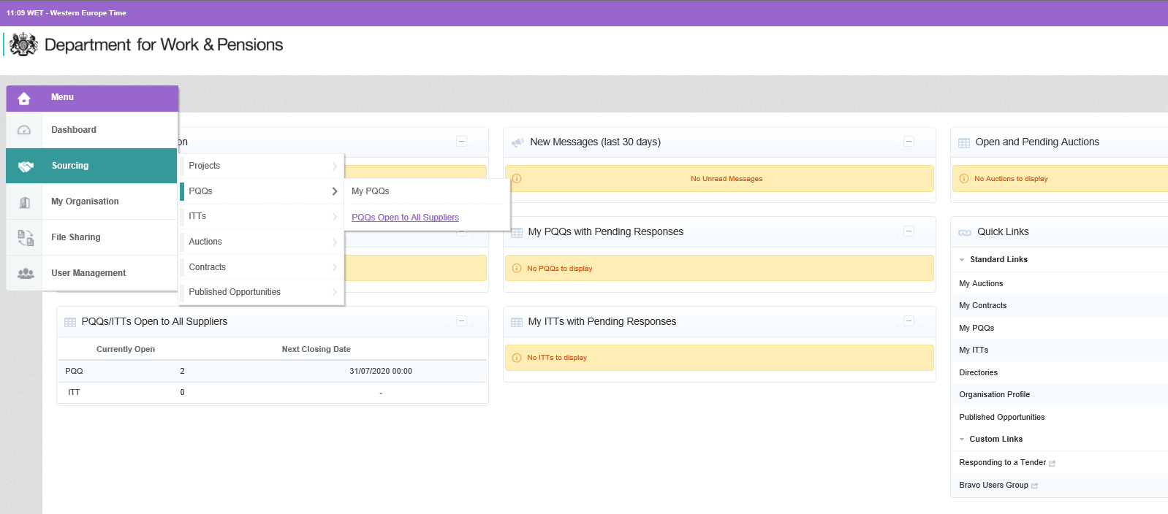

After logging into Bravo, on the left hand side of the Bravo home page is a menu which on opening will allow you to select ‘Sourcing’.
After selecting sourcing, in the submenu that opens you select, ‘PQQs’.
This opens up another menu where you will have the option to select ‘PQQs Open to All Suppliers’.

A quicker method is to click on the PQQs currently open section which is found on the homepage itself. This and the previous section is shown in the image above with a red arrow
Once you have expressed an interest in the Test&Learn DPS it can no longer be found under the section ‘PQQs Open to All Suppliers’. It will instead be found under ‘My PQQs’. This section has been marked with a red star in the above image.

The Test & Learn DPS has the following details:
Title: Dynamic Purchasing System for Employment and Health Related Test and Learn Provision
Project Code: project_20559
PQQ Code: pqq_28831

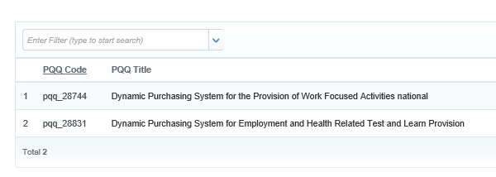
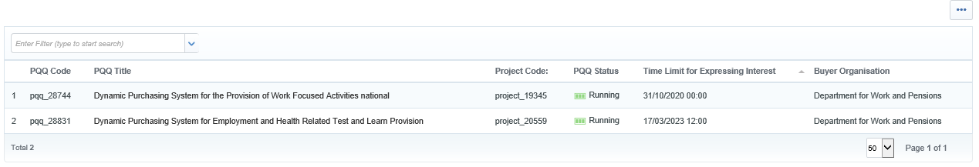

The next page you are brought to will list all of the currently available PQQs.
The title of the Test and Learn DPS is ‘Dynamic Purchasing System for Employment and Health Related Test and Learn Provision’
If you are not able to find the Test & Learn DPS immediately then you can instead filter for it by using its project or PQQ code.
Project Code: project_20559
PQQ Code: pqq_28831

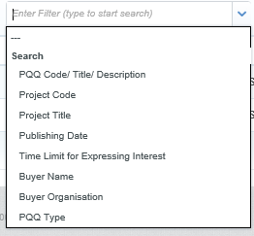
The available filter options are shown to the left.
The first option available PQQ Code/Title/Description is what we are going to use in the example but the Project code could also be used.
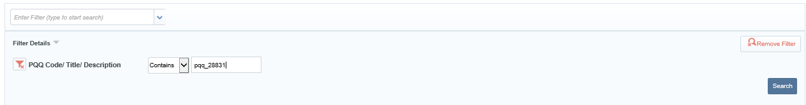
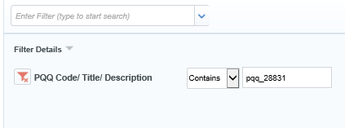

Shown above is the completed filter, remember to click search to apply the filter. After filtering by the PQQ Code, the Test and Learn DPS will be the only remaining option shown.
The title of the Test and Learn DPS is as below:
Title: Dynamic Purchasing System for Employment and Health Related Test and Learn Provision

How to submit a response to the Test & Learn DPS

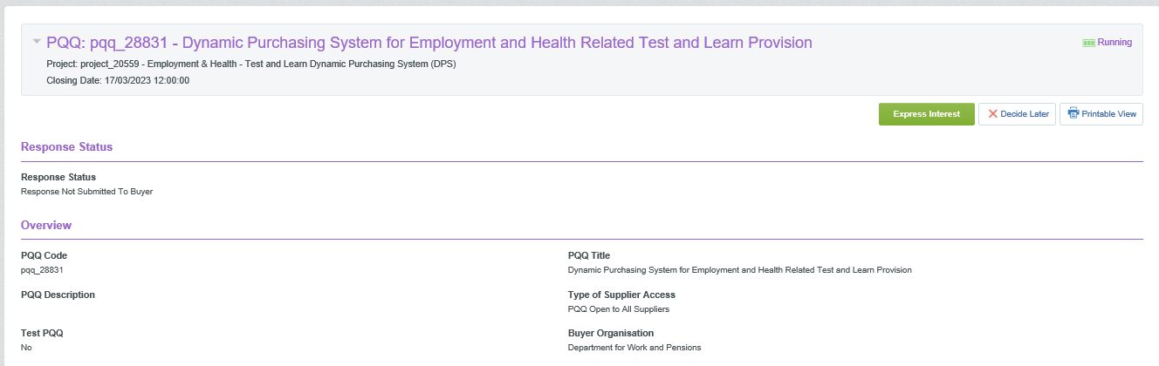
The guide below follows directly after the guide ‘Finding the Test & Learn DPS on Bravo
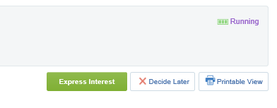

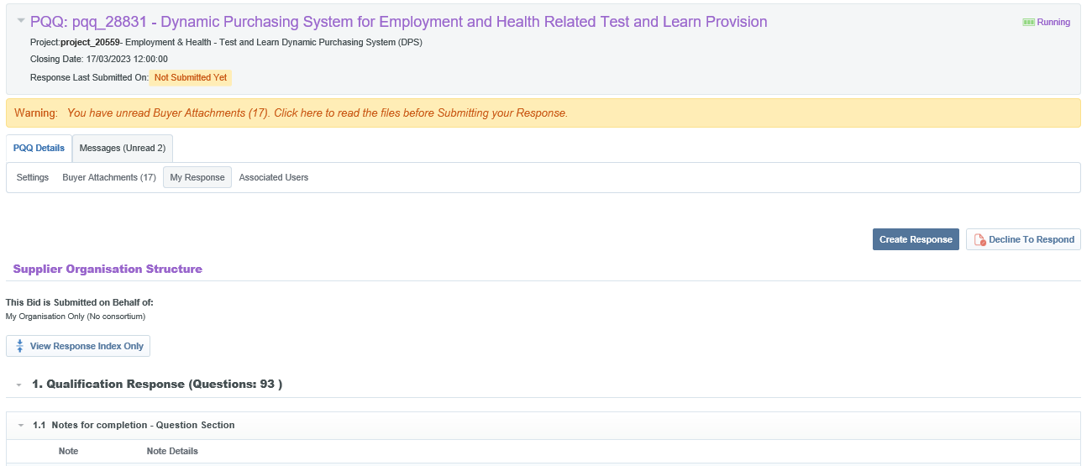
Before you are able to submit a response for the Test & Learn DPS you must first express an interest. This is done by clicking on the green button at the top right handside of the page. The Decide Later button will bring you back to the previous page.
Once you have expressed an interest you are brought to the main page which allows you to access; the questions you must answer, the related Test&Learn documents and the Bravo message system.
Once you have expressed an interest in the Test&Learn DPS it can no longer be found under the section ‘PQQs Open to All Suppliers’. It will instead be found under ‘My PQQs’. This section is shown in ‘Finding the Test & Learn DPS on Bravo’

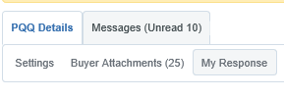

On the top left hand side, you have your tabs which will allow you to move to different sections. The ‘Settings’ tab will allow you to see some minor details such as the PQQ code (a type of reference code) for the Test & Learn DPS.
The ‘Buyer Attachments’ tab includes all of the related documents for the T&L DPS such as the specification. This is also where you will find the FVRA, legal entity template and security information questionnaire.
The messages tab will bring you to your received messages and will give you the options to reply or create a new message. You will immediately have unread messages as you will receive any prior messages that have been sent out to all suppliers.
If you run into any issues or have a query, please send us a message through this messaging system.

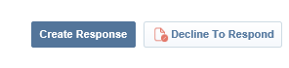

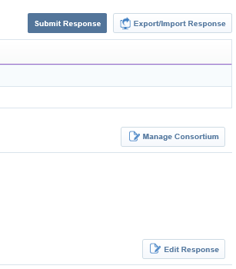
On the top right hand side of the page is the options to; ‘Create Response’ or ‘Decline to Respond’.
If you decline to respond you can change your mind and submit a response later on.
When you create a response you will then be able to submit answers to the questions displayed. Any response you make can be changed at any time.

Once you have clicked on Create Response your options will then change to those displayed on the left. After you have completed all applicable questions you can submit your response.
After your response has been reviewed you will then receive a message on Bravo with your accreditation outcome decision. You may also receive messages querying your response and requesting changes to be made.

After submitting your response edits can be made at any time as necessary.
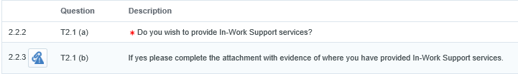

When responding to the questions some of them require templates or other documents. This can be found by clicking on the blue paperclip button to the left of the question. If this is not showing, then the document can be found in the ‘Buyers Attachment’ tab.
A red asterisk * indicates that the question is mandatory and cannot be left blank. If you have no response to a mandatory question, please instead leave a note stating this.

As an explanation of the content of the questions you must answer:
There are two “envelopes” to the application and you will need to ensure all sections are fully completed in order to submit an application to be accredited.
- Qualification envelope: Contains questions on organisation details, legal structure, financial information and questions relating to grounds for mandatory and discretionary exclusion etc.
- Technical envelope: Contains the accreditation questions for the service lines that relate to what your organisation has experience/expertise in. These are split into sections: Target Groups, Support Offered, Geographic Area and Areas of Expertise (disabilities/health conditions).
You must apply for at least one from each of the service lines, target groups and Areas of Expertise otherwise you cannot be accredited.
More information in the detail required in your application such as the specification and instructions to potential suppliers are provided in attachments hosted on the Test & Learn DPS.
Once you have submitted your application you will be told of the outcome and which service lines you have been accredited for. You will then be able to receive future tender opportunities for to the service lines you are accredited for.

T7 Category Confirmation – Applying for Service Lines

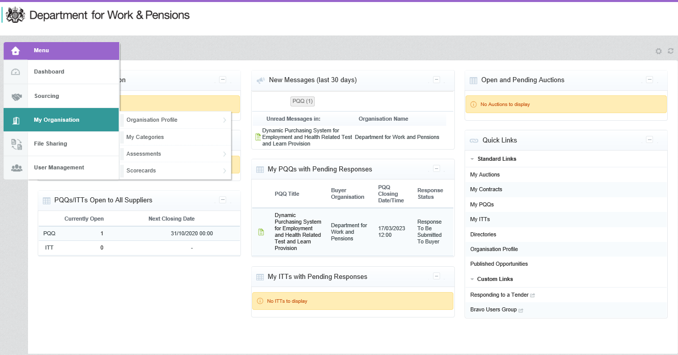
An additional question T7 Category Confirmation has been included in the new Test and Learn DPS. This requires you to add yourself to the category matching the service lines that you have applied for. I will explain how to do this below.
T7 Category Confirmation | After submitting your response to this PQQ, in order to complete your application to the DPS any suppliers which have not already done so must select the corresponding category in the DWP category tree. This can be done by selecting Organisation and then My Categories from the left hand menu.  If you fail to complete this action, your application to the DPS will NOT be considered as complete.  Please confirm you understand and accept this requirement.

After logging into Bravo, on the left hand side of the Bravo home page is a menu which on opening will allow you to select ‘My Organisation’.
After selecting ‘My Organisation’, in the submenu that opens you select, ‘My Categories’.
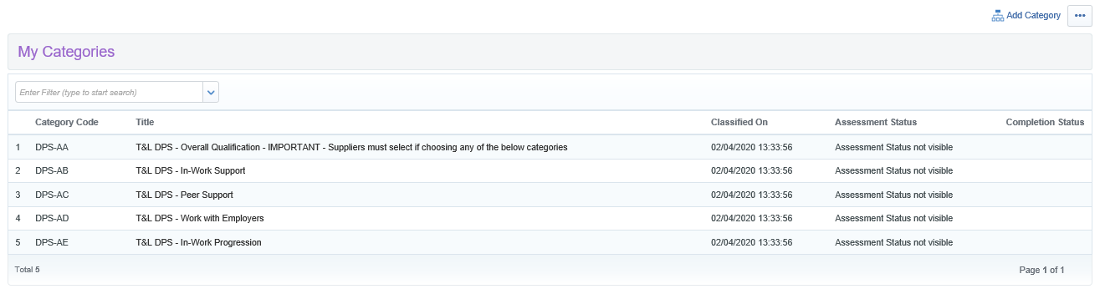
This brings you to a new page where you can view the categories you currently have selected. Ensure that you have the ‘T&L DPS - Overall Qualification’ as a category and the matching categories titled the same as the service lines you have applied for.
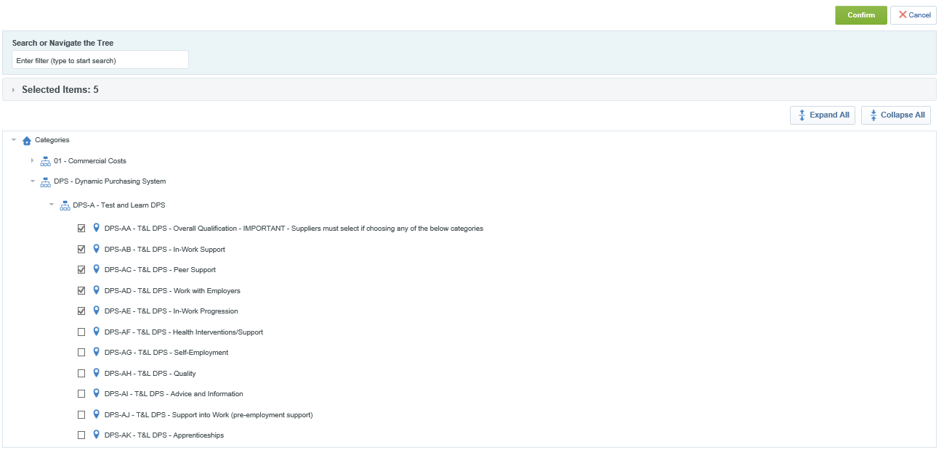
If you are missing a category you can add a category by clicking on ‘Add Category’ in the top right.
After selecting ‘Add Category’ you are brought to the category tree, the screenshot above shows it fully expanded, select the categories you have applied for and confirm.

Checking Your Accreditation Status

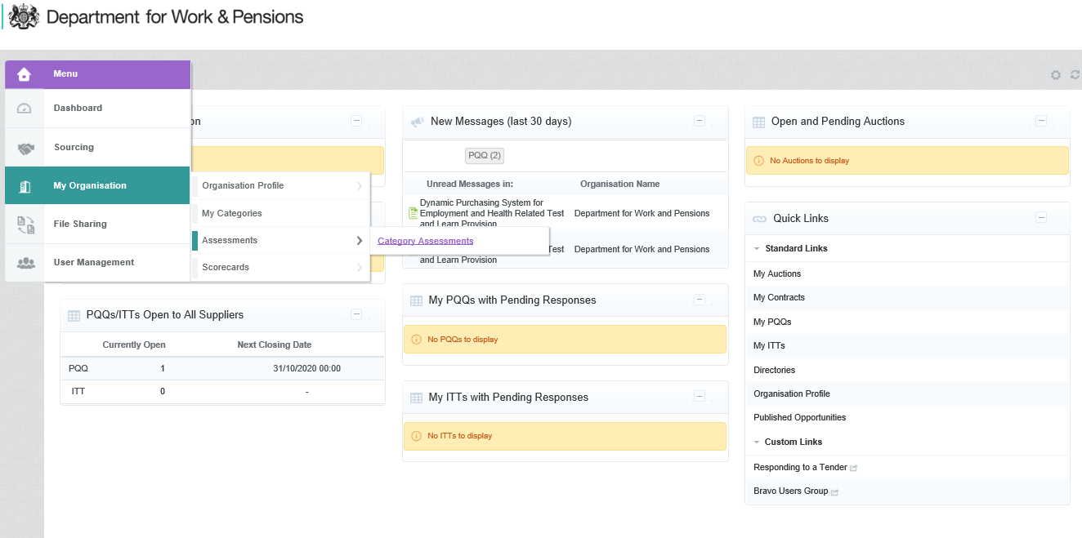
You can check your accreditation status for any service line you have applied for by going into Category Assessments and checking your status.

After logging into Bravo, on the left hand side of the Bravo home page is a menu which on opening will allow you to select ‘My Organisation’.
After selecting ‘My Organisation’, in the submenu that opens you select, ‘Assessments’. The next menu to select is ‘Category Assessments’
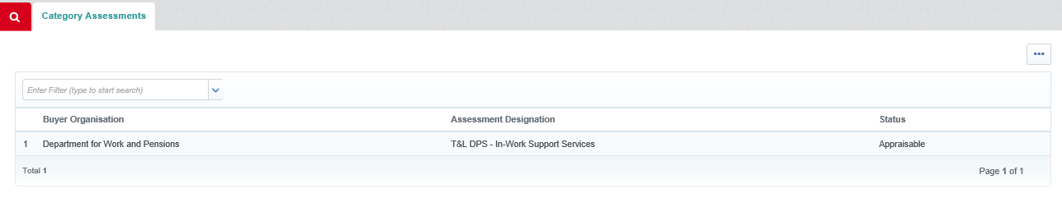
This brings you to the Category Assessments page where you can view your current status. The three main statuses are:
Not Qualified – You have been rejected for this service line, please see your messages for reasons specified or you may have automatically failed due to a response to a mandatory exclusion question.
Qualified – You have been qualified for this service line and will receive the invitation to tender for suitable future call offs.
Appraisable – Your application is still under review, please see your messages to see if any queries have been raised regarding your application.

If you do not see a service line that you have applied for here, it may be because:
You have not selected the service line as a category.
Your application has not been updated on our side, the updates have to be ran manually on our side.
If you have any queries/issues regarding this, please get in touch via the internal messaging system on the DPS or by our shared mailbox
CD.TEST-LEARN@DWP.GSI.GOV.UK

FAQ

How do I get in touch with someone at DWP regarding the DPS/my application?
Please contact us via the internal messaging system found on the Test and Learn DPS or via our shared inbox at CD.TEST-LEARN@DWP.GSI.GOV.UK

Where do I find the FVRA or Legal Entity Template?
These are found in the ‘Buyer Attachments’ tab on the Test and Learn DPS, see the top of page 8 for a screenshot showing this,

Where do I find the templates for each service line?
These are found as attachments next to each question, accessible by clicking on the blue paperclip next to the question. See the top of page 9.

What should I write for my application to the service line.
Please read the information included at the top of the template, sticking to under 500 words. The bullet points provided are the main elements we are looking for in the application.
Please also read the Instructions to Potential Suppliers (pg. 26 onwards) and the Specification, found in the ‘Buyer Attachments’ to find further information and to understand the general purpose of the Test and Learn DPS.
If the service line is asking for information on a service you have yet to provide, please write in regards to the service you would implement in the future.

Does my subcontractor need to be accredited onto the Test and Learn DPS?
Only those we are contracting with directly need to be accredited onto the Test and Learn DPS.

What is a DUNNS number?
The Dun & Bradstreet D-U-N-S Number is a unique nine-digit identifier for businesses issued by Dun & Bradstreet, please see their website for further information.
https://www.dnb.co.uk/duns-number.html
Where are the contracts to apply for, where do I submit my bid?
There is no constant active contract/service that providers can apply for, only once a call off has commenced can suppliers submit their bids if they have received the invitation to tender.
The invitation to tender will only be issued to suitable suppliers accredited for the service line that is being called off from. The service line that will be called off from is unique to the procurement and will be announced in the details of that procurement.

