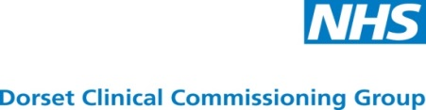
Assisted Conception Service
Expressions of Interest for Market Engagement Event

NHS Dorset Clinical Commissioning Group (CCG) wish to engage with prospective providers who are interested in working with the CCG to design the future service model and discuss potential provider structures for an Assisted Conception Service.
The market engagement meeting will take place on Thursday 18 January 2018 at the NHS Dorset CCG, Vespasian House, Barrack Road, Dorchester, Dorset. DT1 1TG. Providers should report to reception upon arrival. Providers are invited to meet with commissioners to discuss their thoughts regarding the specification and service.
If you are interested in attending this meeting or are unable to attend but would like information sent to you please express your interest by completing and returning this form to DorsetProcurement@Dorsetccg.nhs.uk no later than 12.00 midday on Tuesday 16 January 2018. Attendance at the Market Engagement Meeting will be limited to two individuals from each representative organisation. Please provide name and role of attendees.
Contact name:
Organisation name:
Organisation address
Contact number:
Contact email address
Attendee 1:
Name and position
Attendee 2:
Name and position

I can /cannot attend the Market Engagement Meeting on Thursday 18 January 2018
*delete as appropriate

Please indicate your preferred time slot to meet with the commissioners by marking the relevant slot with an X in the below the time. We will try to give you the timeslot you wish for, however they will be given on a first come first serve basis.
TIME SLOT | PREFERRED TIME
9.15 – 10.00 am
10.05 – 10.50 am
10.55 – 11.40 am
11.45 – 12.30 am
1.00 – 1.45 pm
1.50 – 2.35 pm
2.40 – 3.25pm

Please return this completed form no later than 12.00 midday 16 January 2018

