CONDITION 45(a)
STATEMENT OF REQUIREMENT

Provision of Maintenance to C-17 Mobile Platform Stands and Ancillaries
CORE SERVICE
- The Contractor shall undertake core servicing activities described in this Condition 45(a) Statement of Requirement (SoR) for all in-scope platforms and equipment listed at Annex A at the stated maintenance intervals. All work carried out must be to the satisfaction of the Authority’s Project Manager and the Authority’s representative at RAF Brize Norton (the location of all in-scope platforms and equipment and the location of all servicing).

- The Contractor shall identify a point of contact and shall be responsive to queries by email and telephone and formal ad-hoc TAF Tasking requests in accordance with the Tasking Process (Section 12 iaw. Annex B).

- The Contractor shall ensure that the scheduled maintenance periodicity is not exceeded and is to liaise with the Authority Representative, RAF Brize Norton, Oxfordshire, OX18 3LX, (tele [redacted]), 60 days in advance to arrange the servicing date and site booking requirements.

- The Contractor is to ensure site visits are minimised where possible by combining servicing across platforms which require scheduled maintenance in the same month.

- The Contractor shall provide the Authority copies of all test certificates and inspection reports and shall maintain a ‘Service and Inspection Record Sheet’ for each platform and sign the sheet during each visit to confirm the platform is serviceable and ensure it is also co-signed by the Authority’s representative. Certificates & reports are to be provided in either PDF or MS Word write protected format, within 10 working days from completion of all visits. A template certificate is provided at Annex C for reference (a mutually agreed alternative may also be accepted)

- The Contractor shall inform the Authority Representative at the earliest opportunity should a platform/equipment be deemed unserviceable. Repairs are subject to a Tasking Authorisation Form (TAF) in accordance with the Tasking Process (Section 12).
Schedule of Requirements (Schedule 2)
Item 1 & 1a: Services to Activax Mobile Elevating Work Platforms
- Quantity 2 (two) Activax platforms are used to access the C-17 aircraft during maintenance activities. They are managed at RAF Brize Norton by the Authority’s Representative and require a 6-monthly servicing and an Annual Safe Working Load Test (SWLT) conducted by suitably qualified and competent engineers. The activities comprise:

Item 1: Bi-Annual (6 monthly) Maintenance Programme shall be conducted at the periodicity stated in Annex A and completed in accordance with the Lifting Operations and Lifting Equipment Regulations 1998 (or subsequent versions) and shall include the following:

- Visually inspect machine for damage or faults.
- Check Cylinder Emergency Lowering Valves are closed.
- Check integrity of handrails paying particular attention to the sword pin fasteners.
- Full inspection of structure.
- Check integrity labels ensuring they are secured correctly, and all information is clearly visible.
- Check wheels and casters.
- Carry out a full functional operational check of platform.
- Any unserviceable items are to be highlighted on the Servicing and Inspection Record detailing fault.
- Jacks shall be greased at least bi-annually. Grease through the fitting on the jack with hand or power operated equipment. Grease with No. 1 Consistency Grease.

Item 1a: Annual Safe Working Load Test (SWLT) shall be conducted at the periodicity stated in Annex A. The Contractor shall complete a thorough inspection described below. and provide to the Authority on completion I.A.W. Para 5.

- Visually inspect machine for damage or faults.
- Check Cylinder Emergency Lowering Valves are closed.
- Check integrity of handrails system paying particular attention to the sword pin fasteners.
- Full inspection of structure.
- Check integrity labels ensuring they are secured correctly, and all information is clearly visible.
- Check wheels and casters.
- Carry out a full functional operational check of platform.
- Any unserviceable items are to be highlighted on the Servicing and Inspection Record detailing fault.
- SWLT: Confirmed by issuing the Certificate of Thorough Inspection (Annex C) and Safe Working Load Test of Mobile Elevating Platform certificate to the Authority Representative In Accordnce With (I.A.W.) Para 5.

Schedule of Requirements (Schedule 2) Item 2: Services to HHI Engine Maintenance Stands x 4

- Quantity 4 (four) HHI Engine Maintenance Stands are managed by the Authority representative at RAF Brize Norton and require a 6-month servicing.

The Contractor shall provide suitably qualified and competent engineers responsible for the following tasks:

Bi-Annual (6 monthly) service shall be conducted at the periodicity stated in Annex A for each of the 4 (four) HHI Engine Stands. It shall include the following:

- Visually inspect machine for worn or damaged components or any other faults
- Check all bolted connections, report on frames and handrails. Tighten or replace if needed.
- Visually inspect rubber strips under each deck slider.
- Visually inspect frame, deck, deck sliders, bumpers, wheels, casters, screw, jacks, handrails, swing gate, toggle clamps, linkage shaft and decals; replace if necessary.
- Ensure screw jacks, telescoping legs, and height adjustable stairs have full range of motion. Inspect UHMW for irregular wear.
- Carry out a full functional operational check of platform.
- Any unserviceable items are to be highlighted on the Servicing and Inspection Record detailing fault.
- Provide a service report I.A.W. Para 5.
- Jacks shall be greased at least bi-annually. Grease through the fitting on the jack with hand or power operated equipment. Grease with No. 1 Consistency Grease.

Schedule of Requirements (Schedule 2) Item 3: Services to Universal Aerial Refuelling Receptical Slipway Installation (UARRSI) x1

- The Quantity 1 (one), HHI Universal Aerial Refuelling Receptical Slipway Installation (UARRSI) is managed by the Authority Representative at RAF Brize Norton and requires a 6-monthly servicing.

The Contractor shall provide suitably qualified and competent engineers responsible for the following tasks:

Bi-Annual (6 monthly) service shall be conducted at the periodicity stated in Annex A for the 1 (one) UARRSI Stand. It shall include the following:

- Visually inspect machine for worn or damaged components or any other faults
- Check all bolted connections, report on frames and handrails. Tighten or replace if needed.
- Visually inspect rubber strips under each deck slider.
- Visually inspect frame, deck, deck sliders, bumpers, wheels, casters, screw, jacks, handrails, swing gate, toggle clamps, linkage shaft and decals; replace if necessary.
- Ensure screw jacks, telescoping legs, and height adjustable stairs have full range of motion. Inspect UHMW for irregular wear.
- Carry out a full functional operational check of platform.
- Any unserviceable items are to be highlighted on the Servicing and Inspection Record detailing fault.
- Provide a service report I.A.W. Para 5.
- Apply grease to all designated areas in the O&M manual; ensure that parts are properly lubricated. Clean off excess grease to prevent build up.

Schedule of Requirements (Schedule 2) Item 4: 60T Screw Jacks x 12

- Quantity 12 (twelve), 60T Screw Jacks are managed by the Authority Representative at RAF Brize Norton. The Contractor shall provide suitably qualified and competent engineers to complete SWLTs on a 6 monthly cycle and provide to the Authority on completion I.A.W. Para 5.The tests will be completed in batches of Qty 6 (six) ensuring each 60T Screw Jack is tested on an annual basis, comprising:

- With a calibrated loading device, apply loads of 10, 30, and 55 tons on jack tester. The gage should hold it reading for five (5) minutes at each of the above loads.
- No leakage of hydraulic fluid or malfunction should occur.

Schedule of Requirements (Schedule 2) Item 5: Winch Bridles x18

- Quantity 18 (eighteen), Winch Bridles (9x Single Leg, 9x double leg) are managed by the Authority Representative. The Contractor shall provide suitably qualified and competent engineers to complete the following tasks annually:

- A thorough examination of the bridle should be performed by qualified personnel in accordance with the manufacturer recommendations and bridle regulations.
- Visual testing. A visual test should be performed before using the bridle if any chain links are bent, twisted, or notched; all chain links should be tested using the test key. All other components should be inspected for correct operation and completeness.
- Inspection records of all examinations must be signed by the appropriate personnel I.A.W. Para 5.

TASKING
- For the avoidance of doubt all scheduled and ad-hoc maintenance events and repairs are to be requested priced and accepted via this tasking process, utilising the Task Authorisation Form (TAF) as detailed within Annex B

- If a fault or un-serviceability issue is discovered after during the service, the Contractor is to inform the Authority Representative at the earliest opportunity. The C17 DT is to liaise with the Contractor to identify, price and rectify the fault or un-serviceability through the Tasking process below.
Part 1 – Raising of Tasking Authorisation Form
- All Tasking will be initiated by the Authority by completing Part 1 of the Task Authorisation Form (TAF) as detailed within Annex B and sending it to the Contractor for completion (if the task is the result of an issue discovered by the Contractor during a service, the Authority may require Contractor support in drafting the Part 1):

Part 2 – Price Breakdown

- The Contractor completes the TAF Part 2, annotating the Work to Perform, the Firm Price breakdown, the Task Commence and Completion Date. The Contractor is to sign, date and submit the TAF back to the Authority for approval within 3 Working Days from request. For scheduled maintenance, prices shall not exceed those identified in Schedule 2, Items 1 to 3 and 5 per service.

Part 3 – Task Authorisation

- The Authority’s Commercial Manager and Operations Manager shall review Part 2 and return Part 3 of the TAF to the Contractor with authorisation to proceed. The Contractor should contact the Authority Representative to arrange for the Contractor’s engineers to carry out the servicing or repairs.

Part 4 – Task Completion & Payment

- The Contractor will confirm that the work has been completed in accordance with Part 2 of the TAF to the Authority. The Authority shall sign Part 4 confirming Acceptance and return a copy to the Contractor.

Annex A – Maintenance and Interval Dates

Line  Item |  | Equipment |  | Requirement |  | Dates(s)  Required | Image
1 | Activax Stands (Qty 2)  Manufacture: Activax Limited  Model: V5  Serial Number: 2003-3  Year of Make: 2003 |  | 6 Monthly Service Visit |  | Oct-22  Apr-23  Oct-23  Apr-24  Oct-24  Apr-25  Oct-25  Apr-26  Oct-26  (9 anticipated Visits) |  | 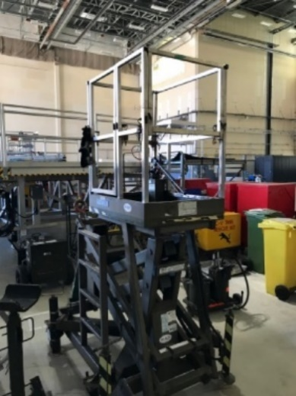
1a |  |  | Annual Safe Working Load Test Servicing |  | Oct-22  Oct-23  Oct-24  Oct-25  Oct-26  (5 anticipated visits)
2 | HHI Engine Maintenance Stands (Qty 4)  Manufacture: HHI  Part Number: 17-046 |  | 6 Monthly Service Visit |  | Oct-22  Apr-23  Oct-23  Apr-24  Oct-24  Apr-25  Oct-25  Apr-26  Oct-26  (9 anticipated visits) |  | 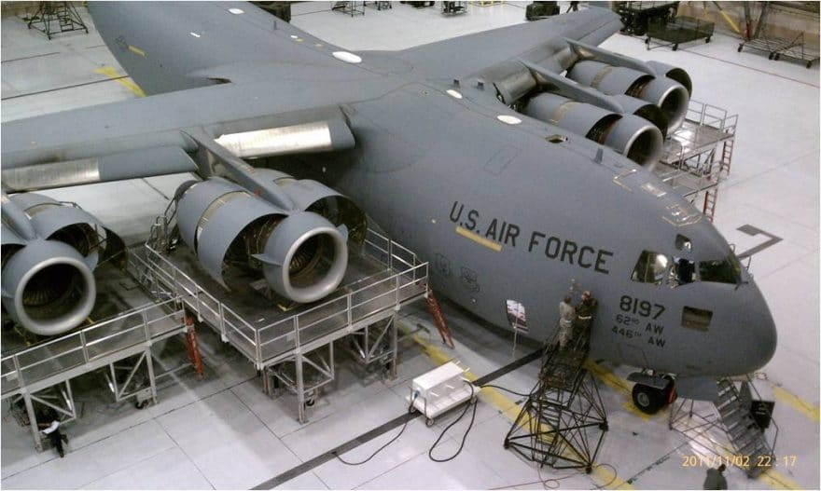
3 | UAARSI Stand (Qty 1)  Manufacture: HHI  Serial Number: TBC |  | 6 Monthly Service Visit |  | May-23  Nov-23  May-24  Nov-24  May-25  Nov-25  May-26  Nov-26  (8 anticipated visits)  (Equipment delivered in May 2022, first service required May 2023) |  | 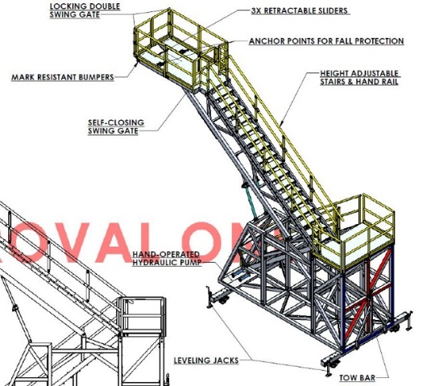
4 | 60T Screw Jacks (Qty 12)  Manufacture: Regent Mfg. Inc.  Model: 8261-010  Serial Numbers: 0294, 0295, 0305, 0293, 0307, 0306, 0303, 0292, 11410-1, 11410-2, 12433-2, 12433-1 |  | Annual Safe Working Load Check  (Batches of 6) |  | Oct-22  Apr-23  Oct-23  Apr-24  Oct-24  Apr-25  Oct-25  Apr-26  Oct-26  (9 visits) |  | 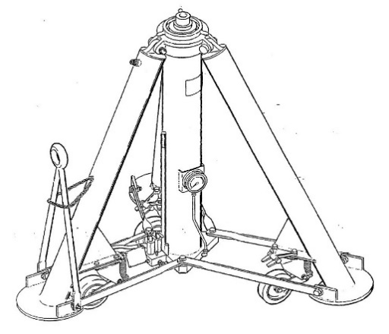
5 | Winch Bridle (Qty 9 Single & Qty 9 Double Leg)  (Total Qty: 18 / 9 pairs)  Manufacture: RUD Chains Ltd  Part Numbers: 7901599 &  7901598  Serial Numbers: 49-66 |  | Annual Safe Working Load Check |  | 8 anticipated visits per calandar year |  | 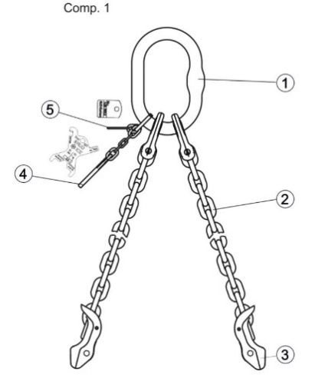  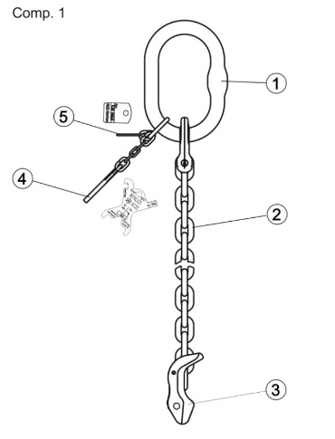

Annex B - Task Authorisation Form

PART 1: TASK REQUIREMENT (to be completed by the Authority)
Contract No.:
C17CSAE Unique Task Number: |  | Version no:
Task Category: (as per the Schedule of Requirement)

Task Title:
Background and Requirement:
Deliverables: |  | Acceptance Criteria: | In accordance with Contract Condition 28 (and Schedule 8), the Authority’s Acceptance Criteria for this task is […]
Part 2 of TAF to be submitted by the Contractor no later than: |  | Task Required by Date:
Signed: (Authority Operations Manager) |  | Date:

PART 2: PRICE BREAKDOWN (to be completed by the Contractor responding to the task proposed by the Authority at Part 1.)
The work described in Part 1 is submitted for authorisation against the following Firm Price quotation:
Work to Perform: |  | Total Firm Price (£) ex VAT:
Type of Work to Perform:
Description:

Task Commencement date:
Task Completion date:

Signature:

Date:

PART 3: TASK AUTHORISATION (to be completed by the Authority for task approval and authorisation)
Operations Manager Endorsement: | Operations Manager approval is hereby given for this task to proceed at a Firm Price of [£................................] ex VAT. For Tasks above £20,000.00, both the Authority’s Project Manager and Commercial Officer are required to sign for authorisation to continue.
Signed:  (Name and post) |  | Date:
Commercial Approval: | The Contractor is duly authorised to carry out the work detailed in Part 1, for the total Firm Price detailed at Part 2 of this form in accordance with the Contract Terms and Conditions.  All other terms and conditions of the Contract remain unchanged.  The Contractor is to acknowledge receipt of the Tasking Order Form within two working days of the signature date below.
Completion date: | A completion date of [……….…………..…….] is given for this task.
Signed:  (Name and post) |  | Date:
PART 4: TASK COMPLETION (to be completed by the Authority)
This is to certify that the Task requirement at Part 1 has been completed to the satisfaction of the Authority and payment can be claimed in accordance with Contract Condition 35.
Signed and Dated: (Name and post)

Annex C - Report of Examination Certificate Template

REPORT OF THE LIFE EXAMINATION L.O.L.E.R
(As required by Lifting Operations & Lifting Equipment Regulations 9 1998 – Schedule 1)

Machine Owner: | Machine Site Address:

MANUFACTURER | MODEL | SERIAL NUMBER | OWNER FLEET NUMBER

Y.O.M | SWL | Examination Date: | Last Examination: | Next Examination:

- Platform to be taken out of service due to the faults resulting in danger to person and property.

- Defect faults to be repaired/organised on receipt of fault findings to prevent danger to person

- Repairs which do not cause any danger and can be carried out on or before next service interval

Inspecting Engineer | Signature | CAP No | Date

Date by which defect(s) named above should be rectified
I hereby declare that they equipment described in this record was thoroughly examined in accordance with the appropriate provisions and was found free from any defects like to affect safety (unless stated otherwise above) and that the particulars are correct.

Authenticator’s Name | Signature | Date

ANNEX D – LABOUR RATES

Table 1 - Firm Labour Rates
Employee role | Firm Price Per hour (£) Ex VAT
 | 05/10/2022 31/12/2023 | 01/01/2024 31/12/2024 | 01/01/2025 31/12/2025 | 01/01/2026 31/12/2026 | 01/01/2027 31/03/2027
Mechanic | [Redacted] | [Redacted] | [Redacted] | [Redacted] | [Redacted]
NDT Inspector | [Redacted] | [Redacted] | [Redacted] | [Redacted] | [Redacted]
Inspector | [Redacted] | [Redacted] | [Redacted] | [Redacted] | [Redacted]
Welder / Plater | [Redacted] | [Redacted] | [Redacted] | [Redacted] | [Redacted]
*FIRM rates are inclusive of labour overheads, profit and all indirect costs.

ANNEX E – QUALIFICATIONS and EXCLUSIONS

[Redacted]

[Redacted]

Mandated 60-day service arrangement does not apply to the AD-HOC Tasking Process.
Schedule of Requirements, Line Item 4: 60T Screw Jacks are not priced or included in the C17CSAE/703473453 provision at contract award. The parties will consider the inclusion of this requirement during the in-service phase.

