**Prior Information Notice questionnaire (PIN) – Defence Science & Technology Futures Collaborative Construct (FCC)**

***The future matters to defence. Dstl is exploring how to invest £100 million over the next 10 years to revitalise research that helps us understand the full potential of global science and technology.***

# Purpose

The purpose of the PIN is to:

* share information on Dstl’s current thinking regarding FCC design, operations and governance;
* obtain views and feedback from the market, including responses to the questions detailed in this document and
* use the feedback and information to inform and support the development of Dstl’s future Business Cases and Procurement strategy.

This PIN is not a request for a full proposal or bid nor should it be taken to be a call for competition, it is purely to obtain information from early engagement with the market.

# Background

Dstl are considering the need for a new service delivery construct, predominantly (but not exclusively) to support the Defence Science and Technology Futures (DSTF) Programme.

DSTF’s vision is that defence is better prepared for the future (typically looking 20 years, or further, ahead) through revitalised investment in science and technology futures activity to:

* identify possible new science and technology with potential to revolutionise future operations;
* establish, mature and rapidly test options and
* translate and promote emerging insights to optimise exploitation of science and technology.

As well as influencing key decision making across defence, DSTF provides the stimulus for making changes to MOD’s research portfolio that takes account of emerging and disruptive science and technology, identifying areas worthy of further exploration. The programme offers a consistent source of advice to defence, on how promising science and technology could impact on, and be utilised by, defence and the implications that might arise from doing, or not doing so.

# Scope of the FCC

Dstl seeks to establish, develop and maintain a collaborative approach that will provide capacity and capability to service DSTF.

An initial visualisation of the system is provided in Figure 1. This shows (within the dark blue line) the proposed boundary for the FCC along with the current thinking about governance, key dependencies and interactions. At this stage, Dstl is open to ideas from the market about how the service will be delivered. Dstl will be the core collaborative and decision-making partner.

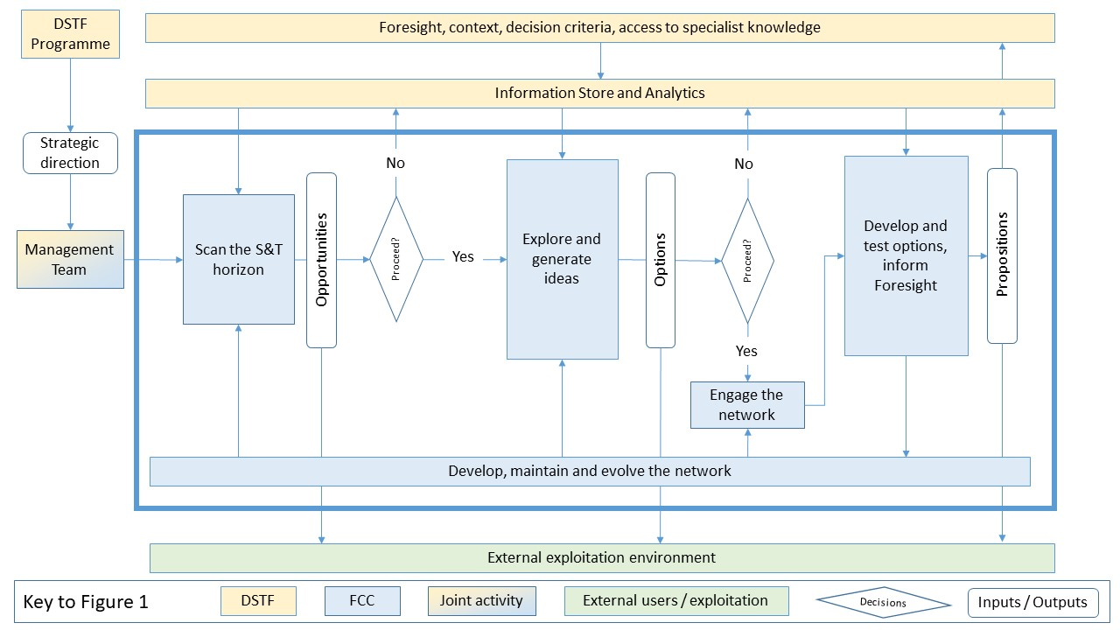Figure 1

Elements of service delivery

# Description of the FCC

The intent is to invest over a period of up to 10 years, starting around Autumn 2024, in order to develop an enduring breadth and depth of capacity and capability via a service delivery mechanism. This will be led by a service provider and enabled by access, via the FCC, to a diverse range of subject matter experts.

The first 12 months will be focused on a managed transition from existing delivery mechanisms and will be constrained to DSTF funding, estimated to be up to £5M. Subsequent years would see a build up to an annual estimated funding of between £9M and £13M depending on the value of additional funding from outside DSTF.

There is an additional expectation that the service delivered will be available to users outside DSTF, including other defence science and technology programmes delivered by Dstl, other parts of defence, and extending into Partners Across Government on occasion. Though the service will be limited to UK Government-based users, outputs from the work may be shared with the UK’s allies.

The progress and direction of the FCC will be reviewed regularly, at least annually, and on a three-year cycle, which will be aligned with the refresh periods for DSTF. There is an expectation of the need to veer and haul between the elements of service delivery (described below) over the duration of the commitment.

## The Elements of Service Delivery (to be read alongside Figure 1)

* Scanning the Science and Technology Horizon - creating Opportunities to exploit science and technology by scanning the broadest possible horizon to identify things which may impact on the way defence operates in the future.
* Exploring Opportunities and generating Ideas - creating Options (which could be, but not limited to science or technology concepts) that present the most significant risks or prospects for defence to make positive change.
* Developing, maturing and conducting fundamental scientific research and novel technology development to test Options - with a view to informing Foresight analysts, creating Propositions (the business cases we need to catalyse change) for exploitation by defence strategists, policy makers, long-term planners and other research programmes;
* Developing, Maintaining and Evolving the Network - maintaining a broad Network of expertise which can be rapidly accessed as a service on demand to work alongside Dstl throughout this process and focus on specialist technical aspects of individual Options as they are developed and tested;
* Building Capability and Capacity - a core expectation will be that the Service Delivery Lead will build an enduring Capacity to operate at pace, with agility to grow the Capability. This will operate across as full as practicable a scope of global science and technology.

Exploitation of Opportunities, Options and Propositions is expected at all stages of Service Delivery, by engaging with diverse stakeholders both within and, if required, outside defence.

## Governance

Decision making and governance will be provided by a Management Team drawn from Dstl (covering contract and project management; technical and contextual advice) and the Contractor (covering service delivery, network, and exploitation management). This Team will be guided by strategic direction from DSTF and have day to day responsibility to set the pace, scope and volume of outputs required. The service delivery will be based on collaborative best practice, requiring trust and a willingness to learn and fail between members of the Management Team.

Initial thinking on the critical success factors is that service delivery will be incentivised via:

* Value for money;
* Influence on defence decision makers;
* Pace, volume and agility of delivery of outputs;
* Creating and exploiting knowledge and
* Improvement of the research capacity and capability.
* Knowledge, Information and Data Management and Intellectual Property (IP) Management

Figure 1 introduces the “Information Store and Analytics” as a core element of supporting functionality of the FCC. Dstl are actively developing tools and approaches that support best practice knowledge, data and information management that may contribute to the functionality of the Information Store and Analytics. The FCC will be expected to contribute to, and draw material from, the Information Store and Analytics alongside any of their own existing tools and techniques.

The FCC will comply with appropriate MOD IP policy. Operating within a collaborative environment has the potential to require some bespoke IP conditions being applied.

## Embedded and supporting Dstl roles

Dstl will initially provide three specific roles into the FCC, all of which are expected to mature and adapt over time:

* Technical Partners will provide assurance that material passing into and out of the Information Store and Analytics is fit for purpose.
* Lead Technical Reviewers will provide assurance that outputs are exploitable and fit for purpose.
* Collaborative Partners will be embedded into elements of the service and will form an integral part of Service Delivery, whilst also ensuring context, decision-making criteria and specialist knowledge are appropriately considered.

## Phasing of transition

A phased transition from how DSTF currently operates is expected to accommodate the elements of service delivery provided by the FCC. It is expected that the period of transition may last up to 12 months and require the FCC to establish an initial Network and focus in the first instance on testing Options and generating Propositions.

# Prior Information Notice Questionnaire

# Please complete the below questionnaire and provide information, which Dstl may seek to clarify and discuss further to support our understanding and inform the future development of the Business Case and Procurement Strategy. Please keep answers brief, a maximum of 2 paragraphs with explanation(s) and suggestion(s) where appropriate.

|  |  |
| --- | --- |
| **Organisation name** |  |
| **POC name and email contact details** |  |
| **Overall viability**  What are the challenges identified to the viability of this approach over the anticipated time frame? Please share your rationale. | |
| **Challenges to delivery**  Do you perceive any challenges to delivery, risks or issues with the proposed design and operation? Please share your rationale. | |
| **Reducing barriers to entry**  What would you consider to be barriers to entry from the perspective of either a Service Provider or a Supplier within the Supply Chain? | |
| **Boundaries**  Please state your views about where the boundaries of the FCC have been positioned. Would a changed boundary provide a better solution? Please share your rationale. | |
| **Governance**  What challenges and opportunities do you perceive in relation to the proposed approach to governance? | |
| **Costing options**  What would you consider to be the constraints and risks to; costing the construct, submitting a cost breakdown and overall price, if the requirement progressed to a competitive procurement? | |
| **Enabling collaboration**  Please state views about what collaborative enablers need to be present for this type of construct. | |
| **Likelihood of tender submission**  Would you be interested in submitting a tender if the FCC requirement progressed to a competitive procurement? If so, please advise on your potential role (e.g. Service Provider, member of the Supply Chain). | |
| **Any other comments or observations**  Please share any additional comments or observations you have including any clarification of detail or intent you would like to see emerge if FCC progresses. | |

**Your completed Prior Information Notice Questionnaire should be returned via email to jmottram@dstl.gov.uk.**