Expression of Interest (EOI)
Background

The Pirbright Institute
The Pirbright Institute (TPI) is a world leading centre for research and surveillance of virus diseases of farm animals and viruses that spread from animals to humans.
Recent and ongoing investment at TPI has resulted in a redevelopment of the site and the construction of a high level containment facilities. One of these facilities is the Brooksby Building (High Containment Large Animal Facility).
The Brooksby Building will be a self-contained, stand-alone, large animal experimental facility designated to accommodate ‘in vivo’ studies involving ‘high containment’ pathogens (SAPO4/ACDP3) of livestock, such as foot-and-mouth disease virus (FMDV) as well as pathogens that can spread from livestock to humans.

Scope of this EOI
The scope of this EOI is to design a room decontamination system, overlayed onto the building layout and schematics, to allow decontamination of six feed and bedding stores and one entry room. The design is to integrate with the existing systems and services planned for the building.
The design must comply with all mandatory regulatory standards and the designer will need to ensure that an allowance is made for HAZOP and Assurance validation reviews prior to design acceptance.
This design may be installed by others therefore TPI will require that all IP and proprietary components utilised within the design are made available to them without restriction.

Room Use
Both the Feed and Bedding Stores and the Entry Room has a dual function. The first function is for entry from external from building to Suites. The second function is to store feed, bedding and possibly other consumables for the suites. In the second mode, the spaces will act as a lobby to allow movement of these materials from a ‘clean’ space to a ‘contaminated’ space.

Room Decontamination
To restock the Feed and Bedding Store and/or Entry Room after a study has started, the space will require decontamination. The decontamination process is to prevent environmental release of SAPO4, GMO4 pathogens and unprotected exposure of ACDP3 pathogens. This process could be undertaken as frequently as weekly.
- The room decontamination should be manually activated from the suite (for the feed and bedding store) or Clean corridor (for the Entry) but run on a pre-programmed automatic cycle
- Room is in a set state for decontamination
  - All entry / exit doors be will required to lock automatically
  - HVAC supply and exhaust dampers to be manually shut

- Emergency escape within these rooms terminate the decontamination cycle
- BMS must register when a cleaning cycle is initiated and completed

Workflow Process

Storage rooms
- The store is clean, empty and decontaminated <<Start State>>
- The holding room door is closed and locked
- Feed and bedding is loaded in the room from the clean corridor.
- Once room is fully loaded, the clean corridor side door is locked
- The holding room door is unlocked and opened
- Feed and bedding is taken from the store through the Suite door
- Once all feed and bedding is used (or at the end of a study) the room contents is removed, manually cleaned and decontaminated using appropriate disinfectant
- The holding room door is closed and locked
- Automatic decontamination activated
- On completion of decontamination cycle, the clean corridor door is unlocked and ready to be opened (Room returns to <<Start State>>)

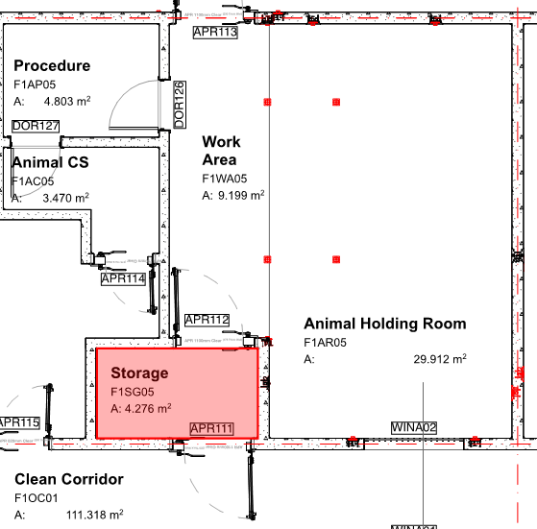
Figure 1 - Typical Storage room (1 of 6)
Figure 2 - Feed and Bedding Store Operations Cycle

Entry
- The Entry room is clean, empty and decontaminated (Start State)
- Clean corridor doors are close and locked
- Feed and bedding is loaded in the room via the unlocked Outer Doors.
- Once room is fully loaded, the Outer Doors are closed and locked
- Clean Corridor doors are unlocked and opened
- Feed and bedding is taken from the Entry room through the clean corridor doors
- Once all feed and bedding is used (or at the end of a study) the room contents is removed, manually cleaned and decontaminated using appropriate disinfectant
- The Clean Corridor doors are closed and locked
- Automatic decontamination activated
- On completion of decontamination cycle, the Outer doors are unlocked and ready to be opened (Room returns to Start State)

Room Decontamination
- All surfaces to be decontaminated – validateable
- Contact times (minimum to be specified upon solution)
- Rinse (dependent upon solution)
- Drying – HVAC on and wait time as part of the automated solution (dampers will be manually opened)
- BMS notified when cycle complete
- Clean side door unlocks
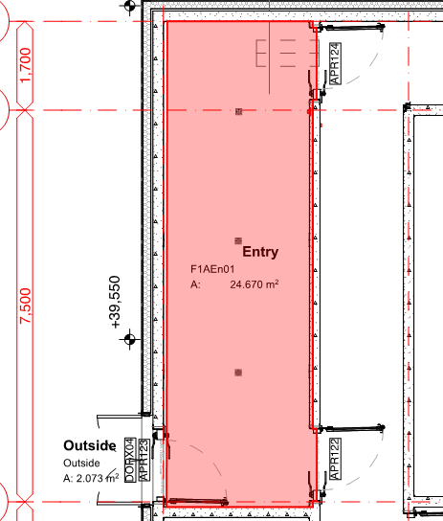
Figure 4 - Entry Operations Cycle
Figure 3 - Entry showing outer doors and clean corridor doors

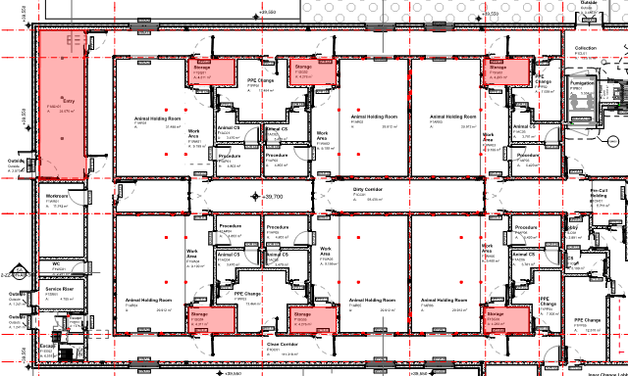
Building General Arrangement

Expression of Interest Form
Contact details:

Name:
Address:

Email:
Organisation: type:

Framework /Advert

Framework /Provider:

Framework Name/Number

(if applicable):
Lot No (if applicable):

Timeline
- Tender for design of solution – December 2020 – January 2021
- Development of solution (with users) – February 2021 – May 2021
- Final solution delivered: May 2021

Response details:
Please respond by (Time and Date): 27th November 2020
Format of Response: Email
Name, address and/or email for response: adam.hunt@pirbright.ac.uk

