**Invitation to tender**

**Construction of Clean Room at Newquay** **TR84HP**

**Ref: Piran SPF_02**

# 1. Background

Having worked on world leading projects in a variety of industries as a manufacturer and direct consultant to major projects Piran Advanced Composites (PAC) Limited have now established ourselves offering a complete service from design, engineering and manufacture of one off, R&D, low volume and high volume structures and components. We have developed novel technologies to be able to offer high quality services to a variety of industries such as Aerospace, Defence, Medical, Automotive and Marine. Our experience ranges from ultra-lightweight novel Aerospace R&D aerostructures through to low/high volume propulsion and flight critical Components

# 2. General Requirement

# PAC will be moving to new premises at Southern Hangar 1, Space port Cornwall, Newquay, Cornwall TR84HP in May 2024. The new premises will enable the company’s growth plans to be realised and undertake manufacture of airframes with large wind spans. As part of the overall refurbishment of these premises, PAC wishes to have built a 2-storey clean room built inside the hangar.

# The purchase of this system is part of a grant funded application process and therefore procurement will be subject to grant approval of the project. We will assess tenders received on a Most Economically Advantageous Tender.

# 3. Tender requirements

Where specific products/finishes are detailed, bidders may offer alternatives providing they are equivalent to or exceed the specifications listed; any alternatives should be raised as part of the clarifications.

1. Outline Drawings

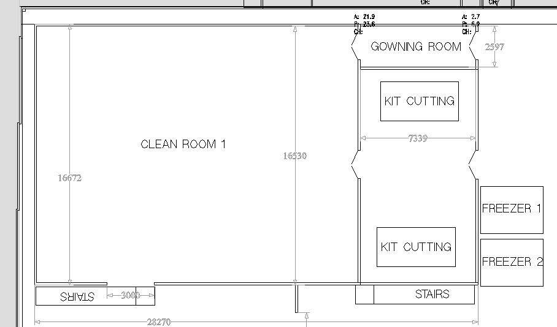

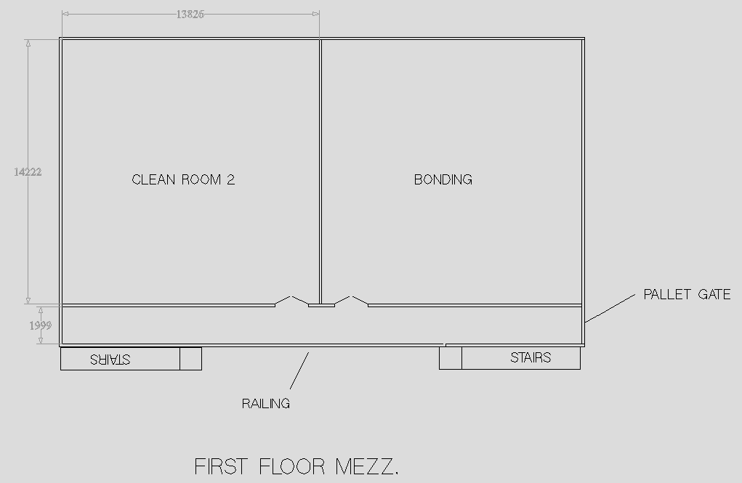

1. MEZZANINE FLOOR
2. Platform Size: 28.300m x 16.700m
3. Column Grid: 4.000m x 3.500m (most economical)
4. Height: 3.200m to the topside (inset construction)
5. Decking: 38mm particle board (Grade C)
6. Loading (UDL): Imposed load 4.800kn/m² plus dead load (mezzanine self-weight) 0.400 kn/m²
7. Handrailing: 25.00 metres total (standard tubular, twin railed c/w kicker)
8. Staircases: 2 standard steel c/w twin railed tubular handrailing – Park Of B Regs.
9. Landings: 2 top landings
10. Base Plates: Based on the assumption of 150mm slab, 150mm hardcore and 80kn/m² gbp
11. Loading Access: 1 No up over safety pallet gate
12. Paint Finishes
13. Main Steel – Shot blasted and primed
14. Decking – Natural P6 grade
15. Deckbeams and Handrail Tubes – Galvanised
16. Handrail Posts & Stair Treads – Sprayed
17. FIRE PROTECTION

Building Regulations state that unless the mezzanine is used purely for storage purposes the structure must be fire rated to one hour. We achieve this by Installing a one-hour fire rated suspended ceiling beneath the structure which has a 24mm white metal grid with 600 x 600 square edged white lay in type tiles. The mezzanine support columns and the exposed bulkheads are protected by white faced column casings and fascias.

1. STUD PARTITIONING

Installation of metal stud and plasterboard partitioning using 15mm plasterboards with 50mm APR insulation within the voids, taped, filled and emulsion painted. Complete with aluminium framed doors and windows with PVC skirting.

1. Layout

As per 3.1. Walls to be solid to full height with 12 windows, 6 x double doors and 2 x 3m wide sliding doors.

1. CEILING

Installation of a suspended ceiling over the first floor partitions complete with a rolled insulation over. This ceiling will be suspended from the roof.

1. ELECTRICAL

To supply and fit

1. Ground Floor

1. Clean Room 1
2. 600mm x 600mm Led light panels (422 Lux Approx)
3. 600mm x 600mm Fire hoods
4. Emergency light modules
5. 1no Switch with integrated em test facility
6. 13no Twin 13A Socket Outlets
7. Kit Cutting
   1. 600mm x 600mm Led light panels (413 Lux Approx)
   2. 600mm x 600mm Fire hoods
   3. Emergency light modules
   4. 1no Switch with integrated em test facility
   5. 5no Twin 13A Socket Outlets
8. Gowning Room
9. 600mm x 600mm Led light panels (375 Lux Approx)
10. 600mm x 600mm Fire hoods
11. Emergency light modules
12. 1no Switch with integrated em test facility
13. 2no Twin 13A Socket Outlets
14. FIRST FLOOR
15. Clean Room 2
16. 600mm x 600mm Led light panels (384 Lux Approx)
17. Emergency light modules
18. 1no Switch with integrated em test facility
19. 10no Twin 13A Socket Outlets
20. Bonding Room
21. 600mm x 600mm Led light panels (384 Lux Approx)
22. Emergency light modules
23. 1no Switch with integrated em test facility
24. 10no Twin 13A Socket Outlets
25. Corridor
26. 600mm x 600mm Led light panels (393 Lux Approx)
27. Emergency light modules
28. 1no Switch with integrated em test facility
29. New dedicated circuits
30. Testing and Commissioning
31. Summary of the Electrical Works
32. Wiring carried out in PVC thermoplastic cables
33. Wiring accessories White in colour Key type switches installed to allow for testing and isolation of the emergency lights.
34. On completion of the works certification and log books to be issuedto the client
35. AIR CONDITIONING

All units to come with individual controls and to run independently to each other. All Units come with a 5-year manufactures parts warranty.

1. Clean Room 1 6no 5Kw Ceiling Cassettes ensuring 28-32kw output
2. Kit Cutting 2no 6KW Ceiling Cassettes ensuring 12-14kw output
3. Clean Room 2 2no 10Kw Ceiling Cassette ensuring 20-25kw output
4. Bonding Room 2no 10Kw Ceiling Cassette ensuring 20-25kw output
5. HEAT RECOVERY VENTILATION

Each unit ducted to exterior via insulated ducting and finished with 2no 600mm x 600mm grills, for supply and return air respectively.

1. Clean Room 1 3no MITSUBISHI SAF1000 for 4 air changes per hour
2. Kit Cutting 1no MITSUBISHI SAF500 for 4 air changes per hour
3. Clean Room 2 2no MITSUBISHI SAF1000 for 4 air changes per hour
4. Bonding Room 2no MITSUBISHI SAF1000 for 4 air changes per hour
5. FORK LIFT AND SKIPS

To be provided by the bidder; allow a provisional sum of £3,000

1. BUILDING REGULATIONS.

Building regulations state that local authority approval will be required for this installation. The supplier is to undertake all correspondence / communication with the relevant building control and fire departments on PAC’s behalf and follow the application through to an official approval. The fees for this will be charged to PAC separately outside the costs for this tender. However, the certificate for compliance is to be issued to PAC when final payment will be made. PAC understands the installation is to commence before final Building Regulations approval has been issued, and therefore the bidder will not be held responsible for any additional items required by the relevant departments.

1. Shared Prosperity Fund Branding and Publicity Guidance <https://ciosgoodgrowth.com/wp-content/uploads/2024/02/UK-SPF-_-Branding-and-Publicity-V12.pdf>

The supplier’s attention is drawn to:

*Plaques and Billboards All projects must install a permanent plaque of significant size (at least 250x200mm as a minimum) at a location readily visible to the public, bearing the appropriate logos, project name and the text:*

*. ‘This project is [funded/part-funded] by the UK Government through the UK Shared Prosperity Fund.’*

*For infrastructure projects, we also encourage the use of temporary billboards while construction works are ongoing. Billboards should be of significant size at a location readily visible to the public and contain the same information as plaques (logos, project name and funding text). All plaques and billboards must be produced and funded by the beneficiary. The cost of producing them should be considered when developing and planning the project. Applicants should note that co-branding is only permitted with Cornwall Council or funders.*

PAC Limited will provide the Plaque but the supplier will be responsible for affixing the Plaque and the provision and erecting of the Billboard.

3.17 PAC would like to draw bidder’s attention to SPF-Net-Zero-Construction-Project-Guidance and how they will incorporate this guidance in the delivery of the project (Enclosure 1)

4**. Budget**

The total maximum budget available for this commission is £275,000 (exc VAT) but inclusive of all expenses.

**Tenders that exceed the total budget will not be considered.**

The budget will be reviewed as part of the tender evaluation detailed in Section 10 and will reflect the degree to which there is a saving on the maximum budget

# 5. Tender and commission timetable

The timescale of the programme is from the date of signing the contract until acceptance by PAC. The timetable for submission of the Tender, completion of the programme are set out below:

|  |  |
| --- | --- |
| **Milestone** | **Date** |
| Date ITT available on Contracts Finder | 9 May 2026 |
| Last date for raising queries | 1700: 17 May 2024 |
| Last date for clarifications to queries | 1700: 20 May 2024 |
| Deadline to return ITT | **1700: 30 May 2024** |
| Evaluation of ITT | 31 May 2024 |
| Award of Contract | 3 June 2024 |
| Contract start | No later 17 June 2024 |
| Contract completion | No later 16 August 2024 |

# 6. Tender submission requirements

Please include the following information in your Tender submission.

6.1 Covering letter (two sides of A4 maximum) to include:

1. Confirmation that the tenderer holds current valid insurance policies as set out below and, if successful, supporting documentation will be provided as evidence:
2. Professional Indemnity Insurance with a limit of indemnity of not less than two million (£2,000,000),
3. Employers Liability Insurance with a limit of indemnity of not less than Five million (£5,000,000)
4. Public Liability Insurance with a limit of indemnity of not less than Five million (£5,000,000).
5. Conflict of interest statement
6. Confirmation that the supplier has read and understood the Shared Prosperity Branding and Publicity Guidance (see Section 3)

6.2 Details of 3 similar projects of value (or greater) and size. Each Example should be no more than 2 sides of A4. Links to websites will not be viewed.

6.3 Project Method Statement. This should include:

a. The management organisation of the company to include who will be responsible for Health and Safety onsite and who will be the Project Manager. Provide the CVs of both of these members of staff (the CV should be a maximum of 1 page of A4).

b. Programme of work that demonstrates how you will meet the proposed timetable and key milestones.

c. Details of any design proposals

d. How you are going to meet some of the SPF-Net-Zero-Construction-Project-Guidance (Enclosure 1)

6.5 Budget

**7. Sub-contracting**

Tenderers should note that a consortia can submit a tender but the sub-contracting of aspects of this commission after appointment will only be allowed by prior agreement with PAC Limited

**8. Conflicts of Interest**

Tenderers must provide a clear statement with regard to potential conflicts of interests. Therefore, **please confirm within your tender submission** whether, to the best of your knowledge, there is any conflict of interest between your organisation and PAC Limited or its programme team that is likely to influence the outcome of this procurement either directly or indirectly through financial, economic or other personal interest which might be perceived to compromise the impartiality and independence of any party in the context of this procurement procedure.

Receipt of this statement will permit PAC Limited to ensure that, in the event of a conflict of interest being notified or noticed, appropriate steps are taken to ensure that the evaluation of any submission will be undertaken by an independent and impartial panel.

# 9. Tender clarifications

Any clarification queries arising from this Invitation to Tender which may have a bearing on the offer should be raised by email to:

[procurement@pirancomposites.co.uk](mailto:procurement@pirancomposites.com)

in accordance with the Tender and Commission Timetable in section 5.

Responses to clarifications will be anonymised and uploaded by PAC Limited to Contracts Finder and will be viewable to all tenderers.

No representation by way of explanation or otherwise to persons or corporations tendering or desirous of tendering as to the meaning of the tender, contract or other tender documents or as to any other matter or thing to be done under the proposed contract shall bind PAC Limited unless such representation is in writing and duly signed by a Director/Partner of the tenderer. All such correspondence shall be returned with the Tender Documents and shall form part of the contract.

# 10. Tender evaluation methodology

Each Tender will be checked for completeness and compliance with all requirements of the ITT. Tenders will be evaluated to determine the most economically advantageous offer taking into consideration the award criteria.

**Tender returns will be assessed on the basis of the following tender award criteria**

|  |  |
| --- | --- |
| Ref 6.1 Covering Letter |  |
| Acceptable covering letter including confirmation of the requirements detailed at 6.1 | Pass/ Fail |
| Ref 6.2 Previous examples | 30 |
| Details of 3 similar projects of value (or greater) and size. Each Example should be no more than 2 sides of A4. Links to websites will not be viewed. |  |
| Ref 6.3 Project Method Statement | 20 |
| Project Method Statement. This should include:  a. The management organisation of the company to include who will be responsible for Health and Safety onsite and who will be the Project Manager. Provide the CVs of both of these members of staff (the CV should be a maximum of 1 page of A4).  b. Programme of work that demonstrates how you will meet the proposed timetable and key milestones.  c. Details of any design proposals  d. How you are going to meet some of the SPF-Net-Zero-Construction-Project-Guidance (Enclosure 1) |  |
| Ref 6.4 Budget | 50 |
| A **fixed fee** for this work (exc VAT) including travel and other expenses  The lowest bid will be awarded the full 50marks. Other bids will be awarded a mark that is proportionate to the level of their bid in comparison to the lowest bid i.e. Marks awarded = 50 x lowest bid / bid |  |

11**. Assessment of the Tender**

The reviewer will award the marks depending upon their assessment of the applicant’s tender submission using the following scoring to assess the response:

|  |  |  |
| --- | --- | --- |
| **Scoring Matrix for Award Criteria** | | |
| Score | Judgement | Interpretation |
| 100% | Excellent | Exceptional demonstration of the relevant ability, understanding, experience, skills, resource and/or quality measures required to provide the goods/works/services. Full evidence provided where required to support the response. |
| 80% | Good | Above average demonstration of the relevant ability, understanding, experience, skills, resource and/or quality measures required to provide the goods/works/services. Majority evidence provided to support the response. |
| 60% | Acceptable | Demonstration of the relevant ability, understanding, experience, skills, resource and/or quality measures required to provide the goods/works/services, with some evidence to support the response. |
| 40% | Minor Reservations | Some minor reservations of the relevant ability, understanding, experience, skills, resource and/or quality measures required to provide the goods/works/services, with little or no evidence to support the response. |
| 20% | Serious Reservations | Considerable reservations of the relevant ability, understanding, experience, skills, resource and/or quality measures required to provide the goods/works/services, with little or no evidence to support the response. |
| 0% | Unacceptable | Does not comply and/or insufficient information provided to demonstrate that there is the ability, understanding, experience, skills, resource and/or quality measures required to provide the goods/works/services, with little or no evidence to support the response. |

.

13**. Tender Award**

Any contract awarded as a result of this tender process will be in accordance with terms and conditions agreed between the two contracting enterprises.

# 14. Tender returns

Tenders are to be returned by email.

Tenders are to be returned in accordance with Section 5

Latest date to be returned: As per Section 5

Latest time to be returned: 17:00

Emailed tenders should be sent electronically to

[procurement@pirancomposites.co.uk](mailto:procurement@pirancomposites.co.uk)

with the following message clearly noted in the Subject box;

**‘Construction of Clean Room at Newquay TR84HP’**

**Tenderers are advised to request an acknowledgement of receipt of their email.**

# 15. Disclaimer

The issue of this documentation does not commit PAC Limited to award any contract pursuant to the tender process or enter into a contractual relationship with any provider of the service. Nothing in the documentation or in any other communications made between PAC Limited or its agents and any other party, or any part thereof, shall be taken as constituting a contract, agreement or representation between PAC Limited and any other party (save for a formal award of contract made in writing by PAC Limited or on behalf of PAC Limited).

Tenderers must obtain for themselves, at their own responsibility and expense, all information necessary for the preparation of their tender responses. Information supplied to the tenderers by PAC Limited or any information contained in PAC Limited’s publications is supplied only for general guidance in the preparation of the tender response. Tenderers must satisfy themselves by their own investigations as to the accuracy of any such information and no responsibility is accepted by PAC Limited for any loss or damage of whatever kind and howsoever caused arising from the use by tenderers of such information.

PAC Limited reserves the right to vary or change all or any part of the basis of the procedures for the procurement process at any time or not to proceed with the proposed procurement at all.

Cancellation of the procurement process (at any time) under any circumstances will not render PAC Limited liable for any costs or expenses incurred by tenderers during the procurement process.

# 16. Enclosures

1. SPF-Net-Zero-Construction-Project-Guidance