Enclosure 1.

1. Standard Product Range
   1. Single tray – Cardboard L95mm W92mm D45mm

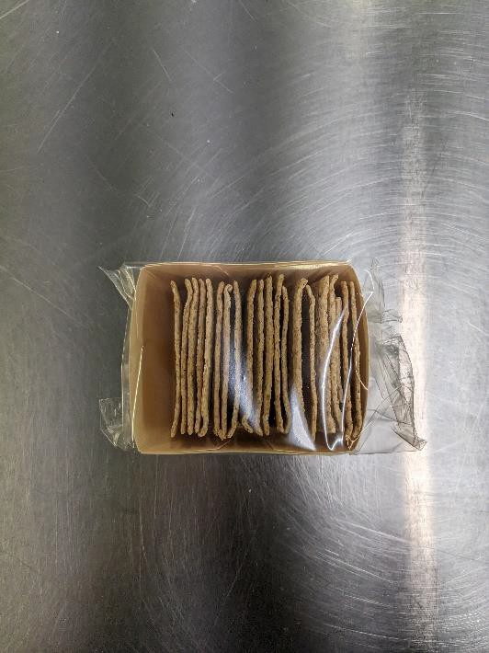

* 1. Single tray – Plastic L80mm W80 D45mm

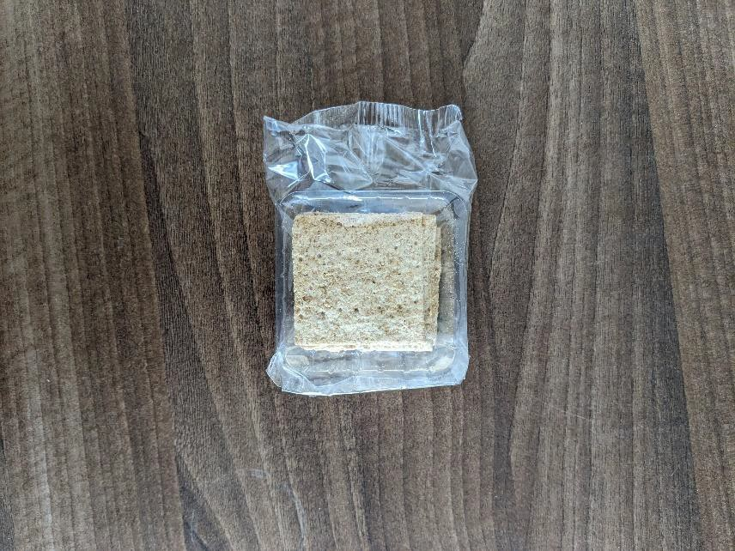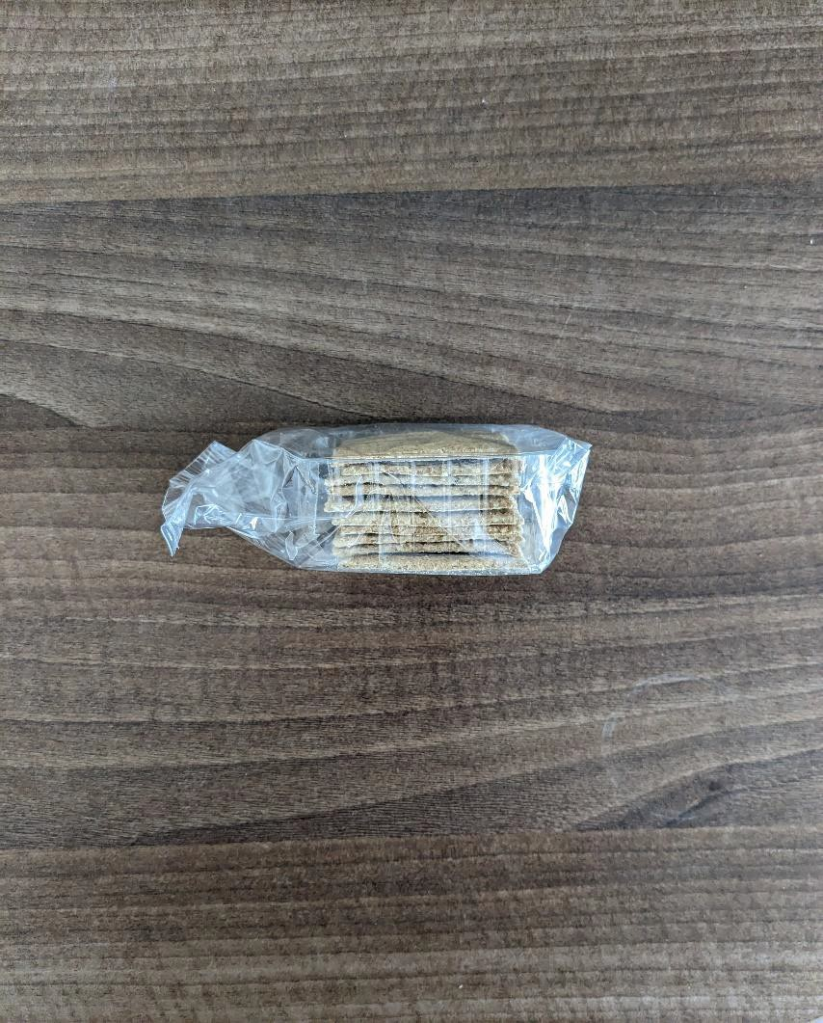

* 1. Double trays – L175 W76mm D40mm

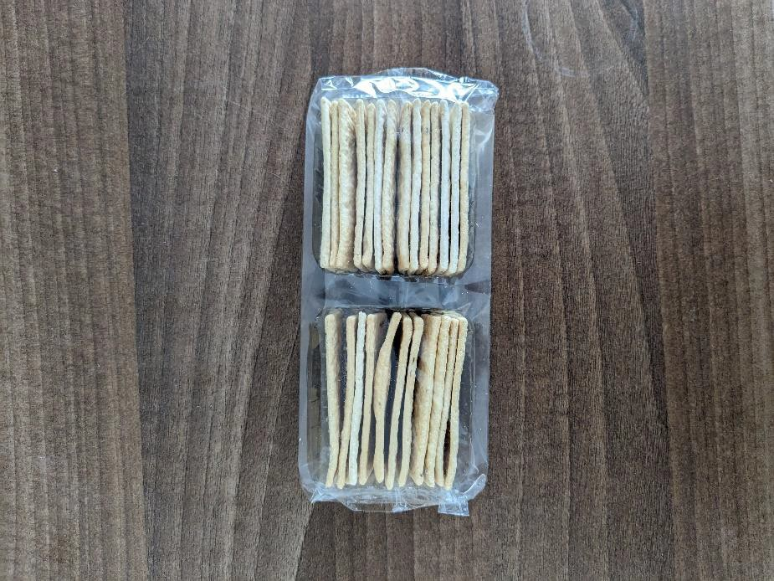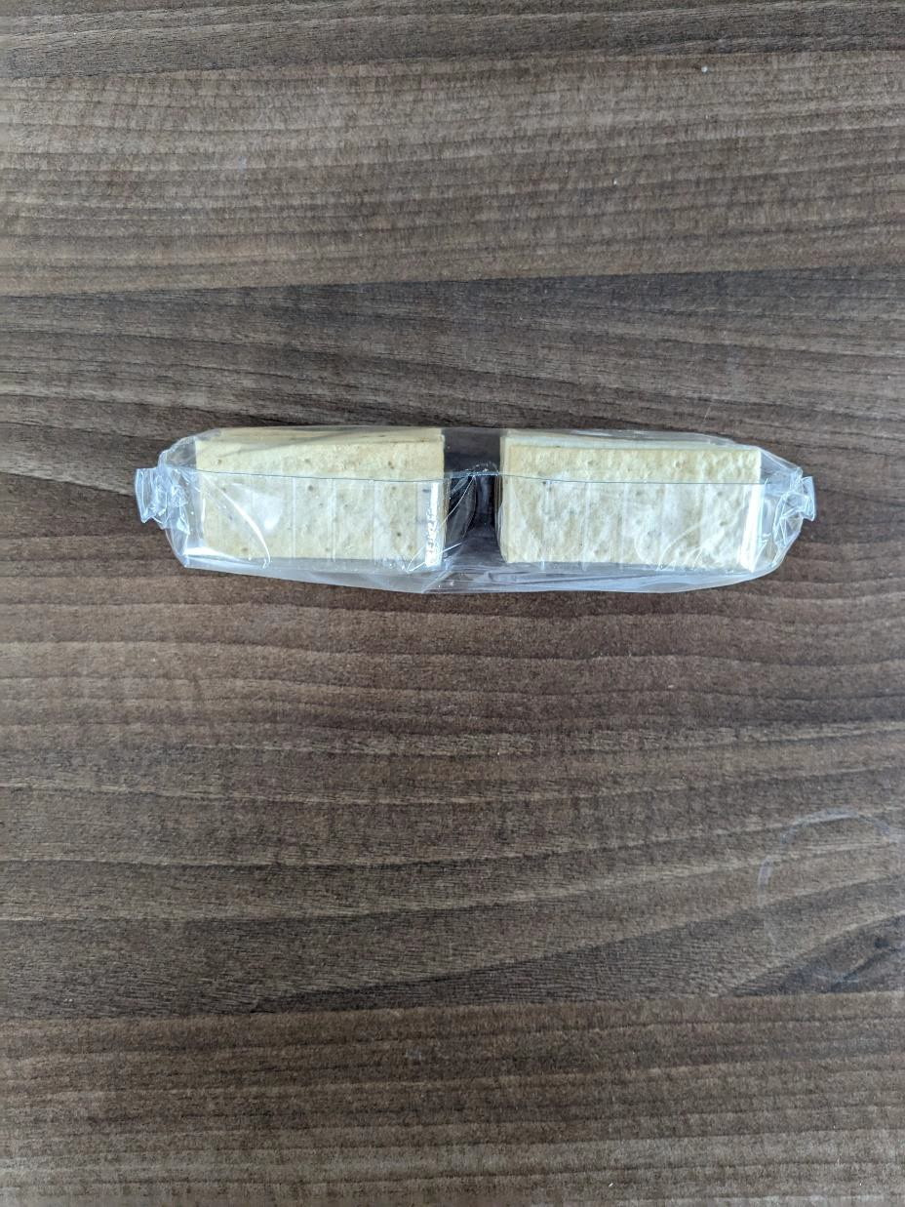

* 1. Large single trays -L140mm W85mm D50mm

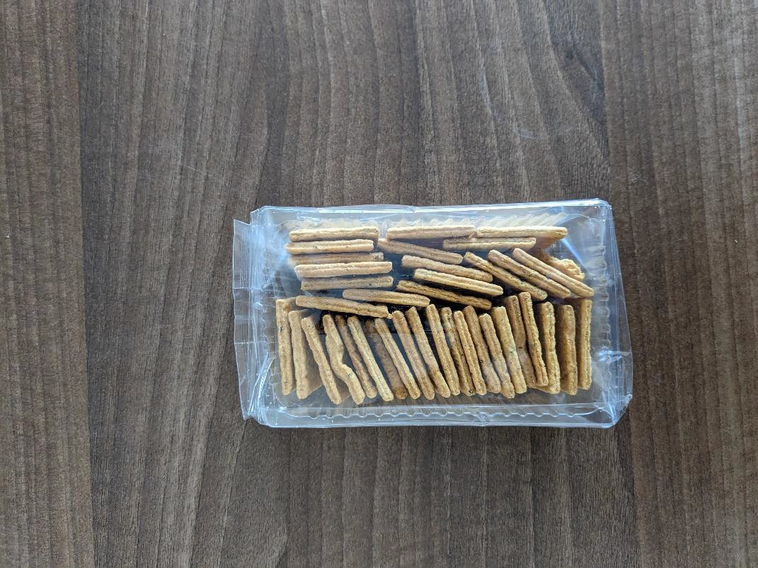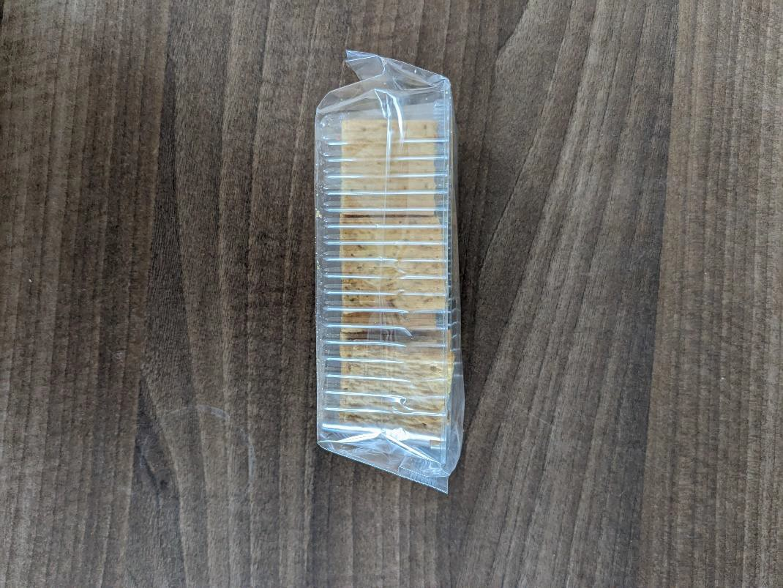

* 1. Unwrapped Biscuits – Squares – W5.5cm L5.5cm

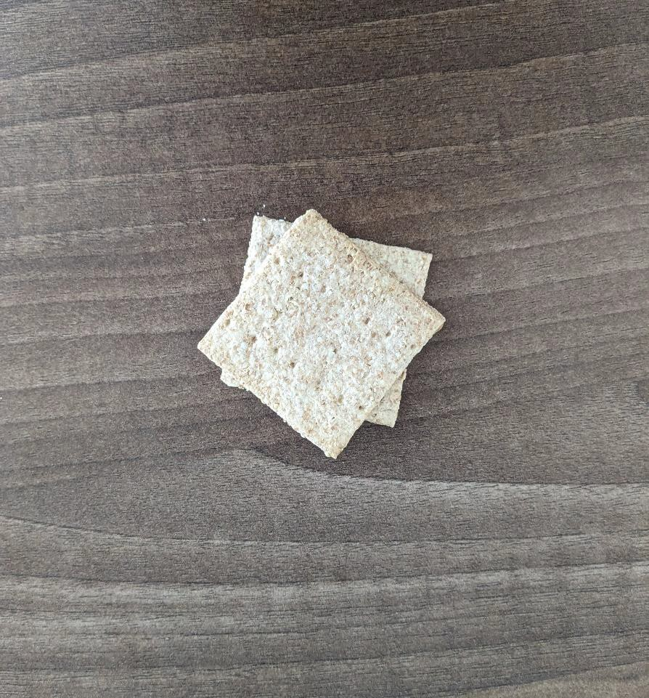

* 1. Unwrapped Biscuits – Thins – W3.2cm L6.8cm

