**BIDDER GUIDANCE – CONTRACT OPPORTUNITY RESPONSE**

Contents

A) VIEWING A CONTRACT OPPORTUNITY 2

B) RESPONDING TO A CONTRACT OPPORTUNITY 5

Please that the print screens are not all from one 'project' and therefore there might be differences in the detail between the different print screens. This does not affect the individual guidance steps.

# VIEWING A CONTRACT OPPORTUNITY

1. Sign into e-procurement portal

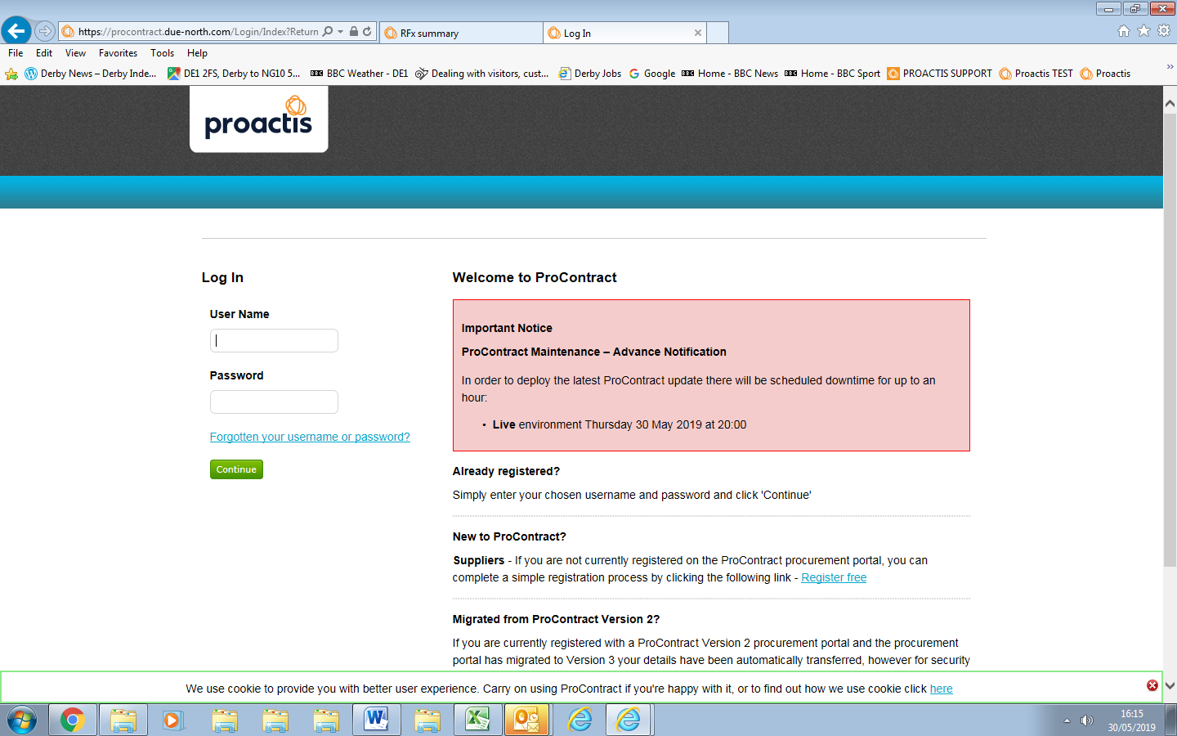

1. Search for the contract opportunity. Follow steps 3 and 4 in the ‘*Bidder Guidance - Registering and Accessing Opportunities on East Mids Tender Portal – BBC*’ document.
2. Click on 'Start'.

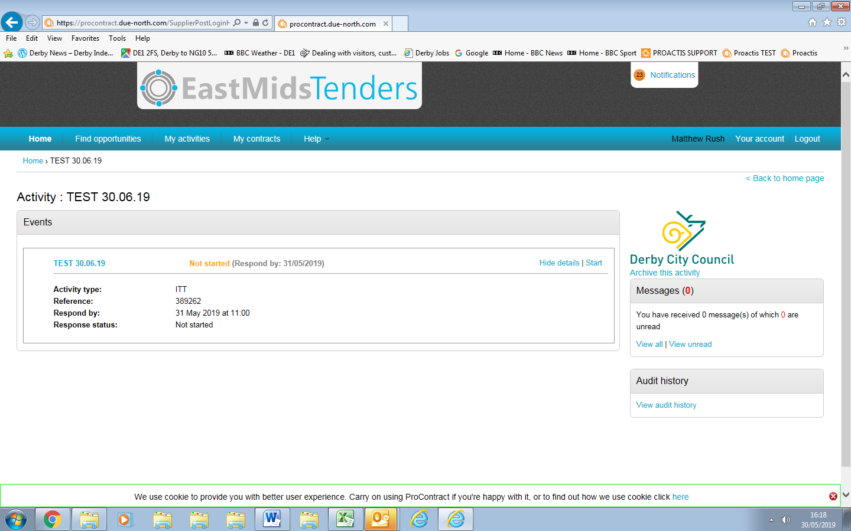

1. This will take you to a different page, showing further details, related attachments Read documents and follow instructions.

*You will usually need to download the response document, complete your response and save the file on your network and then upload the response document and submit by response deadline.*

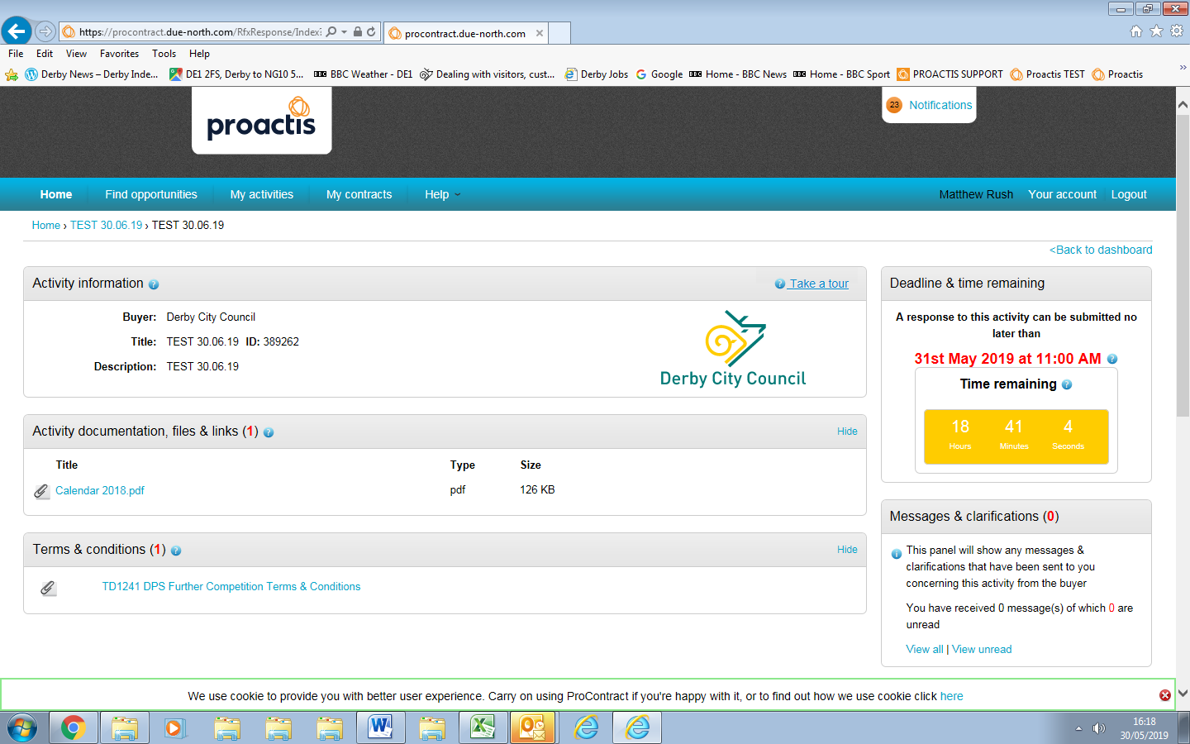

1. Click on response document to open it. Click on 'open' in the pop up box.

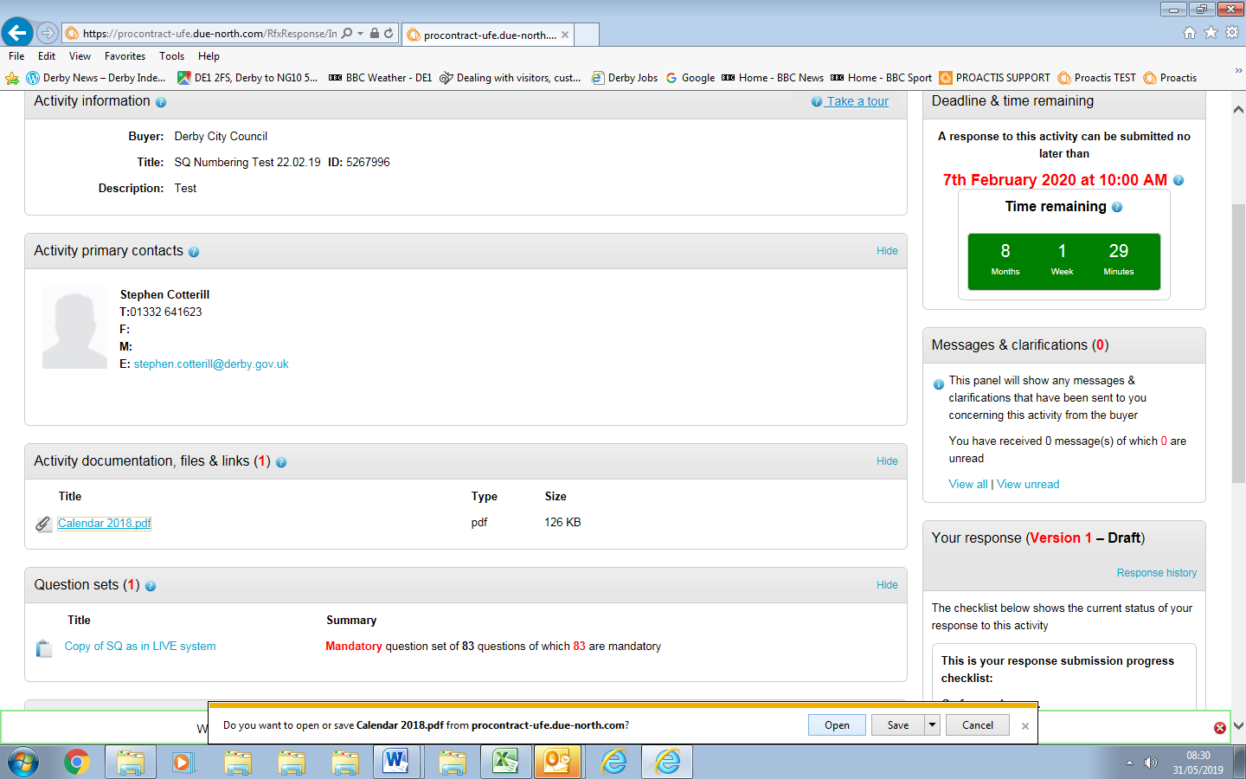

1. This will open the response document. Save this to your local network so that you can complete the response document. Once you have completed the response document and are ready to submit your response go to Section B.

# RESPONDING TO A CONTRACT OPPORTUNITY

1. Log on EastMids Tender Portal at <https://www.eastmidstenders.org/>

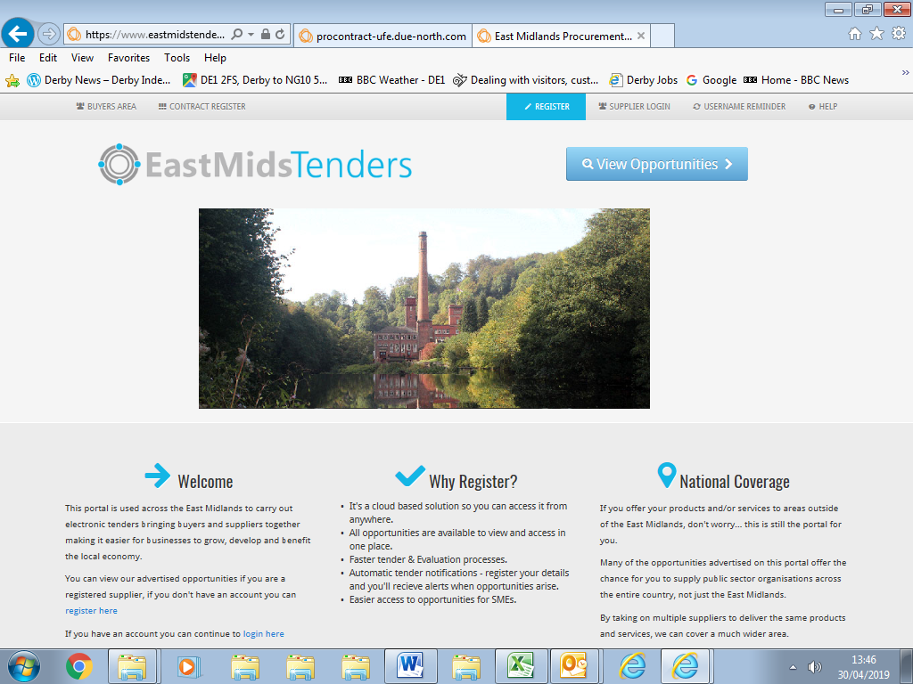

1. Click on 'My Activities'.

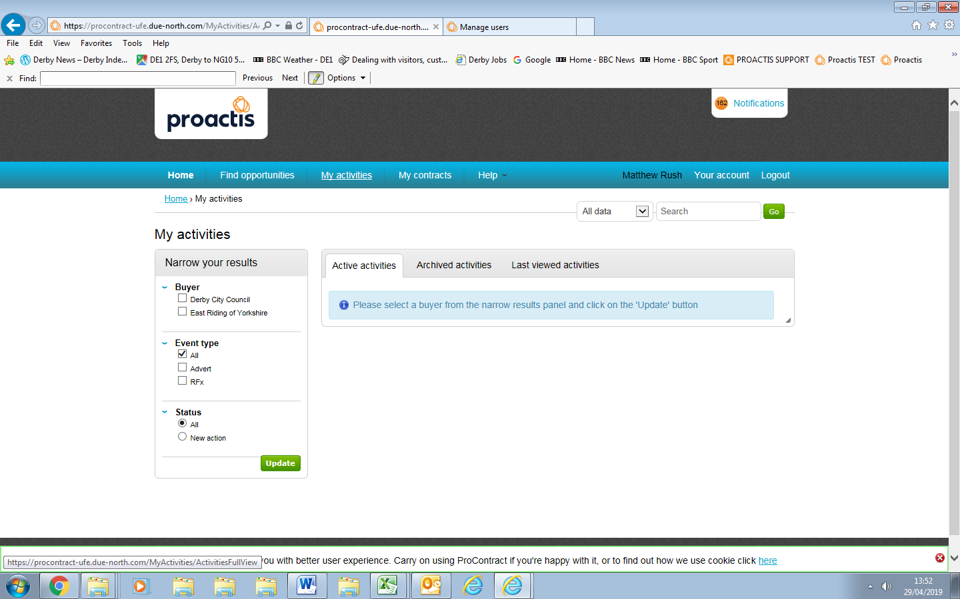

1. Select 'Broxtowe Borough Council from 'Narrow Your Results' section.

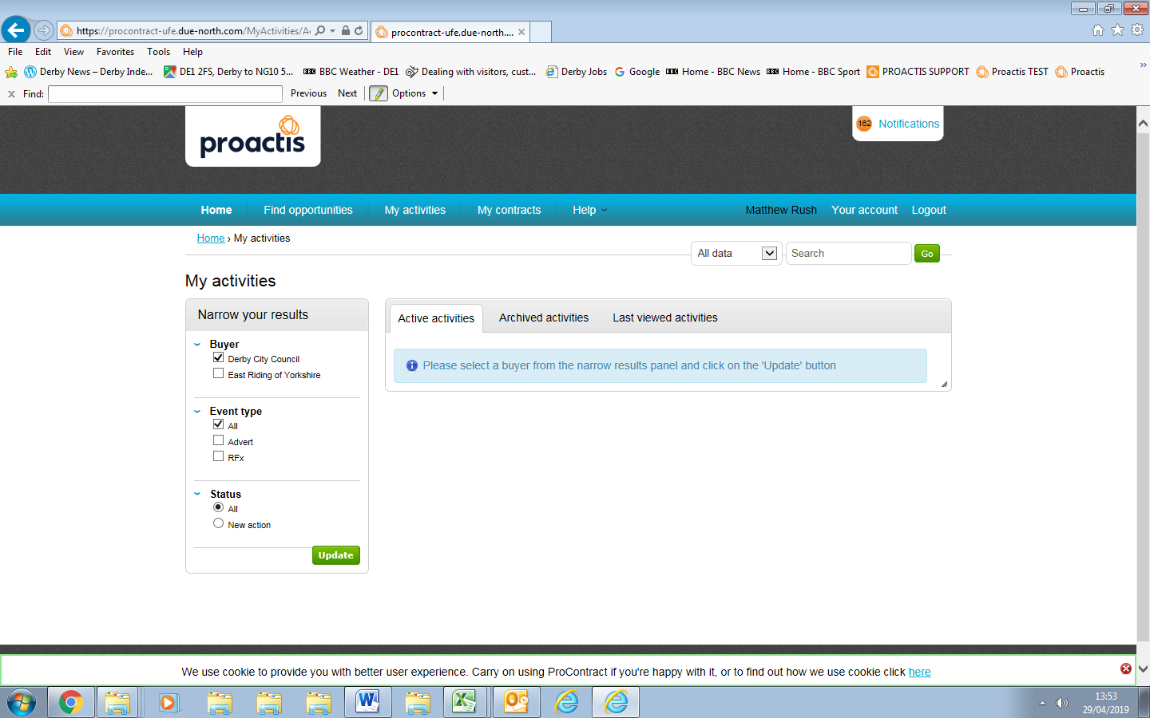

BBrox

1. Click on 'Update'

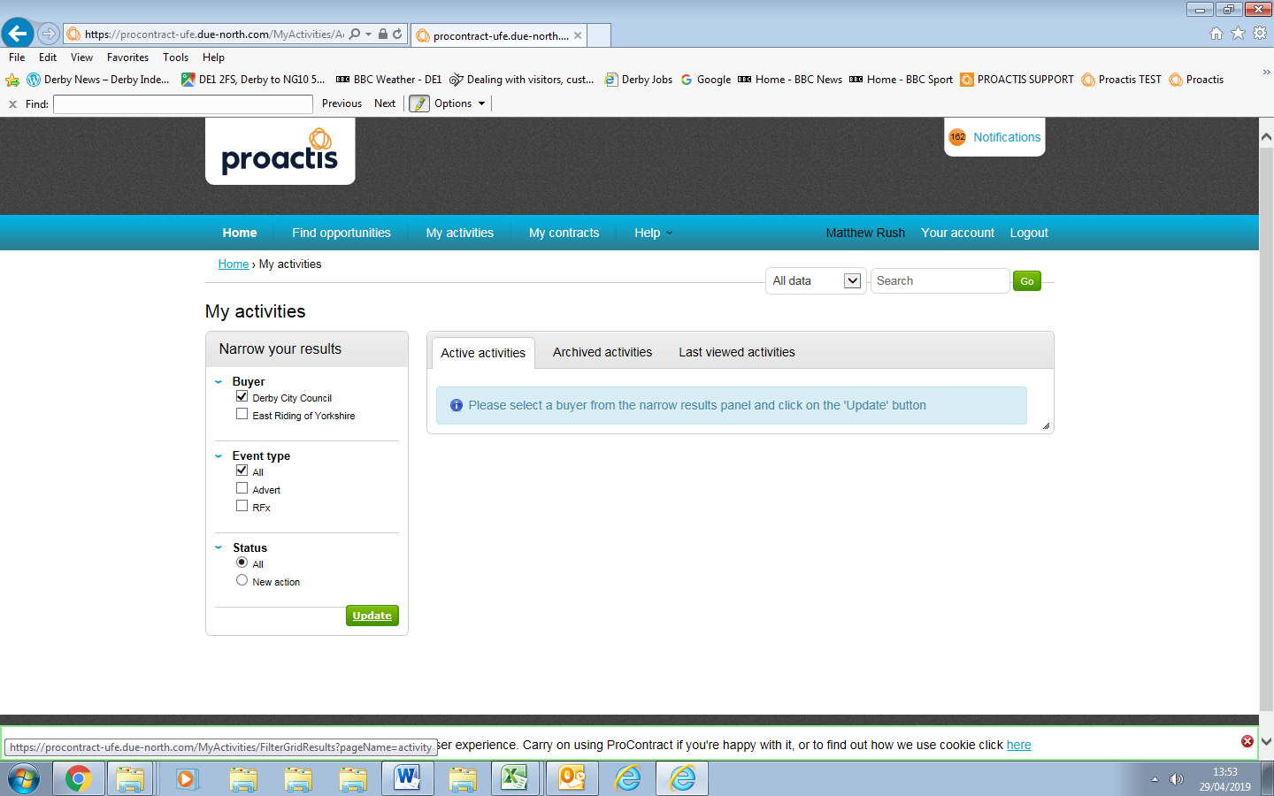

1. Click on relevant contract opportunity in blue text.

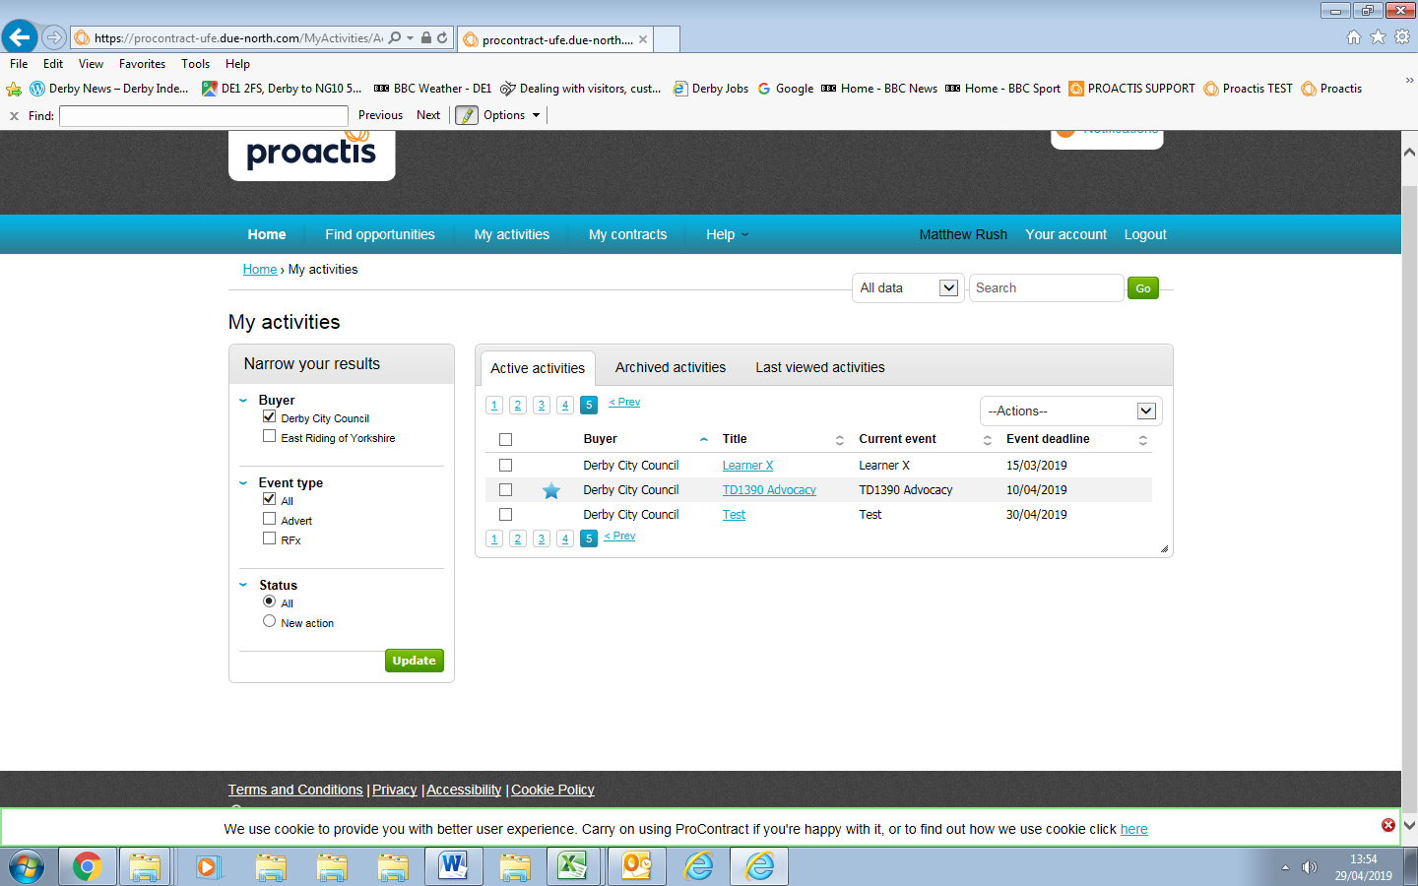

1. Click 'open' on draft response.

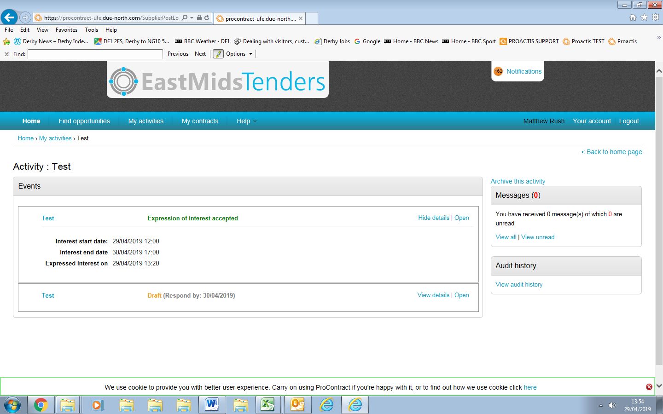

1. This opens up a summary page.

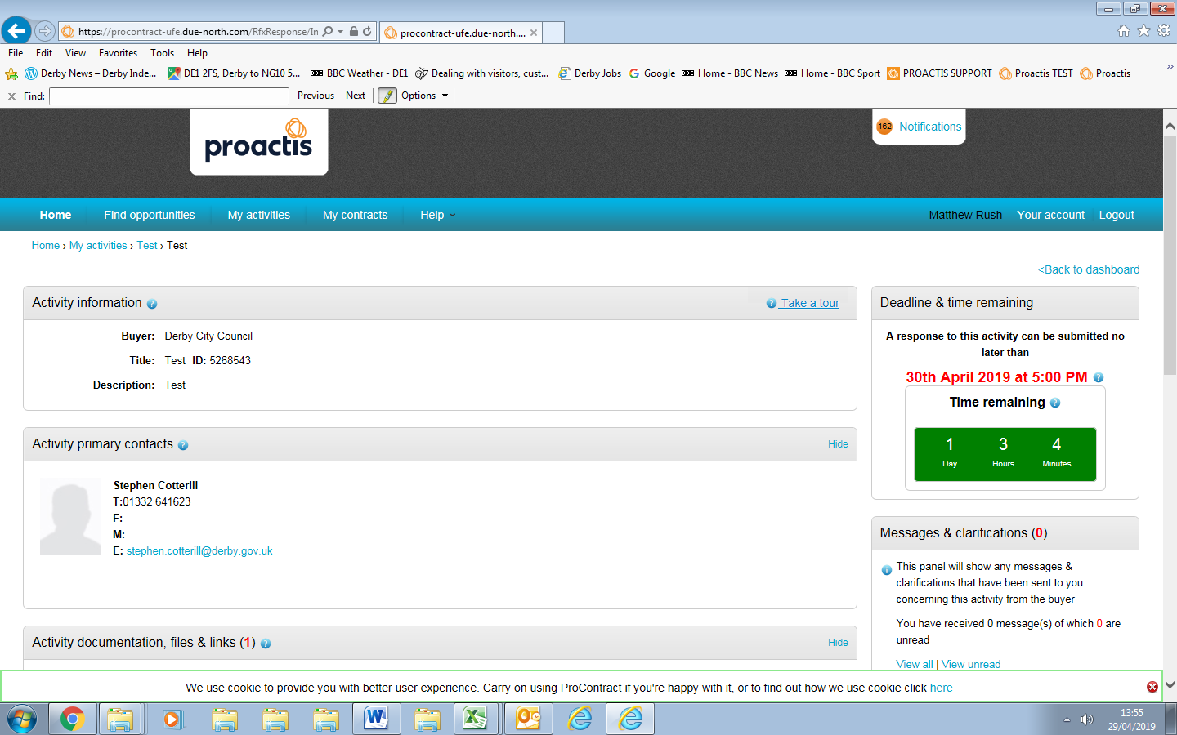

1. Scroll to the bottom left of the page and click on 'View Draft Response'**.**

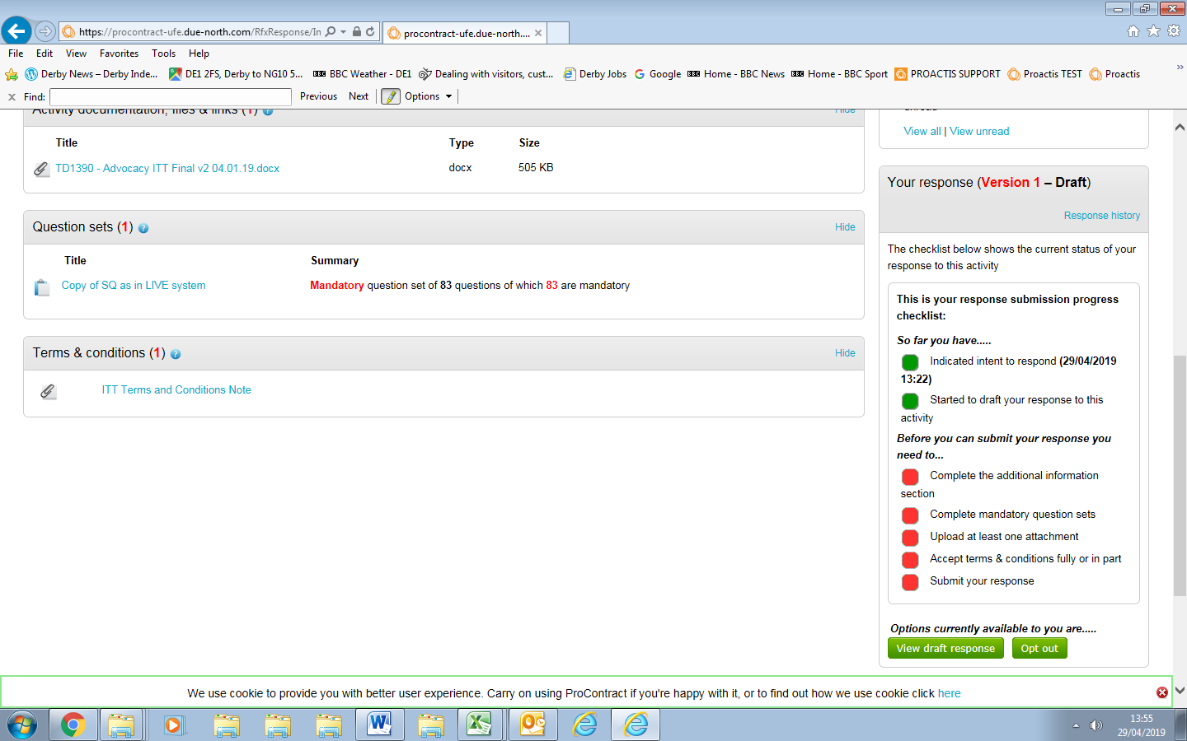

1. Click on 'start my response' which will take you to the response wizard.



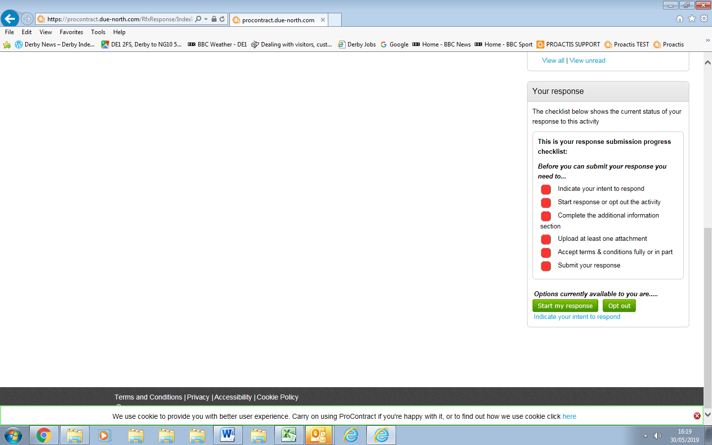

1. Upload the completed response document by clicking on 'Add' in the Response Documentation' section.

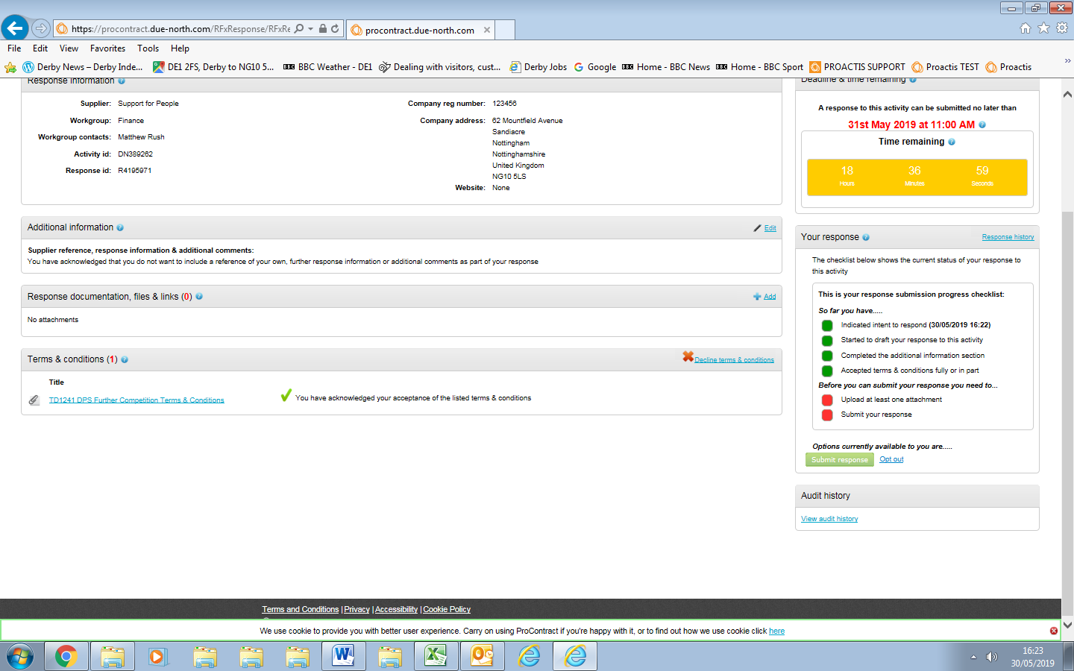

1. A window box will pop up. Click on 'Add files'.

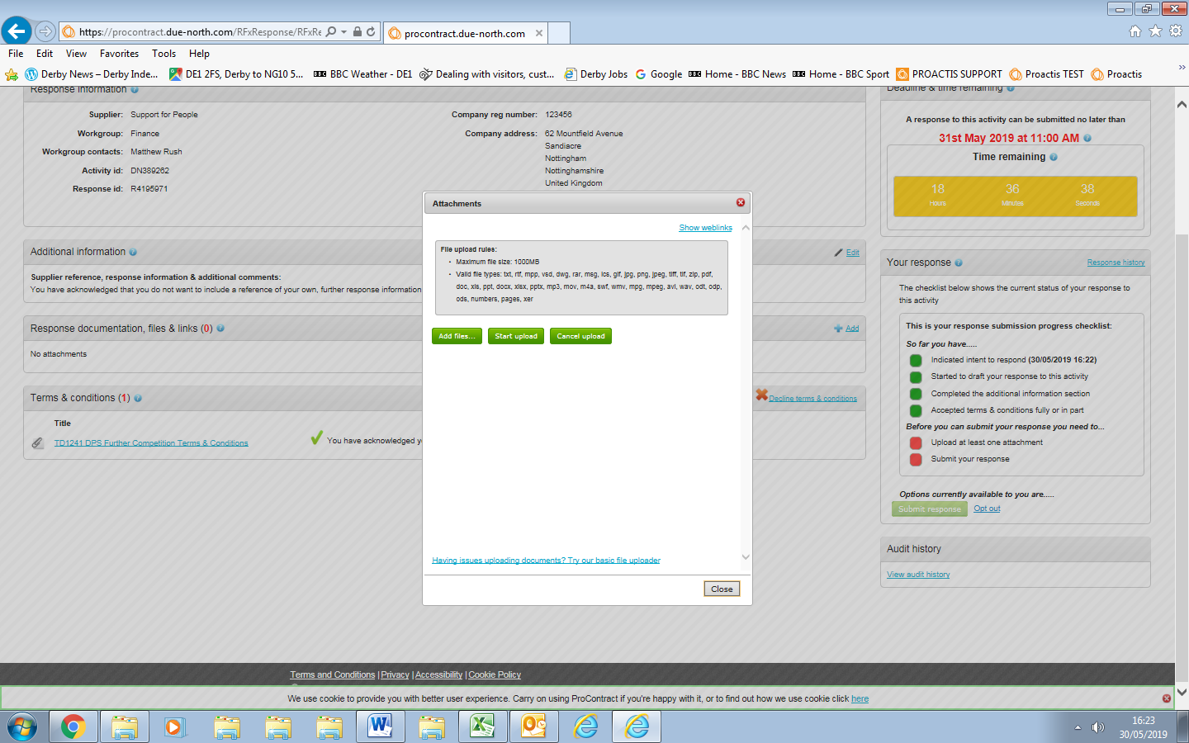

1. Browse your local network to find your completed response document.

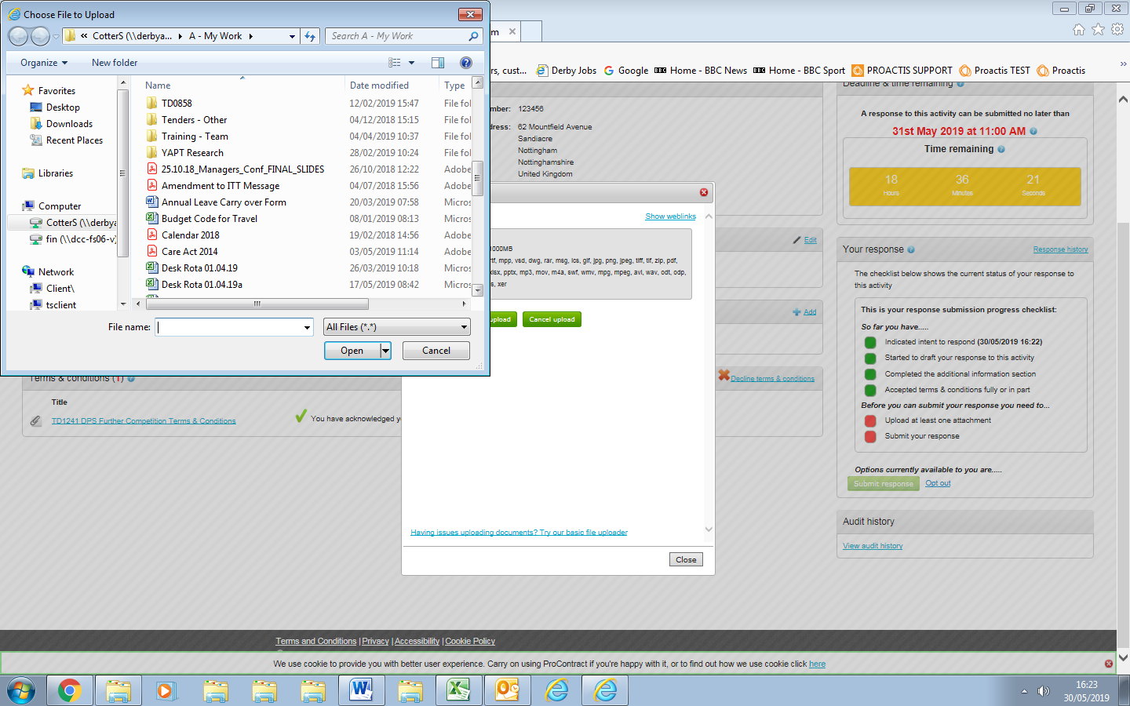

1. Select your completed response document and click on 'open'.

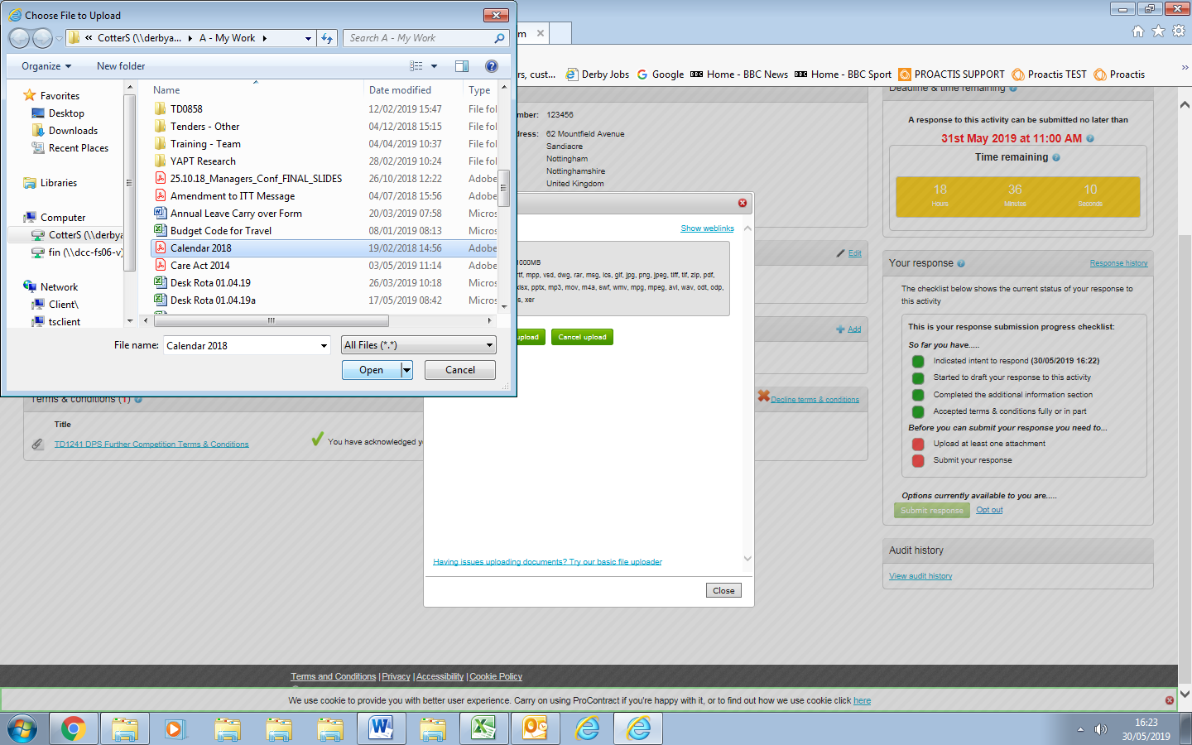

1. Click on 'Start upload'.

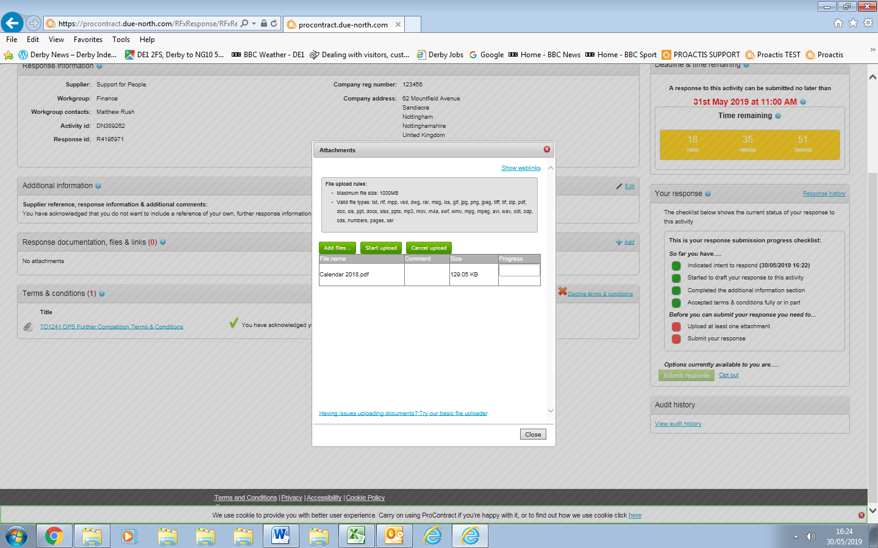

1. This will add the document as an attachment to the response wizard.

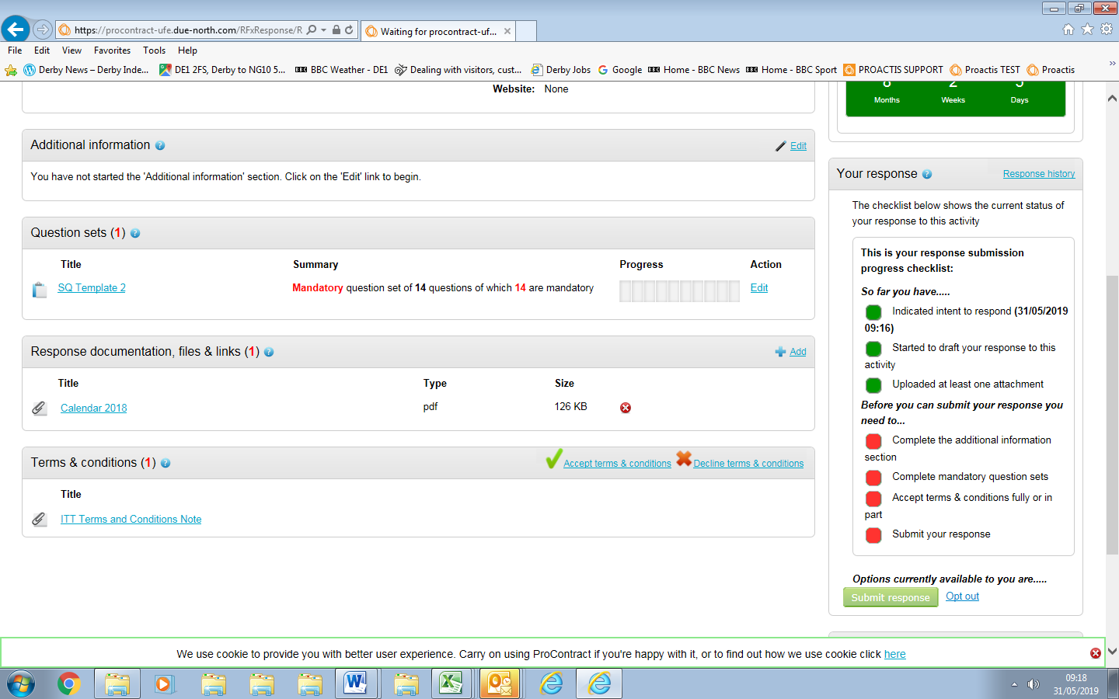

1. Click on 'Edit' in 'Additional Information' section (You may not be required to do steps if this section is not here, so got to step 25 if it is not).

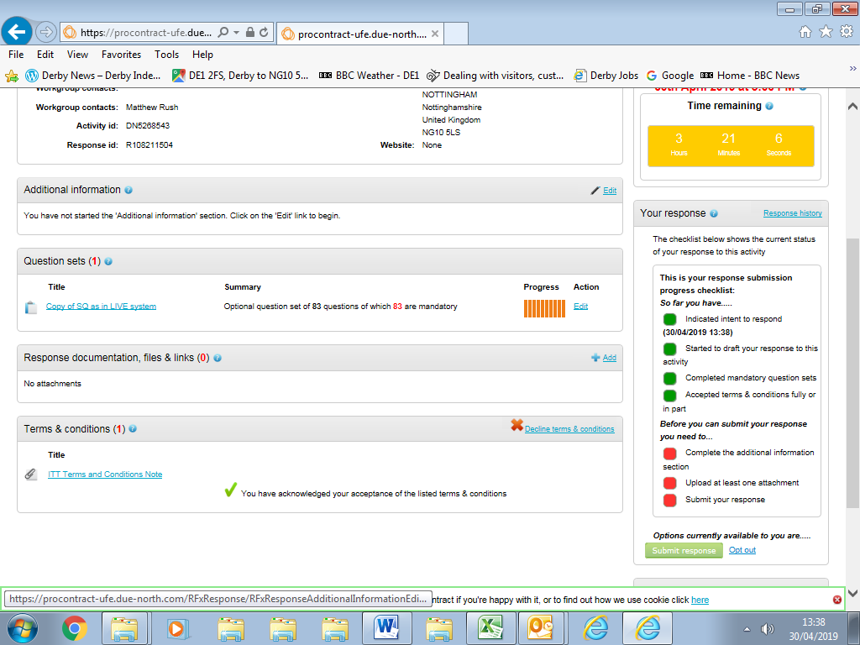

1. Complete further infirmation boxes or tick to confirm you are not providing further information (you are not required to do so).
2. Click on 'Save'.

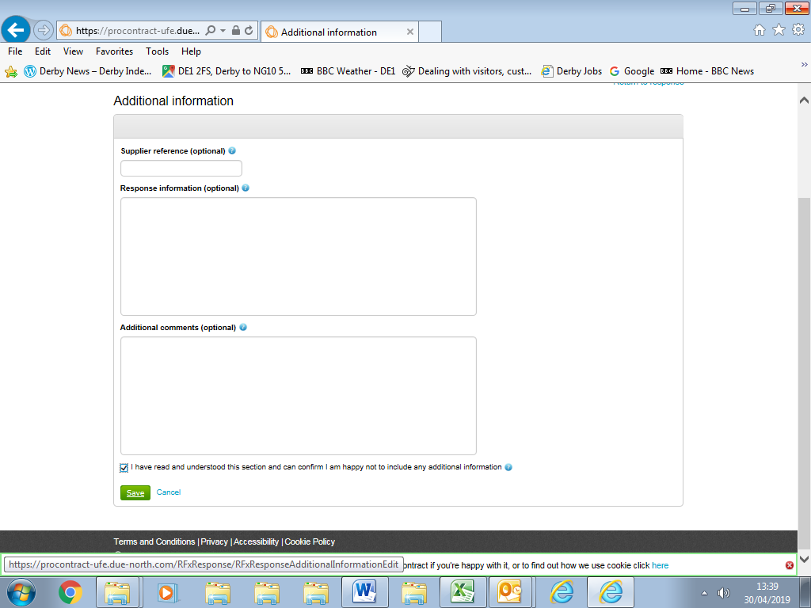

1. This will take you back to the response wizard main page.



1. Complete the remaining requirements as indicated by any red blocks on the 'response submission progress checklist' , for example:

* Accept terms and conditions

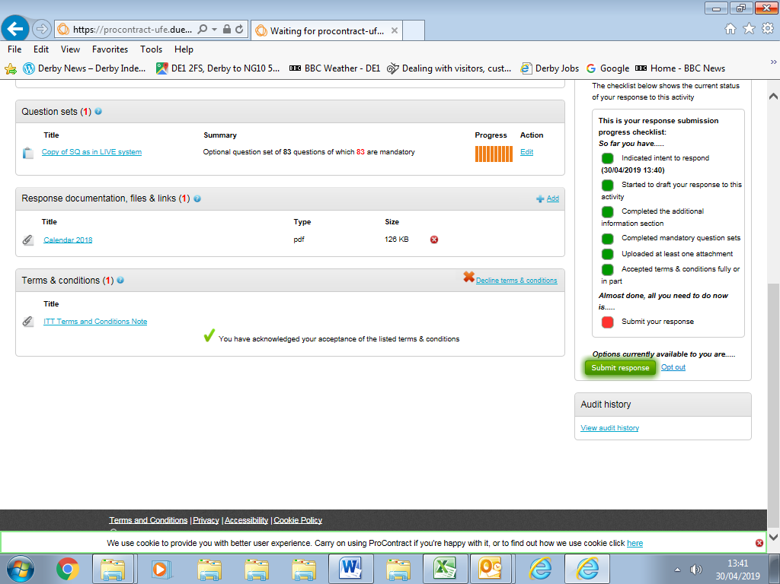

1. Once all required actions are completed click on 'Submit Response'.

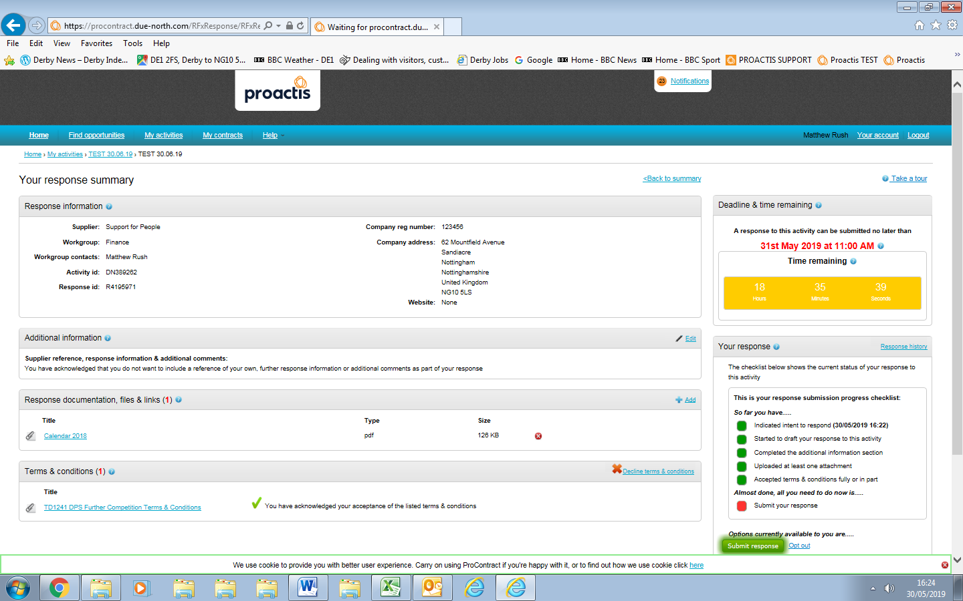

1. Click on 'Yes I am sure’ in the confirmation pop up window.

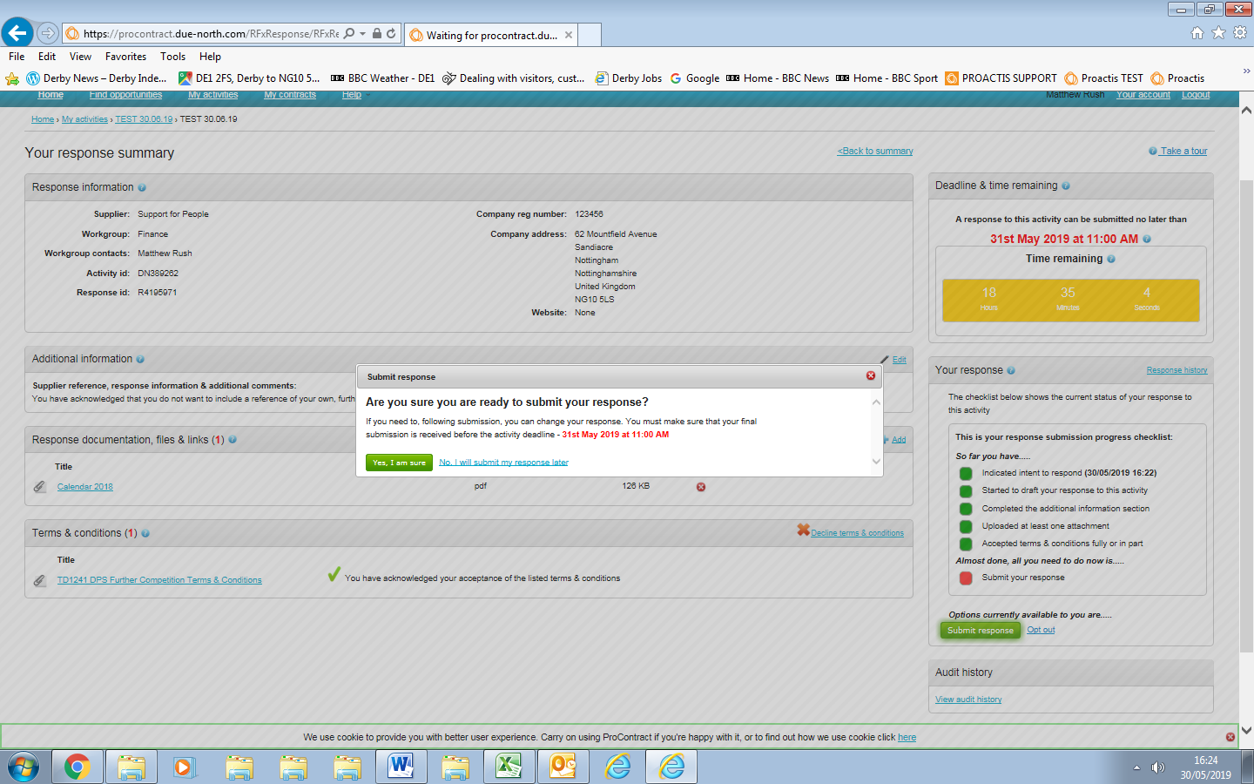

1. Your response has been submitted.

