# REQUEST FOR INFORMATION (RFI)

### REFERENCE NO: C328528

### TITLE: **CMT Inventory Management System**

Authority: [**NHS Blood & Transplant (NHSBT)**](https://www.nhsbt.nhs.uk/)

Date response required:  **24th January 2025**

Dear Supplier,

We would like to inform you about an upcoming requirement and take this opportunity to engage with the market to better understand current solutions and capabilities. We aim to connect with suppliers who may be interested in participating in a potential future procurement process.

At present this requirement is being drafted as a business case and we are seeking suppliers who will be able to provide us with information on the current solutions landscape, present demos of their solution in **week commencing 10th February** and provide information on constraints and key considerations. The principal purpose of this RFI is to gather market information and engage with suppliers as we develop our specification.

Please note the following general conditions:

* This RFI will help us to refine the requirements and a specification in preparation for a procurement activity.
* Suppliers who respond positively will be added to a mailing list with updated details unless they opt-out, which they are free to do at any stage.
* We reserve the right not to proceed with a competition. Nothing shall constitute a commitment to ordering unless we issue a subsequent notice via an open tender or framework.
* Any and all costs associated with the production of such a response to a RFI must be borne by the supplier. We will not contribute in any way to meeting production costs of any response.
* Information contained within this document is confidential and must not be revealed to any third party without prior written consent from us.
* We expect that all responses to this RFI will be provided by potential providers in good faith to the best of their ability in the light of information available at the time of their response.
* No information provided by a potential provider in response to this RFI will be carried forward, used or acknowledged in any way for the purpose of evaluating the potential provider, in any subsequent formal procurement process.

**CURRENT SITUATION**

Novel cellular and molecular therapies offer the promise of new treatments and potential cures for many diseases and disorders, and NHS Blood and Transplant is uniquely positioned to support the exciting developments that are taking place in this field.

Our experience in the processing and storage of stem cells for transplant and the manufacture of clinical grade advanced cellular and molecular therapies, combined with our strong links to clinicians and hospitals, means we can help bring new and ground-breaking treatments to the bedside.

There are strict regulatory requirements governing the effective management of consumables and starting materials used in the manufacture of cell and gene therapies. There is also a requirement to manage cell banks, stability samples and advanced therapy medicinal products in cryostorage. A broad list of regulations the system must comply with include:

* The Human Tissue Act 2004 (as amended)
* The Human Medicines Regulations 2012 (as amended),
* Eudralex Volume 4 - EU Guidelines for Good Manufacturing Practice for Medicinal Products for Human and Veterinary Use (as amended)
* The Medicines for Human Use (Clinical Trials) Regulations 2004 (as amended),
* The Human Medicines (Amendment etc.) Regulations 2019 (as amended)
* Fully Data Integrity complaint system, meets CFR part 11 and EudraLex annex 11

The existing processes are based on a mix of paper based forms and Excel spreadsheets which are manually run and have limited functionality. The current systems of work are not fully compliant with GMP (Good Manufacturing Practice) or data integrity.

The Excel elements have been developed in-house and there is a reliance on SMEs for support or changes. There are multiple systems across the Function that do not allow alignment of the MHRA and HTA processes, high level As-Is process below:

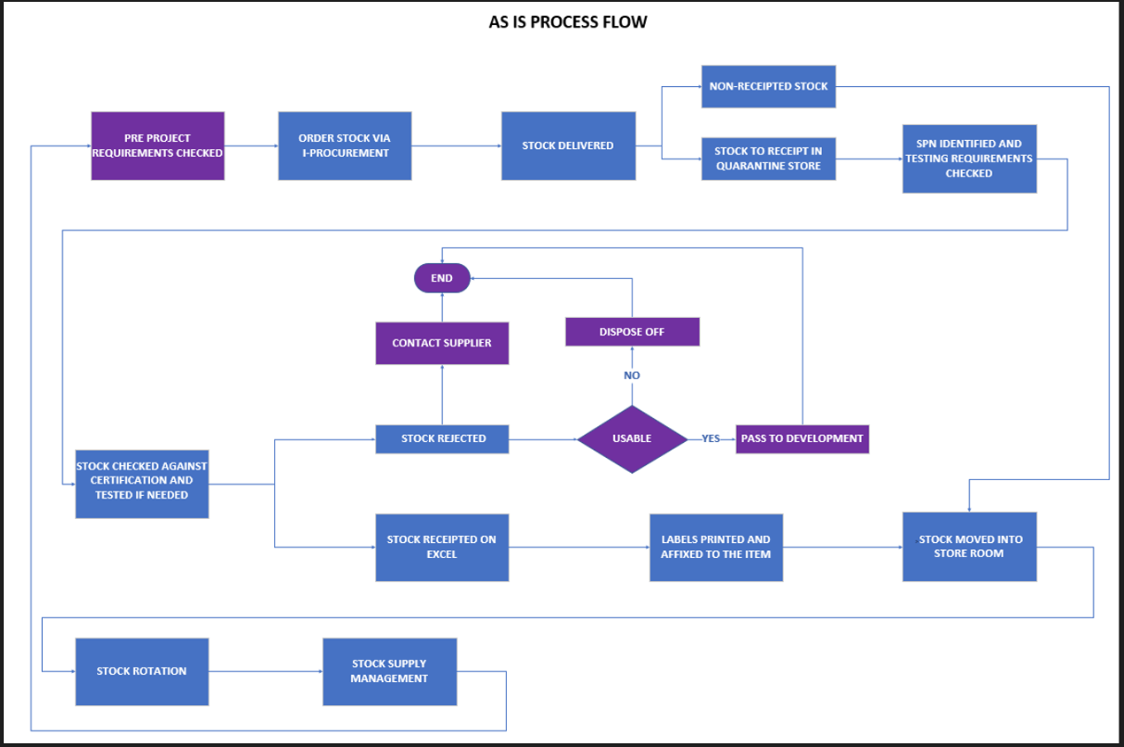

**Website**

<https://www.nhsbt.nhs.uk/cellular-and-molecular-therapies/>

**OUR AIMS – WHAT WE WANT TO ACHIEVE**

NHSBT is looking for one supplier to deliver the following aims:

* Provide a cost effective and flexible, fully compliant platform which will digitise how CMT manages its consumable inventory and stock; allowing NHSBT to deliver improved safety, resilience, compliance and efficiency in line with the NHSBT strategic priority to modernise our operations.
* Provide flexibility to integrate with other systems; procurement, manufacturing records, back off financials. In order to future-proof the solution, the supplier we work with will need to be a flexible partner.
* A solution which could be devolved to NHSBT to make changes.

**Our Objectives – What We Strive to Achieve**

NHSBT seeks a single supplier to help accomplish the following objectives:

* **Implement a Cost-Effective, Compliant Platform**  
  Develop a modern, flexible platform to digitize the management of consumable inventory and stock. This will enable NHSBT to enhance safety, resilience, compliance, and operational efficiency, aligning with our strategic goal of modernizing operations.
* **Ensure Seamless System Integration**  
  Deliver a solution that integrates smoothly with existing systems, such as procurement, manufacturing records, and financial systems. The supplier must offer a flexible, future-proof solution adaptable to evolving needs.
* **Enable Self-Sufficiency**  
  Provide a solution that NHSBT can independently modify and manage, ensuring adaptability and sustainability over time.

Statement of requirements for information:



**WHAT WE ARE LOOKING FOR**

At this stage NHSBT is seeking suppliers who may be interested in a potential future competition. Suppliers can showcase their proposed solutions or provide input to support the development of our business case and specification.

Interested suppliers are encouraged to respond to this RFI by completing the Response Section. If your organisation does not find this opportunity relevant, no response is required.

Suppliers who respond positively will be added to a mailing list and may be invited to a virtual information-gathering session with key stakeholders which will include a demonstration of the proposed solution. At any point suppliers are welcome to opt out of further communication at any point if they choose.

**OUR TIMETABLE**

|  |  |
| --- | --- |
| **DATE** | **ACTIVITY** |
| 06/01/2025 | Publication of the RFI |
| 24/01/2025 | Deadline for submission of an RFI Response indicating whether or not the bidder is interested in taking part in a potential future competition |
| w/c 10/02/2025 | Selection of suppliers invited to virtual discussion and system demonstration |

**QUESTIONS AND CLARIFICATIONS**

Potential providers may raise questions or seek clarification regarding any aspect of this RFI document at any time prior to the response deadline. Questions must be submitted via the Atamis portal. Potential providers can register on the portal at any time and remove themselves from the project if they no longer wish to receive information.

Please note NHSBT will not be able to have individual meetings with suppliers.

**GENERAL CONTACT POINT FOR THIS RFI**

RFI Lead Name: Gordon Mellor

Telephone Number: 07903347578

Email Address: gordon.mellor2@nhsbt.nhs.uk

**RESPONSE SECTION**

|  |  |
| --- | --- |
| **Company Name** |  |
| **Company Registration Number** |  |
| **Named Contact** |  |
| **Email Address** |  |
| **Brief Overview of how your organisation could work with NHSBT to provide this solution and how it could be future-proofed** |  |
| **Please details any constraints and risks you believe are beneficial for NHSBT to consider based on where we want to be and/or previous similar solutions you have delivered?** |  |
| **Does your solution have high performance compute capability that can be scaled in line with NHSBT ambitions should the service be expanded?** |  |
| **How much cloud storage could be made available to store potentially large volumes of clinical data and how is this secured?** |  |
| **Are you able to provide a demonstration of your solution?** |  |
| **Are you able to provide limited access to a sandbox version of your solution?** |  |
| **What is the proposed delivery model (e.g. SaaS, PaaS, managed service, subscription…etc)?** |  |
| **What is the outline cost of your solution per annum and how is this broken down/itemised**  **Please note these costs are for budgeting purposes only and will not be used to inform any procurement decisions** |  |
| **Which procurement route would be suitable under Procurement and Contracts Regulations (2015)? Please include any details of frameworks you work with.** |  |