

**Yate Town Council**

**Abbotswood, Shopping Centre**

**Informal Play Area - Design Brief**

**Abbotswood, Shopping Centre**

**Yate,**

**Bristol,**

**BS37 4NG**

**July 2019**

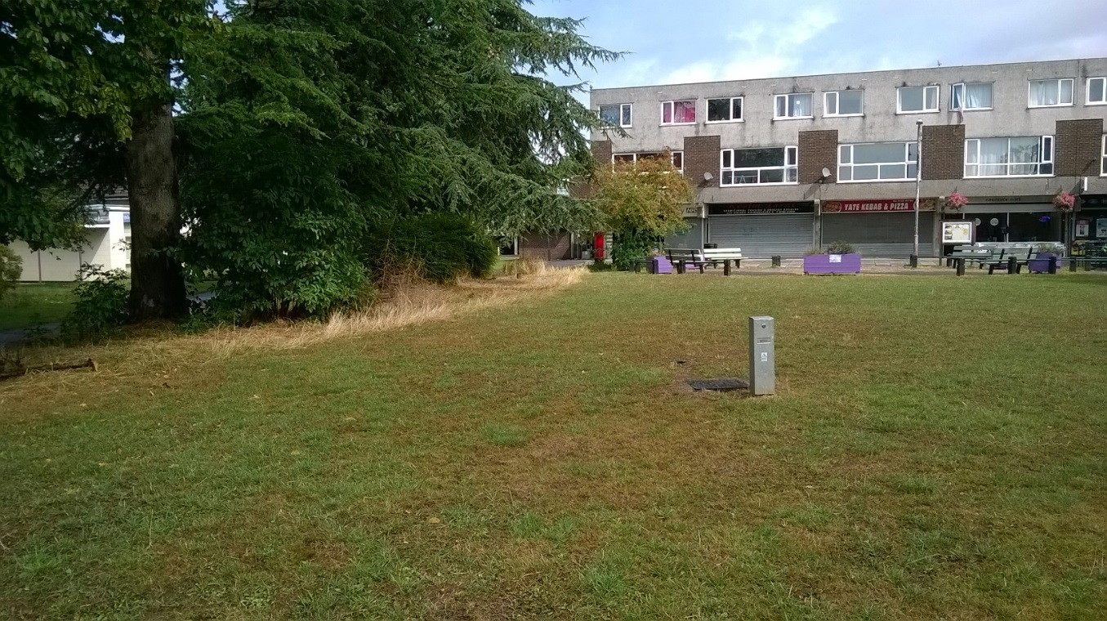

1. **ABBOTSWOOD – BACKGROUND TO THE PROJECT**

Yate Town Council, the client, wishes to expand the informal play area at Abbotswood Shopping Precinct. Some small pieces of timber balance equipment funded with Member Awarded Grant Funding (MAF) have recently been installed. The next phase will aim to install additional play equipment, to be funded by a recent section 106 grant award.

During a public consultation exercise which informed the Abbotswood Community Plan, the addition of an ‘informal children’s play space’ was cited by local people as an important element in the wider improvements to Abbotswood.

Consultation has highlighted that local people are very engaged with environmental issues, developing the area to have a natural feel, using recycled materials or timber would be welcomed. This would further strengthen the work already being undertaken by local community groups, Abbotswood Action Group and the St Nix Family Centre. They have already planted some wild flowers under the trees and along the edges of the grassy area that forms the proposed site.

In addition to providing a fun area for children to play, it is felt that the enhancements would help to improve the wider precinct area and make it a more attractive place for local people to visit, establishing the area as the center of the local community, thus helping to create increased footfall to the shops and feelings of pride and ownership by the community.

1. **DESIGN SPECIFICATION**

Tenderers are invited to put forward proposals for an exciting bespoke scheme for an adventurous play area / trail, located on the grassed areas between, and around the existing mature trees on site. The site area is shown on the attached sketch proposal, and site location plans. The proposal should include the following elements:

* Large bespoke sculptural play feature, to form a centrepiece, for the wider area. Could be insect or animal themed.
* Spiders net climbing equipment (either between trees or freestanding) this item was specifically identified during the public consultation exercise.
* Incorporation of the existing snake balance beam into a new play trail.
* Creation of informal and social seating opportunities, which could be incorporated into the bespoke play elements or a free standing tree seat.
* The area is to have an overall natural feel that could incorporate some landscape features to help tie the individual elements together.
* Surfacing to be low maintenance. Assumed to be rubber grass mats to assist in maintaining the surrounding grass sward while preventing wear.

**Climbing Structures:** The climbing structures need to fit into the spaces available on the plan. The maximum height for any element of the structure is 4m, which is a planning restriction, but it is assumed they will be generally lower. The structures need to offer a play experience for children of all ages but should be geared towards younger children. In order to achieve the natural feel required, the bulk of the equipment should be timber. The site is unfenced public open space and any materials selected will need to be robust and appropriate to the location. The contractor will be required to provide warranties for the longevity of the timber proposed in order to meet the requirements of the specification. It is envisaged that the surfacing beneath the equipment and between trail items will be grass rubber mats, although other alternative, low maintenance surfacing could be considered. The contractor’s proposals should show details of this, or any proposed alternative, along with implications for accessibility.

There are several large mature trees on the edge of the site, contractors may wish to consider incorporating these within the overall design of the play area, however careful consideration should be given to the long term effects that compaction and the installation of play equipment may have on root systems and tree health. The attached sketch proposal plan tries to minimise any impact by generally keeping equipment away from the trees, with the exception of a proposed tree seat.

**Play Trail:** The play trail is designed to link the new equipment together and is envisaged as a series of constructed and natural elements, including timber and low grass mounding or boulders, to create a low-level, off-ground balancing circuit. This should include some elements that can have a dual use as seating as well as balancing. Some alternative routes could be included in the trail to allow for overtaking. The proposals should indicate any surfacing, for safety and/or for wear, beneath these items. The existing snake balance beam should be retained and incorporated within the trail, it can be moved from its current position if required.

**Seating:** opportunities for informal seating could be incorporated into bespoke play features or could include a separate tree seat. Different sitting heights and opportunities for social interaction should be considered.

**Long term maintenance:** The playground is maintained by Yate Town Council. The contractor’s proposals should indicate the maintenance requirements of the new equipment and surfacing, including the inspection requirements, guarantees and availability of spare parts.

**Accessibility:** The contractor’s proposals should include elements that are accessible to all children and supporting text should describe the use, accessibility

and play value of all elements.

**Site Access:**

Vehicle access is via Abbotswood (off Rodford Way). Contractor’s parking / access to be agreed with the Town Council prior to commencement of the contract.

**Insurance Requirements:**

Contractors are required to hold current public liability insurance with a minimum cover of £10 million.

**Site Safety:**

Contractors are required to provide a method statement to demonstrate proposals for site safety during the installation process, including any provision for temporary fencing and safety of the public whilst machinery is manoeuvring on site.

**Site Accommodation:**

Location of site compound and welfare facilities to be agreed with the Town Council.

**Existing Services:**

A NRSWA search has been instigated for the site and the results will be shared with the contractor prior to commencement of the contract.

**Site management:**

The contractor should maintain roads and footpaths within and adjacent to the site and keep clear of mud and debris. Any damage caused by site traffic or otherwise during the works to be made good to the satisfaction of the Council.

**Hand Over:**

At completion, provide a manual for the maintenance and operation of the equipment. Instruct council staff on same and also of use of equipment. Documentation required: general product information, inspection and maintenance information, information on spare parts, supply of any tools for operation, maintenance and cleaning purposes.

**Programme:**

Prior to commencement of the contract, the contractor to provide a programme for the works, including any subcontractor’s works.

**Contract:**

The successful tender will be required to enter into a standard JCT Minor Works form of contract with the client; Yate Town Council.

1. **CONTRACTORS SUBMISSION**

Tenderers are invited to design a scheme which will incorporate the themes outlined above. Tenderers will be required to submit the following information:

* Drawings, including a site plan and appropriate illustrations.
* Written description of the play value of proposed elements within the design.
* A priced schedule of work items, listing individual elements.
* Allowance for a RoSPA inspection at both design and installation stages.
* Provide a method statement prior to beginning work on site to describe how the work will be managed on site, including safety provisions and protection of the public.
* On completion, provide the client with a maintenance manual as specified.

1. **COMMUNITY DESIGN / CONSTRUCTION WORKSHOPS**

The Town Council supports and actively encourages community participation in the regeneration of this area. To that end, contractors are invited to submit proposals to facilitate a community design workshop with the aim to allow children and families to become involved in the project and take on some ownership of the site. The Town Council will assist in the provision of a suitable venue, and will help organise local participation. The contractor’s proposals should describe their methodology and the proposed outcomes from the workshop. This element should be priced separately in the contractor’s submission.

1. **THE BUDGET**

The section 106 grant funding available for this project is **£48,400.00** excluding VAT, The design should be tailored to suit this budget and include within provision for facilitating and attendance at the community work shop. The proposals should be presented to easily identify individually priced elements.

1. **ASSESSMENT**

Submitted proposals will be judged against the following criteria:

* Play value. Schemes should include an explanation of the play value of each item of equipment and also describe how accessibility has been considered.
* Design. Schemes will be assessed in respect of their suitability for the site, including proposed materials and the degree to which the existing features of the site are accommodated into the layout. And how the proposed scheme enhances the wider space and local environment.
* Opportunities provided for community involvement, in the design workshop.
* Cost. Whilst the budget is set the contractor’s designed portion will need to exhibit value for money.
* Maintenance costs, both ongoing and long-term replacement costs will be considered.

**CLIENT DETAILS**

Yate Town Council

Poole Court

Yate

Bristol

BS37 5PP

FAO: Lucy Shilcock

Tel: 01454 866512

Email: lshilcock@yatetowncouncil.gov.uk

**CONTRACT ADMINISTRATOR**

South Gloucestershire Council

Environment and Community Services

Community Spaces Improvement Team

PO Box 1954

Bristol

BS37 0DD

FAO: Andrew Sanders

Tel: 01454 864914

Email: [Andrew.Sanders@southglos.gov.uk](mailto:Andrew.Sanders@southglos.gov.uk)