SMPA Contracts Finder Advert

Provision of Temporary Skilled Labour

|  |  |
| --- | --- |
| **Type of Buyer** | Contractor to Public Sector |
| **Industry** | (Insert CPV Codes) – excluding 45210000  civil engineering series |
| **Location of Contract** | United Kingdom |
| **Value of Contract** | £10,000,000.00 |
| **Procurement Reference** | SMP Alliance Labour |
| **Published Date** | (System Automated) |
| **Closing Date** | (2 weeks from Publish Date) |
| **Closing Time** | 12:00 |
| **Contract Start Date** | 1st September 2022 |
| **Contract End Date** | 1st September 2027 |
| **Contract Type** | Services |
| **Procedure Type** | Competitive Quotation- non-OJEU  Private Procurement Rules |

**Description**

Introduction

The Smart Motorways Programme (SMP) Alliance:The smart motorway programme seeks to further increase the safety performance of National Highways’ strategic road network and mitigate capacity constraints to enhance our customer experience. National Highways have brought together six partners to act with them in an alliance across three functions to deliver the 10yr programme:

* Production Hub: Fluor Ltd
* Digitally Enabled Design Partners: Jacobs UK Ltd and WSP UK Ltd
* On-Site Assembly Partners (OSAPs): bmJV (a joint venture between BAM Nuttall Ltd and Morgan Sindall Construction & Infrastructure Ltd), Balfour Beatty Civil Engineering Ltd and Costain Ltd

On behalf of the SMP Alliance Partners (The *Contracting Authority*) noted above, we are now inviting expressions of interest for the provision of temporary skilled labour for civil engineering trades as further detailed herein. It should be noted that National Highways do not form part of *Contracting Authority* and will be the *Client* under this agreement.

This notice will remain live for two weeks, however SMPA reserves the right to extend or re-open this notice thereafter, or to otherwise provide future opportunity for further registration with regards this scope of works. After close of the advert there will be an additional period for receipt of expressions.

Scope

SMPA represents a national programme of works and we require an integrated team of labour providers to ensure that our projects are resourced with legally compliant and appropriately skilled temporary personnel.

We are therefore seeking to create a primary tier of multiple providers who will collaborate for national coverage, operating a ‘managed service’ and ensuring the ready supply of civils disciplines across our projects.

At this stage we are not fixed on the number or size of providers who will form that managed service. The procurement exercise will be used to determine ‘best in class’ labour agencies who meet our minimum standards, and who best demonstrate collaborative behaviours and cultural alignment to SMPA values. We will use this information to shape our final approach which may or may not include a secondary tier for contingency. Any onward sub-subcontracting would not be governed by this exercise but would need to demonstrate compliance with SMPA requirements.

Orders could be placed by any one of the six SMP Alliance Partners (The *Contracting Authority*).

Private Procurement Rules

This is a supply chain notice, published by a Contractor to the Public Sector. Supply chain notices are business to business transactions and are not bound by the same rules and restrictions as public-sector contracts. The UK government is not responsible for the conduct of such procurement. The SMP Alliance will run a competitive private procurement procedure and award in accordance with its award criteria which will be published as part of the future instructions to tender.

Forecast

Below shows a forecast of operative requirements across the programme. Some works will be delivered by our subcontract partners and our programme is of course subject to change so this is not offered as any commitment of requirements:

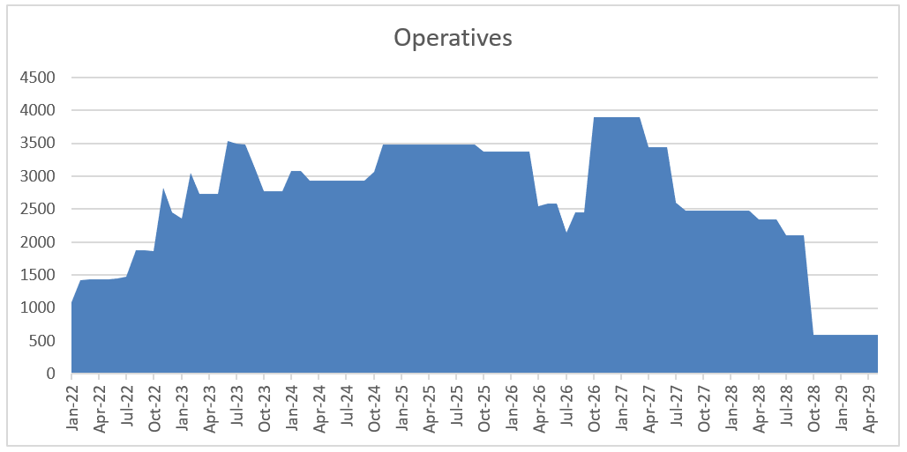

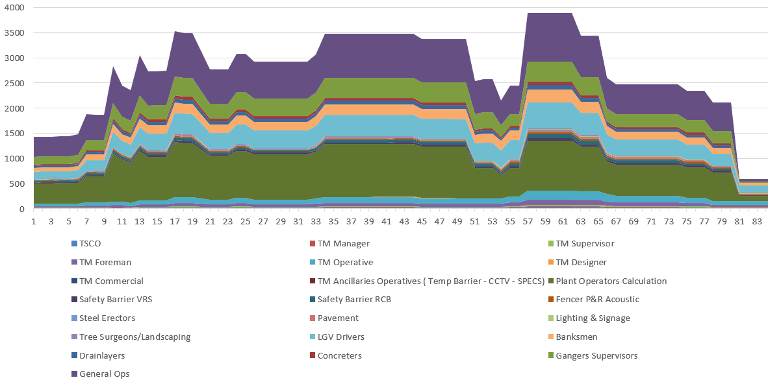

Successful parties would form part of SMPA’s overall supplier network, and would be expected to work together in an enterprise model with the Alliance and the wider supplier network.

Successful parties will have proven alignment with SMPA’s six strategic themes:

1. Home Safe and Well

Everyone arrives home safe, well and feeling positive. The working environment is not just safe, it positively enhances our people’s sense of wellbeing and self-worth. The Alliance adopts leading working practices to protect our customers travelling through our roadworks to be safe at all times.

1. Enriching Communities

Our approach enriches people’s lives and prospects. Opportunities abound in our collaborative culture. We attract new talent of all ages, inspire children to study STEM subjects, and continually find new ways to add lasting value to local communities.

1. Confident Customers

We enhance the lives of our customers and look after our neighbours. We plan our delivery around them. Our customers feel safe, in control and stress-free. They feel listened to and know they can trust us. We treat them as individuals and tailor our interactions to their diverse needs.

1. Agile Frontier Business

Consistent and high-quality delivery generates healthy rewards and resilience for all. The Alliance will transform the highways sector by setting new benchmarks for safety, productivity and quality. This will generate outperformance which will enable the Partners to generate fair profits and Highways England to reinvest.

1. Inspiring Workplaces

Our people feel inspired to maximise their own and each other’s potential. Our environment unites diverse teams to find new ways of working that unleashes fresh thinking and innovation. This develops our strengths and capabilities to transform the delivery and make us successful.

1. Enhancing Local Environments

Local ecosystems and natural habitats are improved as a result of our projects. Our investment in sustainability makes us feel proud of the positive influence and effect we have, knowing we are protecting and enhancing our local environment.

How to Register

Please follow the link to our online SourceDogg portal to provide the documents / information identified below as minimum requirements. Your submission will be assessed by SMPA for compliance with our expectations and alignment to our desired outcomes; only if deemed satisfactory will you be taken through to the next stage.

Minimum Requirements

(Please note the below will be subject to verification audit)

* Current proof of adherence to the Common Assessment Standard, either through Construction Line, Achilles or Builders Profile. Note this is equivalent to ConstructionLine Gold.
* Confirmation that all resources will be provided under PAYE.
* Any geographical preferences and details of your current capacity to supply temporary civils labour in these areas, and resources to manage such, under your existing structure.
* Financial records / turnover information for 2021 and forecast for 2022.
* A short statement (no longer than 3 sides of A4) supporting your expression of interest, describing your experience in the provision of temporary civils labour to a large infrastructure project or programme. This must include:
* no. of workers that your company deployed to the project at commencement, peak and end – please describe your approach to if / how you scaled up from your original capacity to reach peak numbers
* any experience of collaborations with other labour providers
* breadth of relevant trades supplied
* examples of meeting the client objectives
* please include current contact details for at least one referee

Next Steps

Applicants satisfying the minimum requirements as discussed above will be invited to complete a subsequent pre-qualification exercise and thereafter, if shortlisted, may be invited to tender.

Note SMPA will not be bound to issue any invitation to tender to any party at any time, and reserves the right to seek further prequalification or quotations from all, some or none of the applicants at its sole discretion.