

www.gov.uk/naturalengland

Request for Quotation

Evaluation of Year 2 of Health, Wellbeing, Nature & Sustainability decision support tool

August 2022

Request for Quotation

Evaluation of Year 2 of Health, Wellbeing, Nature & Sustainability decision-support tool

(Ref: HWNSEval22)

You are invited to submit a quotation for the requirement described in the specification below.

Please confirm, by email, receipt of these documents and whether you intend to submit a quote.

Your response should be returned to the following email address by:

Email: Emma.Hinton@NaturalEngland.org.uk

Date: 14/09/2022

Time: 17:00

Ensure you state the reference number and ‘Final Submission’ in the subject field to make it clear that it is your response.

### Contact Details and Timeline

Emma Hinton ([Emma.Hinton@NaturalEngland.org.uk](mailto:Emma.Hinton@NaturalEngland.org.uk)) will be your contact for any questions linked to the content of the quote pack or the process, or Patrick Shannon-Hughes ([Patrick.Shannon-Hughes@NaturalEngland.org.uk](mailto:Patrick.Shannon-Hughes@NaturalEngland.org.uk)) between 15th-19th August and between 5th-6th September, or Tom Mainwaring-Evans ([Thomas.Mainwaring-Evans@naturalengland.org.uk](mailto:Thomas.Mainwaring-Evans@naturalengland.org.uk)) on 7th September. Please submit any questions by email and note that, unless commercially sensitive, both the question and the response will be circulated to all tenderers.

|  |  |
| --- | --- |
| Action | Date |
| Date of issue of RFQ | 10/08/2022 at 12:00 |
| Deadline for clarification questions | 07/09/2022 at 17:00 |
| Deadline for receipt of Quotation | 14/09/2022 at 17:00 |
| Intended date of Contract Award | 28/09/2022 |
| Intended Contract Start Date | w/c 10/10/2022 |
| Intended Delivery Date | 31/03/2023 |

### Glossary

Unless the context otherwise requires the following words and expressions used within this Request for Quotation shall have the following meanings (to be interpreted in the singular or plural as the context requires):

|  |  |
| --- | --- |
| “Authority” | Means Natural England acting as part of the Department for Environment, Food and Rural Affairs |
| “RFQ” | Means this Request for Quotation and all related documents published by the Authority and made available to suppliers |
| “Contract” | Means the contract to be entered into by the Authority and the successful supplier. |

### Conditions applying to the RFQ

You should examine your response to the RFQ and related documents ensuring it is complete prior to submitting your completed quotation.

Your quotation must contain sufficient information to enable the Authority to evaluate it fairly and effectively. You should ensure that you have prepared your quotation fully and accurately and that prices quoted are arithmetically correct for the units stated.

The supplier by submitting a quotation is deemed to accept the terms and conditions in the RFQ. Failure to comply with the instructions set out in the RFQ may result in the supplier’s exclusion from this procurement.

### Acceptance of Quotations

By issuing this RFQ the Authority does not bind itself to accept any quotation and reserves the right not to award a contract to any supplier who submits a quotation.

### Costs

The Authority will not reimburse you for any costs and expenses which you incur preparing and submitting your quotation, even if the Authority amends or terminates the procurement process.

### Mandatory Requirements

The RFQ includes mandatory requirements and, if you do not comply with them, your quotation will not be evaluated. All mandatory requirements are set out in Bravo.

### Clarifications

The Authority reserves the right to discuss, confidentially, any aspect of your quotation with you prior to any award of Contract to clarify matters.

### Amendments

The Authority may amend the RFQ at any time prior to the deadline for receipt. If it amends the RFQ the Authority will notify you in writing and may extend the deadline for receipt in order to give you a reasonable time in which to take the amendment into account.

### Conditions of Contract

The terms and conditions attached [Condensed Terms and Conditions](https://assets.publishing.service.gov.uk/government/uploads/system/uploads/attachment_data/file/914956/standard-condensed-terms.odt) will be included in any contract awarded as a result of this RFQ process. The Authority will not accept any material changes to these terms and conditions proposed by a supplier.

### Specification

##### **Background to Natural England**

The Authority is Natural England. The Authority’s priorities are to secure a healthy natural environment; a sustainable, low-carbon economy; a thriving farming sector and a sustainable, healthy and secure food supply.

Our mission is building partnerships for nature’s recovery. This reflects the need for us to work with and through a wide range of people and also the need for rapid action to re-build sustainable ecosystems and thereby protect and restore habitats, species and landscapes.

Further information about the Authority can be found at: [Natural England](http://www.naturalengland.org.uk/)

##### **Background to the specific Natural England work area relevant to this purchase**

Health, Wellbeing, Nature and Sustainability (HWNS) are the basis for thriving local areas. However, they are often given insufficient consideration in strategic planning. We believe that a user-friendly tool that provides validated insights on what matters for these outcomes is needed. This can be used to help shape local strategies and planning so that they help people and nature thrive and contribute to global sustainable development.

Natural England is working with partners to develop an online, interactive Health, Wellbeing, Nature and Sustainability tool. These partners include the Environment Agency, the Office for Health Improvement and Disparities, the What Works Centre for Wellbeing, the Local Government Association, the UK Health Security Agency, the Faculty of Public Health, the University of Exeter and 4 pilot authorities: Liverpool City Region Combined Authority, Norfolk County Council, Sandwell Metropolitan Borough Council and Surrey County Council.

The tool will support Local and Combined Authorities in developing strategic plans which target HWNS outcomes in an integrated way. The tool will empower them to make informed decisions based on the relevant science and evidence.

The tool will have two parts: a dashboard and relevant factor diagrams. The dashboard will provide users with data on how they are doing in terms of health, wellbeing, nature, and sustainability outcomes. The relevant factor diagrams will show users which factors are important for theses outcomes, and how these factors relate to each other and the outcomes, from a local authority perspective.

This is year 2 of the project. In year 1, through a series of workshops with partners and experts, 3 relevant factor diagrams were developed: one for health and wellbeing, one for nature and one for sustainability. Some initial usability testing of these diagrams has taken place.

Also in year 1, a logic model and an accompanying evaluation framework were developed which will enable us to monitor and evaluate the process of tool development and evaluate the impact of the tool (Annex 1). An evaluation of activity in year 1 has already been completed.

This year, several work streams are further developing and refining the HWNS tool. These are:

* Quality assurance (QA) review of the content of the relevant factor diagrams
* Scoping and development of the dashboards
* Workshops with the pilot local authorities to test the latest iterations of the components of the tool (i.e. the relevant factors diagrams and potentially a mocked-up dashboard) in live strategic project development (referred to as ‘the piloting workshops’)

This contract is for the evaluation of the tool at this stage of its development, to establish progress against the evaluation framework and vision for the tool and highlight areas where further development is required. This contract is also for a light-touch end of year 2 evaluation of the progress of the project overall.

Suppliers can deliver the contract either on their own or together with subcontractors. Subcontractors must be selected by the suppliers. A joint application must be submitted. The requirements set out in this document apply to both suppliers and any subcontractors.

##### **Requirement**

This section sets out the contract requirements. Suppliers must explain how they will deliver the required outputs within the specified timeframe and to budget. They must further demonstrate that they have the required skills and experience. Information on how this will be evaluated can be found below under Quotation Submission.

There are two parts to this contract, with some elements running concurrently. Both will be based on the HWNS Evaluation Framework (Annex 1). The two parts are (see below for detail):

1. **Tool Evaluation** – Evaluation of the usability, potential uptake and impact of the current components of the HWNS tool, informed by the piloting workshops taking place with the 4 pilot authorities in Autumn 2022 (planned for November-December)
2. **Year 2 Process Evaluation** – Light-touch evaluation of progress in the second year of the project against the Year 2 process measures in the Evaluation Framework that are not covered in the Tool Evaluation.

We envisage that 80% of the work undertaken in this contract will focus on the tool evaluation, and the remaining 20% of the work will deliver the process evaluation.

This evaluation will be based on a review of existing information (including partnership and advisory group documentation) in addition to an analysis of data collected in the course of delivering this contract (including capturing the views of Local Authorities, other partners, subject matter experts and the tool content delivery partner, in addition to observations of the piloting workshops).

**1) Tool evaluation**

The tool evaluation should focus on the parts of the HWNS Evaluation Framework which require measuring and reporting in Year 2. This includes elements from the Process Evaluation Framework (mainly the Outcomes under ‘Content, Validity and Usability’ and ‘Engagement and Uptake’) and several elements from the Impact Evaluation Framework (see Annex 1).

The successful contractor is required to:

* Review and collate existing evidence from the usability testing carried out in Year 1 and feedback from the QA process being delivered in Year 2
* Work with the HWNS Working Group and the contractor facilitating the piloting workshops to specify data collection (e.g. surveys / polls, note taking) within the workshop needed for evaluation purposes
* Collect additional detailed evidence from the pilot authorities – for example, by delivering semi-structured interviews with key members of staff at each authority – to address the specific requirements as set out in the HWNS Evaluation Framework; to explore their experience of using the tool and applying it to policy or plan development in more detail than the piloting workshops will allow; and to add to our understanding of the baseline position of the pilot authorities in taking an integrated approach to strategic planning and where they see opportunities for its usage.
* Analyse the data against the relevant parts of the HWNS Evaluation Framework
* Provide a report of findings from the evaluation, including: progress and successes; recommendations for improvement; identified gaps and issues; recommendations for case studies; and areas for further research. The draft report will undergo peer review within Natural England, following which revisions may be required. The intention is to publish the final report to Natural England’s Access to Evidence catalogue – this process usually takes up to 2 months to complete and may require a further revision to the report prior to publication. The contractor must use Natural England’s report template for this report.

This requirement **does not include**:

* Designing and facilitating the piloting workshops where the tool is to be tested – this is covered under a separate contract. However, we would expect that the successful contractors will provide input to the design of the piloting workshops to ensure that the outcomes of the workshop can be used successfully in the evaluation.
* A review or evaluation of the content of the dashboard or relevant factor diagrams – this is being undertaken separately, via the QA process.

**2) Year 2 Process Evaluation**

A light-touch evaluation of the project work across Year 2 against the Process elements of the Evaluation Framework. The focus will be largely on governance, progress against the project plan, funding and stakeholder/partner engagement (essentially, those elements that are specified for evaluation in year 2 in the Evaluation Framework and are not covered by the Tool Evaluation).

The main bulk of this work will need to take place near the end of the financial year, but with some planning and data collection from the start of the contract to ensure data is collected at the appropriate time. It will be important to minimise the burden on participating pilot authorities by for example gathering any information needed for the Year 2 Process Evaluation from partners, experts and stakeholders at the time of engagement for the pilot workshops and Tool Evaluation, rather than going back at a later date, wherever possible.

The successful contractor will need to:

* Review the Process Evaluation Framework and work with the HWNS Working Group to plan when and how evaluation data will be collected through the contract.
* Analyse the collected data against the HWNS Process Evaluation Framework.
* Provide a report evaluating project progress at end of Year 2, including recommendations for Year 3 onwards. The draft report will undergo peer review within Natural England, following which revisions may be required. This report will not be published.

**Skills required:**

* Experience in using evaluation frameworks and carrying out evaluation of project deliverables, ideally in the context of health, wellbeing, nature and/or sustainability.
* Demonstrable understanding of how Local and Combined Authorities function and their strategic decision-making processes and cultures
* Expertise in qualitative and quantitative data collection and analysis, in line with good ethical practice and GDPR requirements
* Excellent time management and project management skills to deliver the contract on time and to a high quality so that it can inform the development of the tool.

For any data collected from people in relation to the Tool Evaluation or Year 2 Process Evaluation:

* The proposed data collection methodology must be approved by the Natural England Project Manager and subject to ethical review via Natural England’s Research Ethics Committee, in addition to any other ethical review procedures in place at the contractor’s institution, prior to data collection. The Natural England Project Manager will coordinate the submission to Natural England’s Research Ethics Committee, with input from the contractor. The contractor should provide evidence of any additional ethical approvals obtained at their institution (where relevant) to the Natural England Project Manager.
* Any interviews or focus groups should be recorded and transcribed, and all primary data collected from research participants (including surveys) must be anonymised and archived for future reuse, with participants’ informed consent. An appropriate archive will be agreed with the NE Project Manager.

It is anticipated that this contract will be awarded for a period of approximately 5 months to end no later than 31/03/2023. Prices will remain fixed for the duration of the contract award period. We may at our sole discretion extend this contract to include related or further work. Any extension shall be agreed in advance of any work commencing and may be subject to further competition.

### Outputs and Contract Management

This contract shall be managed on behalf of the Authority by Emma Hinton (<mailto:>Emma.Hinton@NaturalEngland.org.uk).

The successful contractor must appoint a project manager, who will be responsible for the management and delivery of the project and will act as the liaison point for the Natural England Project Manager.

The contractor will be expected to organise and lead a project inception meeting at the start of the project, where they will need to provide a detailed proposal and plan for the work they will undertake and agree any variations.

The contractor is required to update the Natural England Project Manager on progress every fortnight. This update should take the form of a meeting in addition to a short (e.g. maximum of one page of A4) written summary of progress which should be provided at least 24 hours before the meeting. The form and specific timing of these updates will be agreed at the inception meeting. Members of the HWNS Working Group may attend some of these meetings if required.

All meetings between the contractor and Natural England will be held remotely via telephone / videoconferencing (MS Teams preferred). It is the contractor’s responsibility to organise these meetings and to produce and circulate notes of each meeting to those in attendance.

The contractor is responsible for assessing the risks associated with the project as planned and for putting in place mitigation measures to respond to them. The contractor is responsible for reviewing the risk register at least every month, updating it as required and notifying the Natural England Project Manager of any changes.

Deliverables:

* Interview protocol, participant information and consent sheet for any primary data collection delivered by the contractors
* Transcripts of all interviews / focus groups and all other primary data collected by the contractors in the course of delivering this evaluation, for archiving
* Draft Tool Evaluation report(s) (the number of drafts required will depend on whether changes are required following peer review and completion of the Natural England publication process)
* Final Tool Evaluation report
* Draft Process Evaluation report(s) (the number of drafts required will depend on whether changes are required following peer review)
* Final Process Evaluation report
* Webinar (1 hour including time for questions) and accompanying slide deck presenting results to HWNS stakeholders

Timeline:

* Inception meeting w/c **10th October 2022**
* Attend at least one planning meeting for the piloting workshops (early autumn)
* Attend one HWNS Working Group meeting (these usually take place on the 1st Thursday of every month) early in the contract to discuss proposed approach
* Primary data collection (e.g. semi-structured interviews) with pilot authorities prior to and following the piloting workshops
* Observation of each piloting workshop, either in real-time (attending in person or virtually) or via watching recordings of the workshops – expected during November-December 2022
* Draft Tool Evaluation report to be provided by **1st February 2023**, for review by Natural England. Final report due **28th February 2023**, after which the Natural England Project Manager will put the report through the Natural England publications process (which may require subsequent revisions to be made).
* Draft Year 2 Process Evaluation report to be provided by **27th February 2023**, for review by Natural England. Final report due **23rd March 2023**.

We will raise purchase orders to cover the cost of the services and will issue to the awarded supplier following contract award. The supplier shall submit invoices at the following intervals:

* Milestone 1: Provision of final Tool Evaluation report, to the satisfaction of the Natural England Project Manager.
* Milestone 2: Provision of final Year 2 Process Evaluation report, to the satisfaction of the Natural England Project Manager, and conclusion of the contract.

### Prices

Prices must be submitted in £ sterling, **inclusive of VAT.**

### Quotation Submission

We will award this contract in line with the most economically advantageous tender (MEAT) as set out in the following award criteria:

* Price – 40%
* Quality – 60%

**Price**

Please complete the pricing schedule below.

Please indicate an overall cost for the contract, plus set out the total cost for the Tool Evaluation and total cost for Year 2 Process Evaluation. Please indicate separate costs for different tasks and a daily rate for personnel included within the project.

Please detail any risks and assumptions made and exactly what has been included in the prices and list any additional expected expenses separately.

Please provide costs excluding VAT and indicate if VAT will apply to your services and at what rate.

Please note that Natural England reserves the right to award all or some of the elements that make up the total contract.

|  |  |  |  |  |
| --- | --- | --- | --- | --- |
| **Item of work/task** | **Staff name/ Grade** | **Day rate** | **Number of days** | **Total cost exclusive of VAT** |
| Tool evaluation |  |  |  |  |
| Year 2 process evaluation |  |  |  |  |
|  |  |  |  |  |
| **Total** |  |  |  |  |
| **Total inclusive of VAT** |  |  |  |  |

The total price submitted by the supplier will be scored according to the following mechanism.

The weighting and maximum marks available for this part of the request for quotation is 40% and will be awarded to the supplier with the lowest total price. The remaining suppliers will receive marks on a pro rata basis from the lowest to the highest price.

The calculation used is the following:

$$Supplier Score= \left({Lowest Total Price}/{Total Price}\right)×40$$

For example, if three Supplier Responses are received and Supplier A has quoted £3,000 as their total price, Supplier B has quoted £5,000 and Supplier C has quoted £6,000 then the calculation will be as follows:

* Supplier A Score = £3000/£3000 x 40 (Maximum available marks) = 40
* Supplier B Score = £3000/£5000 x 40 (Maximum available marks) = 24
* Supplier C Score = £3000/£6000 x 40 (Maximum available marks) = 20

**Quality**

The following quality criteria are weighted in accordance with the importance and relevance

attached to each one.

| **Criteria** | Weighting | **Description** |
| --- | --- | --- |
| Contract methodology and outputs | 50%  (100 points available, minimum score of 50 required) | Confirmation that your quotation proposal meets our specification.  Suppliers must explain how they will deliver the required outputs within the specified timeframe and to budget (as detailed above under Specification). Please highlight any differences or provide alternatives with reasons/benefits of using those alternatives.  Please ensure your response is clear and well presented.  Your response must be a maximum of 4 sides of A4, font size 10. |
| Skills and experience | 30%  (100 points available, minimum score of 50 required) | Adequate staff resources devoted to the project and with an appropriate expertise.  Suppliers must demonstrate they have the required skills and experience to deliver the required outputs within the specified timeframe and to budget (as detailed above under Specification)  Please show clearly which key staff will be assigned to each of the tasks and outputs of the project and the number of days each will provide.  Please submit CVs of named staff who will work on the project (maximum of 1 side of A4, font size 10pt Arial per staff) that highlights most relevant publications and current or previous work experience.  Your response must be a maximum of 3 sides of A4, font size 10 (excluding CVs). |
| Project and risk management | 20%  (100 points available, minimum score of 50 required) | Suppliers must demonstrate they have suitable project management capabilities within their project team to deliver the contract outputs within the specified timescales and to budget.  Please submit a GANNT plan for delivering the required outputs (as detailed above under Specification).  Please also provide a summary of what you believe to be the main risks and areas of uncertainty, their potential impact on the project and how significant they are, and how you would act to minimise and manage them. This should include contingency plans to cover the unexpected unavailability of staff.  Your response must be a maximum of 2 sides of A4, font size 10 (excluding GANNT plan). |
| Sustainability | Pass/fail | Please provide a copy of a sustainability statement for your organisation, or a brief statement of how you consider sustainability in projects.  The sustainability statement must be a maximum of 1 side of A4, font size 10. |

Quotation responses to each question will be evaluated and scored against the following score criteria:

|  |  |
| --- | --- |
| **Score** | **Justification** |
| For a score of hundred (100): | Excellent - Response is completely relevant and excellent overall.  The response is comprehensive, unambiguous and demonstrates a thorough understanding of the requirement and provides details of how the requirement will be met in full. |
| For a score of seventy (70): | Good - Response is relevant and good.  The response demonstrates a good understanding and provides details on how the requirements will be fulfilled. |
| For a score of fifty (50): | Acceptable - Response is relevant and acceptable.  The response provides sufficient evidence to fulfil basic requirements. |
| For a score of twenty (20): | Poor - Response is partially relevant and/or poor.  The response addresses some elements of the requirements but contains insufficient / limited detail or explanation to demonstrate how the requirement will be fulfilled. |
| For a score of zero (0): | Unacceptable - Nil or inadequate response.  Fails to demonstrate an ability to meet the requirement. |

### Disclosure

All Central Government Departments, their Executive Agencies and Non-Departmental Public Bodies are subject to control and reporting within Government. In particular, they report to the Cabinet Office and HM Treasury for all expenditure. Further the Cabinet Office has a cross-Government role delivering overall Government policy on public procurement, including ensuring value for money and related aspects of good procurement practice.

For these purposes, the Authority may disclose within Government any details contained in your quotation. The information will not be disclosed outside Government during the procurement.

In addition, the Authority is subject to the Freedom of Information Act 2000 and the Environmental Information Regulations 2004, which provide a public right of access to information held by public bodies. In accordance with these two statutes, the Authority may be required to disclose information contained in your quotation to any person who submits a request for information pursuant to those statutes.

By submitting a quotation you consent to these terms as part of the procurement.

### Disclaimers

Whilst the information in this RFQ and any supporting information referred to herein or provided to you by the Authority have been prepared in good faith the Authority does not warrant that this information is comprehensive or that it has been independently verified.

The Authority does not:

* make any representation or warranty (express or implied) as to the accuracy, reasonableness or completeness of the RFQ;
* accept any liability for the information contained in the RFQ or for the fairness, accuracy or completeness of that information; or
* accept any liability for any loss or damage (other than in respect of fraudulent misrepresentation or any other liability which cannot lawfully be excluded) arising as a result of reliance on such information or any subsequent communication.

Any supplier considering entering into contractual relationships with the Authority following receipt of the RFQ should make its own investigations and independent assessment of the Authority and its requirements for the goods and/or services and should seek its own professional financial and legal advice.

### Protection of Personal Data

In order to comply with the General Data Protection Regulations 2018 the contractor must agree to the following:

* You must only process any personal data in strict accordance with instructions from the Authority
* You must ensure that all the personal data that we disclose to you or you collect on our behalf under this agreement are kept confidential.
* You must take reasonable steps to ensure the reliability of employees who have access to personal data.
* Only employees who may be required to assist in meeting the obligations under this agreement may have access to the personal data.
* Any disclosure of personal data must be made in confidence and extend only so far as that which is specifically necessary for the purposes of this agreement.
* You must ensure that there are appropriate security measures in place to safeguard against any unauthorised access or unlawful processing or accidental loss, destruction or damage or disclosure of the personal data.
* On termination of this agreement, for whatever reason, the personal data must be returned to us promptly and safely, together with all copies in your possession or control.

**General Data Protection Regulations 2018**

For the purposes of the Regulations the Authority is the data processor.

The personal information that we have asked you provide on individuals (data subjects) that will be working for you on this contract will be used in compiling the tender list and in assessing your offer. If you are unsuccessful the information will be **held and destroyed within two years** of the award of contracts. If you are awarded a contract it will be retained for the duration of the contract and destroyed within **seven years** of the contract’s expiry.

We may monitor the performance of the individuals during the execution of the contract, and the results of our monitoring, together with the information that you have provided, will be used in determining what work is allocated under the contract, and in any renewal of the contract or in the award of future contracts of a similar nature. The information will not be disclosed to anyone outside the Authority without the consent of the data subject, unless the Authority is required by law to make such disclosures.

**Annex 1 – Logic Model and Evaluation Framework**

This comprises three parts: part A shows the Logic Model, part B shows the Process Evaluation Framework and part C shows the Impact Evaluation Framework. This is available in full in the attached Excel file.



* 1. **Logic Model**

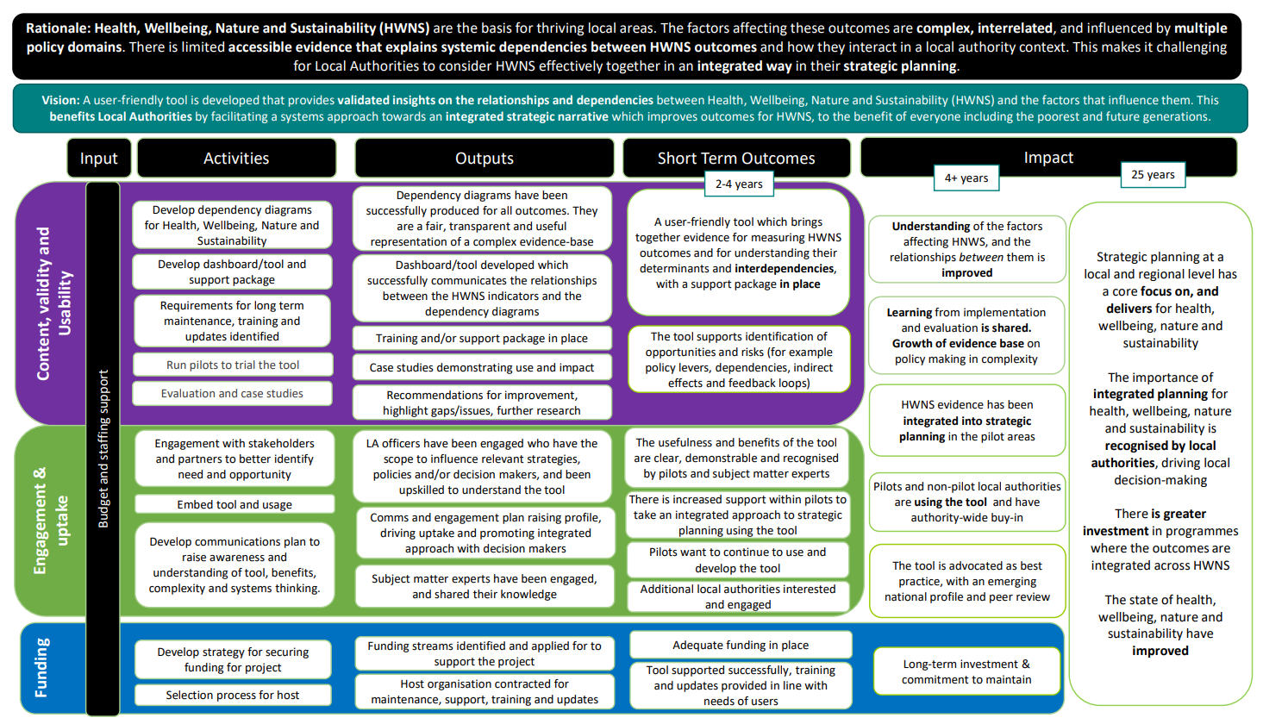

* 1. **Process Evaluation Framework**

Note: only those items that include a ‘Y’ in the Y2 column are within scope for this contract.

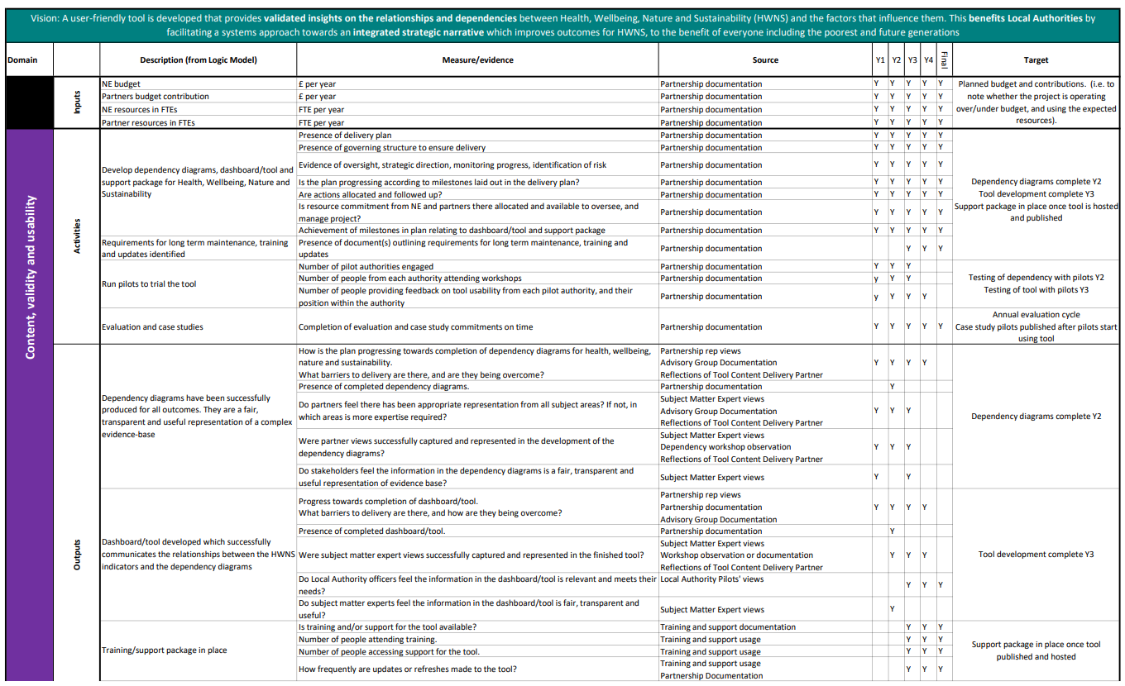

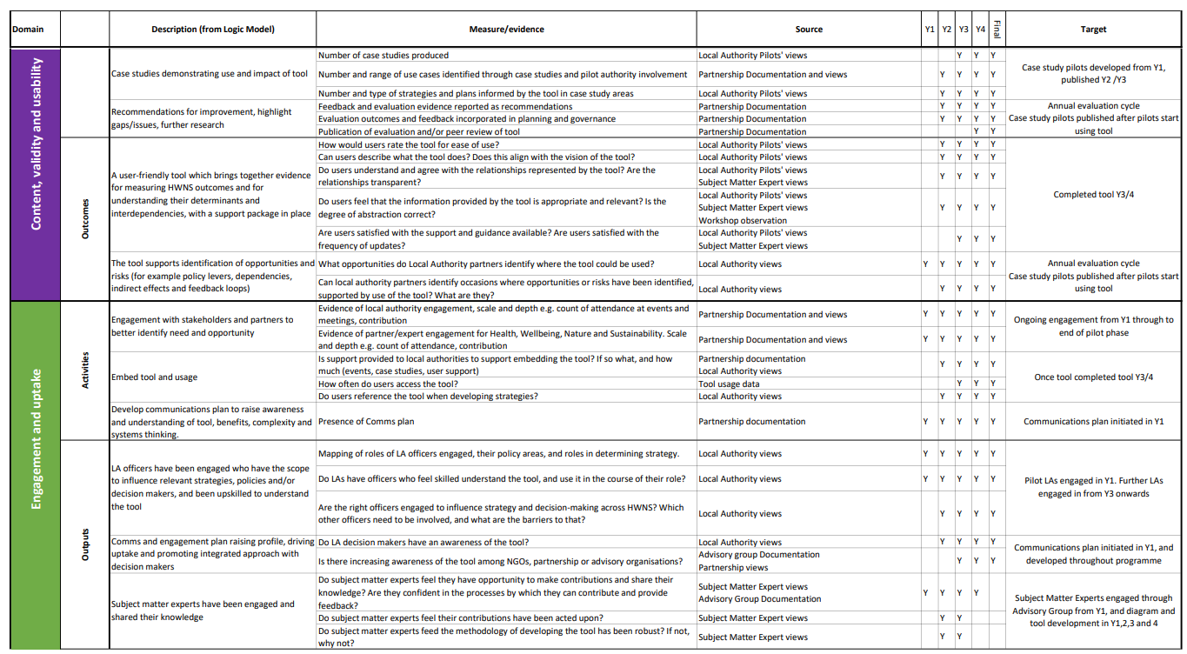

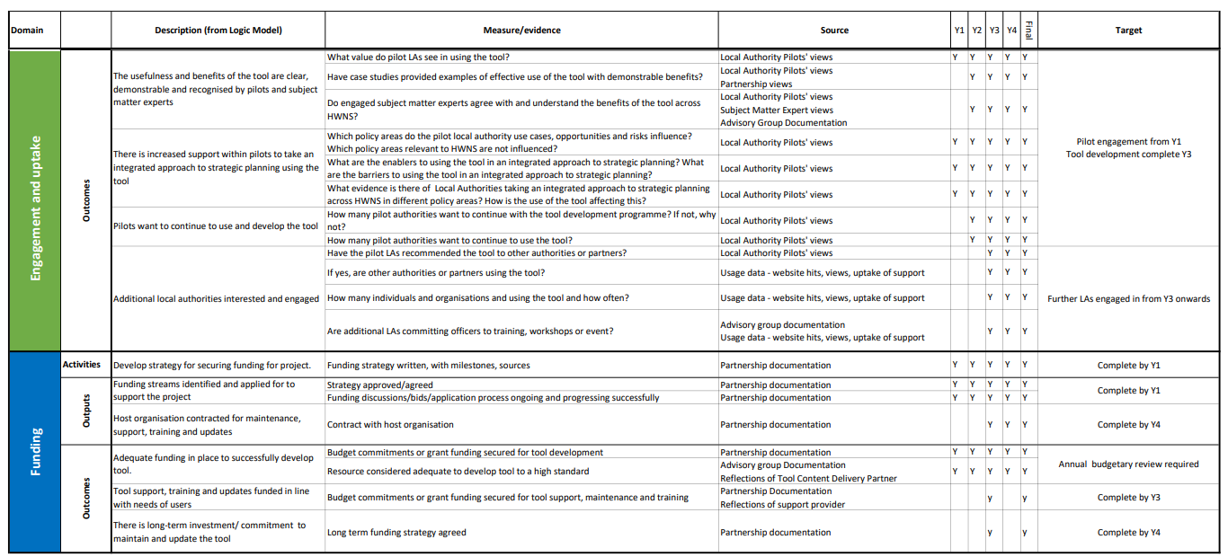

* 1. **Impact Evaluation Framework**

