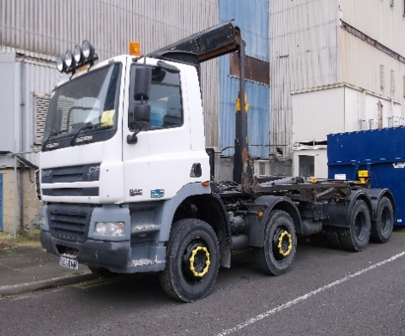**32T Hookloader Specification**

**Vehicle Specification**

* 32,000kg GVW.
* 8x4 axle configuration.
* Automatic gearbox.
* PTO and hook loader conversion, including sheeting system.
* Day cab with rear window.
* Driver air seat.
* Red seat belts.
* Pneumatic parking brake with audible warning.
* Height indicator in cab.
* No smoking sign in cab.
* Air conditioning and cab heater.
* 360-degree visible amber beacons - roof mounted (light bar or beacon), front, and rear.
* Front and rear facing LED work lights.
* Wheel nut indicators fitted to every wheel.
* Safety equipment FORS Silver compliant and TFL DVS 3 Star Rated:
  + Class V and VI close-proximity mirrors.
  + Side underrun guards (where practicable).
  + Blind spot warning signage (where practicable).
  + Audible left-turn and reversing vehicle alarms.
  + Reverse and nearside blind spot camera systems (min 720p video) with in cab colour display.  
    **Camera system must NOT record or store video and must NOT transmit any data wirelessly.**
  + Nearside close-proximity sensors with in-cab audible alarm.
  + Moving off sensors fitted to the front of the vehicle with in-cab audible alarm.
* Side storage locker.
* 2kg fire extinguisher in cab.

**Hire Specification**

* Hire with maintenance:
  + 36-month term.
  + 2,000km per annum.
* Road Fund Licence.
* Full Maintenance Package:
  + Servicing, maintenance, and repair of vehicle.
  + 12-weekly PMI inspections (Safety inspections / Roadworthiness inspections).
  + Annual testing and Preparation.
  + Servicing, maintenance, and repair of vehicle.
  + 12-monthly LOLER inspections + 6 monthly interim inspection.
  + Tyres.
  + Delivery & Collection service for service, maintenance, and repairs.
  + Maintenance planning and management.
  + Maintenance record keeping.
* Breakdown and Recovery.

**Additional Requirements**

* Familiarisation training provided to operators on delivery.
* Operating instructions.
* Maintenance instructions.
* Return condition terms and conditions.
* Early termination or break clause terms and conditions.
* Delivery address: Nuclear Restoration Services, Hinkley Point ‘A’ Power Station, Bridgwater, TA5 1YA.