SCHEDULE 2 – THE SERVICES
- Service Specifications

Mandatory headings 1 – 4: mandatory but detail for local determination and agreement
Optional headings 5-7: optional to use, detail for local determination and agreement.
All subheadings for local determination and agreement

Service Specification No.
Service | Maternity Voices Partnership
Commissioner Lead | Charlotte Barry
Provider Lead | To be appointed
Period | January 2018-March 2019
Date of Review

1. Population Needs
  - National context and evidence base

Better Births provides a national response to the Maternity Review that was commissioned in March 2015 by Simon Stevens, with the intention of enabling maternity services across England to become safer, more personalised, kinder, professional and more family friendly.

Better Births identifies the following seven key themes for action:
- Personalised care- centred on the woman, her baby and her family, based around their needs and their decisions, informed by unbiased information.
- Continuity of carer – to ensure safe care based on a relationship of mutual trust and respect in line the woman’s decision. Every woman should have a midwife who is part of a small team of 4-6midwives.
- Safer care- with professionals working together across boundaries to ensure rapid referral, and access to the right care in the right place; leadership for a safety culture within and across organisations; and investigation, honesty and learning when things go wrong.
- Better postnatal and perinatal mental health care - to address the historic underfunding and provision in these two vital areas, which can have a significant impact on the life chances and wellbeing of the woman, baby and family.
- Multi-professional working - breaking down barriers between midwives, obstetricians and other professionals to deliver safe and personalised care for women and their babies.
- Working across boundaries - to provide and commission maternity services to support personalisation, safety and choice, with access to specialist care whenever needed.
- Reformed payment system - that fairly and adequately compensates providers for delivering high quality care to all women efficiently, while supporting commissioners to commission for personalisation, safety and choice.

Better Births requires Local Maternity Systems to be established that are co-terminus with the Sustainability and Transformation Plan footprint. Local Maternity Systems bring together commissioners, maternity providers, public health providers, maternity voices partnerships and other key stakeholders to work collaboratively on a local maternity transformation plan to deliver the vision and requirements from Better Births.

Local Maternity Systems will be required to provide local leadership in the direct involvement of women and their families in understanding local need and developing innovative solutions to meet those needs

New Maternity Voices Partnerships will be established within each Local Maternity System to champion the transformation of maternity services within a Local Maternity System in co-production with women and their families.

  - Local Context

Maternity Services
The Birmingham and Solihull STP, Bump (Birmingham and Solihull United Maternity and Newborn Partnership), comprises maternity and newborn services provided by:
- Birmingham Women’s and Children’s NHS Foundation Trust (BWCH)
- Heart of England NHS Foundation Trust (HEFT)

Maternity Service Liaison Committees

Two Maternity Service Liaison Committees (MSLCs) have been operating and each aligned to one of the NHS Trusts (BWCH and HEFT) and funded by the CCGs. However, a constant challenge has been to ensure that the committees follow the national guidance for MSLCs, namely having service users making up a third of the committee, and the committee representing the population served by the two Trusts. Another challenge for the MSLCs has been for the feedback to be translated into service improvements through the commissioners and the providers.

Each MSLC has been chaired by a lay chair, both of whom are coming to the end of the tenure.

Birmingham: In 2013, the population in Birmingham was 1.092 Million. The city is more ethnically diverse than the average for England. 58% of Birmingham’s population is white, compared to 85% nationally as seen in Figure 2 (BCC, 2016).

Figure 1: Ethnicity breakdown in Birmingham
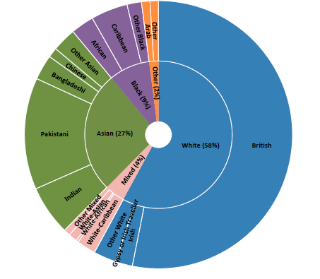
Solihull: Solihull remains significantly less ethnically diverse than other local areas in the West Midlands. In 2011 approximately 11% of Solihull residents were Black, Asian or mixed ethnic minority (BAME) compared with 14.6% in England and 17.3% of the West Midlands, (SCCG, 2015). This figure has doubled since 2001 with younger age groups being more diverse. The impact from international migration has been relatively limited, with just 7% of population born outside UK (14% England) (SMBC, 2016a).

Deprivation
Birmingham and Solihull has pockets of high level of deprivation across which are amongst the most deprived in the UK. Figure 1 shows the distribution of deprivation across the Bump geography.
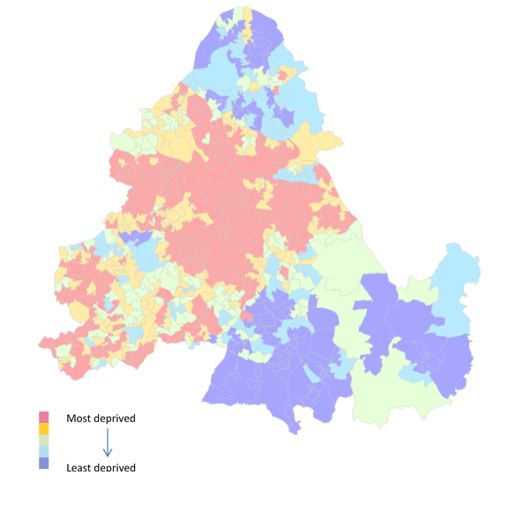
Figure 1: Map of Index of Multiple Deprivation (IMD) 2015 by National Quintile Birmingham and Solihull

Asylum Seeker and Refugee Communities
In addition to the high levels of ethnic diversity in the region, Birmingham has a high number of asylum seekers and refugees. Within the Birmingham locality is a Home Office Initial Accommodation Hostel for asylum seekers and refugees. Many of the women who are housed at the facility, or are dispersed into the local area are pregnant.

Perinatal Mortality
The West Midlands has a high rate of stillbirths, early neonatal and infant deaths compared to England and Wales. Perinatal mortality rates were significantly worse in the West Midlands than for England throughout the fifteen year period 2000 to 2014. For the period 2012 to 2014, the West Midlands perinatal mortality rate (7.9 per 1,000) was significantly worse than the rate for England (6.8 per 1,000) (PHE, 2016).

The areas with poorest outcomes generally have high levels of deprivation. These areas also tend to be a focus for migrant populations, and in particular are dispersal areas for asylum seekers. Many of the risk factors for infant mortality are experienced by migrant women and families, including ethnic minority status, material and social deprivation, nutrition, low educational level, abuse, female genital mutilation, consanguineous marriage, mental health disturbance, infection, and antenatal service access issues.

Vulnerability
As discussed above, there are a number of complex challenges and vulnerable groups within the Bump geography. There are a number of other types of vulnerability affecting pregnant women that are a priority for Bump to support. These include:
- young parents
- women at risk of or experiencing domestic abuse
- migrant or transient women,
- women who have had Female Genital Mutilation (FGM)
- those recently or currently in care
- families where parents have been exposed to 1+ ACE.

It is clear from this that certain pregnant women residing within the Bump footprint are extremely vulnerable and have the greatest need in terms of social and medical risk factors. However, often they do not fully engage with universal NHS maternity services on offer.

Addressing this is a priority for the region. A multi-faceted approach is being taken forward across the agencies to ensure that all women have a good experience of maternity care which is safe, high quality and has positive outcomes for mothers, babies and families through pregnancy and into the early years period. For these reasons it is particularly important that the Maternity Voice Partnership (MVP) ensures that experiences, views and the voices of the most vulnerable women and their families are heard, and are listened, to ensure that the services that are commissioned and provided meet the needs of the entire population of Bump.

2. Outcomes
2.1 NHS Outcomes Framework Domains & Indicators
Domain 1 | Preventing people from dying prematurely
Domain 2 | Enhancing quality of life for people with long-term conditions
Domain 3 | Helping people to recover from episodes of ill-health or following injury
Domain 4 | Ensuring people have a positive experience of care
Domain 5 | Treating and caring for people in safe environment and protecting them from avoidable harm

2.2 Local defined outcomes
The service provider will deliver the following outcomes working in partnership with the local health economy where appropriate (see Appendix 1: key performance indicators and data information requirements)
- Increased equitable access to midwifery-led services
- Support agenda to reduce perinatal mortality rates
- Improved breast feeding rates
- Increased referrals to services providing support for healthy lifestyle choices
- Women will have an informed choice about the most clinically appropriate care for them
- Increased number of service users involved in service planning
- Improved patient experience
- Emotional support

3. Scope
3.1 Aims and objectives of service
- Improving experience of maternity care for families
- Improving safety of maternity care
- Improving engagement with maternity services both through accessing provision and feeding back experiences in real time
- Establishing a single Maternity Voices Partnership across the MVP
- Understanding maternity experiences of women and their families across Birmingham
- Establishing a well-functioning and dynamic forum for issues to be debated and heard
- Influencing governance arrangements to ensure experiences of service users are fed into service improvement
- Influence service provision through healthy relationships with providers and commissioners
- Providing good value for money for commissioners and providers

3.2 Service description

In Year One the service will have two functions:

- Establishing the Maternity Voices Partnership
- Operationalising the MVP

Establishing the MVP
- Design and execute a process for recruiting and electing a chair
- Develop job descriptions for all MVP members
- Identify key stakeholders including those essential for accessing vulnerable and seldom-heard communities
- Promote the new committee
- Recruit a pool of 15 – 20 MVP members who are representative of the diverse communities with Birmingham and Solihull

Operationalizing the MVP
- Administrate the Quarterly Bump MVP meeting and support four interim MVP meetings
- Support representation on the MPV from seldom heard groups present within the local population to make sure their voices are heard – this may require bespoke approaches to women with particular characteristic
- Support the MVP to provide leadership to ensure that the service user voice co-produces both Local Maternity (LMS) System Transformation Plans and provider level operational plans
- Support the MVP to provide advice to inform other forms of health and social care strategic planning, for example the Joint Needs Assessment , Health and Wellbeing Strategies and Sustainability and Transformation Plans
- Support the MVP to provide constructive challenge and engage in the decision-making process with emerging plans to ensure they reflect the needs of local women and their families.
- Support the MVP to explore issues raised by anonymised complaints and comments.
- Support the MVP to provide constructive feedback on existing services and collaboratively identify areas for improvement.
- Support the MVP in their role in the monitoring of provider contracts.
- Work with the CCG/ providers to address specific “hotspots” relating to insight from users such as postnatal care, postnatal primary care checks, and bereavement care.
- Link with Healthwatch
- Link with neighbouring MVPs, especially SWB
- Identify and coordinate location of MVP meetings e.g. first meeting to be at a place with crèche facilities
- Manage a small budget to cover travel expenses and to remunerate Chair and MVP members.
- Develop quarterly reports in line with reporting requirements.

3.3 Staffing
It is expected that all staff are suitably trained to undertake roles relevant to their position.

- DBS checked
- Support women whose first language is not English
- Appropriately trained around providing mentoring and advocacy support
- Have a good understanding of maternity and early year’s services.

3.4 Any acceptance and exclusion criteria and thresholds
n/a

3.5 Interdependence with other services/providers
The Provider will be required to work in partnership with other stakeholders and organisations. These may include (this is not an exhaustive list):

- A range of NHS hospital & community trusts (including GPs, health visitors etc.)
- Social services
- Children’s centres
- Voluntary sector providers
- Independent midwives
- CCGs

4. Applicable Service Standards
4.1 Applicable national standards (e.g. NICE)
Applicable national standards (e.g. NICE)
- n/a
4.2 Applicable standards set out in Guidance and/or issued by a competent body (e.g. Royal Colleges)
- n/a
4.3 Applicable local standards
- n/a

5. Applicable quality requirements and CQUIN goals
  - Applicable Quality Requirements (See Schedule 4 Parts [A-D])
  - Applicable CQUIN goals (See Schedule 4 Part [E])

Not Applicable

6. Location of Provider Premises
The Provider’s Premises are located at: TBC

7. Individual Service User Placement
Not Applicable

