

www.gov.uk/naturalengland
Request for Quotation

Name of the Quotation:
‘Goss_Scrub_24_25’ Scrub Clearance Goss Moor NNR.

11th Sept 2024

Please provide your quotation for the requirement described in the specification, Section 2. Appendix 1 provides site location, Appendix 2 provides proposed scrub clearance areas, Appendix 3 provides access to site location and Appendix 4 provides significant hazards and constraints.
Your response should be returned to the following email address by:
Email: ian.moye@naturalengland.org.uk
Date: 14th November 2024.
Time: Midday
Ensure you include the name of the quotation and ‘Final Submission’ in the subject field to make it clear that it is your response.

Contact Details and Timetable
Ian Moye will be your contact for any questions linked to the content of the quote or the process. Please submit any clarification questions via email to ian.moye@naturalengland.org.uk and note that, unless commercially sensitive, both the question and the response will be circulated to all tenderers.

Action | Date
Date of issue of RFQ | 13-09-2024 at 12:00 hrs GMT
Site visit arrangements | Week commencing the 30th Sept – 4th October 2024 only. Please email ian.moye@naturalengland.org.uk to arrange
Deadline for clarifications questions | 11-10-2024 at midday GMT
Deadline for receipt of Quotation | 18-10-2024 at Midday GMT
Intended date of Contract Award | 23-10-2024
Intended Contract Start Date | 04-11-2024
Contract Duration | 6 – 8 weeks (Approx) depending on priority areas bidding for and/or weather constraints.

Section 1: General Information
Glossary
Unless the context otherwise requires, the following words and expressions used within this Request for Quotation shall have the following meanings (to be interpreted in the singular or plural as the context requires):
“Authority” | means Natural England (NE) who is the Contracting Authority.
“Contract” | means the contract to be entered into by the Authority and the successful supplier.
“Response” | means the information submitted by a supplier in response to the RFQ.
“RFQ” | means this Request for Quotation and all related documents published by the Authority and made available to suppliers.

Conditions applying to the RFQ
You should examine your Response and related documents ensuring it is complete and in accordance with the stated instructions prior to submission.
Your Response must contain sufficient information to enable the Authority to evaluate it fairly and effectively. You should ensure that you have prepared your Response fully and accurately and that prices quoted are arithmetically correct for the units stated.
By submitting a Response, you, the supplier, are deemed to accept the terms and conditions provided in the RFQ. Confirmation of this is required in Annex 2.
Failure to comply with the instructions set out in the RFQ may result in the supplier’s exclusion from this quotation process.
Acceptance of Quotations
By issuing this RFQ the Authority does not bind itself to accept any quotation and reserves the right not to award a contract to any supplier who submits a quotation.
Costs
The Authority will not reimburse you for any costs and expenses which you incur preparing and submitting your quotation, even if the Authority amends or terminates the procurement process.
Self-Declaration and Mandatory Requirements
The RFQ includes a self-declaration response (Annex 1) which covers basic information about the supplier, as well as any grounds for exclusion. If you do not comply with them, your quotation will not be evaluated.
Any mandatory requirements will be set out in Section 2, Specification of Requirements and, if you do not comply with them, your quotation will not be evaluated.
Clarifications
Any request for clarification regarding the RFQ and supporting documentation must be submitted via email no later than the deadline for clarifications set out in the Timetable. The Authority shall be under no obligation to respond to queries raised after the clarification deadline.
The Authority will respond to all reasonable clarifications as soon as possible but cannot guarantee a minimum response time. The Authority will publish all clarifications and its responses to all suppliers via email unless deemed commercially sensitive.
If a supplier believes that a request for clarification is commercially sensitive, it should clearly state this when submitting the clarification request. However, if the Authority considers either that:

the clarification and response are not commercially sensitive; and
all suppliers may benefit from its disclosure,

then the Authority will notify the supplier (via email), and the supplier will have an opportunity to withdraw the request for clarification by sending a further message requesting the withdrawal of the clarification request. If not withdrawn by the supplier within 2 working days of the Authority’s notification, the Authority may publish the clarification request and its response to all suppliers and the Authority shall not be liable to the supplier for any consequences of such publication.
The Authority reserves the right to seek clarification of any aspect of a quotation and/or provide additional information during the evaluation phase to carry out a fair evaluation. Where the Authority seeks clarification on any aspect of the quotation, the supplier must respond within the timeframe requested by the Authority.
Amendments
The Authority may amend the RFQ at any time prior to the deadline for receipt. If it amends the RFQ the Authority will notify you via email.
Suppliers may modify their quotation prior to the deadline for Responses. No Responses may be modified after the deadline for Responses.
Suppliers may withdraw their quotations at any time by submitting a notice via the email to the named contact.
Conditions of Contract
The Authority’s Standard Good and Services Terms & Conditions (used for purchases under £50k) can be located on the Natural England Website and will be applicable to any contract awarded as a result of this quotation process. The Authority will not accept any changes to these terms and conditions proposed by a supplier.
Suppliers should note that the quotation provided by the successful bidder will form part of the Contract.
Prices
Prices must be submitted in £ sterling, exclusive of VAT.
Disclosure
All Central Government Departments, their Executive Agencies and Non Departmental Public Bodies are subject to control and reporting within Government. In particular, they report to the Cabinet Office and HM Treasury for all expenditure. Further the Cabinet Office has a cross-Government role delivering overall Government policy on public procurement, including ensuring value for money and related aspects of good procurement practice. For these purposes, the Authority may disclose within Government any details contained in your quotation. The information will not be disclosed outside Government during the procurement.
In addition, the Authority is subject to the Freedom of Information Act 2000 and the Environmental Information Regulations 2004, which provide a public right of access to information held by public bodies. In accordance with these two statutes, the Authority may be required to disclose information contained in your quotation to any person who submits a request for information pursuant to those statutes.
Further to the Government’s transparency agenda, all UK Government organisations must advertise on Contract Finder in accordance with the following publication thresholds:
Central Contracting Authority’s: £12,000
Sub Central Contracting Authority’s and NHS Trusts: £30,000

For the purpose of this RFQ the Authority is classified as a 'Sub Central Contracting Authority' NE, with a publication threshold of '£30,000' inclusive of VAT.
If this opportunity is advertised via Contracts Finder, we are obliged to publish details of the awarded contract including who has won the contract, the contract value, and indicate whether the winning supplier is a small and medium-sized enterprise (“SMEs”) or voluntary organisation or charity. A copy of the contract must also be published with confidential information redacted.
By submitting a Response, you consent to these terms as part of the procurement.
Disclaimers
Whilst the information in this RFQ and any supporting information referred to herein or provided to you by the Authority have been prepared in good faith the Authority does not warrant that this information is comprehensive or that it has been independently verified.
The Authority does not:
- make any representation or warranty (express or implied) as to the accuracy,
reasonableness or completeness of the RFQ;
- accept any liability for the information contained in the RFQ or for the fairness, accuracy or completeness of that information; or
- accept any liability for any loss or damage (other than in respect of fraudulent misrepresentation or any other liability which cannot lawfully be excluded) arising as a result of reliance on such information or any subsequent communication.
- Any supplier considering entering into contractual relationships with the Authority following receipt of the RFQ should make its own investigations and independent assessment of the Authority and its requirements for the goods and/or services and should seek its own professional financial and legal advice.

Protection of Personal Data
In order to comply with the General Data Protection Regulations 2018 the supplier must agree to the following:
You must only process any personal data in strict accordance with instructions from the Authority.
- You must ensure that all the personal data that we disclose to you, or you collect on our behalf under this agreement are kept confidential.
- You must take reasonable steps to ensure the reliability of employees who have access to personal data.
- Only employees who may be required to assist in meeting the obligations under this agreement may have access to the personal data.
- Any disclosure of personal data must be made in confidence and extend only so far as that which is specifically necessary for the purposes of this agreement.
- You must ensure that there are appropriate security measures in place to safeguard against any unauthorised access or unlawful processing or accidental loss, destruction or damage or disclosure of the personal data.
- On termination of this agreement, for whatever reason, the personal data must be returned to us promptly and safely, together with all copies in your possession or control.
General Data Protection Regulations 2018
For the purposes of the Regulations the Authority is the data processor.
The personal information that we have asked you provide on individuals (data subjects) that will be working for you on this contract will be used in compiling the tender list and in assessing your offer. If you are unsuccessful the information will be held and destroyed within two years of the award of contracts. If you are awarded a contract, it will be retained for the duration of the contract and destroyed within seven years of the contract’s expiry.
We may monitor the performance of the individuals during the execution of the contract, and the results of our monitoring, together with the information that you have provided, will be used in determining what work is allocated under the contract, and in any renewal of the contract or in the award of future contracts of a similar nature. The information will not be disclosed to anyone outside the Authority without the consent of the data subject, unless the Authority is required by law to make such disclosures.
Equality, Diversity & Inclusion (EDI)
The Client is striving to create a diverse and inclusive working environment where every individual has equality of opportunity to progress and to apply their unique insights to making the UK a great place for living. The Service Provider is expected to respect this commitment in all dealings with Natural England staff and service users.
Suppliers are expected to;
support Defra group to achieve its Public Sector Equality Duty as defined by the Equality Act 2010, and to support delivery of Defra group’s Equality & Diversity Strategy meet the standards set out in the Government’s Supplier Code of Conduct work with Defra group to ensure equality, diversity and inclusion impacts are addressed (positive and negative) in the goods, services and works we procure, barriers are removed and opportunities realised.

Sustainable Procurement
Addressing global sustainability impacts and realising additional community benefits within commercial activity is core to Defra group’s approach, working with its supply chain is key to achieving sustainable outcomes. In addition to supporting Defra group to meet its outcomes we look to understand and reduce negative sustainability impacts associated with our commercial activity and realise benefits.
The Client encourages its suppliers to share these values, work to address negative impacts and realise opportunities, measure performance and success.
Suppliers are expected to have an understanding of the Sustainable Development Goals, the interconnections between them and the relevance to the Goods, Services and works procured on the Client’s behalf
Conflicts of Interest
The concept of a conflict of interest includes but is not limited to any situation where an Involved Person or Relevant Body has directly or indirectly, a financial, economic or other personal interest which might be perceived to compromise their impartiality and independence in the context of the procurement procedure and/or affect the integrity of the contract award.
We expect suppliers to mitigate appropriately against any real or perceived conflict of interest through their work with government. A supplier with a position of influence gained through a contract should not use that position to unfairly disadvantage any other supplier or reduce the potential for future competition
Where the supplier is aware of any circumstances giving rise to a conflict of interest or has any indication that a conflict of interest exists or may arise you should inform the Authority of this as soon as possible (whether before or after they have submitted a quotation). Tenderers should remain alert to the possibility of conflicts of interest arising at all stages of the procurement and should update the Authority if any new circumstances or information arises, or there are any changes to information already provided to the Authority. Failure to do so, and/or to properly manage any conflicts of interest may result in a quotation being rejected.
Provided that it has been carried out in an open, fair and transparent manner, routine pre-market engagement carried out by the Authority should not represent a conflict of interest for the supplier.

Section 2: The Invitation
Specification of Requirements
Background to Natural England
We're the government’s adviser for the natural environment in England. We help to protect and restore our natural world. We were established by an Act of Parliament in 2006. Our purpose is to help conserve, enhance and manage the natural environment for the benefit of present and future generations, thereby contributing to sustainable development.
Our vision is ‘Thriving Nature for people and planet’. We aim to achieve this through our mission ‘Building partnerships for Nature’s recovery’
Further information about the Authority can be found at: www.naturalengland.org.uk
Site Location.
See (Appendix 1) provides the location of Goss Moor. Goss Moor is located approximately 12km southwest of Bodmin, Cornwall, between the villages of St Dennis and Roche.

Working Area.

See (Appendix 2) for proposed scrub clearance areas 2024/2025. Scrub clearance areas are identified and divided into three priorities and are shown as Priority 1, Priority 2 and Priority 3. Priority 1 is Approx. 3.8ha (gross), Priority 2 is Approx. 6.1ha (gross) and Priority 3 is Approx. 0.8ha (gross) The total scrub priority areas is Approx. 10.7ha (gross).

Site Access, parking and welfare area.

See (Appendix 3) for access route to working area, parking and welfare area. Please note that the access route, parking welfare area provided are those to be used for the duration of the contract. No other tracks to be used unless NE give permission to do so.

Access tracks must not be blocked as they are frequently used by visitors, dog-walkers, horse-riders, NNR staff/volunteers and other contractors. Locked gates, keys/number codes will be provided to the successful contractor, any keys provided must be returned on completion of the contract.

Constraints & Hazards.

See (Appendix 4) for constraints and hazards.

Background to the specific work area relevant to this purchase
Natural England are seeking a suitable and qualified contractor that can demonstrate that they have worked on SSSI and SAC sites, to remove approximately 10.7Ha gross of light to medium dense to scattered scrub within Goss Moor NNR. The total hectarage is divided into 3 separate priority areas, each separate area has a priority, Priority 1 being top priority and so on. Bidders can bid for as many priority areas.
Scrub clearance can be achieved by either or a mixture of mechanical means (grubbing out and/or tree snips) and/or manual clearance. Scrub removed will be burnt in-situ and ash will be buried in-situ within areas that are not deemed to cause any negative impacts on priority habitats and/or features. There will also a requirement of chemical stump treatment on stumps greater than 2inches in diameter. Works to commence early November 2024 and to be completed by late December 2025.
Additional scrub within the same priority areas may be added depending on the success of the original clearance priority areas, particular interest of the deadline achieved would be greatly approved to warrant potential additional clearance areas and if budget allows and/or financial confirmation.
The scope of works within priority area 1 in general are as follows:
- Within wetter areas mechanically grub and/or tree snip out light scrub, namely bramble, gorse, semi mature willow and occasional birch.

- In drier areas, such as bunds/humps (archaeological features) the use of chainsaws to be used to cut all woody material (unless been identified to be retained) – no grubbing out of any woody material to be conducted within these areas. Cut to above ground no less than 200mm.

- As above, and where semi mature trees are too big to grub out regardless of dry or wet ground (unless been identified to be retained), the use of tree snips and/or manual cutting using chainsaws of semi - mature willow. Cut to above ground no less than 200mm.

- Semi to mature trees, namely oak, birch and willow will be retained. Such retained trees will be shown to bidders during site visit. The assumption of retaining number of individual trees will be no more than 20 across the whole clearance area.

- As above but identified with a 'X' these trees are to be felled, snedding of limbs from main stem/s to be kept in its entire length and where possible the main stem/s cut into lengths between 3m - 5m lengths. Stems to be stacked into piles/ limbs to be stacked into piles. Piles to be stacked outside of the working zone/s. The assumption number of individual trees requiring this methodology will be no more than 10 across the whole clearance are

- All brash woody materials apart from trees felled marked with an X to be burnt in-situ. Burn sites to be agreed on site by Natural England. Natural England would visualise at least 6 individual burn sites. Burning site locations will be discussed during the site visit. Mechanical uses to transport material to each individual burn site can be used.
- Chemical stump treating would be required on all cut stumps >2inches in diameter using only a Forestry Commission approved and aquatic friendly glyphosate e.g., 360g roundup pro-biactive.

- All Herbicide, blue dye & water to be supplied by the contractor. Contractors must specify which Glyphosate formulation they will use in their method statement. The methodology should specify any measures/equipment that will be used to minimise run-off. Care must be taken to minimise run-off onto any non-target plants. A daily record of herbicide record sheet MUST be completed and provided to NE when issuing invoices. Failure to provide herbicide daily record sheets may result in payment delays.

- Blue dye must be mixed with the herbicide at manufacturer’s recommended concentration to enable the treated stumps to be distinguished.

The scope of works within priority area 2 in general are as follows:
- Only light to medium scrub to removed leaving semi to mature trees by either tree’s snips or manual chainsaws, clearing saws and brushcutters. Mature trees to retain are those that have a trunk girth greater than 30inches in diameter measured at approx. 200mm above ground level. The objective of the clearance within this priority area is to remove encroaching young scrub. There will be areas containing light to medium scrub within groups of mature trees. In this situation clear light to medium scrub around the edges of each group of mature trees.

- Light scrub such as bramble to be brushcut. In wetter areas bramble can be brushcut to ground level and in drier areas brushcut to no lower than 200mm above ground. Changes in this methodology may change on the direction of the ecologist recommendations in relation to hibernating dormice. A mechanical mulcher can be used to mulch bramble and other light scrub to ground level in wetter areas where there is no evidence and/or no likelihood of hibernating dormice present. This methodology will be confirmed by the ecologist.

- All other brash woody materials to be burnt in-situ. Mechanical uses to transport material to each individual burn site can be used. Such methodology of transportation must follow a single extraction route to prevent negative impacts of potential hibernating dormice. Such route will be defined by the ecologist.

- Burn sites to be agreed on site by Natural England. Natural England would visualise at least 6 individual burn sites. Burning site locations will be discussed during the site visit and/or during the works.

- Chemical stump treating would be required on all cut stumps >2inches in diameter using only a Forestry Commission approved and aquatic friendly glyphosate e.g., 360g roundup pro-biactive.

- All Herbicide, blue dye & water to be supplied by the contractor. Contractors must specify which Glyphosate formulation they will use in their method statement. The methodology should specify any measures/equipment that will be used to minimise run-off. Care must be taken to minimise run-off onto any non-target plants. A daily record of herbicide record sheet MUST be completed and provided to NE when producing invoices. Failure to provide may result in payment delays.

- Blue dye must be mixed with the herbicide at manufacturer’s recommended concentration to enable the treated stumps to be distinguished.

The scope of works within priority area 3 in general are as follows:
- Along both sides of the river Fal all scrub removed by manual removal, using chainsaws and brushcutters/clearing saws to create a minimum of 5m width corridor from top of the riverbank.

- Several sections of retained scrub along each side of the river – an indicative retained scrub areas will be Approx. 20m – 30m apart staggered each side of the river Fal, and/or where semi mature trees are present. Each retained scrub/tree areas will be approx. 20m². These areas will be identified during the site visits and/or during the working operations.

- Stumps to be cut no lower than 200mm above ground level.

- All cut material to burnt in-situ – indicative location burn sites will be discussed during the site visit. NE visualise there would be at least 6 separate burn sites on each side of the river Fal.

- Chemical stump treating on stumps >2inches in diameter using only a Forestry Commission approved and aquatic friendly glyphosate e.g., 360g roundup pro-biactive.

- All Herbicide, blue dye & water to be supplied by the contractor. Contractors must specify which Glyphosate formulation they will use in their method statement. The methodology should specify any measures/equipment that will be used to minimise run-off. Care must be taken to minimise run-off onto any non-target plants. A daily record of herbicide record sheet MUST be completed and provided to NE when issuing invoices. Failure to provide may result in payment delays.

- Blue dye must be mixed with the herbicide at manufacturer’s recommended concentration to enable the treated stumps to be distinguished.

All priority areas of clearance have the potential to be utilised by dormice, an ecologist will present during the works to conduct an Ecological Clerks of Works (ECoW) where there are significant likelihoods of hibernating dormice presence e.g., within drier ground conditions. In the event of a recorded hibernating dormice an exclusion zone will be conducted - such exclusion zone size will be concluded by the ecologist according to dormice best practices based on the methodology of works being conducted. Due size of the working area this should not cause downtime.
Health and Safety Obligations
The appointed contractor must liaise with Ian Moye before commencing works. Natural England has a new Contractor Policy (Sept 2022) which includes an on-site Health & Safety pre commencement meeting and an ecological briefing induction forms the pre-commencement meeting which must be completed prior to works commencing.
- A list of site hazards is provided under the title of Hazards and Constraints. A map has also been supplied within (Appendix 4). The contractor must submit examples of Method Statement and example Risk Assessments from similar works in the Tender
- A site-specific Risk Assessments and Methods statement will be required by the appointed contractor before starting the Contract. These must be approved by Ian Moye prior to the commencement of the contract.
- All work must comply with HASAW, COSHH, HAVS, Noise and FEPA regulations.
- CDM may apply, NE will supply CDM if required.
- Herbicide is only to be applied by a person holding NPTC PA1/PA6AW certificates. Copies of such certificates should be included in the tender.
- Chainsaws are only to be used by persons with an in-date chainsaw certificate’s such as NPTC CS30 & 31 (or equivalent). Low eco-toxicity non-fling bio-degradable chainsaw oil to be used. Copies of such certificates to be included in the tender
- Brushcutters and/or clearing saws are only to be used by persons with current NPTC brush-cutter/clearing saw certificates. Copies of such certificates to be included in the tender
- The use of 360 tracked machines are only to be used by persons with the relevant training and certificates, such as Construction Plant Competence Scheme (CPCS) or equivalent. Copies of such certificates to be included in the tender
- Appropriate PPE for all working operations to be always worn. PPE requirements should be demonstrated within the appointed contractors RAMS.
- Hand and Arm vibration syndrome (HAVS) regulations & guidelines to be followed.
- The appointed contractor is expected to provide first aid/emergency eye-wash provision and an adequate number of trained first aiders. Copies of such certificates to be included in the tender.
- The appointed contractor MUST sign in and out of each working day to Ian Moye. Ian Moye will provide contact number during pre-commencement meeting. Repetitive failure to sign in and out may lead to the contract being terminated.
- Warning signs to be erected NE to supply map to the appointed contractor of the locations were to sight warning signs.
- Care must be taken because of the presence of ditches/borrow-pits, bogs, marshes, livestock, visitors, horse riders, dog walkers, historical cut stumps, and protected species.
- NO LONE WORKING, due to the significant hazards and risks of the work required and the complexity of the working site.
- A record of all daily herbicide used must be completed on an Herbicide Record sheet. Failure to do so may result in delayed payment and/or being declined until such Herbicide Record sheets are provided.
- Any accidents on the site must be reported immediately to Ian Moye so an incident report can be completed.
- The appointed contractor to supply all machinery and equipment and associated fuels, oils unless NE has specified within the tender to conduct the works.
- All machinery and equipment to be in GWO and have all the correct safety features associated with each machine and equipment.
- Agreed burning sites of brash to be agreed during the Health & Safety Pre-Commencement meeting.
- The nature of Goss Moor is complex and Natural England highly recommend that contracts that wish to tender for the works conduct a site visit. Natural England will favour those who attend a site visit/s.
Hazards & Constraints.
The nature of Goss provides many hazards and constraints. The appointed contractor will be expected to undergo a pre commencement site safety meeting in the NE office address of Goss Moor (NE to provide office address to the awarded contractor) and to conduct a physical walk over of the working area. This will take approximately 1 day and would be expected to be conducted the day before the works commence.
The following significant hazards, are as follows:
- Disorienting
- Uneven, and unstable terrain.
- Wet/boggy/marshy ground
- Drainage ditches/hollows
- Open water, namely the river Fal and ponds
- General visitors, including horse riders and dog walkers
- Livestock – cattle and ponies
- Archaeological features, namely tin streaming bunds*.
- Adders
- Ticks including other biting insects
- Dormice
- Vegetation (particularly purple-moor grass litter) poses a fire risk in dry and windy weather.

*Care to be taken in around tin streaming (archaeological features) no grubbing out on such features – any scrub cut must be done either by manual chainsaws and/or using mechanical tree snips avoiding riding over such features.

Site visits will be conducted week commencing Week commencing the 30th Sept – 4th October 2024 only. Location of the site meeting will be provided to bidders by contacting ian.moye@naturalengland.org.uk

Payment
The Authority will raise purchase orders to cover the cost of the services and will issue to the awarded supplier following contract award.
The Authority’s preference is for all invoices to be sent electronically, quoting a valid Purchase Order number after all the work has been completed and/or per/ha.
It is anticipated that this contract will be awarded for a period of 6 - 8 weeks' to end no later than 23rd December 2024 (depending on weather constraints). Prices will remain fixed for the duration of the contract award period. We may at our sole discretion extend this contract to include related or further work. Any extension shall be agreed in writing in advance of any work commencing and may be subject to further competition.
Evaluation Methodology
We will award this contract in line with the most economically advantageous tender (MEAT) as set out in the following award criteria:
Technical – 60%
Commercial – 40%

Evaluation criteria
Evaluation weightings are 60% technical and 40% commercial, the winning tenderer will be the highest scoring combined score.
Award Criteria | Weighting (%) | Evaluation Topic & Weighting | Sub-Criteria | Weighted Question
Technical | 60% | Service | Able to demonstrate the methodology of works required. | 1 Question  Q1 (20% of technical score available).
Technical | 60% | Service | Health & Safety Policy | 1 Question  Q2 (10% of technical score available).
Technical | 60% | Service | Certifications/Qualifications | 1 Questions  Q3 (10% of technical score available).
Technical | 60% | Service | Risk Assessment Process | 1 Question  Q4 (20% of technical score available).
Technical | 60% | Service | Accidents/Near Misses and RIDDOR | 1 Question  Q5 (10% of technical score available).
 |  |  | Inspection and testing of machinery and equipment | 1 Question  Q6 (20% of technical score available).
 |  |  | Time scale delivery | 1 Question  Q7 (10% of technical score available).
Commercial | 40% | Whole life cost of the proposed Contract | Commercial Model | 1 Question  Q8 (100% of commercial score available)

Technical (60%)
Technical evaluations will be based on responses to specific questions covering key criteria which are outlined below. Scores for questions will be based on the following:
Description | Score | Definition
Very good | 100 | Addresses all the Authority’s requirements with all the relevant supporting information set out in the RFQ. There are no weaknesses and therefore the tender response gives the Authority complete confidence that all the requirements will be met to a high standard.
Good | 70 | Addresses all the Authority’s requirements with all the relevant supporting information set out in the RFQ. The response contains minor weaknesses and therefore the tender response gives the Authority confidence that all the requirements will be met to a good standard.
Moderate | 50 | Addresses most of the requirements with most of the relevant supporting information set out in the RFQ. The response contains moderate weaknesses and therefore the tender response gives the Authority confidence that most of the requirements will be met to a suitable standard.
Weak | 20 | Substantially addresses the requirements but not all and provides supporting information that is of limited or no relevance or a methodology containing significant weaknesses and therefore raises concerns for the Authority that the requirements may not all be met.
Unacceptable | 0 | No response or provides a response that gives the Authority no confidence that the requirement will be met.

Technical evaluation is assessed using the evaluation topics and sub-criteria stated in the Evaluation Criteria section above.
Separate submissions for each technical question should be provided your response should clearly show what has been provided in the table below and will be evaluated in isolation. Tenderers should provide answers that meet the criteria of each technical question.

Methodology | Detailed Evaluation Criteria
Q1 Provide details of the methodology and approaches proposed to deliver the requirements of this project. Able to demonstrate the methodology of works required from similar works. Including key personnel that have worked on similar sites such as SSSI and SAC sites and are aware of the ecological sensitivity and complexity of such sites.  Responses should not exceed 400 words. | Your response should:  1) Demonstrate a clear understanding of the nature of the requirements of the methodology.  2) Be a clear, practical, achievable, and cost-effective methodology to deliver these requirements.  3) Have information in sufficient detail to allow a full appraisal of the suitability of the approach to deliver for the project.

Health & Safety Policy | Detailed Evaluation Criteria
Q2 Provide your organisations health & safety policy | Your response should:  - Demonstrate you have an appropriate health & safety policy, which has been reviewed in the last 2 years.

Certifications/Qualifications | Detailed Evaluation Criteria
Q3 Confirm your organisation have the required certifications/qualifications to undertake the works. | Your response should:  - State your organisation have all the certifications/qualifications required to undertake the work.  - Your organisation has demonstrated and reassured Natural England that any certifications/qualifications not stated will be secured prior to the contract commencement.

Risk Assessment Process | Detailed Evaluation Criteria
Q4 Relevant risk assessments for the works required | Your response should:  - Provide relevant site-specific risk assessments from previous contract.  - Demonstrate appropriate hazards and controls, that demonstrates competence in application of this process.

Accidents/Near Misses and RIDDOR | Detailed Evaluation Criteria
Q5 Provide processes of reporting | Your response should:  - Demonstrate relevant accident reporting described along with any post-accident actions to prevent recurrence.  - Provide examples that are relevant and demonstrates process.  - Demonstrate RIDDOR description, categories, timescales and understanding of responsibilities reflect current legislative requirements.

Inspection and testing of machinery and equipment | Detailed Evaluation Criteria
Q6 Provide your organisations inspections/testing checks are conducted | Your response should:  - Provide sufficient explanation of process provided with evidence of internal or external checks being carried out on your organisations machinery and equipment that will be used during the contract period.  - Demonstrate an understanding of PUWER and LOLER (where relevant).

Time scale delivery | Detailed Evaluation Criteria
Q7 Provide details to confirm your organisation can conduct the works within the time scale proposal. | Your response should:  - Demonstrate that your organisation has the resources and the availability to conduct the works required.  - Demonstrate your organisation can conduct the works within the given timescale.

Commercial (40%)
The Contract is to be awarded as a 'fixed price' which will be paid according to the completion of the deliverables stated in the Specification of Requirements.
Suppliers are required to submit a total cost to provide the deliverables stated in the Specification of Requirements. In addition to this the Commercial Response template must be completed to provide a breakdown of the whole life costs against the scope/objectives used in the delivery of this requirement.
Two Purchase orders will be provided, the first for the scrub removal and the second for herbicide stump treatment, and as shown below within the Commercial Response.

Commercial Model cost | Detailed Evaluation Criteria
Q8 Provide costings | Please state the total overall cost for this requirement. Prices should exclude VAT within the Commercial Response.

Commercial Response (to be completed by the supplier)
Priority Areas | Description of scope/objectives of works required | Cost per Hectare | Total Cost per scope of works
1 | Scrub clearance 3.8ha (gross)  As shown within RFQ of the scope/objectives of works 1 – 6 within section 2. | £ | £
2 | Scrub clearance 6.1ha (gross)  As Above | £ | £
3 | Scrub clearance 0.8ha (gross)  As shown within RFQ of the scope/objectives of works 1 – 4 within section 2. To include costs for conducting Health & Safety pre-commencement meeting (office and site based) allow at least two hours | £ | £
1 | Stump treatment  As shown within RFQ of the scope/objectives of works 7 – 9 within section 2. | £ | £
2 | Stump treatment  As above | £ | £
3 | Stump treatment  As shown within RFQ of the scope/objectives of works 5 – 7 within section 2. | £ | £
 | Total Overall Cost Excl. VAT

Calculation Method
The method for calculating the weighted scores is as follows:
Technical
Score = (Bidder’s Total Technical Score / Highest Technical Score) x [60%] (Maximum available marks)

Commercial
Score = (Lowest Quotation Price / Supplier’s Quotation Price) x [40%] (Maximum available marks).
The total score (weighted) (TWS) is then calculated by adding the total weighted commercial score (WC) to the total weighted technical score (WT): WC + WT = TWS.
Information to be returned
Please note, the following information requested must be provided. Incomplete tender submissions may be discounted.
Please complete and return the following information:
- completed Commercial Response template
- separate response submission for each technical question (in accordance with the response instructions)
- completed Mandatory Requirements (Annex 1)
- completed Acceptance of Terms and Conditions (Annex 2)

Award
Once the evaluation of the Response(s) is complete all suppliers will be notified of the outcome via email. The successful supplier then will be issued the contract via a Purchase Order.

Annex 1 Mandatory Requirements
Part 1 Potential Supplier Information
Please answer the following self-declaration questions in full and include this Annex in your quotation response.
Part 1.1 Potential Supplier Information:
Question no. | Question | Response
1.1(a) | Full name of the potential supplier submitting the information
1.1(b) | Registered office address (if applicable)
1.1(c) | Company registration number (if applicable)
1.1(d) | Charity registration number (if applicable)
1.1(e) | Head office DUNS number (if applicable)
1.1(f) | Registered VAT number
1.1(g) | Are you a Small, Medium or Micro Enterprise (SME)? | (Yes / No)
1.1 (h) | Public and Employers’ liability insurance minimum policy value 5m | (Yes/ No)

Note: See EU definition of SME https://ec.europa.eu/growth/smes/business-friendly-environment/sme-definition_en
Part 1.2 Contact details and declaration
By submitting a quotation to this RFQ I declare that to the best of my knowledge the answers submitted and information contained in this document are correct and accurate.
I declare that, upon request and without delay you will provide the certificates or documentary evidence referred to in this document.
I understand that the information will be used in the selection process to assess my organisation’s suitability to be invited to participate further in this procurement.
I understand that the authority may reject this submission in its entirety if there is a failure to answer all the relevant questions fully, or if false/misleading information or content is provided in any section.
I am aware of the consequences of serious misrepresentation.

Question no. | Question | Response
1.2(a) | Contact name
1.2(b) | Name of organisation
1.2(c) | Role in organisation
1.2(d) | Phone number
1.2(e) | E-mail address
1.2(f) | Postal address
1.2(g) | Signature (electronic is acceptable)
1.2(h) | Date

Part 2 Exclusion Grounds
Part 2.1 Grounds for mandatory exclusion
Question no. | Question | Response
2.1(a) | Please indicate if, within the past five years you, your organisation or any other person who has powers of representation, decision or control in the organisation been convicted anywhere in the world of any of the offences within the summary below.
 | Participation in a criminal organisation. | (Yes / No)  If yes please provide details at 2.1 (b)
 | Corruption. | ((Yes / No)  If yes please provide details at 2.1 (b)
 | Fraud. | (Yes / No)  If yes please provide details at 2.1 (b)
 | Terrorist offences or offences linked to terrorist activities | (Yes / No)  If yes please provide details at 2.1 (b)
 | Money laundering or terrorist financing | (Yes / No)  If yes please provide details at 2.1 (b)
 | Child labour and other forms of trafficking in human beings | (Yes / No)  If yes please provide details at 2.1 (b)
2.1(b) | If you have answered yes to question 2.1(a), please provide further details.  Date of conviction, specify which of the grounds listed the conviction was for, and the reasons for conviction.  Identity of who has been convicted  If the relevant documentation is available electronically, please provide the web address, issuing authority, precise reference of the documents.
2.1 (c) | If you have answered Yes to any of the points above have measures been taken to demonstrate the reliability of the organisation despite the existence of a relevant ground for exclusion? (i.e. Self-Cleaning) | (Yes / No)
2.1(d) | Has it been established, for your organisation by a judicial or administrative decision having final and binding effect in accordance with the legal provisions of any part of the United Kingdom or the legal provisions of the country in which the organisation is established (if outside the UK), that the organisation is in breach of obligations related to the payment of tax or social security contributions? | (Yes / No)
2.1(e) | If you have answered yes to question 2.3(a), please provide further details. Please also confirm you have paid or have entered a binding arrangement with a view to paying, the outstanding sum including where applicable any accrued interest and/or fines.

Part 2.2 Grounds for discretionary exclusion
Question no. | Question | Response
2.2(a) | The detailed grounds for discretionary exclusion of an organisation are set out on this webpage, which should be referred to before completing these questions.  Please indicate if, within the past three years, anywhere in the world any of the following situations have applied to you, your organisation or any other person who has powers of representation, decision or control in the organisation
2.2(b) | Breach of environmental obligations? | (Yes / No)  If yes please provide details at 2.2 (f)
2.2(c) | Breach of social obligations? | (Yes / No)  If yes please provide details at 2.2 (f)
2.2(d) | Breach of labour law obligations? | (Yes / No)  If yes please provide details at 2.2 (f)
2.2(e) | Shown significant or persistent deficiencies in the performance of a substantive requirement under a prior public contract, a prior contract with a contracting entity, or a prior concession contract, which led to early termination of that prior contract, damages or other comparable sanctions? | (Yes / No)  If yes please provide details at 2.2 (f)
2.2 (f) | If you have answered Yes to any of the above, explain what measures been taken to demonstrate the reliability of the organisation despite the existence of a relevant ground for exclusion? (Self Cleaning)

Annex 2 Acceptance of Terms and Conditions
I/We accept in full the terms and conditions appended to this Request for Quote document.
Company ____________________________________________________
Signature ____________________________________________________
Print Name ____________________________________________________
Position ____________________________________________________
Date ____________________________________________________
Appendix 1. Location of Goss Moor NNR

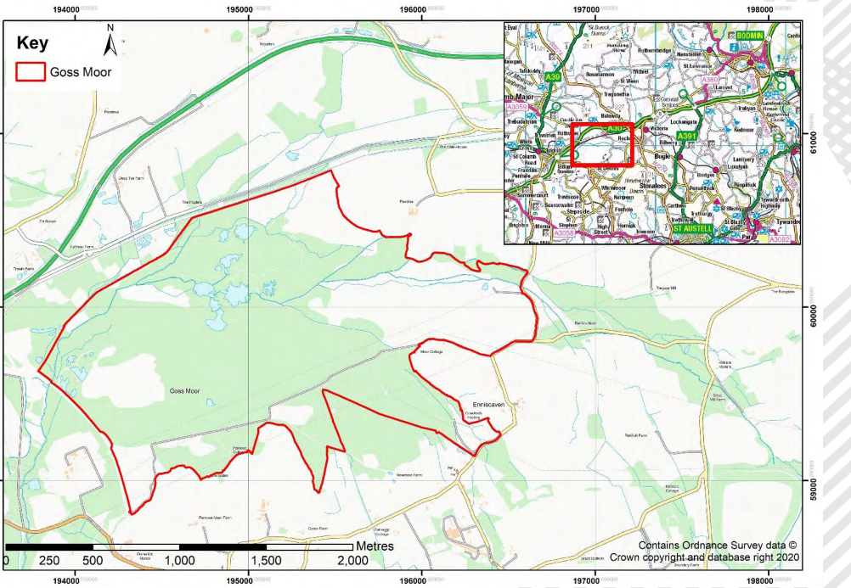

Appendix 2
Priority Scrub Clearance areas 1 – 3 Goss Moor.

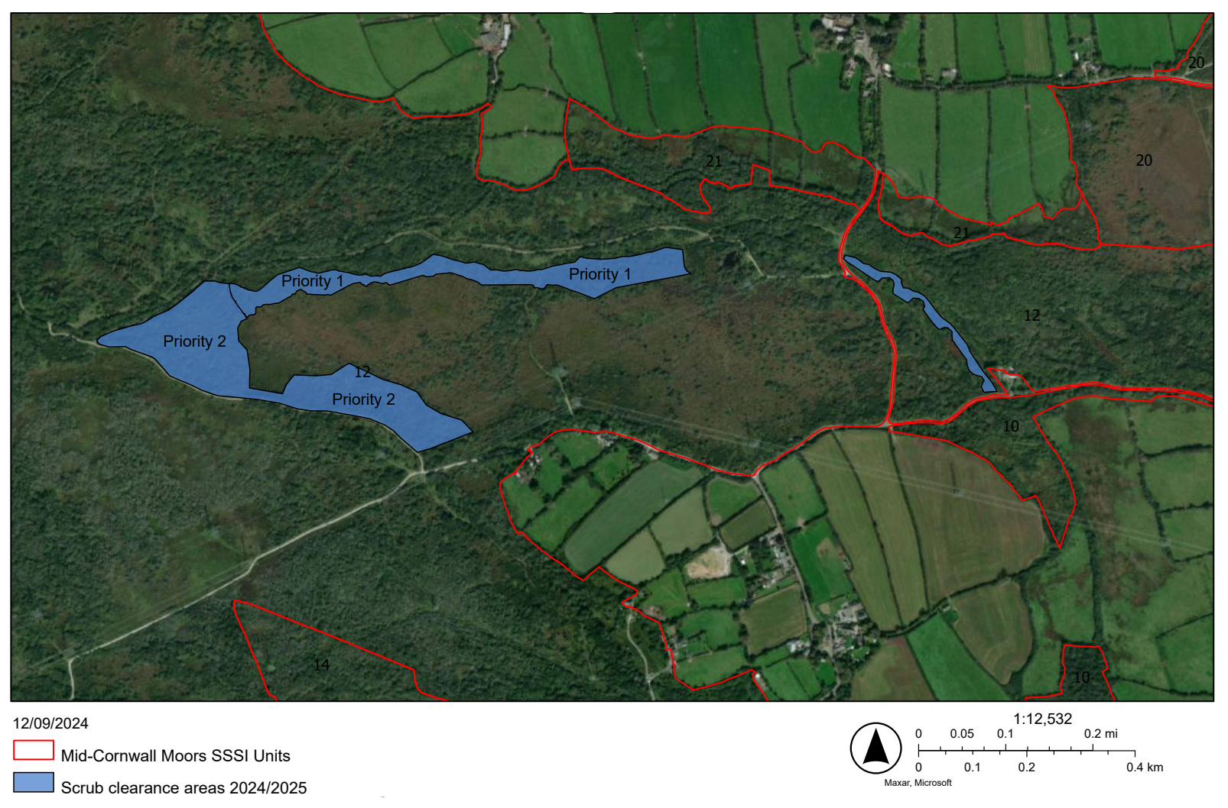
Priority Area 3

Appendix 3. Access route to working area, parking and welfare

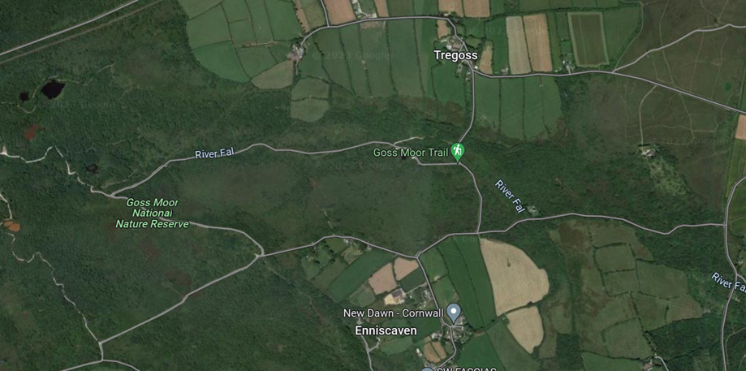

Legend:

Vehicle access route off unnamed public highway – access route for all types of vehicles and machinery. Access through galvanised access gate (code/key) will be provided to appointed contractor.
Location of parking, welfare area.

Appendix 4. Hazards and Constraints

Legend:

Multi use track used heavily by public, visitors and NNR staff - DO NOT OBSTRUCT.
Open water River Fal.
Public Highway.
Flat boggy ground with mounds of archaeological features.
Open water – Pond.

END

