

Date: October 4th 2023.

Dear Sir or Madam,

**TENDER FOR 1) SHINGLE HABITAT RESTORATION, AND 2) INSTALLATION OF BRUSHWOOD FENCING ON LONG ISLAND, LANGSTONE HARBOUR**

LIFE on the edge. LIFE19NAT/UK/964. Co-funded by the European Union

**Suppliers can bid for one of more of the two lots outlined above.**

To be delivered in the period January – April 2024

You are invited to tender in competition with others to provide the goods and/or services specified above to the RSPB.

The following documents are enclosed and must be, where applicable, completed and signed on behalf of the supplier.

|  |  |
| --- | --- |
| Document A | Instruction and Information |
| Document B | RSPB: A Brief Introduction |
| Document C | Specification of Goods / Services |
| Document D | Company Information |
| Document E | Form of Offer |
| Document F | Terms and Conditions |
| Document G | Certificate of Bona Fide Offer |

Your tender response should be emailed to [wez.smith@RSPB.org.uk](mailto:wez.smith@RSPB.org.uk) by 09:00 on Wednesday November 1st 2023.

Only tenders submitted in accordance with the RSPB’s Terms and Conditions will be considered. Any tenders that are incomplete, or received after the time indicated, may be disregarded.

If you wish to discuss any aspect of this tender prior to tendering, please email [Wez.Smith@rspb.org.uk](mailto:Wez.Smith@rspb.org.uk) or [David.Whelan@rspb.org.uk](mailto:David.Whelan@rspb.org.uk).

If you do not wish to tender on this occasion, we’d welcome your feedback.

Yours faithfully

David Whelan – Warden, RSPB Langstone Harbour Reserves

Wez Smith – Senior Project Manager, LIFE on the edge

|  |  |
| --- | --- |
|  | **Document A**  **Instructions and information** |

1. This document is designed to be completed electronically. You are required to mark boxes, insert information or submit additional documentation in response to the questions herein. Whilst the text boxes should expand as you add text, if there is insufficient space for your response please attach a separate document clearly marked with the name of your Company, the reference number and the number(s) of the question(s) to which it relates. Please ‘sign’ this document by adding your name to the end of Document G.
2. If you are unable to comply with a request for information or provide documentation requested then a written account explaining the absence of the information must accompany the return of this tender. Please be aware that the failure to respond to any of the questions, without a written reason, may result in a negative evaluation of that element within the overall evaluation of this questionnaire.
3. The RSPB may require supplementary information or clarification or further evidence of the information given. The RSPB may wish to visit reference sites given as evidence of relevant experience.
4. The RSPB may request interviews with all or a selection of applicants or none. Applicants will be notified in due course. The ability of suppliers may also be determined by, amongst other factors, references, certification, site visits and ‘mystery shopping’.
5. Please answer the questions specifically for your company, NOT for the group if you are part of a group of companies. Please note the term “Company” refers to: Sole proprietor, partnership, incorporated company, co-operative, or voluntary organisation as appropriate.
6. During the term of this agreement and for 1 year thereafter, neither party shall solicit to work for it any person who is or was employed by the other party and who has been involved in the provision of the Services at any time during the preceding 12 months. For the avoidance of doubt, if a person who is or was employed by the other party at the relevant time responds to a publicly advertised recruitment campaign, the recruiting party shall not be deemed to have solicited that person from the other party. If either party is in breach of this it shall pay to the other party an amount equivalent to the gross salary paid by that other party to the relevant employee for the final 12 months of employment.
7. No charge will be made to the RSPB by applicants for any preparation costs accrued during the tender process, whether the applicant was successful or not.
8. You are invited to submit your best offer for the work as detailed below. The RSPB reserves the right to undertake post-tender negotiations.
9. If you require any further information or clarification regarding this tender, please email [Wez.Smith@rspb.org.uk](mailto:Wez.Smith@rspb.org.uk) or [David.Whelan@rspb.org.uk](mailto:David.Whelan@rspb.org.uk)
10. It should be noted that in any contractual relationship that is subsequently entered into, reference will be made to the detailed information provided in the formal response to this tender document provided by the successful organisation. Thus, answers and information given in your reply will become a binding part of the contractual obligations between yourselves and the RSPB.
11. Timetable

|  |  |
| --- | --- |
| Invitation to Tender document sent out | Wednesday October 4th 2023 |
| Tender documents to be returned | Wednesday November 1st 2023 before 09:00. |
| Award of contract | Friday November 10th 2023 |
| Commencement of works | January to March 2024 |
| End of contract | On site completion, before end of April 2024. |

1. The RSPB does not bind itself to accept the lowest or any Tender and reserves the right to accept part only of a Tender. RSPB reserves the right to procure individual elements of the required solution from one or more supplier as appropriate.

Whilst the RSPB aims to provide feedback on failed submissions this may not always be possible, and the RSPB is under no obligation to do so.

1. Tender Evaluation Process

Tenders that fail to meet essential requirements may be excluded from consideration.

Tenders that fulfil essential requirements will be evaluated on the basis of the most economically advantageous tender. Weightings as detailed below.

|  |  |
| --- | --- |
| **Criterion** | **Weighting** |
| Ability to meet the tender criteria, setting out a proposed methodology for its completion. | 40% |
| Cost of services | 40% |
| Health & Safety plus Environmental considerations | 20% |

|  |  |
| --- | --- |
|  | **Document B**  **A Brief Introduction** |

For details on the RSPB’s challenges and achievements in the previous financial year please go to [How the RSPB is Run | About Us - The RSPB](https://www.rspb.org.uk/about-the-rspb/about-us/how-the-rspb-is-run/).

For an overview of the RSPB please go to: [About the RSPB - The RSPB](https://www.rspb.org.uk/about-the-rspb/)

**Background context to the project and site**

The low-lying coastlines of north-west Europe support globally important numbers of breeding, migrating and wintering waterbirds. These birds and their habitats are protected within an extensive network of SPAs, but are nevertheless under great and growing pressure. This is due partly to natural erosion and deposition, partly to climate change-induced sea-level rise, and partly to developmental and recreational impacts. The RSPB Sustainable Shores report (2018) highlighted the past losses, poor quality of remaining, and predicted future losses of coastal habitat and recommends a programme of habitat management/creation to address this. The report highlights where losses will be greatest, and where the best opportunities occur to address these problems. This project builds on these recommendations and aims to bring significant benefit to multiple breeding and wintering shorebird species locally by safeguarding a uniquely used area of shingle habitat and where possible, improving upon its availability.

The RSPB has secured funding via ‘LIFE on the edge’, Bird Aware Solent, our core charitable funding and potentially others, to carry out habitat creation and restoration for shore birds at our Langstone Harbour reserve in Hampshire. The reserve comprises of a series of shingle and saltmarsh islands within the northern part of Langstone Harbour. These islands currently provide vital breeding and wintering habitat for a host of species but hold the potential for further productive and resilient habitat for breeding little tern, sandwich tern, oystercatcher, ringed plover and a wide range of migrating and wintering species.

Long Island is one of the northern most islands of the reserve and has an extensively vegetated shingle and soil ridge on its north-eastern side, currently not useable for shingle nesting or roosting birds. By depositing fresh shingle on this ridge, we aim to create ideal condition for breeding and roosting coastal birds.

Langstone Harbour has been designated a SSSI, SPA, Maritime SAC and Ramsar site, The RSPB have been liaising with Natural England, the Marine Management Organisation and licensing/permissions have been granted to carry out works, including a Marine Licence from the MMO, and Planning permission from Havant Borough Council.

This project is part of an ongoing and wider plan to improve habitat for beach nesting and roosting birds throughout southern England and to make the Langstone Harbour islands more resilient to climate change and rising sea levels. The works being tendered for are part of a set of three projects planned for 2024 which the RSPB are aiming to follow with a further six similar projects of larger and smaller scale throughout the Solent before 2028.

**BRIEF DESCRIPTION OF WORKS**

The information below is not intended to limit creative or original thinking in the preparation of proposals.

The primary aim of this project is to deliver and use shingle to increase the height of a ridge on Long Island in Langstone Harbour by ≤0.7m. This will be accompanied by a brushwood fence on the west side of the ridge. Tendering parties may wish to bid on all parts or selected parts.

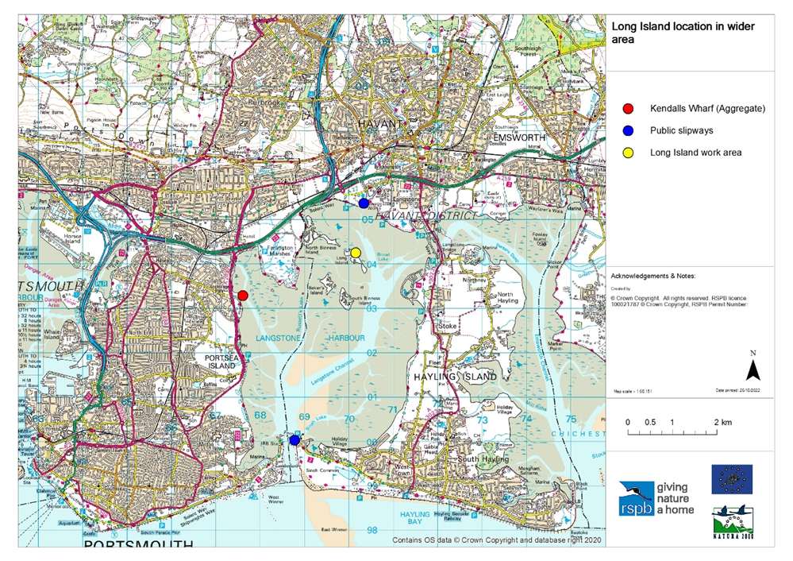

**Figure 1: A map showing the work site within the wider area and highlighting potential slipways to use and the Kendalls Aggregate Wharf.**

It is envisaged that works will take place between January and March 2024.This window of opportunity has been selected in order to limit the disturbance to the designated birdlife for whom the project is being carried out. Activities are permitted in April but earlier completion is preffered.

Flexibility in how our aims are achieved is open to the tendering party, but a brief is set out in section 4.2 of the attached shadow HRA which informed both the marine licence and planning permission. Any major changes that require works outside of the scope of the marine licence or planning permission will require an amendment however and this may not be feasible in the delivery timescale.

The main focus of this tender is the collection, delivery and placement of 1000 tonnes of shingle, to enhance a ridge approximately 150 metres long, 7-10 metres wide and ≤0.7m high on Long Island. The placement area will be marked by the RSPB in advance of works taking place. A brushwood fence 150m long will be created to the east of the ridge.

Our vision for the shingle placement is to have the bulk of material being larger cobbles which are more resistant to wave action, with a heavy capping of smaller shingle more suitable for nesting and roosting bird use. An approximate ratio of larger to smaller shingle would be 90/10%.

Shingle is to be collected from Kendalls Wharf on the eastern side of Langstone Harbour (Grid Ref: SU676032). There will be 30m of berthing space available at high water, usually with another vessel unloading immediately to the south. Shingle purchase, (which includes the cost of dockside loading), will be undertaken by the RSPB separately to this tender. It is expected that multiple journeys will be required in order to collect and deliver the full complement of shingle.

The initial vision is for the use of a vessel with a crane to offload shingle to Long Island via a shallow draft pontoon. Plant machinery such as tracked dumpers and/or light weight excavators could then distribute the shingle evenly across the project area. During a high spring tide, the fully loaded vessel could depart Kendall’s Wharf after loading with shingle and land on the east side of Long Island (Grid reference SU 70184 04260). From there, the shingle could be offloaded, and the vessel returned to be reloaded and ready for the next high tide.

In order to meet the condition of our permitting, vessel landings must be undertaken during high spring tides only and protective matting / bog mats must be placed over the route between the landing site and placement area so that the foreshore and saltmarsh is protected from compaction and truncation. The highest spring tides in the proposed period take place approximately:

* January 11th to 16th.
* February 9th to 15th
* February 25th to 28th
* March 9th to 15th
* March 25th to 30th
* April 7th to 13th
* April 23rd to 28th.

**Figure 2: A map of the site components to be created/installed on Long Island.**

**Figure 3: The Long Island work area at low water as viewed from the North West. Shingle placement area in yellow, brushwood fence location in red.**

**Figure 4: A cross section of the proposed works on Long Island (East to West).**

A brushwood fence must be erected on the west side of the newly created shingle ridge. This will prevent the shingle from encroaching on and smothering coastal saltmarsh, a protected habitat. This simple solution will be created by inserting poles into the ground and filling the middle with brushwood faggots. Some additional side supports may be needed (see figure 5 and attached HRA).

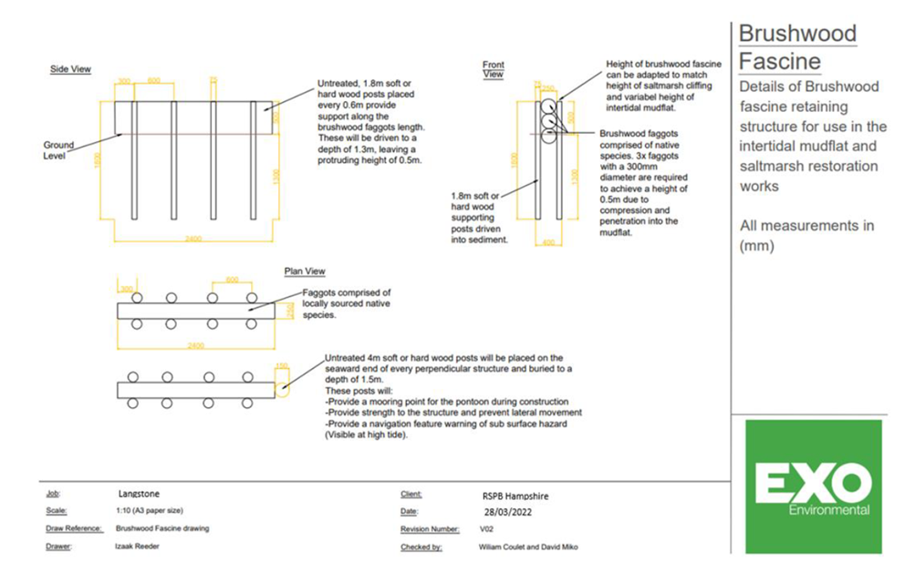

**Figure 5: A diagram of the proposed brushwood fence.**

**Figure 6: Elevation map showing potential access and bog mat placement for option A (from attached HRA document).**

Planning Permission and a marine licence are in place for this work and another site (West Hayling) as part of a joint application. Details included in the tender pack.

A preliminary and detailed UXO investigation report (including site investigation) have been carried out for the specified actions on site with sign off being provided. No UXO were found.

Each tendering party may wish to bid for both parts of this tender (shingle delivery/placement and brushwood fencing) or just a selected part.

Langstone Harbour has the following designations:

* Special Protected Area (SPA)
* Special Area of Conservation
* RAMSAR site
* Site of Special Scientific Interest (SSSI) <https://designatedsites.naturalengland.org.uk/SiteDetail.aspx?SiteCode=s1001182>

We expect the selected contractor to manage their operations within the law and spirit of those environmental designations and leave minimal trace of presence upon completion of the task. We expect contractors to co-operate with us throughout the period for which they are working on the project and an atmosphere of openness and trust whereby all parties communicate issues and risks promptly and involve themselves in appropriate and timely resolution.

We will require to see proof of contractors’ insurances, relevant qualifications including those related to health and safety.

We expect all people working on the project:

* To be responsible for their own and others’ health and safety.
* As this is a nature reserve designated SSSI, SPA, SAC and Ramsar to take extreme care not to harm the environment and to minimise wildlife disturbance.
* To act appropriately as a representative of RSPB on a site that is visible to the public.
* To respect our deadlines (as they are conditions of funding) and the requirements of working on a nature reserve.
* To comply with Construction Design Management Regulations 2015 as well as all other relevant HSE regulations.
* To identify where costs can be saved or where opportunities arise to deliver more within our budgetary constraints.

|  |  |
| --- | --- |
|  | **Document C**  **Specification** |

The successful supplier/suppliers will supply a service to which the following points will apply.

**You may bid for one or more lots.**

All tendering parties must complete section 3. If multiple contractors are required to carry out the project at the same time, it is expected that the supplier of the shingle habitat creation (Lot 1, the most significant works) will be the principal contractor.

The information below is a statement of minimum requirements and is not intended to limit creative or original thinking in the preparation of proposals.

**Lot one: The delivery and placement of shingle on Long Island.**

1. Liaising with the RSPB and the aggregate supplier, the tendering party must collect and deliver 1000 tonnes of shingle (which the RSPB will procure) to the project site via a suitable vessel or vessels. The proposed landing site is at grid ref SU702041. Shingle is being procured from Kendall Aggregates and it is envisioned that shingle will be loaded at (and transported from) Kendell’s Wharf (grid ref SU676032). Dockside loading will be carried out by Kendell’s, but the selected contractor must be able access the available berthing space (30m in length).

*Are you able to meet this specification in full? If so please give details below*

*If not please state any differences in service offered*

|  |
| --- |
| Specification met? Yes /Part met  / No (tick as appropriate)  Details |

1. The supplier must use the transported shingle to create an enhanced shingle ridge (to be marked out by the RSPB). The area of deposition will be approximately 150m long, 7-10m wide and ≤0.7m high. The shingle will consist of two sizes, with the base layer (approx. 90% of the delivery) being larger cobbles and the surface (approx. 10% of the delivery) being smaller shingle. Protective matting / bog mats must be placed over the route between the landing site and placement area to protect the saltmarsh beneath.

*Are you able to meet this specification in full? If so please give details below*

*If not please state any differences in service offered*

|  |
| --- |
| Specification met? Yes /Part met  / No (tick as appropriate)  Details |

**Lot two:** **The installation of a brushwood fence on the west side of the raised shingle ridge (this will need to take place shortly before/during or after the shingle habitat works).**

1. The supplier must install a brushwood fence, as per the HRA and MMO licence, along the western side of the shingle deposit. This will be 150m in length.

*Are you able to meet this specification in full? If so please give details below*

*If not please state any differences in service offered*

|  |
| --- |
| Specification met? Yes /Part met  / No (tick as appropriate)  Details |

**Section 3 (all tendering parties to complete):**

1. The supplier must comply with all of the conditions set out within the attached Marine Licence. This includes the limiting of vessel landings to high spring tides, the use of protective matting / bog mats on the route between the landing site and placement area and the need to adhere to the Clean/Check/Dry code and supply a brief on how this will be done.

*Are you able to meet this specification in full? If so please give details below*

*If not please state any differences in service offered*

|  |
| --- |
| Specification met? Yes /Part met  / No (tick as appropriate)  Details |

1. The supplier must comply with the planning permission granted set out in the attached decision except for points 3,4,5, and 8 (which do not apply to Long Island). The chosen contractor will need to produce a Construction Environment Management Plan as per point 7. The RSPB will complete point 6 (archaeology). The supplier should be able to deliver the needed works between January and April 2024 as per point 9. Please outline your ability to meet these timelines. Full documents from planning permission (APP/22/00850) available on the Havant Borough portal [here](https://planningpublicaccess.havant.gov.uk/online-applications/applicationDetails.do?activeTab=documents&keyVal=DCAPR_254120).

*Are you able to meet this specification in full? If so please give details below*

*If not please state any differences in service offered*

|  |
| --- |
| Specification met? Yes /Part met  / No (tick as appropriate)  Details |

1. The project is working to tight timescales where you will have to work closely with a shingle supplier and potentially other contractors (subject to specifications bid for). This could coincide with challenging weather conditions (health and safety is of utmost importance, and works may need to be rescheduled if weather conditions are too extreme). The supplier should be able to deliver the needed works between January and April 2024. Please outline your ability to meet these timelines.

*Are you able to meet this specification in full? If so please give details below*

*If not please state any differences in service offered*

|  |
| --- |
| Specification met? Yes /Part met  / No (tick as appropriate)  Details |

1. The supplier must meet the Construction (Design & Management) Regulations irrespective of whether or not the project is notifiable to the HSE and also be able to share appropriate health and safety documentation/planning via an exchange of information before commencement. For the purpose of this project, the supplier of the shingle delivery and placement will take on the role of principle contractor.

*Are you able to meet this specification in full? If so please give details below*

*If not please state any differences in service offered*

|  |
| --- |
| Specification met? Yes /Part met  / No (tick as appropriate)  Details |

1. As part of the tender, the supplier must set out in a brief their proposed scheme of works to meet these specifics above (1 to 7). Please use this opportunity to set out your proposed approach to the project, details of the machinery, method etc. We’d also welcome an introduction to the supplier’s company and their existing experience if appropriate. New or original solutions to the projects aims are welcome.

*Are you able to meet this specification in full? If so please give details below*

*If not please state any differences in service offered*

|  |
| --- |
| Specification met? Yes /Part met  / No (tick as appropriate)  Details |

|  |  |  |  |
| --- | --- | --- | --- |
|  | | | **Document D**  **Company Information** |
| **1.0** | **General** | | |
|  |  | | |
| **1.1** | **Registered Name**    **Trading Name (if different)** | | |
|  |  | | |
| **1.2** | **Correspondence Details**  **Name of person applying on behalf of the company**    **Address:**    **Telephone:**    **Mobile:**    **Email:** | | |
|  | **Registered office Address (if different from above)** | | |
|  |  | | |
| **1.3** | **Company Registration No (if applicable)**    **VAT registration number (if applicable)** | | |
|  |  | | |
| **1.4** | **Date company was founded (if a limited company, date of incorporation)** | | |
|  |  | | |
| **1.5** | **Company structure and nature of company**  Please outline the nature of the company, whether it is a partnership, sole trader, plc etc.    Is the company proposed as party to the contract part of a larger organisation? If so please explain the relationship between the various parts of the organisation, up to the ultimate holding company.    Current number of full time equivalent staff currently employed by the company (not larger parent company) | | |
|  |  | | |
| **1.6** | **Accreditation by / Membership of Trade Association(s)**  **Is your Company registered with any industry accreditation body? YES  NO**  **If yes, please provide details:**    **Is your Company on any public sector Framework agreements? YES NO**  **If yes, please provide details:**    **Please state membership of any professional bodies/ other associations below:** | | |
| **1.7** | **Quality Assurance**  **Is all / part of your company ISO9001 Quality Assured? YES NO**  **Is all / part of your company ISO14001 Quality Assured? YES NO**  **If yes please provide copy of certification**  **Do you have any other Quality Assurance? If Yes, please summarise details below** | | |
|  |  | | |
| **1.8** | **Environmental Commitments**  **Is all / part of your company registered under Science Based Targets (**[**https://sciencebasedtargets.org/net-zero**](https://sciencebasedtargets.org/net-zero)**), Business Climate Hub (**[**https://businessclimatehub.org/uk/**](https://businessclimatehub.org/uk/)**) or equivalent? YES NO**  **If Yes, please summarise details below** | | |
|  |  | | |

|  |  |
| --- | --- |
| **2.0** | **Financial & Business Probity** |
|  |  |
|  |  |
|  |  |
| **2.1** | | **Judgements etc.**  **Are there any judgements, claims or suits pending or outstanding against your company?**  **Yes  No** If Yes, please provide full details  **Has your company ever failed to complete a contract?**  **Yes  No** If Yes, please provide full details |
| **2.2** | | Please answer all of the following questions as they apply to your Company’s circumstances. Please confirm that:  1) being a company, no resolution has been passed or Order of the Court made for the company’s winding up otherwise than for the purposes of bona fide reconstruction or amalgamation, nor has a receiver, manager or administrator on behalf of a creditor been appointed in respect of the company’s business or any part thereof, nor is it the subject of any proceedings for any of the above procedures, nor is it the subject of similar procedures under the law of any other state.  **Confirmed  Not confirmed  Non-applicable**  2) being a partnership, it has not granted a trust deed or become otherwise apparently insolvent, or it is not the subject of a petition presented for sequestration of its estate.  **Confirmed  Not confirmed  Non-applicable**  3) being an individual, you are not bankrupt, or have not had a receiving order or administration order made against you, or have not made a composition or arrangement or trust deed with or for the benefit of your creditors, or have not made any conveyance or assignment for the benefit of your creditors, or have not had a petition presented for sequestration of your estate or do not appear to be able to pay or to have no reasonable prospect of being able to pay a debt within the meaning of the Insolvency Act or any similar procedure under the law of any EC member state.  **Confirmed  Not confirmed  Non-applicable**  4) no Directors, Partners, Associates or the Company Secretary have been involved in any Company which has been liquidated or gone into receivership.  **Confirmed  Not confirmed  Non-applicable**  5) none of the Directors, Partners, Associates or the Company Secretary have been convicted of a criminal offence relating to the conduct of their business or profession.  **Confirmed  Not confirmed  Non-applicable**  6) neither the Company nor any of the Directors, Partners, Associates or Company Secretary has committed an act of grave misconduct in the course of their business or profession.  **Confirmed  Not confirmed  Non-applicable**  7) all obligations relating to the payment of taxes under the law of any part of the United Kingdom or the EC member state in which the Company is established has been fulfilled  **Confirmed  Not confirmed  Non-applicable**  8) all obligations relating to the payment of social security contributions under the law of any part of the United Kingdom or the EC member state in which the Company is established have been fulfilled.  **Confirmed  Not confirmed  Non-applicable**  If you have ticked **‘Not confirmed’** for any questions above please give details here |

|  |  |
| --- | --- |
| **2.3** | Please list the names of any Director, Partner, Associate or Company Secretary who have been employed by the RSPB, giving department and dates.    Please give details of any Director, Partner, Associate or Company Secretary who have a relative who is employed by the RSPB at a senior level.    Please list the names of any Director, Partner, Associate or Company Secretary who have any involvement in other Companies who provide services to the RSPB    Is any work being undertaken or likely to be undertaken during the next three years by the Company or staff within it which could give rise to a conflict of interest through acting for third parties or otherwise? If yes, please explain the actual or likely circumstances and how such potential conflicts of interest would be handled. |

|  |  |  |  |  |  |
| --- | --- | --- | --- | --- | --- |
| **2.4** | **Insurances (a scanned copy of each certificate may be requested)** | | | | |
|  |  | **Insurer** | **Policy No** | **Value of Cover** | **Expiry Date** |
|  | Employers Liability |  |  |  |  |
|  | Public Liability |  |  |  |  |
|  | Prof. Indemnity |  |  |  |  |
|  | All Risks  (if applicable) |  |  |  |  |

|  |  |
| --- | --- |
| **2.5** | **Has your company (or any building/project you have undertaken) won any awards, accolades or recognition?**  **YES  NO** If yes please provide full details. |

|  |  |
| --- | --- |
| **3.0** | **Health & Safety and Environment** |
|  |  |
| **3.1** | Has your company been served with any enforcement or prohibition notices or been prosecuted in the past 5 years for breaches of health & safety legislation?  **YES**  **NO** If yes please provide full details. |
| **3.2** | Has your company been served with any enforcement or prohibition notices or been prosecuted in the past 5 years for breaches of environmental legislation?  **YES  NO** If yes please provide full details. |
| **3.3** | Has your company been served with any enforcement or prohibition notices or been prosecuted in the past 5 years for breaches of data protection legislation?  **YES  NO** If yes please provide full details. |
| **3.4** | Have any restrictive clauses in relation to your company’s Employer’s Liability, Public Liability or Professional Indemnity Insurance policies been enforced in the last 5 years due to past Health & Safety performance?  **YES**  **NO**  If yes please provide full details. |

|  |  |
| --- | --- |
|  | **Document E**  **Form of Offer** |

**Cost**

Please set out below a breakdown of your tender quote for each option.

For supplier bidding for multiple lots, please state (under assumptions, below) if you would be prepared to carry out this lot as a standalone piece of work, or only in conjunction with other lots bid for. Also please state if carrying any of these lots requires you to sub-contract.

Indicate full details of expected payment terms including any upfront payments required to cover the cost of equipment/materials.

**Lot 1: The delivery and placement of shingle on Long Island:**

|  |  |
| --- | --- |
| Cost of completing project as outlined in specifications. (1000 tonnes of shingle delivered to create an enhanced shingle ridge). Please provide a breakdown of costs. | £      + VAT |
| Assumptions: |  |

**Lot 2: The installation of a brushwood fence on the west side of the raised shingle ridge:**

|  |  |
| --- | --- |
| Cost of completing project as outlined in specifications (Document C), a brushwood fence of 150m length. Please provide a breakdown of costs. | £      + VAT |
| Assumptions: |  |

**Added Value**

As well as any charity rate that you may be able to offer, the RSPB is always open to corporate partnerships that deliver benefit to your organisation, the RSPB and nature. Working as part of your CSR agenda we can provide opportunities for fundraising, secondments, interns and volunteering, offering your staff both personal and career development opportunities. We also welcome all forms of gifts in kind as valuable contributions to our work.

Suppliers should provide details of any associated added value features/services/gifts in kind available to the RSPB under the terms of this Tender. (Attach separate document if needed).

Please note, added value donations will not be part of the criteria we use to decide on which supplier to choose.

**References**

Suppliers are requested to provide details of three references from their existing clientele, supplying full name, address, telephone number, email address, contact name, period of Contract and the estimated annual value of the Contract. In supplying this information, Suppliers shall have granted the RSPB permission to seek such information as deemed necessary, in relation to the Suppliers performance with their nominated references.

Reference 1

|  |  |  |
| --- | --- | --- |
| Company Name |  | |
| Address |  | |
| Telephone No |  | Ext |
| Email |  | |
| Contact |  | Dates of work |
| Nature of work done |  | Value of contract |

Reference 2

|  |  |  |
| --- | --- | --- |
| Company Name |  | |
| Address |  | |
| Telephone No |  | Ext |
| Email |  | |
| Contact |  | Dates of work |
| Nature of work done |  | Value of contract |

Reference 3

|  |  |  |
| --- | --- | --- |
| Company Name |  | |
| Address |  | |
| Telephone No |  | Ext |
| Email |  | |
| Contact |  | Dates of Work |
| Nature of work done |  | Value of contract |

|  |  |
| --- | --- |
|  | **Document F**  **RSPB Terms and Conditions** |

The basis of the contractual agreement between RSPB and the applicant is detailed in the [‘RSPB Terms and Conditions of Purchase of Goods and Services’](https://www.rspb.org.uk/about-the-rspb/about-us/how-the-rspb-is-run/supplier-terms-and-conditions/) – please click on this link to download. In applying for this tender you are explicitly agreeing to be bound by these Terms and Conditions for the duration of the contract. If you require any alterations to these Terms and Conditions please state your issues below. (Attach separate document if needed)

The RSPB expects that all suppliers it works with to adhere to certain ethical and environmental standards. Please download the [RSPB Ethical and Environmental Procurement Policy](https://www.rspb.org.uk/about-the-rspb/about-us/how-the-rspb-is-run/supplier-terms-and-conditions/) and tick this box if you agree to be bound by its terms and conditions 

|  |  |
| --- | --- |
|  | **Document G**  **Certificate of Bona Fide Offer** |

We certify that this offer is made in good faith, and that we have not fixed or adjusted the amount of the offer by or under or in accordance with any agreement of arrangement with any other person. We also certify that we have not, and we undertake that we will not:

1 a) communicate to any person other than the person inviting these offers the amount or approximate amount of the offer or proposed offer, except where the disclosure, in confidence, of the approximate amount of the offer was necessary to obtain insurance quotations required for the preparation of the offer;

b) enter into any agreement with any other person that s/he shall refrain from making an offer or as to the amount of any offer to be submitted;

2 pay, give or offer or agree to pay or to give any sum of money or other valuable consideration directly or indirectly to any person for doing or having done or causing or having caused to be done in relation to any offer or proposed offer for the goods/services any act or thing of the sort described in 1 a) or 1 b) above.

We acknowledge that if we acted or shall act in contravention of this certificate, the RSPB will be entitled to cancel the agreement and to recover from ourselves the amount of any loss and expense resulting from such cancellation.

I state that everything in this tender submission is truthful, that if found to be untruthful the RSPB can terminate any agreement between the RSPB and the company formed on the basis of this tender, and we will pay to the RSPB any loss or expenses the RSPB suffers as a result of such untruthfulness, whether an agreement is entered into or not.

In this certificate, the word “person” includes any persons and any body or association, corporate or unincorporated; “any agreement or arrangement” includes any transaction, formal or informal, and whether legally binding or not.

|  |  |
| --- | --- |
| Signed |  |
| On behalf of |  |
| Date |  |

**Please note: a name added in an electronic document is functionally equivalent to a signature.**