KEF-799 SOLE SOURCE JUSTIFICATION REQUEST FORM

Section 1 – Essential Information (Demander completes section 1-3 in consultation with the Buyer / Procurement Specialist)
Name of Supplier / Contractor |  |  | GAU |  | NDA correspondence log number (if applicable)
Programme name |  |  |  | Desiccant and Catalyst | Site name |  |  | Dungeness A
- New or existing Purchase Order (PO)? Please delete / complete as appropriate: |  |  |  |  | New / Existing |  | Existing PO No:
- Original Value |  |  |  |  | £
- Total of Previous Variations |  |  |  |  | £
- Value (this SSJ request) |  |  |  |  | £47,160
- Total Authorised |  |  |  |  | £47,160
- proposed New / Revised Contract Start Date |  |  |  |  | 01/03/2025
- proposed New / Revised Contract End Date / or term of contract |  |  |  |  | 01/03/2026
- Has the supplier previously provided these works, goods or services to the Company via a direct award or a sole source? Please delete / complete as appropriate:  * If this is being bought on a regular basis, consider whether sole source is the best value for money |  |  |  |  | No /  Yes – see summary but not for this body of work | Summary of 12 months previous spend:
Section 2 - Brief Description of goods/services required
Undertake radiochemical analysis of 26 desiccant and catalyst samples, with the aim of providing data suitable for developing a radiological inventory and informing the optimal waste management route. Analysis is to be performed on a phased approach: a fixed price is provided for Phase 1; whilst a price-per-sample is provided for Phase 2. The extent of required Phase 2 analysis will not be known until the Phase 1 analysis results have been received. The maximum possible cost is ~ £23,000, but it is more likely to be < £5,000.

The samples have already been taken and are currently stored on site. Their activities are expected to be in the Intermediate Level Waste (ILW) range.

Section 3 - Sole Source Justification (select any that apply) |  |  |  |  |  |  |  |  | UBW *¹
X |  | Minimum needs can only be satisfied by unique supplies / services available from this source |  |  |  |  |  |  | Notavail
 |  | The item(s) or service(s) purchased involve patented, copyrighted or proprietary processes |  |  |  |  |  |  | Notavail
 |  | Only the specific make or model of the equipment or parts described shall satisfy needs for replacement parts or additional units to meet standardisation requirements. |  |  |  |  |  |  | Nocomp
 |  | Control of raw materials makes the supplies or services available from only one source |  |  |  |  |  |  | Notavail
X |  | Unusual or compelling urgency precludes fair and effective competition. Delay in award shall most likely result in NDA financial loss or a prolonged hazardous or unsafe situation. (Applies to genuine emergencies not driven by poor planning or preparation). |  |  |  |  |  |  | Nocomp
 |  | The purchase order or subcontract is issued for electric power, water or other public services for which the rates are publicly regulated and available from only one source. |  |  |  |  |  |  | Notavail
Detailed justification*² building on selection(s) above
Samples of Dungeness A desiccant and catalyst were obtained in Q1 2024. Prior to this, a competitive tendering exercise under the WCASS Framework was held, resulting in procurement of a supplier to undertake the analysis of these samples. Unfortunately, it subsequently became evident that the supplier was not fit-for-purpose for delivering the scope of work, hence the contract was terminated.

The samples have since been stored on site awaiting procurement of an alternative supplier. Due to their high activity, many laboratories are unable to accept these samples. Three laboratories were directly contacted: one could not accept the samples (GEL), whilst the other two (GAU and NNL) provided quotes for the work.

The NNL quote stipulates that they cannot start analysis of these samples until they complete other NRS work which they are currently working on, thereby delaying the start of analysis until November 2025 at the earliest. Their quote also specifies an 18 month analysis period, meaning the work will likely not be completed until 2027. In contrast, GAU can receive and start analysis of the samples immediately, and will fully complete within one calendar year, though likely significantly sooner.

According to good practice guidelines, the holding time for samples should be minimised to prevent the loss of volatile radionuclides, particularly tritium. Since tritium accounts for the vast majority of activity in these samples, it is crucial that they are analysed as soon as possible, as they have already been in storage for nearly a year. Additionally, Dungeness A site require data from the analysis of these samples to permit onward routing of the waste, and therefore remove the hazard of maintaining the drums in storage on site. Given this, accepting the NNL quote or undergoing another round of competitive tendering would cause unacceptable delays in the analysis.

A direct award to GAU would allow us to establish a contract immediately, with prior discussions already having taken place to facilitate this process. The GAU quote is also substantially cheaper than NNL. If the full extent of Phase 2 analysis is assumed, the maximum GAU price is < £50k, compared to £305k quoted by the NNL. Furthermore, the GAU quote is technically compliant and GAU have analysed similar materials previously, hence there is high confidence they can deliver this work to the required standard.

Section 4 - Sole Source Validation
The following actions have been taken to determine potential sources for the goods and/or services and to validate the need to sole source this procurement action:
(Buyer / Procurement Specialist to complete section 4-5)
 | A market survey was conducted using publications and/or trade journals, with Procurements support to identify potential suppliers.
 | Other sources were sought through publication of the requirements in Find a Tender Service (FTS), or other publications and trade journals.
 | Drawings and specifications were reviewed to determine if less restrictive requirements would meet project needs. Performance specifications were considered, as well as technical specifications.
X | Under unusual or compelling urgency no other potential sources were contacted or sought.
 | Other – detail

Section 5 – Other Considerations
 | The request is for a worker who provides their service through an intermediary, but would be classed as an employee if they were contracted directly. | IR35 may apply - Seek guidance from the People & Corporate Category team and / or Head of Commercial Standards *⁴

Section 6 – Declaration and Approvals *³:
The Public Contract Regulation 2015 (as amended) state that all awards over £25,000 (excluding VAT) in value must be advertised on the Contracts Finder portal to ensure open and transparent procurement.
By requesting this sole source justification, I the undersigned, understand that the Company will publish the award of this contract and that as the demander, I confirm that this sole source award is sufficiently robust to defend any formal legal challenge.

I also confirm that I the undersigned have no personal or pre-existing relationships or vested interests in the award of this contract.
Demander: Name, title and date | Signature
Jason White | 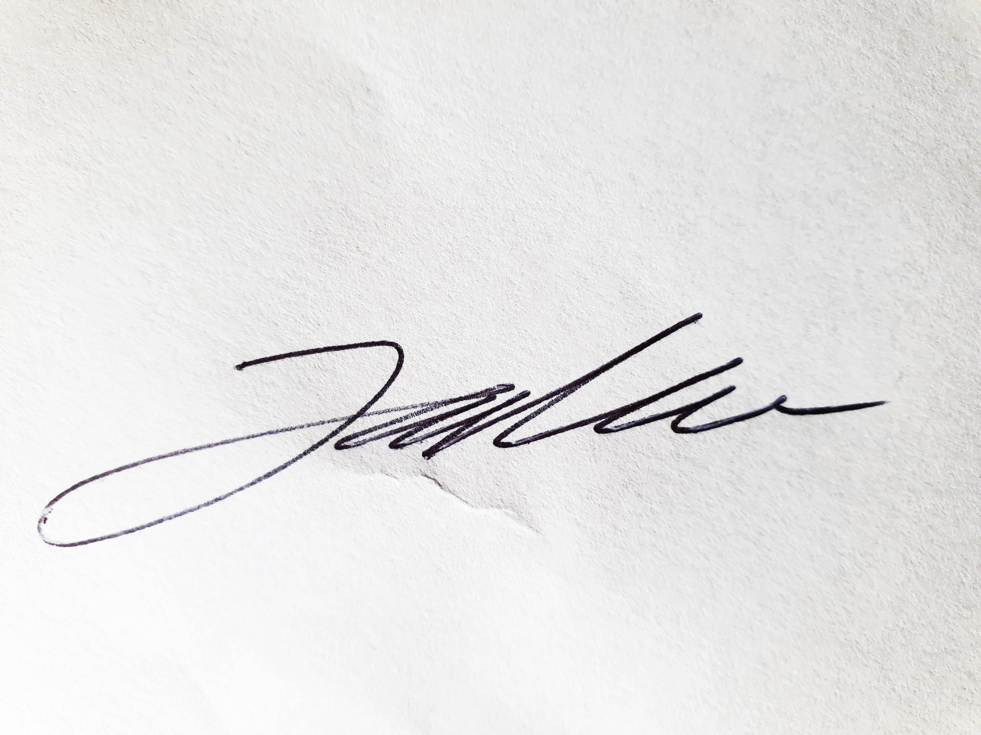
Buyer / Procurement Specialist: Name, title and date | Signature
Suz Williams Supply Chain Lead Waste Ops

Sole Source Procurement Approval (Category / Supply Chain Managers / Relevant Head of Procurement: Name, Title and date | No signature required – approval is via the Sole Source step in UBW
Kevin Sheppard

NDA: Name, title and date | Signature

Notes:

*¹ | UBW options relating to Sole Source are as follows:  - Notavail - Only one supplier can provide the good / service.  - Nocomp (competition dispensed with) - More than one supplier can supply the good / service but there is a specific reason why one supplier is favoured over the others.  - Competed – Purchase has been competed
*² | Justification MUST be detailed enough to explain why the Sole source option has been chosen i.e. why the relevant boxes have been selected.
*³ | The following authorisations are required:  - £0 - £10,000 = Buyer  - >£10,000 – £50,000 = Category / Supply Chain Managers  - >£50,000 - £5,000,000 = P&SC Heads of Procurement  - >£5,000,000 = NDA (Approved within UBW by the Commercial Director upon receipt of evidence of NDA approval (obtained by the P&SC Heads of Procurement)).  - >£10,000,000 = Department for Energy Security and Net Zero (DESNZ)  Over 5 years in duration = NDA  Note that Legal must review sole source contracts over £5,000,000 prior to NDA approval being sought. Note that legal input may be required for sole source procurements below this threshold that are higher risk.  - These delegation limits relate to the duration of the commitment.  No form is required for values under £10,000 – the Buyer should include a brief justification in UBW for these
*⁴ | IR35 impacts  The off payroll working rules can apply if a worker (sometimes known as a contractor) provides their services through their own limited company or another type of intermediary to the client.  An intermediary will usually be the worker’s own personal service company, but could also be any of the following:  - a partnership,  - a personal service company, or  - an individual  The rules make sure that workers, who would have been an employee if they were providing their services directly to the client, pay broadly the same Income Tax and National Insurance contributions as employees. These rules are known as ‘IR35’.  The client is the organisation who is or will be receiving the services of a contractor. They may also be known as the engager, hirer, or end client. The client is responsible for determining if the off payroll working rules apply.  Seek advice from the People & Corporate Category team and / or Head of Commercial Standards if it is possible this could apply.
Other | Failure to attach a completed copy of this form in UBW or providing one with insufficient explanations will result in rejection of the request.

